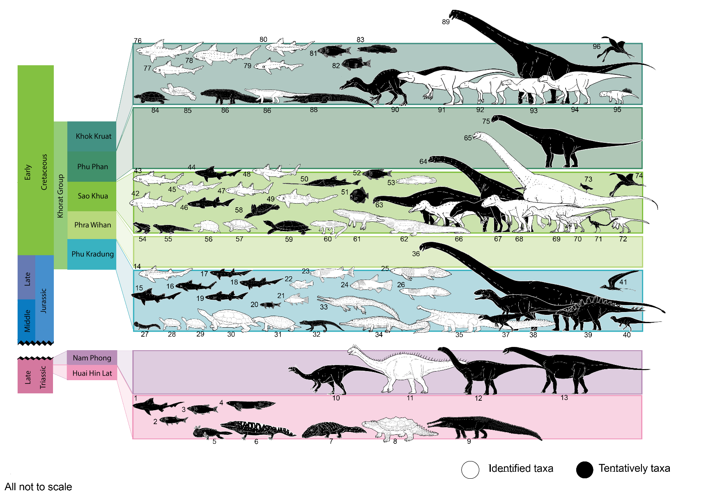
Supplementary

Figure 1. Mesozoic vertebrate fauna from the Indochina Terrane of Thailand, species-level identified taxa shown in white silhouettes, tentatively identified taxa in black silhouettes (Modified from Lionel Cavin: All not to scale).

Huai Hin Lat Formation
1. Hybodus sp.
2. Palaeonisciformes indet.
3. Semionotiformes indet.
4. Ceratodontoidei indet.
5. Plagiosauridae indet.
6. Stereospondyli indet.
7. Cyclotosaurus cf. posthumus
8. Proganochelys ruchae

9. Phytosauria indet.
- Footprints (archosauria indet.)

Nam Phong Formation
10. Basal sauropodomorpha indet.
11. Isanosaurus attavipachi
12. Sauropoda cf. Vulcanodontidae
13. Sauropoda cf. Tazoudasaurus

- Footprints (tetrapod indet., sauropoda and theropoda)

Phu Kradung Formation
14. Acrodus kalasinensis
15. Hybodus sp.
16. Heteroptychodus sp.
17. Lonchidion sp.
18. Lissodus sp.
19. Jiaodontus sp.
20. Ptycholepidae indet.
21. Thaiichthys buddhabutrensis
22. Khoratichthys gibbus
23. Isanichthys palustris
24. Isanichthys lertboosi
25. Ferganoceratodus martini
26. Ferganoceratodus annekempae
27. Brachyopidae indet.
28. Phunoichelys thirakhupti
29. Kalasinemys prasarttongosothi
30. Basilochelys macrobios
31. Yakemys multiporcata
32. Atoposauridae indet.
33. Indosinosuchus potamosiamensis
34. Indosinosuchus kalasinensis
35. Chalawan thailandicus
36. Mamenchisauridae indet.
37. Theropoda indet.
38. Metriacanthosauridae indet.
39. Stegosauridae indet.
40. Basal neornithischia indet.
41. Rhamphorhynchoidea indet

Phra Wihan Formation
- Footprints (crocodyliformes, sauropoda, theropoda and ornithopoda)

Sao Khua Formation
42. Heteroptychodus steinmanni
43. Heteroptychodus kokutensis
44. Hybodus sp.
45. Lonchidion khoratensis
46. Parvodus sp.
47. Isanodus paladeji
48. Isanodus nongbualamphuensis
49. Mukdahanodus trisivakulii
50. Sclerorhynchoid indet.
51. Pycnodontiformes indet.
52. Ginglymodi indet.
53. Siamamia naga
54. Anura indet.
55. Anguimorpha indet. (egg fossil)
56. Isanemys srisuki
57. Protoshachemys rubra
58. Kizylkumemys sp.
59. Trionychoidea indet.
60. Theriosuchus grandinaris
61. “Goniopholis” phuwiangensis
62. Siamosuchus phuphokensis
63. Sauropoda cf. Diplodocoidea
64. Sauropoda cf. Brachiosauridae
65. Phuwiangosaurus sirindhornae
66. Siamosaurus suteethorni
67. Carcharodontosauria indet.
68. Siamotyrannus isanensis
69. Phuwiangvenator yaemniyomi
70. Vayuraptor nongbualamphuensis
71. Compsognathidae indet.
72. Kinnareemimus khonkaenensis
73. Aves indet.
74. Ornithocheridae indet.
- Footprints (theropoda)

Phu Phan Formation
75. Sauropod indet.
- Footprints (theropoda)

Khok Kruat Formation
76. “Hybodus” aequitridentatus
77. Heteroptychodus steinmanni
78. Thaiodus ruchae
79. Khoratodus foreyi
80. Acrorhizodus khoratensis
81. Lanxangichthys sp.
82. Ginglymodi indet.
83. Siamamia sp.
84. Kizylkumemys khoratensis
85. Shachemys sp.
86. Goniopholididae indet.
87. Eusuchia indet.
88. Khoratosuchus jintasakuli
89. Titanosauriformes indet.
90. Spinosauridae indet.
91. Siamraptor suwati
92. Siamodon nimngami
93. Ratchasimasaurus suranareae
94. Sirindhorna khoratensis
95. Psittacosaurus sattayaraki
96. Pterosauria indet.
- Footprints (crocodyliformes,
theropoda and ornithopoda)

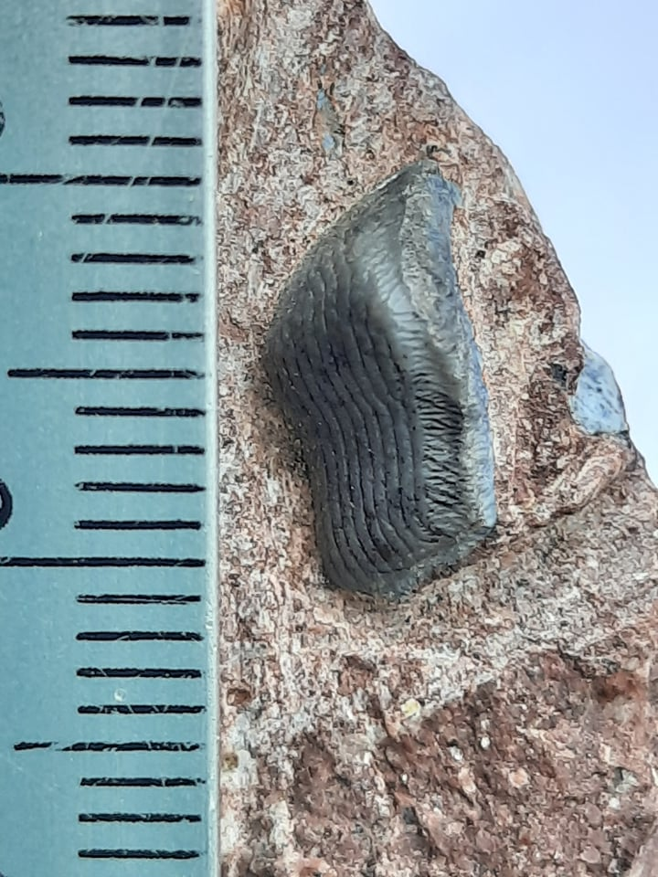
Figure 2. Tooth of Heteroptychodus steinmanni from Ban Saphan Hin (housed in private colletion), Nakhon Ratchasima Province in apical view: Photo courtesy of Witaya Nimngami

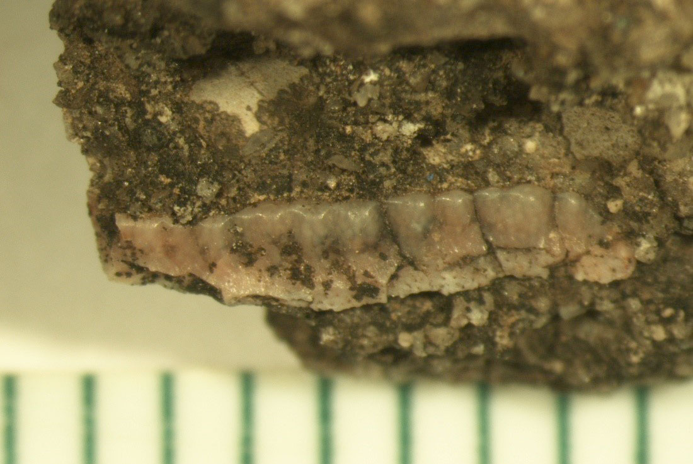
Figure 3. Tooth of Thaiodus ruchaea from Lam Pao Dam, Kalasin Province in lingual view: Photo courtesy of Gilles Cuny.

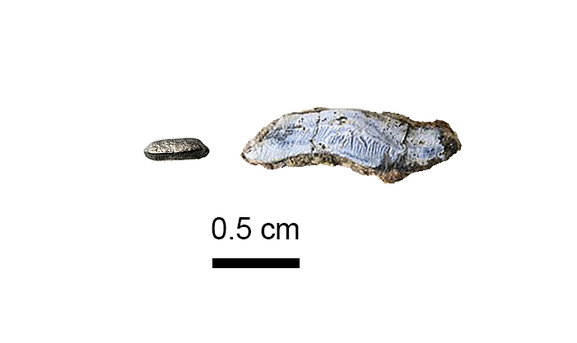
Figure 4. Teeth of Hybodonts indet. from Lam Pao Dam (housed in Sirindhorn Museum colletion), Kalasin Province in apical view: Photo courtesy of Wansiri Boonla.

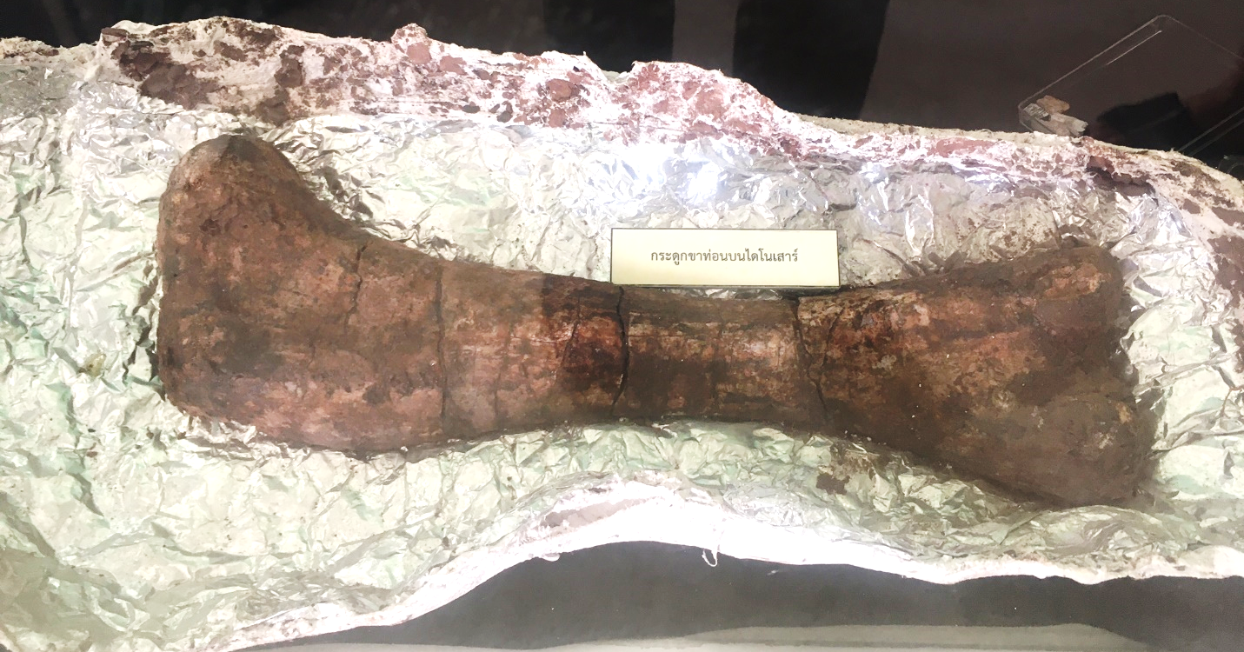

Figure 5. A left femur approximately 40 cm in length of a probable juvenile sauropod from Khok Pha Suam in posterior view. It is on an exhibit at the local museum under the supervision of Na Kham Subdistrict Administrative Organization.

