Supplementary file D
Phylogenetic trees
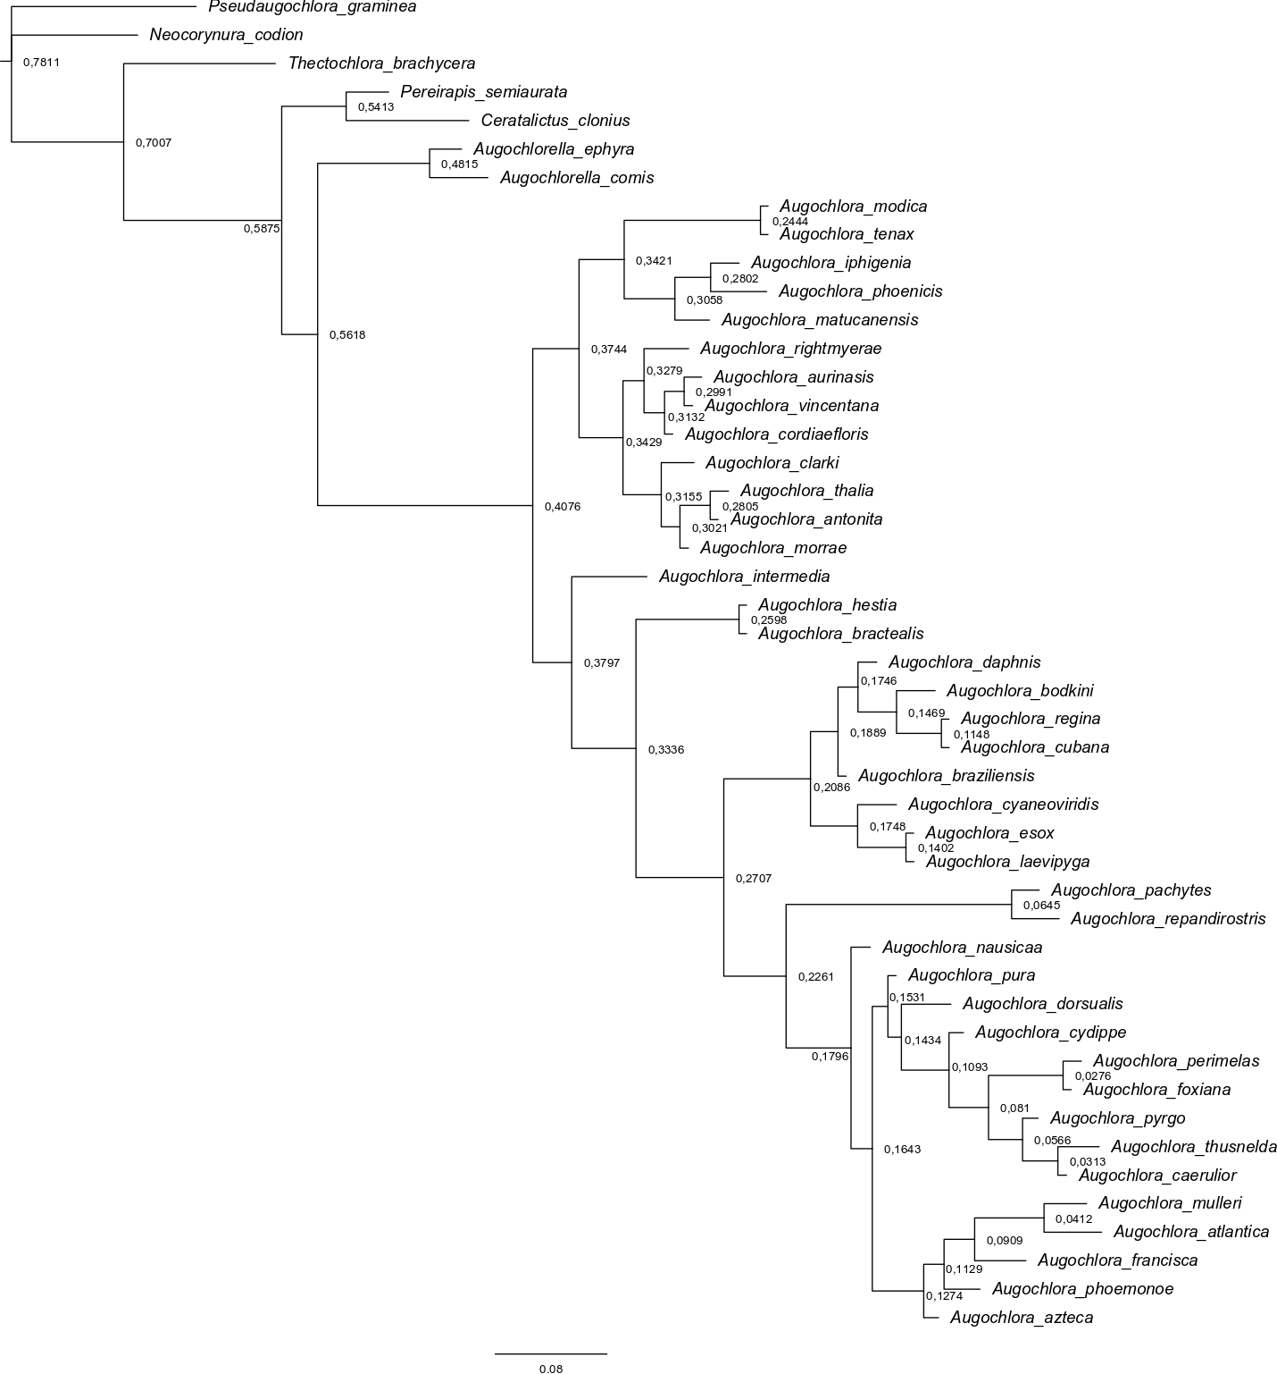
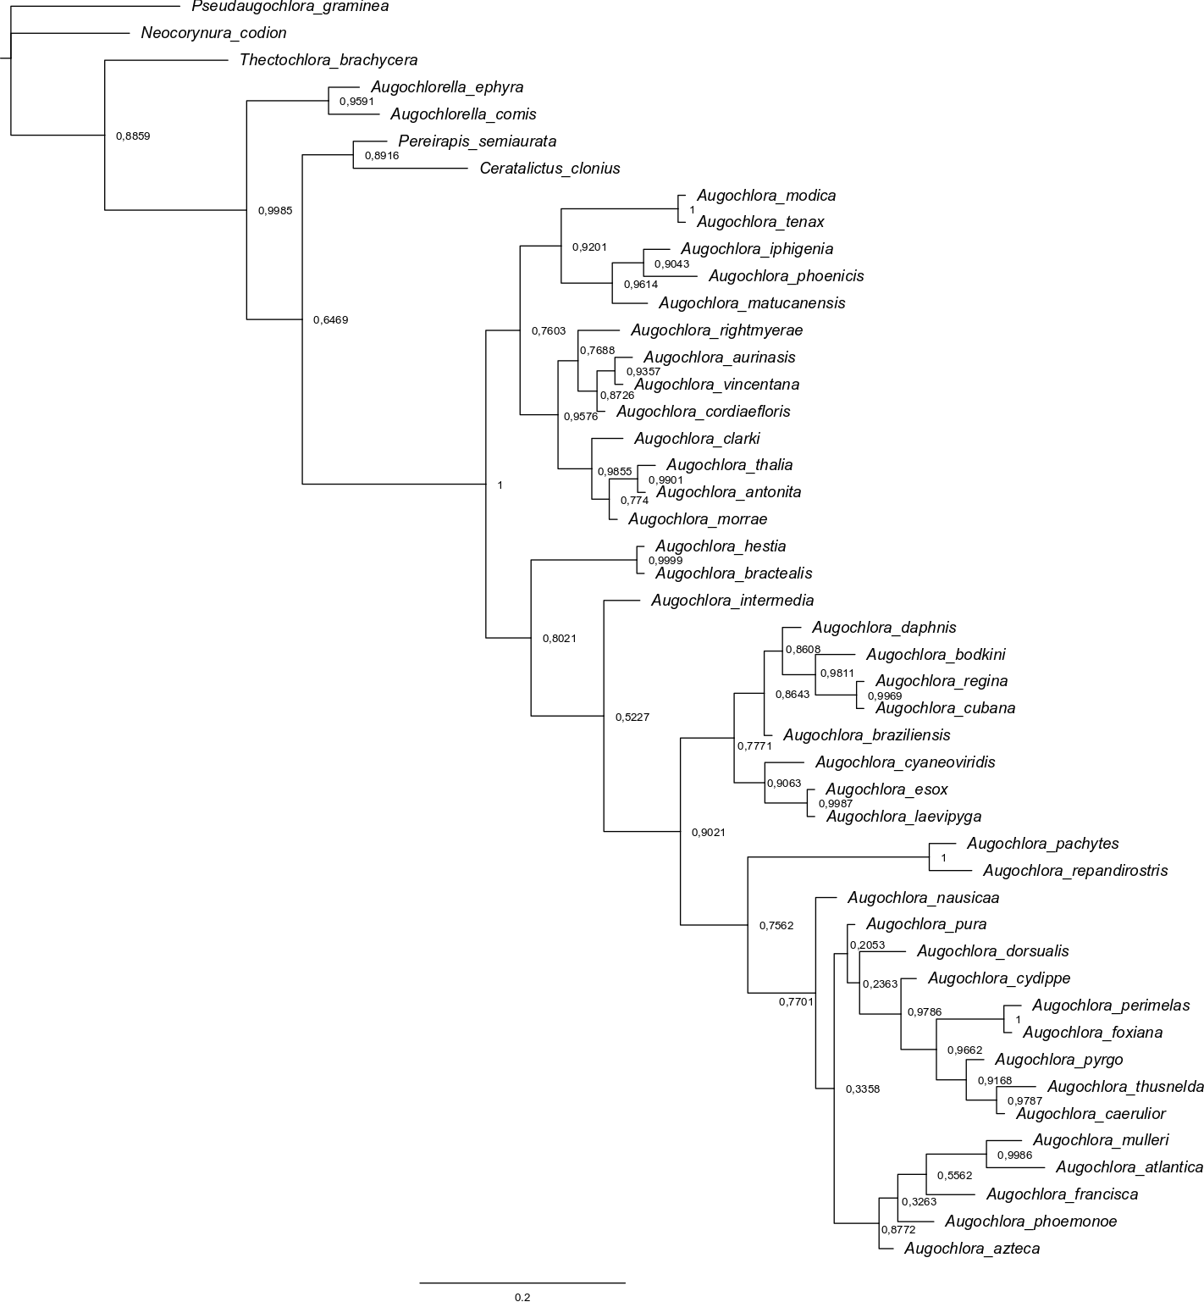
Figure 1. Majority-rule consensus tree derived from bayesian analysis of partitioned data.

Figure 2. Majority-rule consensus tree derived from bayesian analysis of unpartitioned data.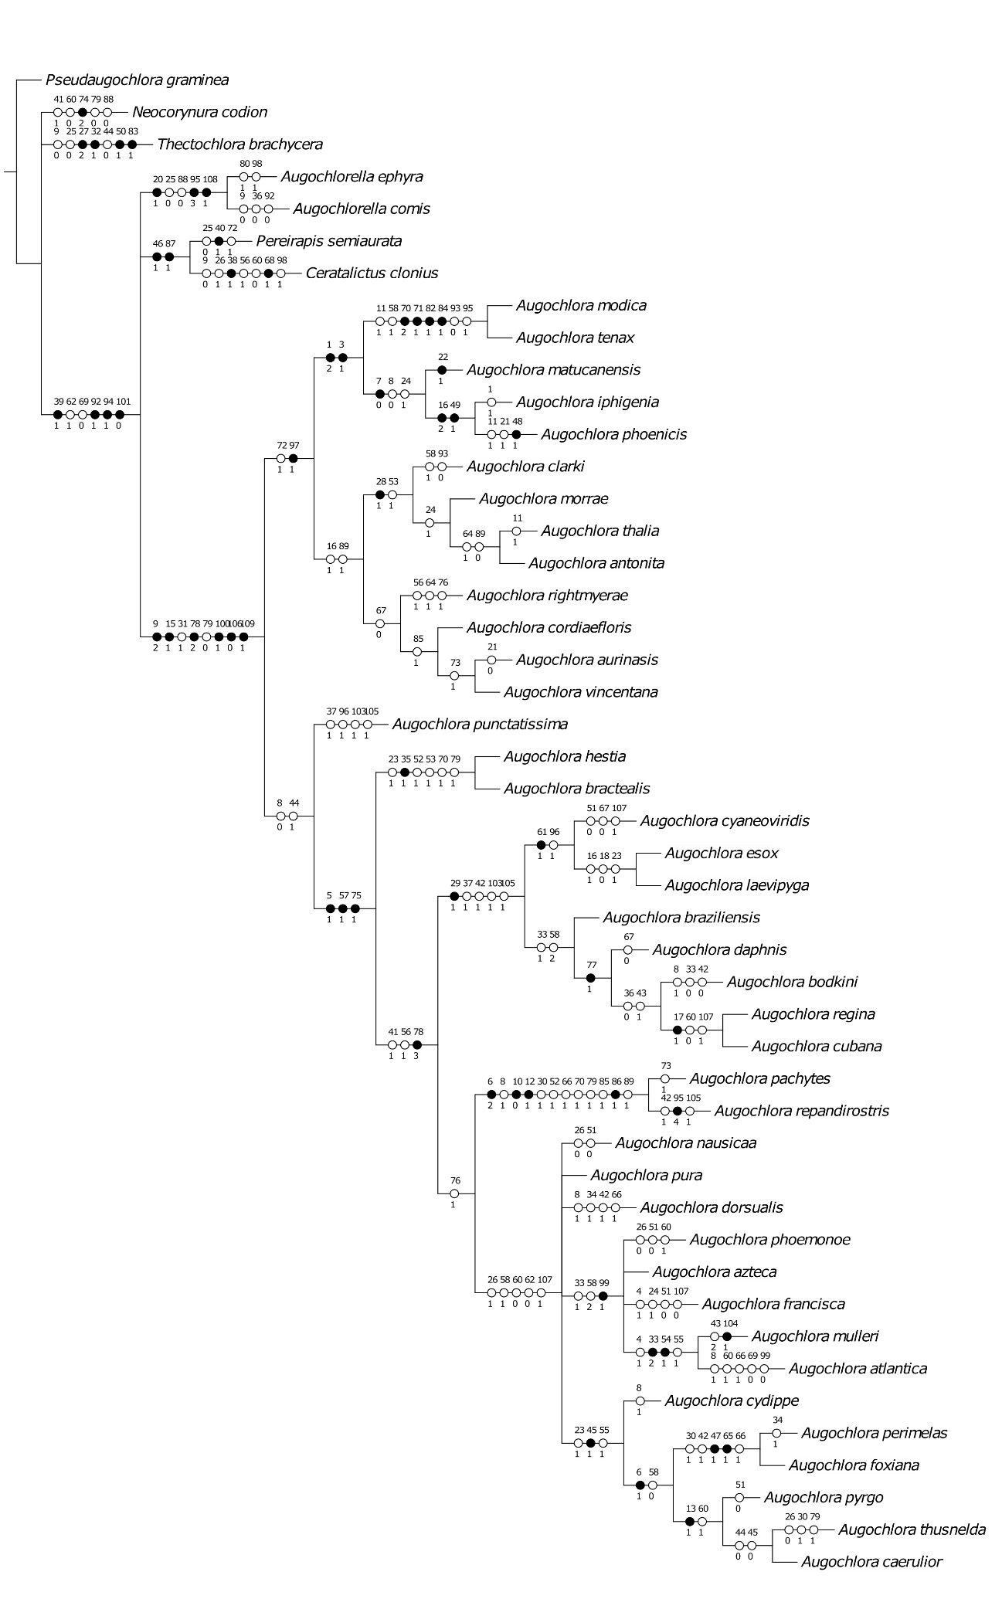
Figure 3. Strict consensus tree derived from parsimony analysis using equal weights (fast optimization).

