Supplementary material 1
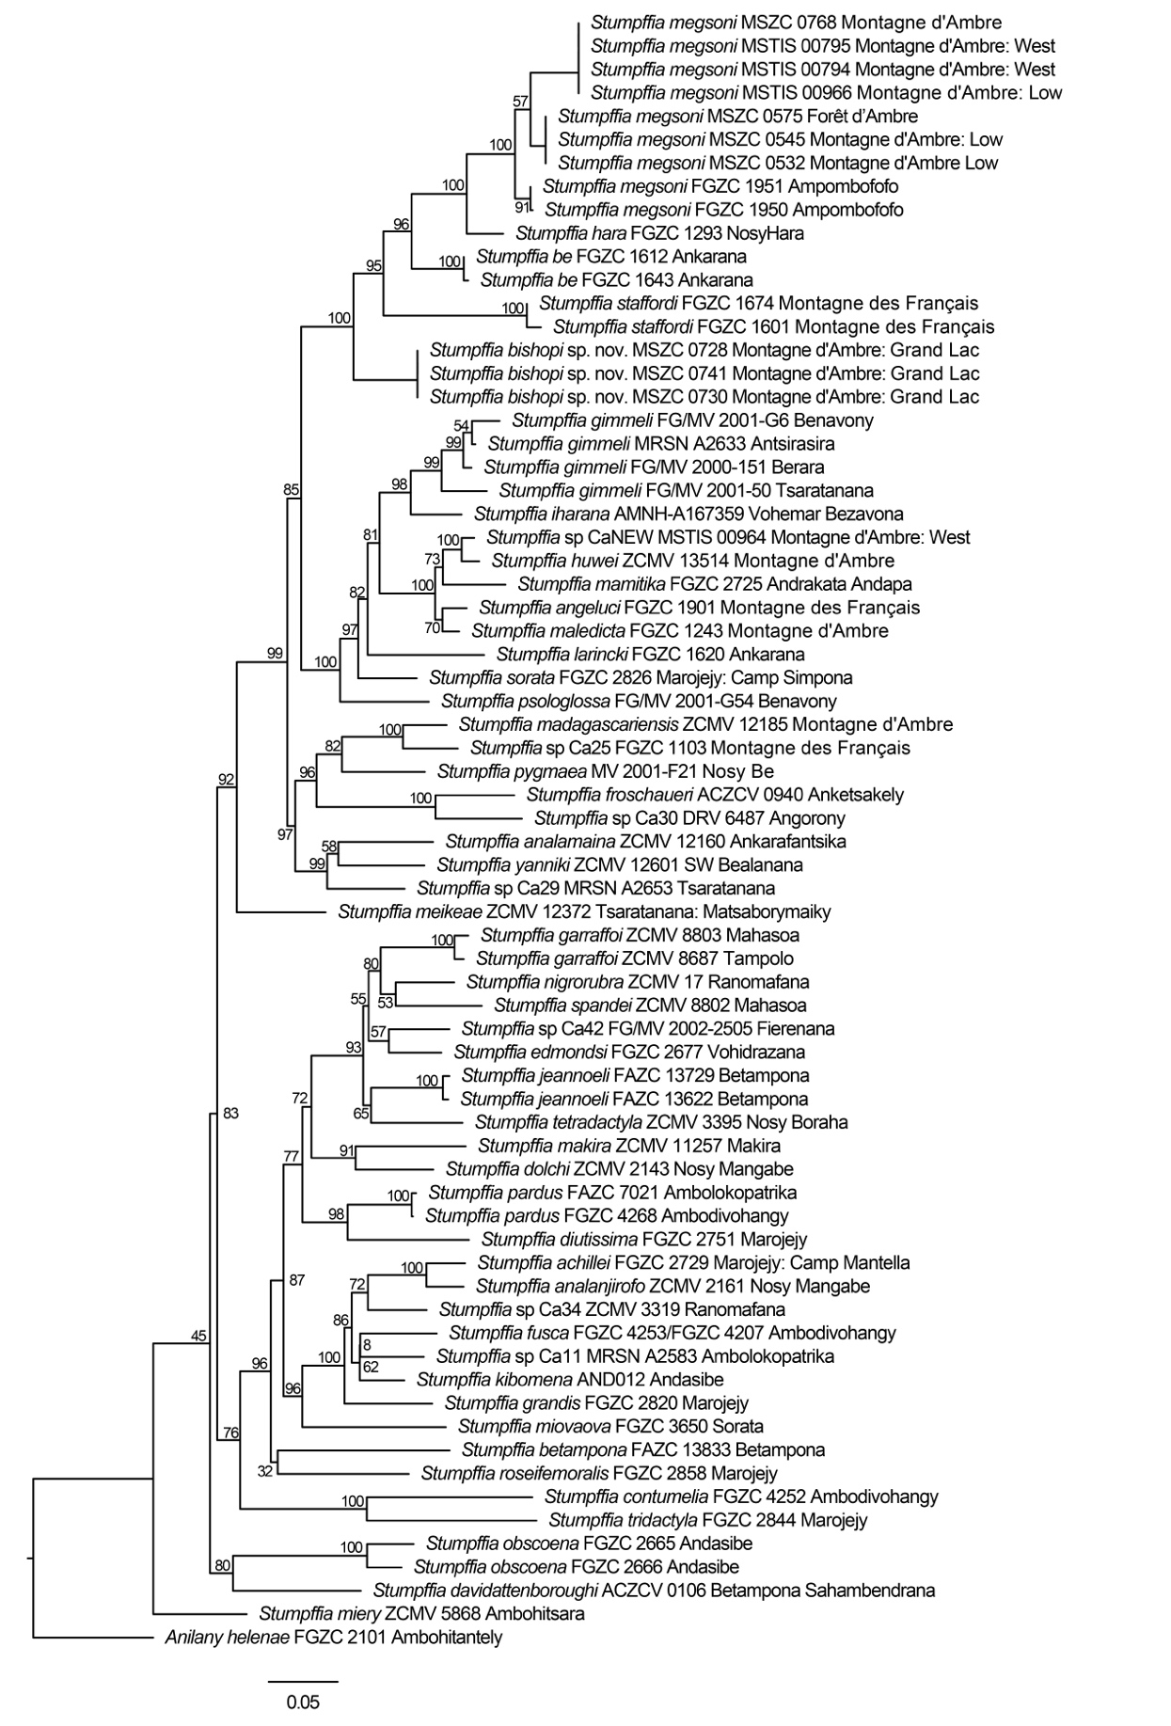
Supplementary Figure S1. Maximum Likelihood phylogeny of Stumpffia based on 1246 bp of the 3’ and 5’ segments of the 16S rRNA mitochondrial gene. Numbers at nodes indicate bootstrap support based on 500 bootstraps. Note that this tree serves as a guide for the identification of the focal taxa of this study, and is not intended to be a robust phylogenetic hypothesis for the genus, for which the data would be far from adequate. GenBank numbers of the respective sequences are given in Suppl. material 2: Table S1.

