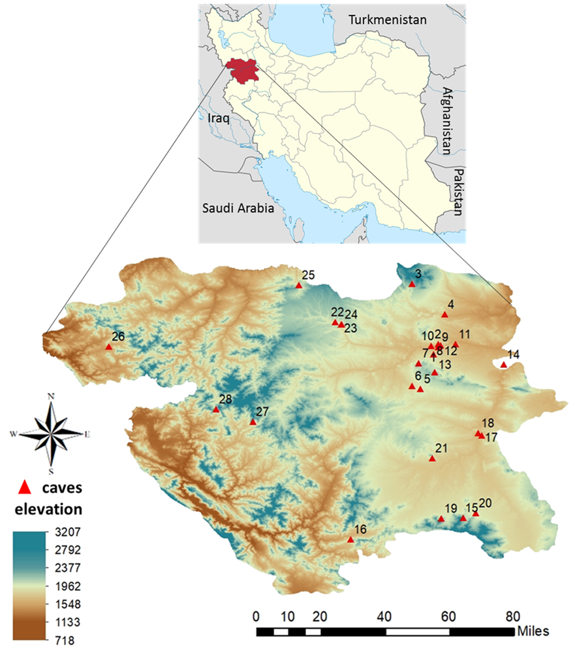

Figure 1S. The geographical location of Kurdistan Province in the west of Iran and 28 caves investigated in the study area. Numbers refer to caves as indicated in Table 1.
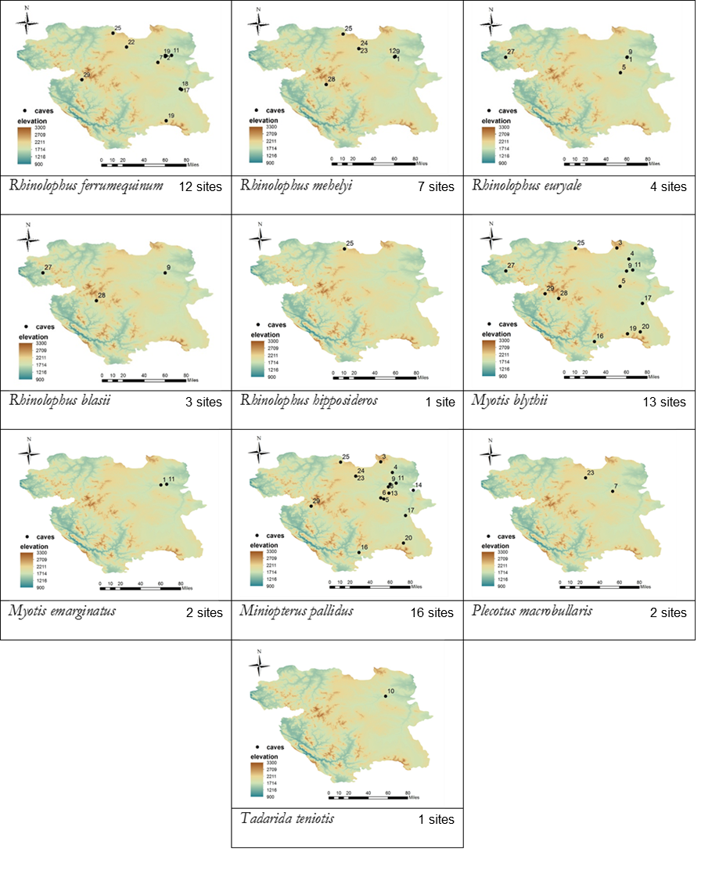
Figure 2S. Separate distribution maps for each bat species with their site numbers.

