Species | Genbank | Voucher | Locality
Species | Accession No. | Voucher | Locality
Hemidactylus aaronbaueri | HM595640 | CES08022 | India, Maharashtra, Pune, Ghatgar
Hemidactylus acanthopholis | MG711531 | CES17066 | India, Tamil Nadu, Tirunelveli, Kallidaikurichi
Hemidactylus angulatus | HM559620 | EBG 746 | Guinea, Daniah River at Koulete River
Hemidactylus aquilonius | EU268373 | CAS 206649 | Myanmar, Sagaing Division, Alaungdau Kathapa Natl. Park
Hemidactylus biokoensis | EU268371 | CAS 207777 | Equatorial Guenea, Bioko Island, 3.6 km N of Luba
Hemidactylus cf. graniticolus | MK569818 | CESG146 | India, Tamil Nadu, Dharmapuri, Sitteri
Hemidactylus cf. graniticolus | MK569819 | CESG139 | India, Tamil Nadu, Salem, Yercaud
Hemidactylus cf. graniticolus | MK569820 | CESG122 | India, Tamil Nadu, Namakkal, Kollimalai base
Hemidactylus cf. graniticolus | MK569821 | CESG123 | India, Tamil Nadu, Namakkal, Kollimalai base
Hemidactylus cf. graniticolus | MN482224 | CES15265 | India, Tamil Nadu, Gingee
Hemidactylus chikhaldaraensis | MK569807 | IAG062 | India, Maharashtra, Amravathi, Gawilgarh Fort
Hemidactylus chipkali | MK569808 | CESG323 | India, Madhya Pradesh, Hoshangabad, Pachmarhi
Hemidactylus coalescens | EU268370 | WRB no number | Gabon, Rabi
Hemidactylus craspedotus | HM559618 | LLG 5613 | Malaysia, Perak, Temengor
Hemidactylus depressus | HM559621 | ADS29A | Sri Lanka, Galkotte
Hemidactylus easai sp. nov. | OM487118 | ZSI/WGRC/IR.V/3471 | India, Kerala, Palakkad dist, Attapadi
Hemidactylus easai sp. nov. | OM487119 | BNHS 3103 | India, Kerala, Palakkad dist, Attapadi
Hemidactylus flaviviridis | EU268356 | ID 7626 | India, Rajasthan, Kuldhara
Hemidactylus frenatus | MN482223 | CES12020 | India, Karnataka, Chikbellapur
Hemidactylus garnotii | HM559631 | CAS 215549 | Myanmar, Sagaing Div., Mon Ywa Dist
Hemidactylus giganteus | MH454760 | CES11044 | India, Karnataka, Challakere
Hemidactylus gleadowi | MH454761 | MH454691 | India, Karnataka, Bagalkot
Hemidactylus gracilis | MH454762 | CES13006 | India, Karnataka, Hubballi
Hemidactylus graniticolus | MK569812 | AK348 | India, Karnataka, Bangalore Rural, Harohalli
Hemidactylus graniticolus | MK569813 | AK347 | India, Karnataka, Bangalore Urban, Alahalli
Hemidactylus graniticolus | MK569814 | CES15213 | India, Karnataka, Mandya, Bhimanakindi betta
Hemidactylus graniticolus | MK569815 | CES15236 | India, Karnataka, Ramanagara, Ramdev Betta
Hemidactylus graniticolus | MK569816 | CESG380 | India, Tamil Nadu, Erode, Padavalkalvai
Hemidactylus graniticolus | MK569817 | AK117 | India, Tamil Nadu, Erode, Sankari
Hemidactylus graniticolus | MH454763 | CES15257 | India, Tamil Nadu, Krishnagiri, Murugan temple
Hemidactylus greefii | EU268369 | CAS 219044 | São Tome and Principe, São Tome Island, Praia da Mutamba
Hemidactylus gujaratensis | MG760344 | CES17076 | India, Gujurat, Girnar Hill
Hemidactylus haitianus | HM559633 | AMB 4188 | Dominican Republic, Santo Domingo
Hemidactylus hemchandrai | MH454764 | CES16279 | India, Maharashtra, Ravanwadi
Hemidactylus hunae | HM559640 | AMB7416 | Sri Lanka, Pitakumbura
Hemidactylus imbricatus | EU268354 | JFBM2 | Pakistan (captive specimen)
Hemidactylus kangerensis | MK569822 | CES14190 | India, Andhra Pradesh, East Godavari, VR Puram
Hemidactylus kangerensis | MK569824 | BNHS2486 | India, Chhattisgarh, Bastar, Kanger Valley National Park
Hemidactylus karenorum | EU268362 | CAS 210670 | Myanmar, Mandalay Division, Kyaukpadaung Township, Popa Mt. Park
Hemidactylus kolliensis | MT943048 | NCBS BH736 | India, Tamil Nadu, Perambalur, Pachaimalai
Hemidactylus leschenaultii | MN482225 | CES14072 | Nellore, Andra Pradesh
Hemidactylus leschenaultii 1 | HM559635 | AMB 7443 | Sri Lanka, Polonnaruwa
Hemidactylus longicephalus | HM559637 | CAS 218939 | São Tomé et Principe, São Tomé
Hemidactylus maculatus | MK569827 | AK062 | India, Maharashtra, Pune, Mulshi
Hemidactylus maculatus | HM559641 | BNHS1516 | India, Maharashtra, Raigad Dist., Zirad
Hemidactylus malcolmsmithi | MH454765 | CES11065 | India, Himachal
Hemidactylus murrayi | GQ458054 | CAS 206638 | Myanmar, Mandalay Division
Hemidactylus paaragowli | MK802893 | CESL274 | India, Kerala, Kollam District, Devarmalai-Sivagiri Hill Complex
Hemidactylus parvimaculatus | GQ458053 | ADS36 | Sri Lanka, Kartivu
Hemidactylus parvimaculatus 1 | MH454766 | CES14174 | India, Andhra Pradesh, Araku valley
Hemidactylus platyurus | HM559619 | KU 304111 | Philippines, Lubang Id., Occidental Mindoro Prov., Lubang Barangay Paraiso
Hemidactylus prashadi | MK569843 | CESG359 | India, Maharashtra, Kolhapur, Patgaon
Hemidactylus reticulatus | MH454767 | CES13062 | India, Karnataka, Kollegal
Hemidactylus robustus | EU054287 | FMNH 245519 | Pakistan, Baluchistan Province, Gwadar Division, Makran District
Hemidactylus sahgali | MG742362 | NCBS-AU709 | India, Maharashtra, Pune, Saswad
Hemidactylus sankariensis | MK569844 | NCBSBH682 | India, Tamil Nadu, Erode, Sankari
Hemidactylus sataraensis | MH454768 | CES14220 | India, Maharashtra, Satara
Hemidactylus scabriceps | MH454769 | CES12008 | India, Tamil Nadu, Tirunelveli, Tirunelveli
Hemidactylus sirumalaiensis | MT943051 | NCBS-BH744/AK 909 | India, Tamil Nadu, Dindigul, Sirumalai
Hemidactylus siva | MK569845 | NHM.OU.REP.H | India, Karnataka, Bellary, Hampi
Hemidactylus sushilduttai | MK569852 | CES11079/NCBS-AU157 | India, Andhra Pradesh, Visakhapatanam , Simhachalam
Hemidactylus tamhiniensis | MN482222 | CES 14023 | India, Maharashtra, Pune, Tamhini Ghat
Hemidactylus treutleri | MN482237 | CES14116 | India, Andra Pradesh, Atmakur
Hemidactylus triedrus | MH666065 | NCBS-AU703 | India, Andhra Pradesh, Nellore, Nellore
Hemidactylus vanam | MK569854 | CESG393 | India, Tamil Nadu, Madurai, Saptur
Hemidactylus whitakeri | MH666066 | NCBS-AU713 | India, Kodalagurki village, Bangalore rural District
Hemidactylus yajurvedi | MH454772 | CES12006 | India, Chattisgarh, Kanker District
Dravidogecko douglasadamsi | MN520270 | BNHS 2349 | India, Tamil Nadu state, Tirunelveli district, Manjolai estate
Dravidogecko septentrionalis | MN520273 | BNHS 2343 | India, Kerala State, Wayanad district, Lakkidi Village
Table 1. List of sequences used for the phylogenetic analyses in this study.
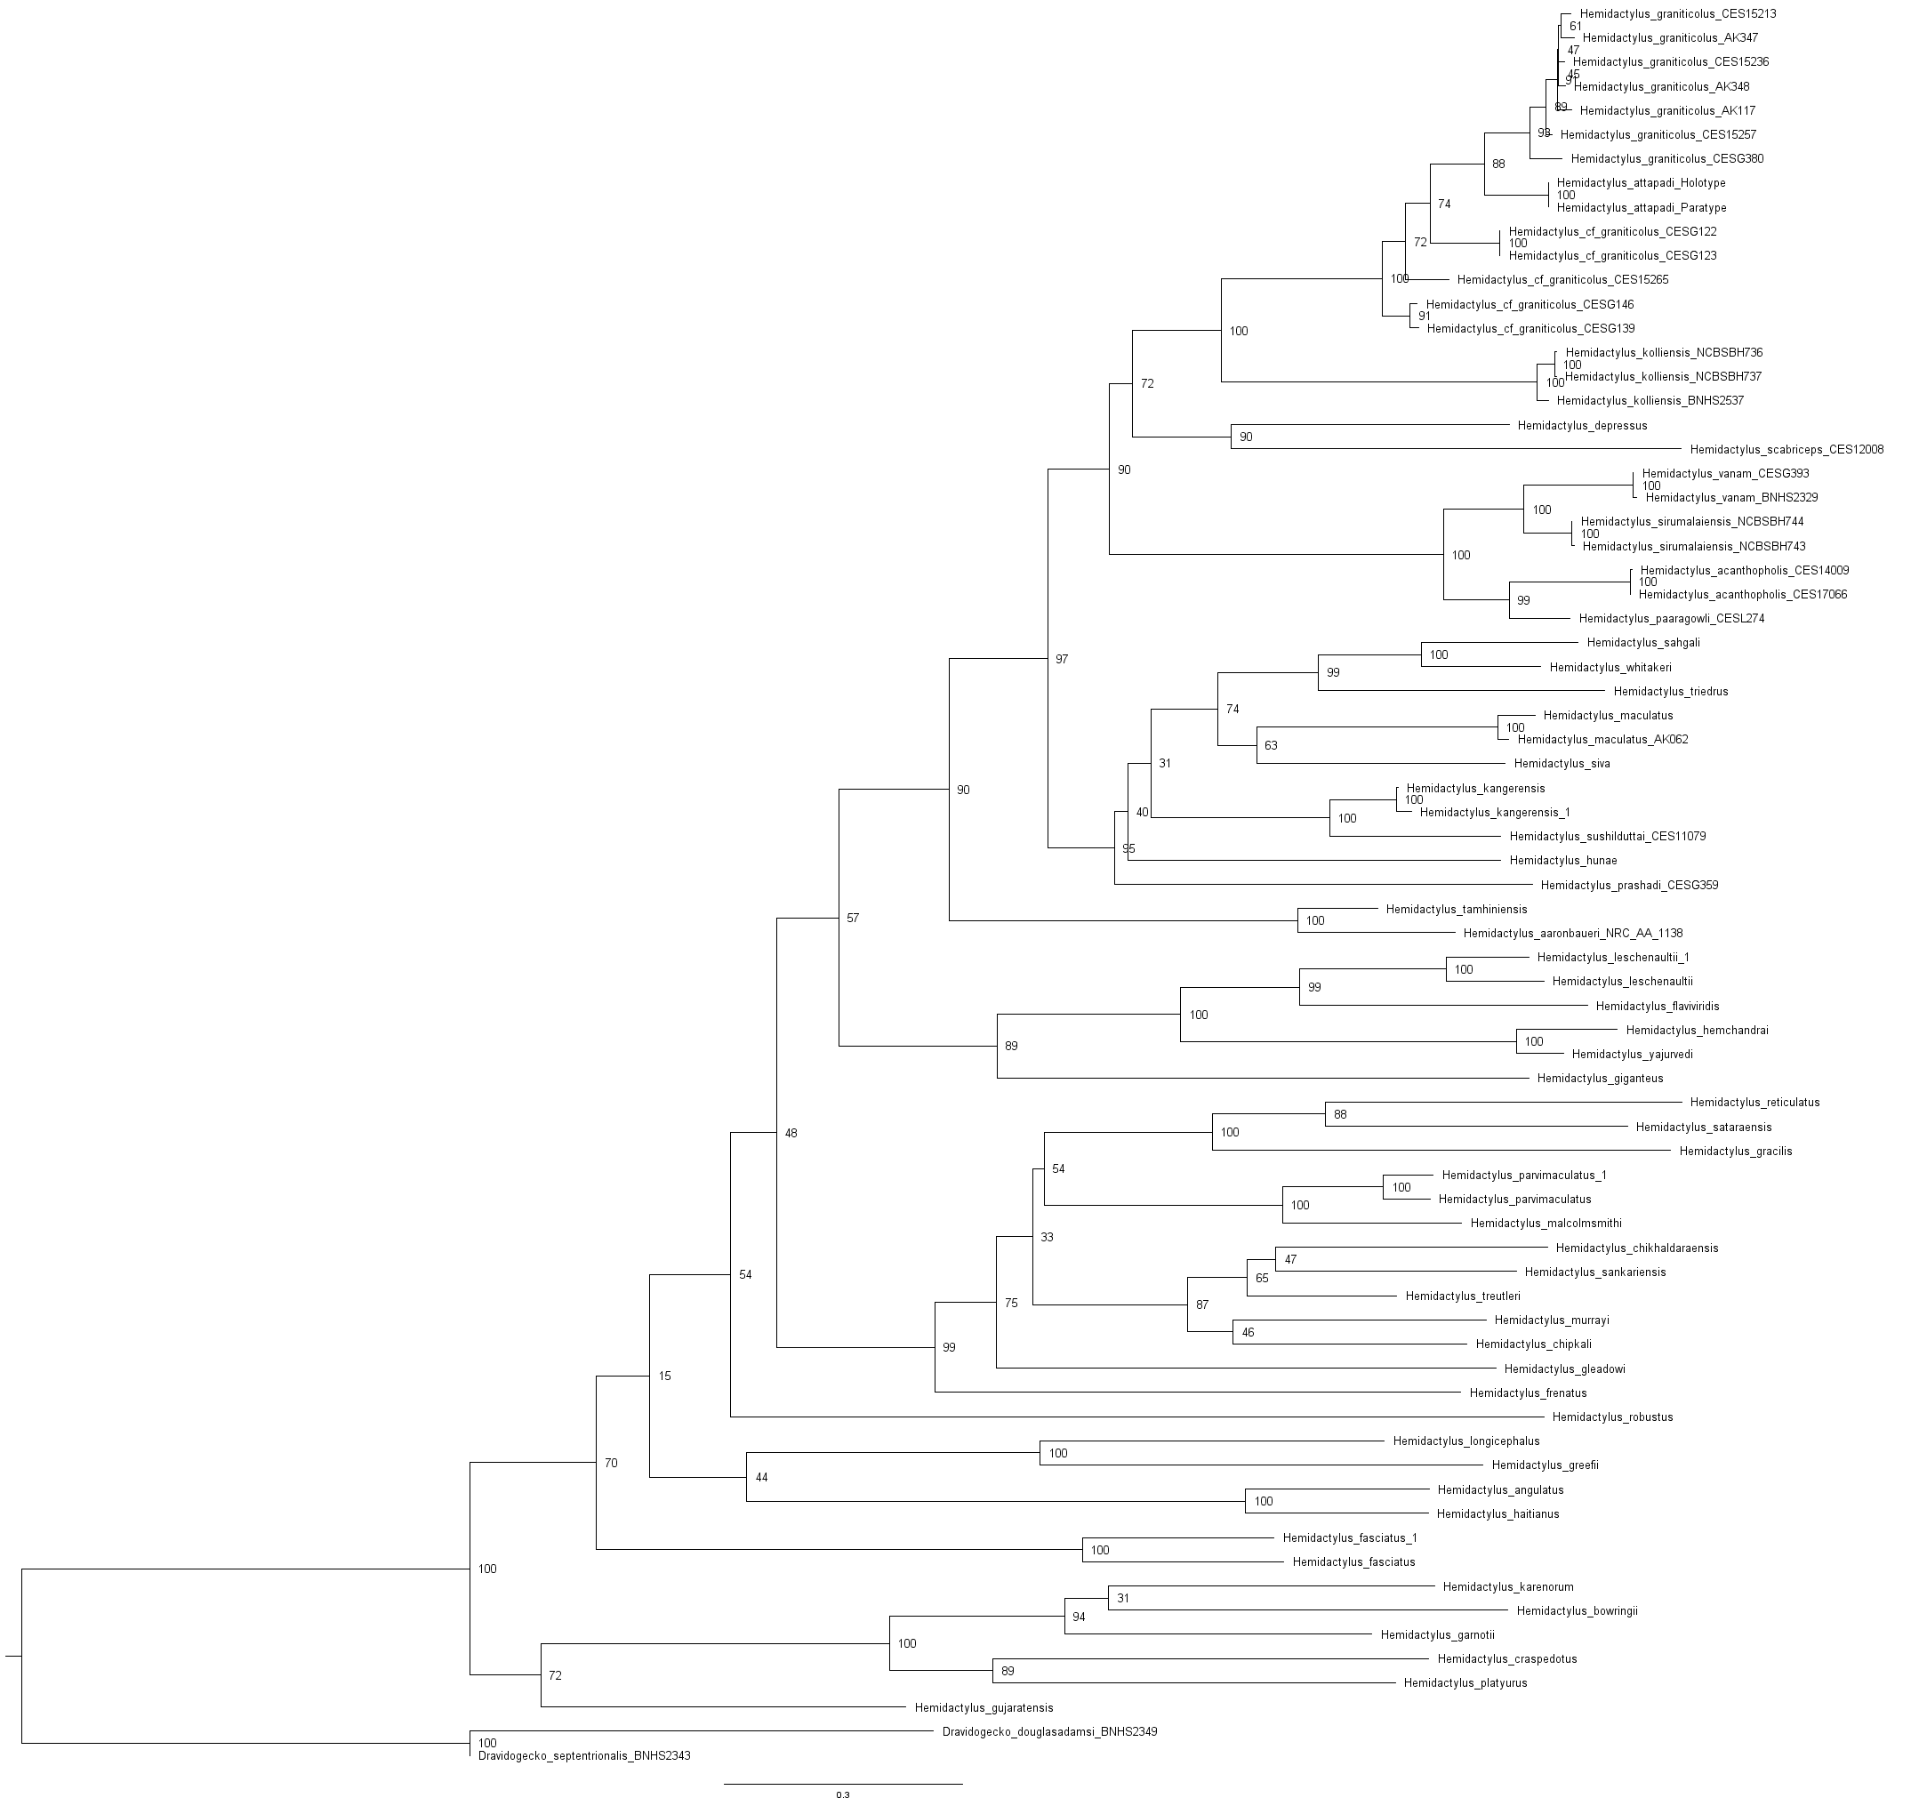
Figure. 1. Maximum Likelihood tree showing the relationships of Asian Hemidactylus sp. Numbers at the internal nodes represent the bootstrap support. Scale = substitutions per site
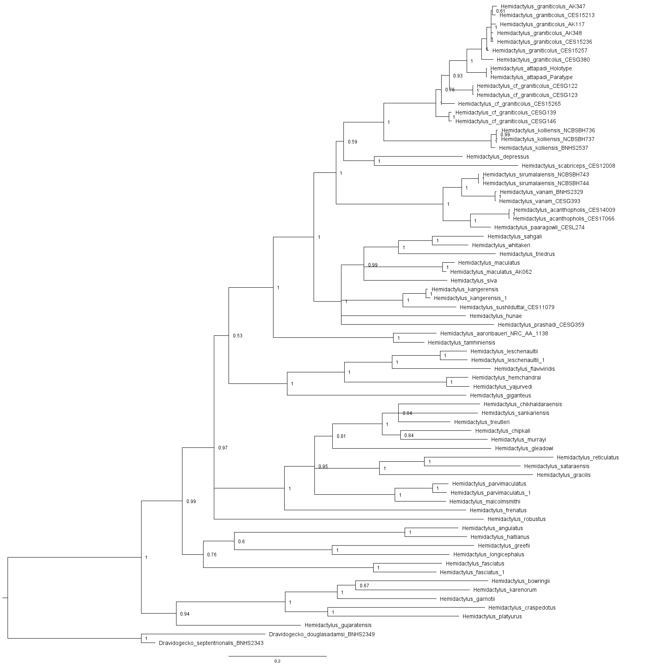
Figure. 2. BI tree showing the relationships of Asian Hemidactylus sp. Numbers at the internal nodes represent the posterior possiblities. Scale = substitutions per site
Figure. 3. Dorsal aspect of Hemidactylus easai sp. nov. (CES 08026) from the Nilgiris.

