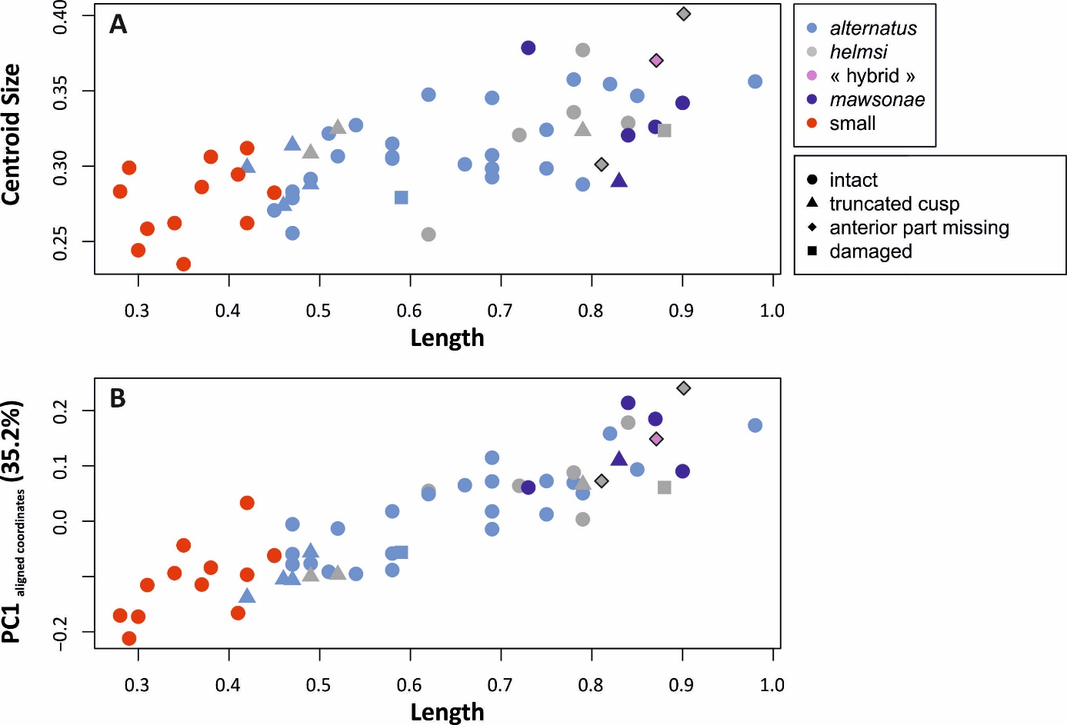
Supplementary Figure 3. Relationship between length and geometric morphometrics of the posterior part of the element. A, Length vs Centroid Size of the posterior part. B, Length vs PC1 based on the aligned coordinates. Symbols with the thick black outline correspond to the interpolated length values.

