Supplementary Online Material 1

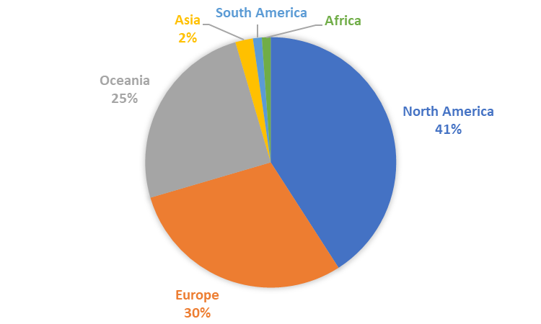(a)
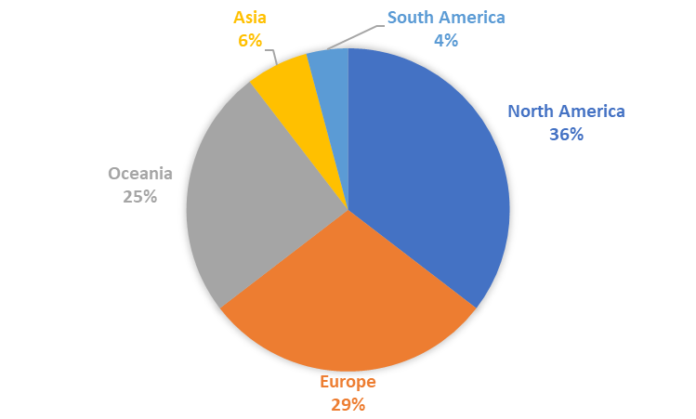(b)
Figure S1: Geographical affiliation of (a) the authors of scientific articles (n = 264) on assisted colonization (assignment of the lead authors and co-authors was done based on Internet research at which institute they carried out their research), and of (b) the authors of scientific articles who took part in the survey (n = 48) on assisted colonization.

