Supplementary files

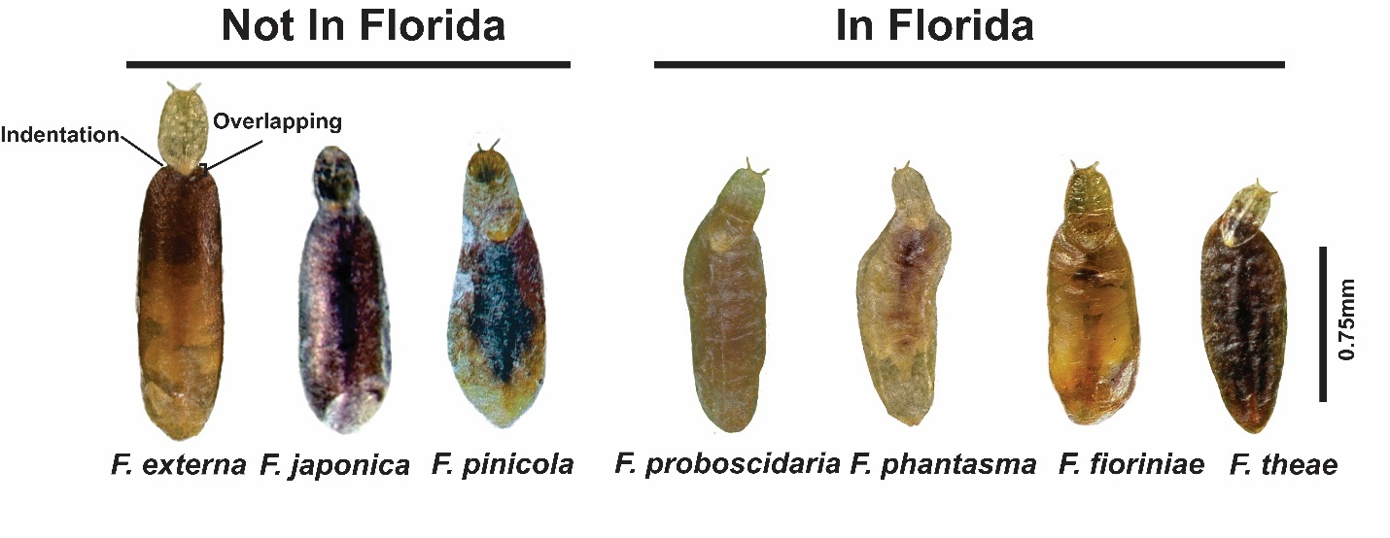 Supplementary Figure 1. Comparison of field habitus of first-instar exuviae overlapping second-instar exuviae of seven Fiorinia species occurring in the USA.

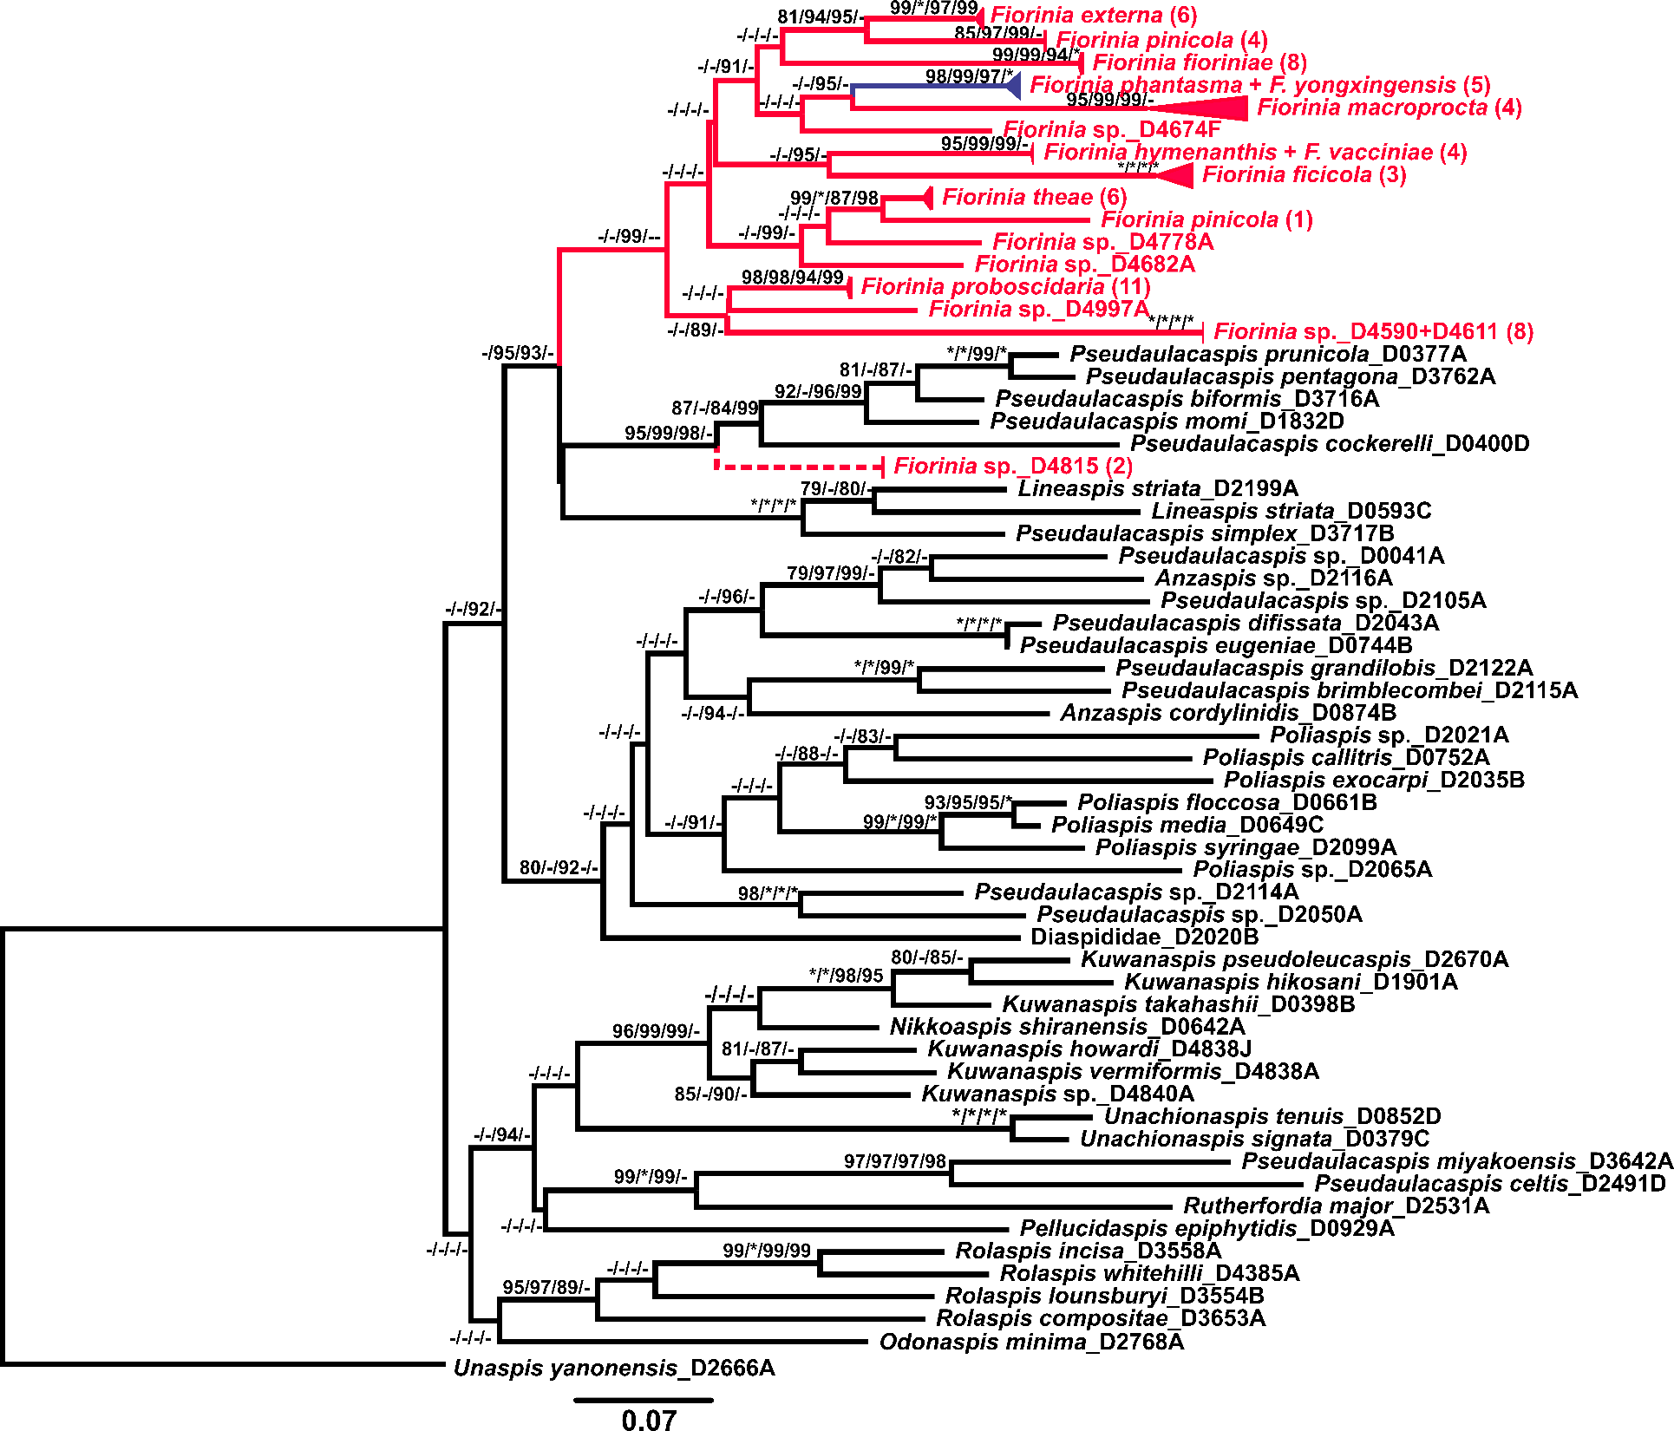

Supplementary Figure 2. Maximum likelihood bootstrap consensus tree of the subtribe Fioriniina based on 28S, EF1-α, 5’-COI, 3’-COI, and COII. The clade highlighted in solid red indicates a monophyletic Fiorinia.
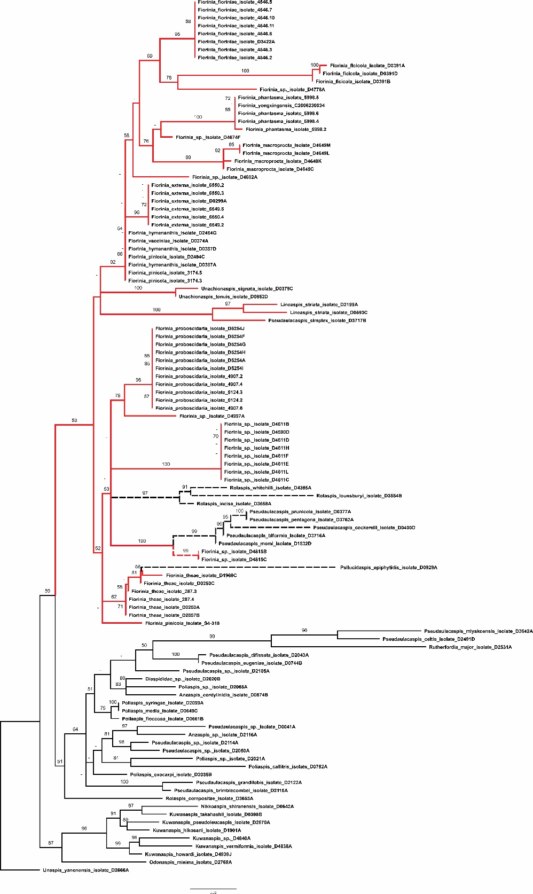

Supplementary Figure 3. Maximum likelihood bootstrap consensus tree of the subtribe Fioriniina based on 28S. The clade highlighted in red contains Fiorinia. Red dashed line indicates two Fiorinia sp. isolates placed with Pseudaulacaspis species. Dashed black lines indicate non-Fiorinia species placed in the Fiorinia clade. Bootstrap support values equal or greater than 50 are indicated on the tree.

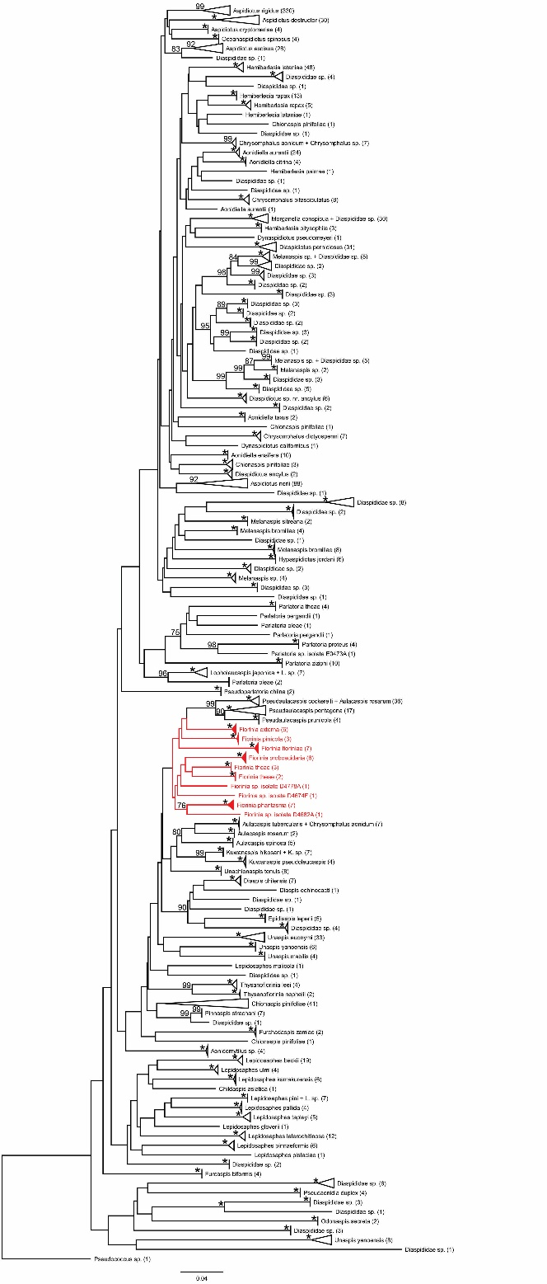

Supplementary Figure 4. Neighbor-joining tree of Diaspididae 5’-COI barcodes. Terminal taxa are labeled to their narrowest identification-level. Numbers in parentheses after terminal taxa indicate how many sequences are represented in each cluster. The cluster of Fiorinia species is highlighted in red. Bootstrap support values greater than 75 are indicated on the tree. Nodes with 100 percent bootstrap support are indicated by a “*”.

