Supplementary information for

Don’t forget the vertical perspective: assessment of distributional dynamics of cave-dwelling invertebrates in both ground and parietal microhabitats

Supplementary Figure 2
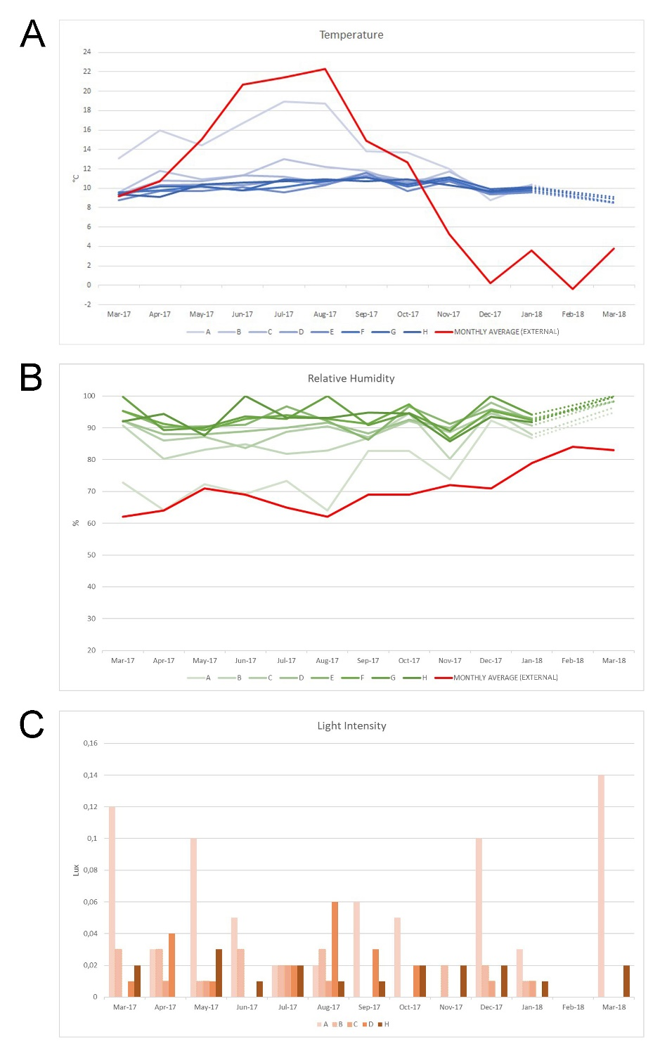
Supplementary Fig.2. Monthly Temperature (A), Relative Humidity (B) and Light Intensity (C) in Baraccone Cave for each sampling area. The external monthly average data (red lines) were taken from a meteorological station (Perlo municipality) 3.6 km away from Baraccone Cave (data from Arpa Piemonte). In February 2018 it was not possible to reach the Baraccone Cave due to the presence of large amounts of ice and snow.

References:

Arpa Piemonte. https://www.arpa.piemonte.it/rischinaturali/accesso-ai-dati/annali_meteoidrologici/annali-meteo-idro/banca-dati-meteorologica.html [accessed: December 20, 2020].

