Supplementary information for

Don’t forget the vertical perspective: assessment of distributional dynamics of cave-dwelling invertebrates in both ground and parietal microhabitats

Supplementary Figure 1

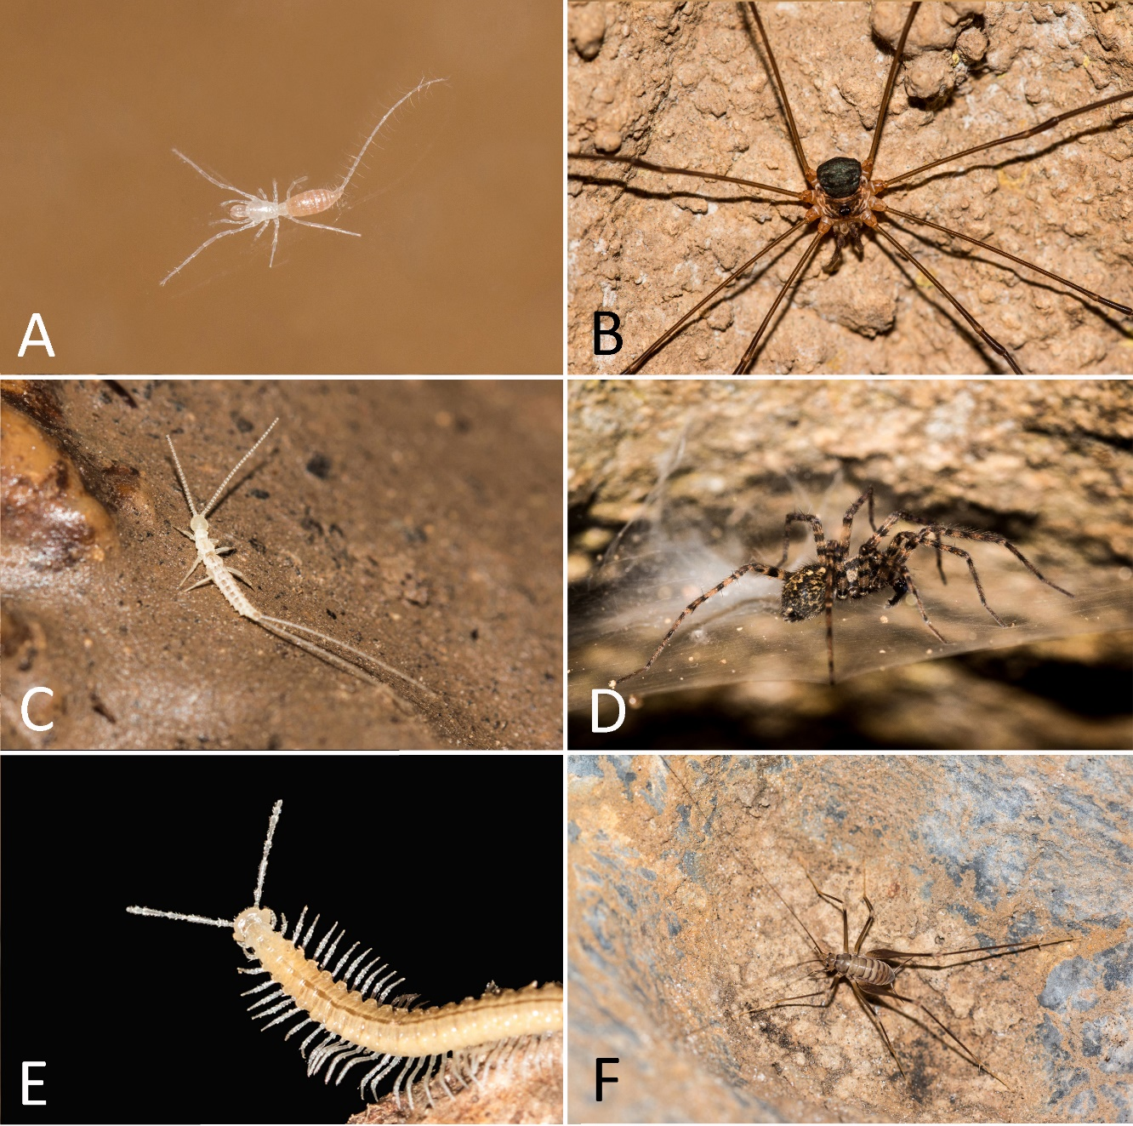
Supplementary Fig. 1. Fauna observed in Baraccone Cave. A – The troglobiont palpigrade Eukoenenia strinatii; B – The Opiliones Amilenus aurantiacus; C - The troglobiont Diplura Campodea sp. D - The troglophile spider Tegenaria silvestris; E – The troglobiont diplopode Plectogona sp.; F – The troglophile grasshopper Dolicopoda azami (Photos by V. Balestra).

