Supplementary Materials
to
Ulman, A., Yildiz, T., Demirel, N., Çanak, O., Yemişken, E. and D. Pauly. 2021. The biology and ecology of the invasive silver-cheeked toadfish (Lagocephalus sceleratus), with emphasis on the Eastern Mediterranean. NeoBiota

Appendix 1. The Gill-Oxygen Limitation Theory
Individual fish can monitor their current metabolic rate (Q) relative to their maintenance rate (Qmaint), rather like we humans can tell that we are out of breath. As fish grow, their metabolic rate declines because their gill surface area (GSA) cannot keep up with their weight, because it grows according to GSA = α·W^{d}, with d<1 (De Jager and Dekkers 1974; Pauly 2021), where α is a species-specific scaling factor and d is the slope of a plot of log(GSA) vs. log(W), while α is the antilog of the intercept. Therefore, their relative oxygen supply declines with growth. When it approaches a level where Q_{m} ~ 1.35·Q_{maint}, this triggers the hormonal cascade leading to maturation and spawning, with the latter requiring a mate (Pauly, 1984, 2019, 2021). Thus, metabolic rate determines both size and first maturity and maximum size, the latter of which occurs when HW^{d} = kW (see equation 1 in the main text). This is why L_{m} and L_{max} must be studied together (Amarasinghe and Pauly, 2021).

Here, a test of the Gill-Oxygen Limitation Theory (GOLT; Pauly 2021) was performed, i.e., we checked whether the ratio L_{max}^{D} vs L_{m}^{D}, which is mathematically equivalent to ratio Q_{m}/Q_{maint} (Pauly 1984) has, in L. sceleratus, the expected value of ~1.35 when D = 0.6, with D = 3(1-d). In most fish, d ranges between 0.75 and 0.85 (De Jager and Dekker 1975; Pauly 2019, 2021), and thus we will assume d = 0.8, and hence D = 0.6 for L. sceleratus, whose gill surface area has apparently never been studied. If it is further assumed that the estimate of L_{max} originates from the same population as L_{m}, The 95 % confidence interval of the L_{max}^{D}/L_{m}^{D} ratio was estimated using the method of Fieller (1940), as implemented in www.graphpad.com/quickcalcs/ErrorProp1.cfm.
A feature of the length at first maturity (L_{m}) in different populations of L. sceleratus is that it is a predictable fraction of the maximum length (L_{max}) reached in its different populations (see Table S6). This is demonstrated here in Figure S1, i.e., a plot of L_{max}^{D} vs. L_{m}^{D}, where D = 0.6. Figure S1 documents that the length at first maturity of L. sceleratus (L_{m}) in a given population is a predicable fraction of the maximum length that L. sceleratus reaches in that population (L_{max}), but only when these two lengths are raised to a power (D) which makes the ratio L_{max}^{D}/ L_{m}^{D} mathematically equivalent to the ratio of their metabolic rate at first maturity to their metabolic rate at L_{max} , i.e., Q_{m}/Q_{maint} (see above, and Pauly 1984, 2019). This, and the fact that the mean L_{max}^{D}/ L_{m}^{D} ratio estimated here has a 95% confidence interval overlapping with that estimated earlier for other teleosts (i.e., 1.22 – 1.53; see Pauly 2021) suggests that maturation and spawning, as in other teleosts, are triggered by size-mediated respiratory stress

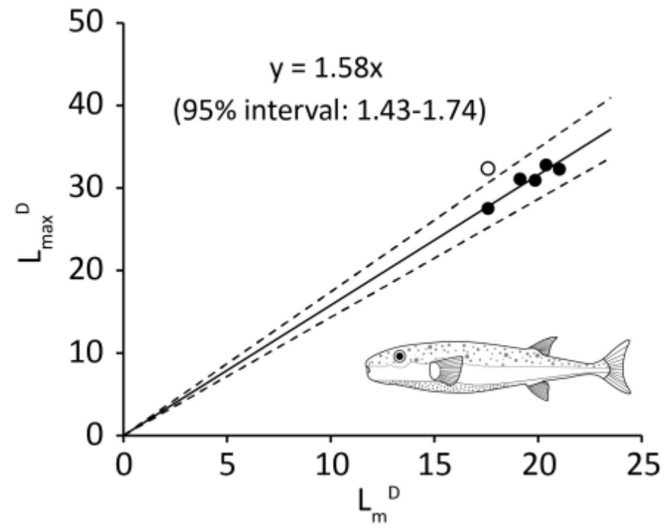
Figure S1. Plot of L_{max}^{D} vs. L_{m}^{D} (for D = 0.6) in different populations of L. sceleratus (see Table S7 for details). Whether or not the apparent outlier (open dot) is included, the confidence interval of the mean ratio (1.43-1.74) if it is not included, overlaps with that estimated from earlier studies, i.e., 1.22-1.52 and hence this ratio is compatible with the Gill-Oxygen Limitation Theory (GOLT; Pauly 2021).
However, this result remains tentative due (i) to the low number of L_{m} & L_{max} data pairs currently available for L. sceleratus, and possibly (ii) the new feature documented in Figure 7 that L_{m} estimates from within the peak of the spawning season may be lower than L_{m} estimated outside that peak. Depending on when in the season the L_{m} estimates in Table S7 were obtained, this will influence the L_{max}^{D} / L_{m}^{D} ratio; clearly this is an issue that will require further investigation.

References

Amarasinghe, U.S. and D. Pauly. 2021 The relationship between size at maturity and maximum size in cichlid populations corroborates the Gill- Oxygen Limitation Theory (GOLT). Asian Fisheries Science 34: 14-22.
De Jager S, Dekkers WJ (1974) Relations between gill structure and activity in fish. Netherlands Journal of Zoology 25: 276–308.
Pauly D (1984) A mechanism for the juvenile-to-adult transition in fishes. ICES Journal of Marine Science 41: 280–284.
Pauly D (2019) Gasping Fish and Panting Squids: Oxygen, Temperature and the Growth of Water-Breathing Animals. 2nd edition. Excellence in Ecology Series vol. 22. International Ecology Institute, Oldendorf/Luhe.
Pauly, D. 2021. The Gill-Oxygen Limitation Theory (GOLT) and its critics. Science Advances, 7(2), https://doi.org/10.1126/sciadv.abc6050.

Table S1. Sex ratios for L. sceleratus from Mediterranean and Suez Canal studies. The bold M:F ratios highlight cases where the ratio of males is higher than females, which is in every Turkish study.
Male | Female | M:F | Locality | Reference
77 | 99 | 1:1.3 | Suez Canal | Sabrah et al (2006)
336 | 320 | 1:0.95 | Turkey | Aydın (2011)
140 | 123 | 1:0.88 | Turkey | Yıldırım (2011)
295 | 240 | 1:0.81 | Turkey | Irmak (2012)
81 | 32 | 1:0.4 | Turkey | Tüzün (2012)
49 | 28 | 1:0.57 | Turkey | Başusta et al. (2013)
87 | 118 | 1:1.35 | Lebanon and Syria | Khalaf et al. (2014)
33 | 82 | 1:2.1 | Lebanon | Boustany et al. (2015)
408 | 371 | 1:0.91 | Egypt | Farrag et al. (2015)
90 | 96 | 1:1.07 | Gulf of Suez, Egypt | Ali et al. (2015)
78 | 101 | 1: 1.29 | Egypt | Ali et al. (2015)
110 | 98 | 1:0.89 | Turkey | Özbay (2015)
413 | 330 | 1:0.8 | Turkey | Ersönmez (2019)
110 | 98 | 1:0.88 | Turkey | Torcu-Koç et al. (2020)
456 | 270 | 1:0.69 | Turkey | This study

Table S2. Length-weight relationships of Lagocephalus sceleratus from this study in southwestern Turkey; total length in cm; weight in g
Sex | N | Length range (mean) | A | b | r²
Females | 266 | 17.7 - 72.3 (45.6) | 0.0081 | 3.096 | 0.978
Males | 447 | 17.1 - 77.2 (47.3) | 0.0087 | 3.071 | 0.965
Unidentified | 302 | 13.0 - 49.4 (18.9) | 0.0183 | 2.837 | 0.903
All fish pooled | 1013 | 13.0 -77.2 (38.4) | 0.0161 | 2.914 | 0.954

Table S3. Some length-weight parameters with sex, length range, length type and sample size (N) for L. sceleratus from Mediterranean and other studies.
N | Length (cm) | Length type | Sex | a | b | r² | Location | Reference
49 | 8.9-78.4 | TL | male | 0.0381 | 2.645 | 0.939 | Turkey, N.E. Medit. | Başusta et al. (2013)
28 | 15.4-52.3 | TL | female | 0.0138 | 2.915 | 0.973 | Turkey, N.E. Medit. | Başusta et al. (2013)
99 | 19.1-69.5 | TL | female | 0.0209 | 2.842 | 0.980 | Egypt, Gulf of Suez | Sabrah et al. (2006)
77 | 18.5-78.5 | TL | male | 0.0160 | 2.905 | 0.988 | Egypt, Gulf of Suez | Sabrah et al. (2006)
67 | 9.0-71.5 | FL | pooled | 0.0194 | 2.904 | 0.992 | New Caledonia | Letourneur et al. (1998)
997 | 12.5-68.0 | TL | pooled | 0.0122 | 2.981 | 0.994 | Turkey, Antalya Bay | Aydın et al. (2017)
656 | 12.5-65.0 | TL | pooled | 0.0120 | 2.979 | 0.99 | Turkey, Antalya Bay | Aydın (2011)
94 | 9.0-72.0 | FL | pooled | 0.0182 | 2.924 | 0.994 | New Caledonia | Kulbicki et al. (2005).
795 | 5.0-83.0 | TL | pooled | 0.0130 | 2.933 | 0.996 | Egypt, Mediterranean | Farrag et al. (2015)
148 | 11.2-18.3 | TL | pooled | 0.0133 | 2.99 | 0.776 | Malaysia, S. Johore | Simon and Mazlan (2008)
290 | 5.3-63.1 | TL | pooled | 0.0164 | 2.893 | 0.990 | Greece, Rhodes Island | Kalogirou (2013)
6656 | 6.0-77.0 | TL | pooled | 0.0106 | 3.018 | -- | Cyprus | Michailidis (2010)
125 | 16.7-63.8 | TL | pooled | 0.0164 | 2.927 | 0.974 | Turkey, Muğla | Bilge et al. (2017)
69 | 5.4-62.5 | TL | pooled | 0.0172 | 2.892 | -- | Turkey, Antalya Bay | Mutlu et al. (2017)
52 | 19.0-57.4 | TL | male | 0.0108 | 2.991 | 0.990 | Turkey, Antalya Bay | Zengin and Türker (2020)
48 | 13.2-57.6 | TL | female | 0.0096 | 3.034 | 0.992 | Turkey, Antalya Bay | Zengin and Türker (2020)
98 | 14.9-67.5 | TL | female | 0.0100 | 3.064 | 0.988 | Turkey, Mersin Bay | Özbay (2015)
110 | 20.4-67.6 | TL | male | 0.0150 | 2.979 | 0.988 | Turkey, Mersin Bay | Özbay (2015)
32 | 12.8-42.7 | SL | female | 0.0277 | 2.846 | 0.985 | Turkey, Antalya Bay | Tüzün (2012)
81 | 13.2-32.0 | SL | male | 0.0198 | 2.958 | 0.982 | Turkey, Antalya Bay | Tüzün (2012)
132 | 20.5-73.5 | -- | pooled | 0.1430 | 2.99 | 0.975 | Lebanon | Boustany et al. ( 2015)
413 | 14.6-73.1 | -- | male | 0.0114 | 2.989 | 0.994 | Turkey, Finike Bay | Ersönmez (2019)
330 | 15.3-73.4 | -- | female | 0.0116 | 2.986 | 0.995 | Turkey, Finike Bay | Ersönmez (2019)
110 | 20.4-67.6 | FL | male | 0.0160 | 2.959 | 0.967 | Turkey, Mersin Bay | Torcu-Koç et al. (2020)
98 | 14.9-67.5 | FL | female | 0.0100 | 3.064 | 0.988 | Turkey, Mersin Bay | Torcu-Koç et al. (2020)
456 | 13.6-77.2 | TL | male | 0.0087 | 3.071 | 0.965 | Turkey, Fethiye & Datça | This study
270 | 13.0-72.3 | TL | female | 0.0081 | 3.096 | 0.978 | Turkey, Fethiye & Datça | This study
Table S4. Length-frequency data of Lagocephalus sceleratus collected in Southwestern Turkey from June 2019 to November 2020.
Mid-class length (cm) | Sampling month/year
Mid-class length (cm) | 6/19 | 7/19 | 8/19 | 9/19 | 10/19 | 11/19 | 12/19 | 1/20 | 2/20 | 3/20 | 4/20 | 5/20 | 6/20 | 11/20
14.5 |  |  |  |  |  |  |  |  |  | 11 |  |  |  | 47
18.5 |  |  |  |  |  |  |  | 4 |  | 3 |  | 5 |  | 171
22.5 |  |  |  |  |  |  |  | 2 | 1 |  |  | 19 | 2 | 41
26.5 |  |  |  |  |  |  | 2 | 1 | 1 |  |  | 13 |  | 19
30.5 |  |  |  |  |  |  |  | 2 |  |  |  | 5 |  | 4
34.5 |  |  |  |  |  |  |  | 3 |  |  | 1 | 7 |  | 10
38.5 | 2 |  |  |  | 3 | 1 | 4 | 5 | 3 |  | 1 | 9 | 7 | 14
42.5 | 60 | 4 | 5 | 6 | 7 | 9 | 2 | 3 | 4 | 2 | 3 | 13 | 10 | 13
46.5 | 72 | 11 | 9 | 9 | 12 | 5 | 3 | 6 | 2 | 3 | 7 | 8 | 13 | 12
50.5 | 40 | 3 | 7 | 6 | 1 | 14 | 2 | 3 | 1 | 2 | 2 | 3 | 16 | 3
54.5 | 15 | 4 | 1 |  | 1 | 5 | 3 |  | 2 | 2 | 2 | 5 | 22 | 3
58.5 | 5 | 1 | 3 | 3 |  | 2 | 2 | 2 |  |  | 5 | 1 | 35 | 1
62.5 | 7 |  |  |  |  | 2 |  |  |  |  | 1 | 2 | 12 | 2
66.5 | 1 | 2 |  |  |  | 3 |  |  |  |  |  |  | 4
70.5 |  | 2 |  |  |  |  |  |  |  |  | 1 | 1 | 1
74.5
78.5 |  |  |  |  |  |  |  |  |  |  | 1

Table S5. Growth parameters estimates for Lagocephalus sceleratus in the Mediterranean Sea (L in cm).
L_{max} | L∞ | k (year⁻¹) | t₀ (year) | ᴓ’ | Ageing method | Reference
42.7 | 48.2 | 0.52 | 0.27 | 3.08 | Length- frequency | Tüzün (2012)
57.6 | 79.5 | 0.186 | -0.618 | 3.07 | Vertebral marks | Zengin & Türker (2020)
78.5 | 81.1 | 0.26 | -- | 3.23 | Length-frequency | Sabrah et al. (2006)
77.0 | 82.0 | 0.5 | -- | 3.52 | Length- frequency | Michailidis (2010)
- | 82.3 | 0.191 | -- | 3.11 | Length- frequency | Sabrah et al. (2006
77.2 | 88.7 | 0.27 | -- | 3.43 | Length-frequency | This study
- | 102 | 0.189 | - | 3.29 | Otoliths | Farrag et al. (2015);
83.0 | 106 | 0.17 | 0.0228 | 3.28 | Length- frequency | Farrag et al. (2015)
83.0 | 109 | 0.17 | 0. 119 | 3.29 | Vertebral marks | Farrag et al. (2015)
72.8 | 114 | 0.11 | -0.664 | 3.16 | Vertebral marks | Başusta et al. (2017)
73.4 | 114 | 0.108 | -0.595 | 3.15 | Vertebral marks | Ersönmez (2019)
67.5 | 118 | 0.115 | -0.178 | 3.21 | Vertebral marks | Özbay, 2015
67.6 | 119 | 0.115 | -0.178 | 3.21 | Vertebral marks | Torcu-Koç et al. (2020)
65.0 | 126 | 0.099 | 0.43 | 3.20 | Length-frequency | Aydın (2011)
70.4 | 97.8 | 0.178 | -- | 3.23 | --- | Means of 14 values above
*Computed from mean log(K) = ᴓ’-2log(L∞)

Table S6. Mean length at first maturity (Lm) and maximum length (Lmax) for L. sceleratus at various locations of the Suez Canal and Mediterranean Sea.
Female | Male | Pooled | L_{max} | Region | Reference
43.3 | 42.1 | -- | 78.5 | Suez Canal | Sabrah et al. (2006)
-- | -- | 45.0 | 77.0 | Cyprus, Greece | Michailidis (2010)
-- | --- | 36.0 | 63.1 | Rhodes, Greece | Kalogirou (2013)
-- | --- | 45.0 |  | Lebanon & Syria | Khalaf et al. (2014)
-- | -- | 41.9 | ≈73 | S.W. Cyprus | Rousou et al. (2014)
-- | -- | 48.8 |  | S.E. Cyprus | Rousou et al. (2014)
-- | -- | 40.0 | 73.5 | Lebanon | Boustany et al. (2015)
37.1 | 36.3 | -- | NA | Egypt (G. of Suez) | Amira et al. (2015)
36.3 | 32.5 | -- | NA | Egypt (Medit.) | Amira et al. (2015)
33.7ª | 39.0ª |  | 77.2 | Fethiye, Turkey | This study

ª refers to the samples from within the spawning season

Table S7. Frequency of non-indigenous species (NIS) preyed upon by L. sceleratus in this study
NIS prey items | Total found
Torquigener flavimaculosus | 10
Lagocephalus sceleratus | 10
Parupeneus forsskali | 3
Pterois miles | 3
Lagocephalus suezensis | 1
Lagocephalus spp. | 2
Siganus spp. | 2
Cerithium scabridum | 2
Diadema setosum | 1

Table S8. IRI Results of prey items for 34 sampled L. sceleratus.
Taxonomic group | FO % | N% | W% | IRI | IRI%
Fishes | 47,55 | 61,76 | 64,48 | 6002,92 | 88,08
Crustaceans | 20,59 | 29,41 | 7,71 | 764,27 | 11,21
Molluscs | 5,39 | 8,82 | 0,12 | 48,24 | 0,71

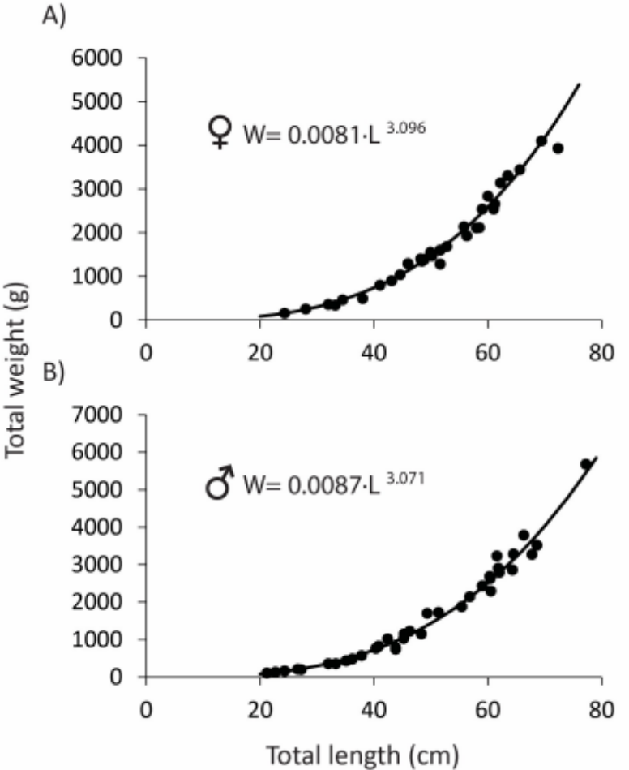

Figure S2. Length-weight relationships for A) female and B) male Lagocephalus sceleratus showing only a random selection of 35 each of the 456 length-weight data pairs sampled for males and 270 for females and used to compute the parameters of the length-weight relationships in A and B (see also Table S3).

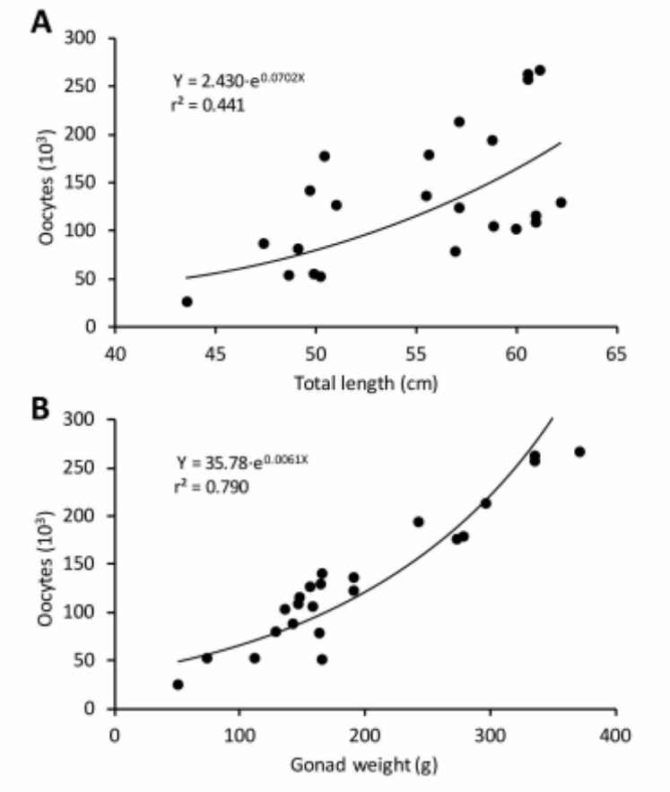
Figure S3. Relationships, in Lagocephalus sceleratus between fecundity and total length, total weight and gonad weight during peak spawning in June 2020.

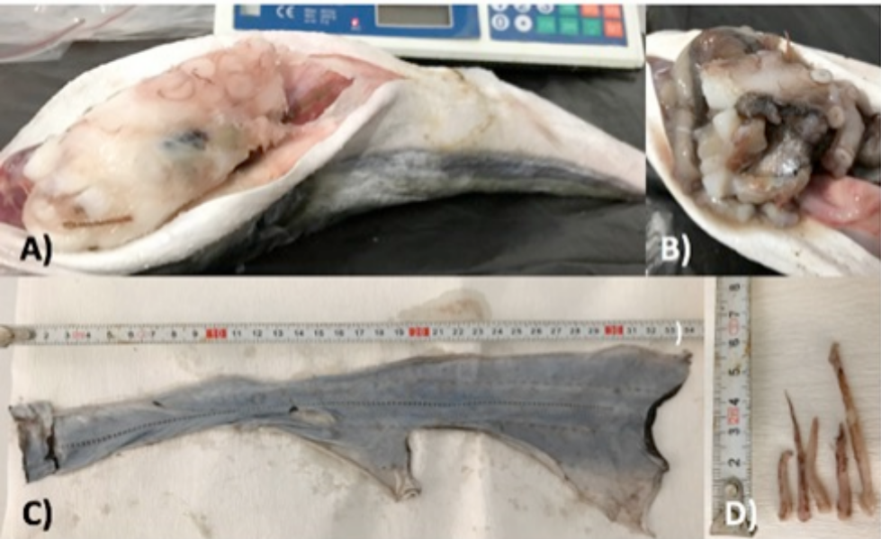
Figure S4. Stomach contents of Lagocephalus sceleratus showing freshly ingested cephalopods: Loligo vulgaris (A), Octopus vulgaris (B); and parts of Tremoctopus violaceus (C).

