Supplementary Materials
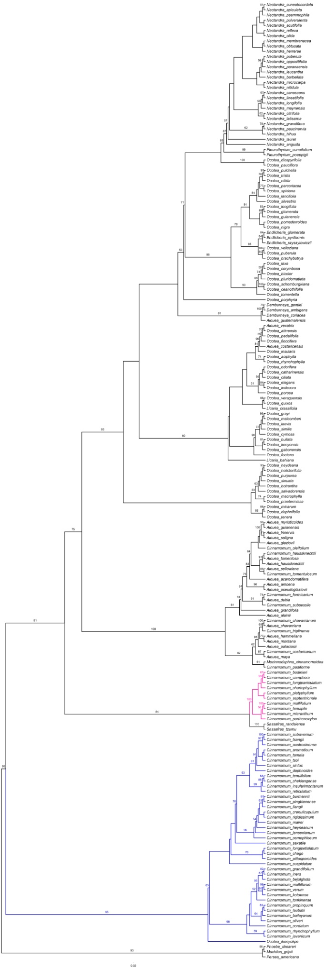
Figure S1. A maximum likelihood cladogram of the Cinnamomum group based on nrITS displaying the polyphyletic status of the Asian Cinnamomum. Sequences were retrieved from Genbank, and their accession number was listed in Supplementary Materials-Table S1. Sequences were aligned in Mafft 7.308-win64, and manually adjusted in BioEdit 7.2.5. The format was transformed in SequenceMatrix Windows 1.7.8. The final alignment of nrITS contains 185 sequences with 751 columns, 471 distinct patterns, 226 parsimony-informative, 117 singleton sites, and 408 constant sites. The tree was reconstructed with RAxML-HPC2 on XSEDE with the GTRCAT model. Bootstrap values were only marked above branches when they are higher than 50%. The final tree was viewed and adjusted in FigTree v1.4.0, and then beautified in Adobe Illustrator CS2 ver. 12.0.0. We also reconstructed a ML tree using IQ-TREE Web Server (http://iqtree.cibiv.univie.ac.at/) with bootstrap analysis as ‘standard’ and the number of bootstrap alignments as ‘100’, and got the same topology with low to moderate (60% or higher) bootstrap supports in general.
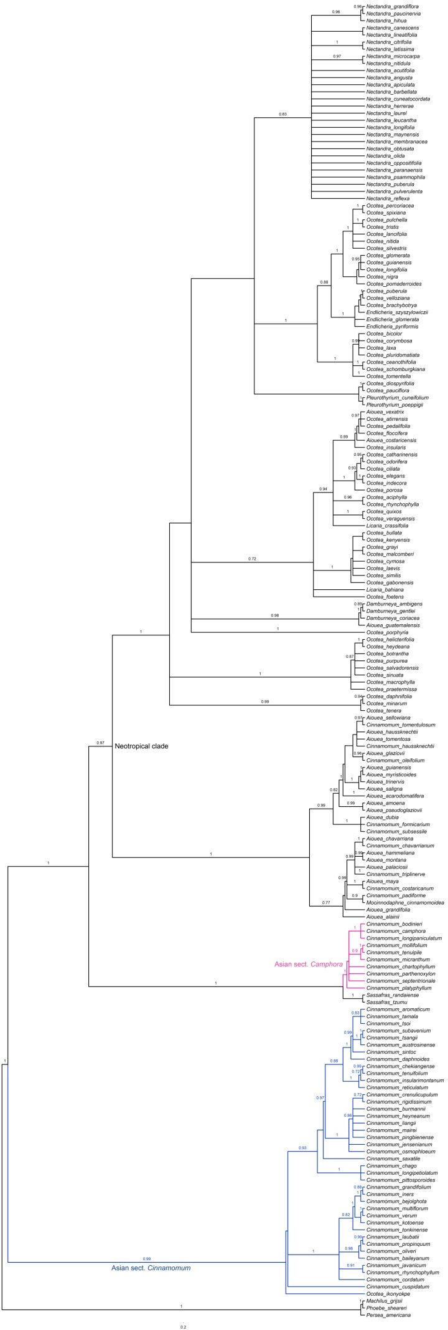
Figure S2. A Bayesian cladogram of the Cinnamomum group based on nrITS displaying the polyphyletic status of the Asian Cinnamomum. Sequences were retrieved from Genbank, and their accession number was listed in Supplementary-Table S1. Sequences were aligned in Mafft 7.308-win64, and manually adjusted in BioEdit 7.2.5. The format was transformed in SequenceMatrix Windows 1.7.8. The tree was reconstructed with MrBayes on XSEDE with the Nst=6, Rates=invgamma, Ngen=1,000,000, Markov chain was sampled every 1,000, and Sumt Burnin Value=25. The final tree was viewed and adjusted in FigTree v1.4.0, and then beautified in Adobe Illustrator CS2 ver. 12.0.0. Posterior probabilities were shown above branches only when they are higher than 0.70.

Table S1. Sequences obtained from Genbank for phylogenetic reconstruction of the Cinnamomum group.
Species | Accession No.
Aiouea acarodomatifera Kosterm. | MF110006.1
Aiouea alainii (C.K.Allen) R.Rohde | MF110007.1
Aiouea amoena (Nees & Mart) R.Rohde | MF110008.1
Aiouea chavarriana (Hammel) R.Rohde | MF110009.1
Aiouea costaricensis (Mez) Kosterm. | MF110011.1
Aiouea dubia (Kunth) Mez | KU139905.1
Aiouea glaziovii (Mez) R.Rohde | MF110013.1
Aiouea grandifolia van der Werff | MF110014.1
Aiouea guatemalensis (Lundell) Renner | MF110015.1
Aiouea guianensis Aubl. | AF272251.1
Aiouea hammeliana (W.C.Burger) R.Rohde | MF110016.1
Aiouea haussknechtii (Mez) R.Rohde | MF110017.1
Aiouea maya Lorea-Hern. | MF110020.1
Aiouea montana (Sw.) R.Rohde | MF110021.1
Aiouea myristicoides Mez | MF110022.1
Aiouea palaciosii (van der Werff) R.Rohde | MF110023.1
Aiouea pseudoglaziovii Lorea-Hern. | MF110024.1
Aiouea saligna Meisn. | KX509821.1
Aiouea sellowiana (Nees & Mart) R.Rohde | MF110025.1
Aiouea tomentosa (Meisn.) R.Rohde | MF110031.1
Aiouea trinervis Meisn. | MF110032.1
Aiouea vexatrix van der Werff | MF110033.1
Cinnamomum austrosinense H.T.Chang | KU139818.1
Cinnamomum baileyanum (F.Muell. ex F.M.Bailey) Francis | KU139820.1
Cinnamomum bejolghota (Buch.-Ham.) Sweet | KU139822.1
Cinnamomum bodinieri H.Lév. | KU139824.1
Cinnamomum burmannii (Nees & T.Nees) Blume | KU139825.1
Cinnamomum camphora (L.) J.Presl | KX509822.1
Cinnamomum chago B.S.Sun & H.L.Zhao | KU139830.1
Cinnamomum chartophyllum H.W.Li | KU139831.1
Cinnamomum chavarrianum (Hammel) Kosterm. | KU139833.1
Cinnamomum chekiangense Nakai | KU139834.1
Cinnamomum cordatum Kosterm. | KU139835.1
Cinnamomum costaricanum (Mez & Pittier) Kosterm. | KU139836.1
Cinnamomum crenulicupulum Kosterm. | KU139838.1
Cinnamomum cuspidatum Miq. | KU139839.1
Cinnamomum daphnoides Siebold & Zucc. | KU139841.1
Cinnamomum dubium Nees | KU139862.1
Cinnamomum formicarium van der Werff & Lorea-Hern. | KX509823.1
Cinnamomum grandifolium Cammerl. | KU139844.1
Cinnamomum haussknechtii (Mez) Kosterm. | KU139845.1
Cinnamomum heyneanum Nees | KU139847.1
Cinnamomum iners Reinw. ex Blume | KU139848.1
Cinnamomum insularimontanum Hayata | KX509825.1
Cinnamomum javanicum Blume | KU139852.1
Cinnamomum jensenianum Hand.-Mazz. | KU139853.1
Cinnamomum kotoense Kaneh. & Sasaki | KU139854.1
Cinnamomum laubatii F.Muell. | KU139855.1
Cinnamomum liangii C.K.Allen | KU139856.1
Cinnamomum longipaniculatum (Gamble) N.Chao ex H.W.Li | KU139857.1
Cinnamomum longipetiolatum H.W.Li | KU139858.1
Cinnamomum mairei H.Lév. | KU139859.1
Cinnamomum micranthum (Hayata) Hayata | KU139860.1
Cinnamomum mollifolium H.W.Li | KU139861.1
Cinnamomum oleifolium (Mez) Kosterm. | KU139864.1
Cinnamomum oliveri F.M.Bailey | KU139865.1
Cinnamomum osmophloeum Kaneh. | KU139866.1
Cinnamomum padiforme (Standl. & Steyerm.) Kosterm. | KU139868.1
Cinnamomum parthenoxylon (Jack) Meisn. | KU139871.1
Cinnamomum pingbienense H.W.Li | KU139873.1
Cinnamomum pittosporoides Hand.-Mazz. | KU139874.1
Cinnamomum platyphyllum (Diels) C.K.Allen | KU139875.1
Cinnamomum porrectum (Roxb.) Kosterm. | KU139870.1
Cinnamomum propinquum F.M.Bailey | KU139876.1
Cinnamomum reticulatum Hayata | KU139879.1
Cinnamomum rhynchophyllum Miq. | KU139880.1
Cinnamomum rigidissimum H.T.Chang | KU139881.1
Cinnamomum saxatile H.W.Li | KU139882.1
Cinnamomum septentrionale Hand.-Mazz. | KU139883.1
Cinnamomum sintoc Blume | KU139884.1
Cinnamomum subavenium Miq. | KU139888.1
Cinnamomum subsessile (Meisn.) Kosterm. | KU139889.1
Cinnamomum tamala (Buch.-Ham.) T.Nees & Eberm. | KU139891.1
Cinnamomum tenuifolium (Makino) Sugim. | KU139892.1
Cinnamomum tenuipile Kosterm. | KU139893.1
Cinnamomum tomentulosum Kosterm. | KU139894.1
Cinnamomum tonkinense (Lecomte) A.Chev. | KU139896.1
Cinnamomum triplinerve (Ruiz & Pav.) Kosterm. | KU139897.1
Cinnamomum tsangii Merr. | KU139900.1
Cinnamomum tsoi C.K.Allen | KU139901.1
Cinnamomum verum J.Presl | KU139827.1
Damburneya ambigens (S.F.Blake) Trofimov | KX509828.1
Damburneya coriacea (Sw.) Trofimov & Rohwer | KX509829.1
Damburneya gentlei (Lundell) Trofimov | KX509830.1
Endlicheria glomerata Mez | MF110065.1
Endlicheria pyriformis (Nees) Mez | MF110066.1
Endlicheria szyszylowiczii Mez | MF110067.1
Licaria bahiana Kurz | MF110068.1
Licaria crassifolia (Poir.) P.L.R. de Moraes | MF110069.1
Machilus grijsii Hance | KX509833.1
Mocinnodaphne cinnamomoidea Lorea-Hern. | AF272288.1
Nectandra acutifolia (Ruiz & Pav.) Mez | KX509834.1
Nectandra angusta Rohwer | KX509835.1
Nectandra apiculata Rohwer | KX509836.1
Nectandra barbellata Coe-Teix. | KX509837.1
Nectandra canescens Nees & Mart. | KX509838.1
Nectandra citrifolia Mez & Rusby | KX509842.1
Nectandra cuneatocordata Mez | KX509843.1
Nectandra grandiflora Nees & Mart. | KX509845.1
Nectandra herrerae O.C.Schmidt | KX509846.1
Nectandra hihua (Ruiz & Pav.) Rohwer | KX509847.1
Nectandra latissima Rohwer | KX509848.1
Nectandra laurel Klotzsch ex Nees | KX509849.1
Nectandra leucantha Nees & Mart. | KX509850.1
Nectandra lineatifolia (Ruiz & Pav.) Mez | KX509851.1
Nectandra longifolia (Ruiz & Pav.) Nees | KX509852.1
Nectandra maynensis Mez | KX509853.1
Nectandra membranacea (Sw.) Griseb. | KX509854.1
Nectandra microcarpa Meisn. | KX509856.1
Nectandra nitidula Nees & Mart. | KX509857.1
Nectandra obtusata Rohwer | KX509858.1
Nectandra olida Rohwer | KX509859.1
Nectandra oppositifolia Nees & Mart. | KX509860.1
Nectandra paranaensis Coe-Teix. | KX509861.1
Nectandra paucinervia Coe-Teix. | KX509862.1
Nectandra psammophila Nees & C. Mart. | MF110070.1
Nectandra puberula (Schott) Nees | KX509863.1
Nectandra pulverulenta Nees | KX509864.1
Nectandra reflexa Rohwer | KX509865.1
Ocotea aciphylla (Nees & Mart.) Mez | KX509866.1
Ocotea atirrensis Mez & Donn. | MF110077.1
Ocotea botrantha Rohwer | AF272297.1
Ocotea brachybotrya (Meisn.) Mez | GQ480376.1
Ocotea bullata (Burch.) E. Meyer | AF272298.1
Ocotea catharinensis Mez | KF420963.1
Ocotea ceanothifolia (Nees) Mez | AF272299.1
Ocotea ciliata L.C.S. Assis & Mello-Silva | MF110072.1
Ocotea corymbosa (Meisn.) Mez | GQ480375.1
Ocotea cymosa (Nees) Palacky | KJ189018.1
Ocotea daphnifolia (Meisn.) Mez | GQ480378.1
Ocotea diospyrifolia (Meisn.) Mez | GQ480379.1
Ocotea foetens (Aiton) Baill. | KX509869.1
Ocotea gabonensis Fouilloy | MF110075.1
Ocotea glomerata (Nees) Mez | GQ480380.1
Ocotea grayi van der Werff | AF272301.1
Ocotea guianensis Aubl. | AF272302.1
Ocotea helicterifolia (Meisn.) Hemsl. | AF272303.1
Ocotea heydeana (Mez & Donn.Sm.) Bernardi | AF272304.1
Ocotea ikonyokpe van der Werff | AF272305.1
Ocotea indecora (Schott) Mez | MF110076.1
Ocotea insularis (Meisn.) Mez | MF110074.1
Ocotea kenyensis (Chiov.) Robyns & R.Wilczek | KJ189025.1
Ocotea lancifolia (Schott) Mez | GQ480383.1
Ocotea laxa (Nees) Mez | GQ480384.1
Ocotea longifolia Kunth | GQ480385.1
Ocotea macrophylla Kunth | KX509870.1
Ocotea malcomberi van der Werff | AF272307.1
Ocotea minarum (Nees & Mart.) Mez | GQ480386.1
Ocotea nigra Benoist | AF272308.1
Ocotea nitida (Meisn.) Rohwer | GQ480387.1
Ocotea odorifera (Vell.) Rohwer | KX509871.1
Ocotea pauciflora (Nees) Mez | AF272310.1
Ocotea percoriacea Kosterm. | AF272311.1
Ocotea pluridomatiata A.Quinet | GQ480389.1
Ocotea pomaderroides (Meisn.) Mez | GQ480390.1
Ocotea porosa (Nees & Mart.) Barroso | MF110078.1
Ocotea porphyria (Griseb.) van der Werff | MF110079.1
Ocotea praetermissa van der Werff | KX509872.1
Ocotea puberula (Rich.) Nees | GQ480391.1
Ocotea pulchella (Nees & Mart.) Mez | KX509873.1
Ocotea purpurea (Mez) van der Werff | KX509874.1
Ocotea quixos (Lam.) Kosterm. | MF110080.1
Ocotea racemosa (Danguy) Kosterm. | KJ189017.1
Ocotea salvadorensis (Lundell) van der Werff | KX509875.1
Ocotea schomburgkiana (Nees) Mez | AF272315.1
Ocotea silvestris Vattimo | GQ480394.1
Ocotea sinuata (Mez) Rohwer | KX509876.1
Ocotea spixiana (Nees) Mez | AF272316.1
Ocotea tenera Mez & Donn. | MF110082.1
Ocotea tomentella Sandwith | AF272317.1
Ocotea tristis (Nees & Mart.) Mez | AF272318.1
Ocotea velloziana (Meisn.) Mez | GQ480395.1
Ocotea veraguensis (Meisn.) Mez | AF272319.1
Persea americana Mill. | KX509877.1
Phoebe sheareri (Hemsl.) Gamble | KX509878.1
Pleurothyrium cuneifolium Nees | KX509879.1
Pleurothyrium poeppigii Nees | KX509880.1
Sassafras randaiense (Hayata) Rehder | EF491212.1
Sassafras tzumu (Hemsl.) Hemsl. | EF491209.1

Table S2. Sequences obtained from the GenBank for phylogeny of Asian Cinnamomum.
Taxon | ITS | RPB2 | LEAFY
Alseodaphnopsis hainanensis | FJ755440 | KU140409 | HQ697006
Alseodaphnopsis rugosa | HQ697183 | KU140410 | HQ697012
Cinnamomum appelianum | KU139817 | KU140330 | KU140244
Cinnamomum austrosinense | KU139818 | KU140331 | KU140245
Cinnamomum bejolghota | KU139822 | KU140335 | KU140249
Cinnamomum bodinieri | KU139824 | KU140336 | KU140251
Cinnamomum burmannii | KU139825 | KU140337 | KU140252
Cinnamomum camphora | KU139826 | KU140338 | KU140253
Cinnamomum chartophyllum | KU139832 | KU140344 | KU140259
Cinnamomum chavarrinum | AF272261 | KU140345 | −
Cinnamomum chekiangense | MF110041 | KU140346 | KU140260
Cinnamomum daphnoides | FM957803 | KU140352 | KU140266
Cinnamomum doederleinii | KU139842 | − | KU174408
Cinnamomum glanduliferum | KU139843 | KU140354 | KU140269
Cinnamomum iners | KU139849 | KU140360 | KU140275
Cinnamomum insularimontanum | KY271510 | KU140361 | KU174418
Cinnamomum japonicum | KU139851 | KU140361 | KU140277
Cinnamomum jensenianum | KU139853 | KU140363 | KU140279
Cinnamomum liangii | KU139856 | KU140366 | KU174422
Cinnamomum longipaniculatum | KX546754 | KT248715 | KU140283
Cinnamomum macrostemon | GU598521 | − | −
Cinnamomum mairei | KU139859 | KU140368 | KU174423
Cinnamomum micranthum | KY271519 | KU140369 | GQ260581
Cinnamomum osmophloeum | KY271528 | KU140375 | −
Cinnamomum parthenoxylon | KU139871 | KU140377 | KU140295
Cinnamomum pauciflorum | KU139872 | KU140378 | KU140296
Cinnamomum pingbienense | KU139873 | KU140379 | KU140297
Cinnamomum pittosporoides | KU139874 | KU140380 | KU140298
Cinnamomum reticulatum | KU139879 | − | KU174432
Cinnamomum rigidissimum | KU139881 | KU140386 | KU140305
Cinnamomum saxatile | KU139882 | KU140387 | KU140306
Cinnamomum septentrionale | KU139883 | KU140388 | KU140307
Cinnamomum subavenium | KU139888 | KU140393 | KU140312
Cinnamomum tamala | KX822090 | KU140396 | KU174439
Cinnamomum tenuifolium | KU139892 | KU140397 | KU140316
Cinnamomum tenuifolium | − | − | KU140316
Cinnamomum tonkinense | KU139895 | KU140400 | KU140319
Cinnamomum tsangii | KU139900 | KU140405 | KU140324
Cinnamomum verum | MF110061 | KU140407 | KU140326
Cinnamomum wilsonii | KU139904 | KU140408 | KU140328
Phoebe hungmoensis | HQ697206 | KU140413 | HQ697138
Phoebe zhennan | HQ697212 | KT248761 | HQ697161

