Appendix S1. Catalogue of Chinese Monolepta
Note. Species with third antennal segment longer than second are denoted by Wagner
Abbreviation of words in this study:
Type locality: TL.
Type deposition: TD.
For this catalogue, the type species were deposited in the following museums.
BMNH The Natural History Museum, London, UK
BPBM Bishop Museum Honolulu, Hawaii, USA
BRH Biohistory Research Hall, Takatsuki, Osaka, Japan
CAS California Academy of Sciences, San Francisco, California, USA
EIHU Institute of Systematic Entomology, Hokkaido University, Japan
IZAS Institute of Zoology, Chinese Academy of Sciences, Beijing, China
KUEC Kyushu University, Fukuoka, Japan
KUTJ Kagawa University, Entomology laboratory, Takamatsu-shi, Japan
LM Lev Medvedev’s collection
MCZC Museum of Comparative Zoology, Cambridge, Harvard University, Massachusetts, USA
MNHN Muséum National d'Histoire Naturelle, Paris, France
NHRS Naturhistoriska riksmuseet, Stockholm, Sweden
NMEG Naturkundemuseum, Erfurt, Germany
SDEI Senckenberg Deutsches Entomologisches Institut, Müncheberg, Germany
SMNS Staatliches Museum fww.naturkunde, Stuttgart, Germany
USNM National Museum of Natural History, [formerly, United States National Museum], Washington D.C., USA
ZMHB Museum für Naturkunde der Humboldt-Universität, Berlin, Germany
ZMUM Moscow State University, Moscow, Russia

Monolepta aglaonemae Gressitt & Kimoto, 1963 (Fig. A1)
Monolepta aglaonemae Gressitt & Kimoto, 1963: 607. TL China: Hainan. TD CAS.
Distribution China: Fujian, Guangdong, Hainan.
Host plant Aglaonema sp.
Monolepta alnivora Chen, 1976 (Fig. A2)
Monolepta alnivora Chen, 1976: 205. TL China: Xizang. TD IZAS.
Distribution China: Xizang.
Host plant Alnus cremastogyne.
Monolepta annamita (Laboissière, 1935)
Monolepta annamita Laboissière, 1935: 143 (new name for Luperodes ferruginea Allard, 1889). TL Vietnam. TD MNHN.
Luperodes ferruginea Allard, 1889: 311 (nec Karsch, 1882).
Distribution China: Taiwan. Vietnam, Laos, Thailand.
Monolepta arundinariae Gressitt & Kimoto, 1963 (Fig. A3)
Monolepta arundinariae Gressitt & Kimoto, 1963: 609. TL China: Jiangxi. TD CAS.
Distribution China: Henan, Jiangsu, Hubei, Jiangxi, Hunan, Fujian, Guangxi, Sichuan.
Host plants Gramineae, Arundinaria sp.
Monolepta asahinai Chûjô, 1962
Monolepta asahinai Chûjô, 1962: 116. TL China: Taiwan. TD KUTJ.
Distribution China: Taiwan.
Monolepta bacboensis Medvedev, 2012
Monolepta bacboensis Medvedev, 2012: 494. TL China: Yunnan. TD LM.
Distribution China: Yunnan; Vietnam.
Monolepta brittoni Gressitt & Kimoto, 1963 (Fig. A4)
Monolepta brittoni Gressitt & Kimoto, 1963: 604, 611. TL China: Hainan. TD CAS.
Distribution China: Hainan.
Monolepta capitata Chen, 1942 (Fig. A5)
Monolepta capitata Chen, 1942: 58. TL China: Sichuan. TD IZAS.
Distribution China: Hubei, Hunan, Fujian, Sichuan.
Host plant Rubus sp.
Monolepta cavipennis Baly, 1878 (Fig. A6)
Monolepta cavipennis Baly, 1878: 459. TL India. TD BMNH.
Luperodes albofasciata Allard, 1889: 310. Synonymized by Kimoto (1989: 127).
Diacantha fasciata Allard, 1889: 318, 323. Synonymized by Kimoto (1989: 127).
Candezea trifasciata Jacoby, 1900: 139 (nec Jacoby, 1896). Synonymized by Bryant (1923: 146).
Monolepta siamensis Weise, 1915: 177 (new name for Candezea trifasciata Jacoby, 1900).
Distribution China: Guangdong, Hainan, Hong Kong, Guangxi, Yunnan. Vietnam, Laos, Cambodia, Thailand, India.
Monolepta cheni Beenen, 2008 (Fig. A7)
Monolepta cheni Beenen, 2008: 65 (new name for Monolepta straminea Chen, 1976). TL China: Xizang. TD IZAS.
Monolepta straminea Chen, 1976: 206 (nec Harold, 1880).
Distribution China: Xizang.
Monolepta chinkinyui Kimoto, 1996
Monolepta chinkinyui Kimoto, 1996: 38. TL China: Taiwan. TD BRH.
Distribution China: Taiwan.
Monolepta discalis Gressitt & Kimoto, 1963 (Fig. A8)
Monolepta discalis Gressitt & Kimoto, 1963: 612. TL China: Yunnan. TD BSBM.
Distribution China: Gansu, Zhejiang, Guizhou, Yunnan.
Monolepta epistomalis Laboissière, 1934 (Fig. A9)
Monolepta epistomalis Laboissière, 1934: 9. TL China: Gansu. TD NHRS.
Distribution China: Gansu, Zhejiang, Hunan.
Monolepta erythrocephala (Baly, 1878) (Fig. A10)
Luperodes erythrocephala Baly, 1878: 380. TL Pakistan. TD BMNH.
Monolepta erythrocephala Maulik, 1936: 430.
Distribution China: Sichuan. India, Nepal, Bhutan, Pakistan.
Monolepta eunicia Maulik, 1936 (Fig. A11)
Monolepta eunicia Maulik, 1936: 395. TL India. TD BMNH.
Distribution China: Sichuan, Guizhou. Myanmar, India.
Monolepta flavovittata Chen, 1942 (Fig. A12)
Monolepta flavovittata Chen, 1942: 61. TL China: Hebei. TD IZAS.
Distribution China: Gansu, Shaanxi, Hebei, Hubei, Fujian. Vietnam.
Monolepta gracilipes Chûjô, 1938 (Fig. A13)
Monolepta gracilipes Chûjô, 1938: 145. TL China: Taiwan. TD TARI., SDEI. Synonymized with Monolepta pallidula (Baly, 1874) by Kimoto (1969: 47).
Monolepta gracilipes Lee, 2009: 16. Removed from synonymy Monolepta pallidula (Baly, 1874).
Distribution China: Taiwan.
Monolepta hongkongense Kimoto, 1967
Monolepta hongkongense Kimoto, 1967: 61. TL China: Hong Kong. TD KUEC.
Distribution China: Hong Kong.
Monolepta horni Chûjô, 1938 (Fig. A14)
Monolepta horni Chûjô, 1938: 146. TL China: Taiwan. TD SDEI, TARI.
Distribution China: Taiwan.
Monolepta hupehensis Gressitt & Kimoto, 1963 (Figs. A15, 16)
Monolepta hupehensis Gressitt & Kimoto, 1963: 604, 615. TL China: Hubei. TD IZAS.
Distribution China: Hebei, Hubei.
Monolepta indochinensis Medvedev, 1999
Monolepta indochinensis Medvedev, 1999: 184. TL Vietnam. TD LM, NMEG, SMNS.
Distribution China: Yunnan. Vietnam, Thailand.
Monolepta kuroheri Kimoto, 1966 (Fig. A17)
Monolepta kuroheri Kimoto, 1966: 31. TL China: Taiwan. TD KUEC.
Distribution China: Taiwan.
Monolepta lauta Gressitt & Kimoto, 1963 (Fig. A18)
Monolepta lauta Gressitt & Kimoto, 1963: 604, 617. TL China: Hainan. TD CAS.
Distribution China: Hainan, Guizhou. Vietnam, Laos.
Monolepta leechi Jacoby, 1890 (Figs. A19, 20)
Monolepta leechi Jacoby, 1890: 216. TL China: Hubei. TD MCZC.
Distribution China: Hubei, Fujian, Taiwan, Guangdong, Guizhou, Yunnan. Vietnam,
Laos, India, Nepal.
Monolepta liui Gressitt & Kimoto, 1963 (Figs. A21, 22)
Monolepta liui Gressitt & Kimoto, 1963: 618. TL China: Yunnan. TD USNM.
Distribution China: Guizhou, Yunnan.
Monolepta longicornis (Jacoby, 1890)
Taphinella longicornis Jacoby, 1890: 194. TL China: Hubei. TD BMNH.
Arthrotus longicornis Gressitt & Kimoto, 1963: 698.
Monolepta longicornis Wilcox, 1973: 552.
Distribution China: Hubei.
Monolepta longitarsoides Chûjô, 1938 (Figs. A23, 24)
Monolepta longitarsoides Chûjô, 1938: 147. TL China: Taiwan. TD TARI
Distribution China: Zhejiang, Hubei, Jiangxi, Hunan, Fujian, Taiwan, Guangdong,
Hainan, Guangxi, Sichuan, Guizhou.
Monolepta lunata Gressitt & Kimoto, 1963 (Fig. A25)
Monolepta lunata Gressitt & Kimoto, 1963: 620. TL China: Hainan. TD CAS.
Distribution China: Hainan. India.
Monolepta maana Gressitt & Kimoto, 1963 (Fig. A26)
Monolepta maana Gressitt & Kimoto, 1963: 621. TL China: Fujian. TD BSBM.
Distribution China: Fujian.
Monolepta mandibularis Chûjô, 1962
Monolepta mandibularis Chûjô, 1962: 120. TL China: Taiwan. TD KUTJ.
Distribution China: Taiwan.
Monolepta meihuai Lee, Tian & Staines, 2010
Monolepta meihuai Lee, Tian & Staines, 2010: 306. China: Taiwan. TD TARI.
Distribution China: Taiwan.
Monolepta meridionalis Gressitt & Kimoto, 1963 (Fig. A27)
Monolepta meridionalis Gressitt & Kimoto, 1963: 622. TL China: Guangdong. TD CAS.
Distribution China: Guangdong, Hainan.
Monolepta minor Chûjô, 1938 (Fig. A28)
Monolepta minor Chûjô, 1938: 149. TL China: Taiwan. TD TARI.
Monolepta seminigra Chûjô, 1962: 118. Synonymized by Kimoto (1969: 50).
Distribution China: Taiwan. Japan.
Monolepta minutissima Chen, 1942 (Fig. A29)
Monolepta minutissima Chen, 1942: 60. TL China: Guangxi. TD IZAS.
Distribution China: Guangxi.
Monolepta nakanei Kimoto, 1969
Monolepta nakanei Kimoto, 1969: 52. TL China: Taiwan. TD KUEC.
Distribution China: Taiwan.
Monolepta occifluvis Gressitt & Kimoto, 1963 (Fig. A30)
Monolepta occifluvis Gressitt & Kimoto, 1963: 624. TL China: Guangdong. TD CAS.
Distribution China: Guangdong, Guangxi.
Monolepta ongi Lee & Staines, 2010 (Fig. A31)
Monolepta ongi Lee & Staines, 2010: 538. TL China: Taiwan. TD TARI.
Distribution China: Taiwan.
Monolepta ovatula Chen, 1942 (Fig. A32)
Monolepta ovatula Chen, 1942: 60. TL China: Guangxi. TD IZAS.
Distribution China: Hubei, Jiangxi, Fujian, Guangxi, Guizhou.
Host plants Bambusoideae.
Monolepta pallidula (Baly, 1874) (Fig. A33)
Luperodes pallidulus Baly, 1874: 187. TL Japan. TD BMNH.
Monolepta pallidula: Chûjô, 1938: 144.
Distribution China: Gansu, Henan, Anhui, Zhejiang, Hubei, Jiangxi, Hunan, Fujian, Taiwan, Guangdong, Hainan, Guangxi, Sichuan, Guizhou, Yunnan, Xizang. Korea Peninsula, Japan, Vietnam, Laos, Thailand.
Host plants Populus euphratica, Styrax japonica, Styracaceae, Bambusoideae.
Monolepta palliparva Gressitt & Kimoto, 1963 (Fig. A34)
Monolepta palliparva Gressitt & Kimoto, 1963: 626. TL China: Guizhou. TD BSBM.
Distribution China: Jiangxi, Hainan, Guizhou, Yunnan.
Monolepta parenthetica Gressitt & Kimoto, 1963 (Fig. A35)
Monolepta parenthetica Gressitt & Kimoto, 1963: 627. TL China: Hubei. TD BSBM.
Distribution China: Hubei, Sichuan.
Monolepta quadricavata Chen, 1976 (Fig. A37)
Monolepta quadricavata Chen, 1976: 205. TL China: Xizang. TD IZAS.
Distribution China: Xizang. Nepal.
Monolepta quadriguttata (Motschulsky, 1860)
Luperodes quadriguttata Motschulsky, 1860: 233. TL Russia. TD ZMUM.
Monolepta quadriguttata: Ogloblin, 1936: 315, 320, 434.
Distribution China: Heilongjiang, Ningxia, Gansu, Guangxi, Yunnan. Russia, Korea Peninsula, Japan.
Host plants Leguminosae, Cruciferae, Cannabinaceae.
Monolepta rufofulva Chûjô, 1938 (Fig. A38)
Monolepta rufofulva Chûjô, 1938: 149. TL China: Taiwan. TD TARI.
Distribution China: Taiwan, Sichuan, Yunnan.
Monolepta sasajii Kimoto, 1969 (Fig. A39)
Monolepta sasajii Kimoto, 1969: 53. TL China: Taiwan. TD KUEC.
Distribution China: Taiwan.
Monolepta sauteri Chûjô, 1935 (Fig. A40)
Monolepta sauteri Chûjô, 1935: 173. TL China: Taiwan. TD SDEI, TARI.
Distribution China: Fujian, Taiwan, Guangdong, Hainan, Guangxi, Guizhou, Yunnan.
Monolepta schereri Gressitt & Kimoto, 1963 (Fig. A41)
Monolepta schereri Gressitt & Kimoto, 1963: 630. TL China: Hubei. TD CAS.
Distribution China: Hubei, Guizhou.
Monolepta selmani Gressitt & Kimoto, 1963 (Fig. A42)
Monolepta selmani Gressitt & Kimoto, 1963: 631. TL China: Hubei. TD CAS.
Distribution China: Gansu, Zhejiang, Hubei, Hunan, Guizhou, Yunnan.
Monolepta semenovi Ogloblin, 1936 (Fig. A43)
Monolepta semenovi Ogloblin, 1936: 318, 434. TL China: Sichuan. TD ZMUM.
Distribution China: Guizhou, Sichuan. Russia.
Monolepta severini (Jacoby, 1896)
Luperus severini Jacoby, 1896: 276. TL India.
Monolepta severini Kimoto, 2001: 42.
Distribution China: Yunnan. Nepal, India, Burma, Thailand, Laos, Vietnam.
Monolepta sexlineata Chûjô, 1938 (Fig. A44)
Monolepta sexlineata Chûjô, 1938: 150. TL China: Taiwan. TD SDEI.
Monolepta duvivieri Jacoby, 1904: 404 (nec Jacoby, 1897).
Monolepta lineata Weise, 1915: 117 (nec Karsch, 1882).
Monolepta madrasensis Wilcox, 1973: 562. (new name for Monolepta duvivieri Jacoby, 1904 and for Monolepta lineata Weise, 1915). Synonymized by Kimoto (1989: 150).
Distribution China: Jilin, Hebei, Shanxi, Shaanxi, Gansu, Fujian, Taiwan, Guangdong, Hainan, Guangxi, Yunnan. Vietnam, Laos, Cambodia, Thailand, India, Nepal, Bhutan, Sri Lanka.
Host plant Saccharum officinarum.
Monolepta shaowuensis Gressitt & Kimoto, 1963 (Fig. A45)
Monolepta shaowuensis Gressitt & Kimoto, 1963: 632. TL China: Fujian. TD BSBM.
Distribution China: Hubei, Jiangxi, Hunan, Fujian, Guangdong.
Monolepta signata (Oliver, 1808) (Fig. A46)
Galeruca signata Olivier, 1808: 665. TL China: Hong Kong. TD MNHN.
Crioceris neglecta Sahlberg, 1829: 29. Synonymized by Maulik (1936: 410).
Luperodes hieroglyphicus Motschulsky, 1858: 104. Synonymized by Wagner (2012: 210).
Luperodes quadripustulatus Motschulsky, 1858: 105. Synonymized by Maulik (1936: 410).
Monolepta elegantula Boheman, 1859: 183. Synonymized by Weise (1913: 229).
Luperodes dorsalis Motschulsky, 1866: 415. Synonymized by Wagner (2012: 210).
Luperodes quadriguttata Fairmaire, 1887: 333. Synonymized by Weise (1913: 229).
Monolepta signata Jacoby, 1889: 229.
Monolepta biarcuata Weise, 1889: 632. Synonymized by Weise (1922: 104).
Monolepta picturata Jacoby, 1896: 292. Synonymized by Wagner (2012: 210).
Monolepta simplex Weise, 1913: 229. Synonymized by Weise (1924: 168).
Monolepta signata ab. belmonti Piton, 1943: 138. Synonymized by Wilcox (1973: 534).
Monolepta signata ab. bipunctata Piton, 1943: 138. Synonymized by Wilcox (1973: 533).
Monolepta signata ab. coalita Piton, 1943: 138. Synonymized by Wilcox (1973: 533).
Monolepta signata ab. lutea Piton, 1943: 138. Synonymized by Wilcox (1973: 533).
Monolepta signata ab. pici Piton, 1943: 138. Synonymized by Wilcox (1973: 533).
Monolepta signata ab. sexmaculata Piton, 1943: 138. Synonymized by Wilcox (1973: 534).
Monolepta signata ab. yunnanensis Piton, 1943: 138. Synonymized by Wilcox (1973: 534).
Distribution China: Heilongjiang, Jilin, Liaoning, Inner Mongolia, Gansu, Hebei, Shanxi, Shaanxi, Henan, Zhejiang, Hubei, Jiangxi, Hunan, Fujian, Taiwan, Guangdong, Hong Kong, Hainan, Guangxi, Sichuan, Guizhou, Yunnan, Xizang. Mongolia, Russia, Korea Peninsula, Japan, Vietnam, Laos, Thailand, Cambodia, India, Myanmar, Nepal, Bhutan, Sri Lanka, Philippines, Malaysia, Singapore, Indonesia, New Guinea, Australia.
Host plants Leguminosae, Gossypium sp., Zea mays, Arachis hypogaea, Salix sp., Viburnum sp., Rubus sp., Pyracantha crenulata.
Monolepta subapicalis Gressitt & Kimoto, 1963 (Fig. A47)
Monolepta subapicalis Gressitt & Kimoto, 1963: 634. TL China: Sichuan. TD CAS.
Distribution China: Shaanxi, Gansu, Hubei, Hunan, Fujian, Guizhou. Vietnam, Bhutan.
Monolepta subrubra Chen, 1942 (Fig. A48)
Monolepta subrubra Chen, 1942: 57. TL China: Shaanxi. TD IZAS.
Distribution China: Shaanxi, Fujian.
Monolepta takizawai Kimoto, 1996
Monolepta takizawai Kimoto, 1996: 39. TL China: Taiwan. TD EIHU.
Distribution China: Taiwan.
Monolepta weigeli Medvedev, 2012
Monolepta weigeli Medvedev, 2012: 494. TL China: Yunnan. TD NMEG.
Distribution China: Yunnan.
Monolepta wilcoxi Gressitt & Kimoto, 1965 (Fig. A49)
Monolepta antennalis Gressitt & Kimoto, 1963: 605 (nec Lea, 1923). TL China: Sichuan. TD BSBM.
Monolepta wilcoxi Gressitt & Kimoto, 1965: 801 (new name for M. antennalis Gressitt & Kimoto, 1963).
Distribution China: Sichuan, Guizhou.
Monolepta xanthodera Chen, 1942 (Fig. A50)
Monolepta xanthodera Chen, 1942: 58. TL China: Shaanxi, Sichuan. TD IZAS.
Distribution China: Shaanxi, Gansu, Hubei, Hunan, Fujian, Taiwan, Sichuan, Guizhou, Yunnan, Xizang.
Monolepta yama Gressitt & Kimoto, 1965
Monolepta yama Gressitt & Kimoto, 1965: 802 (new name for M. monticola Gressitt & Kimoto, 1963). TL China: Yunnan. TD BSBM.
Monolepta monticola Gressitt & Kimoto, 1963: 623 (nec Weise, 1915).
Distribution China: Henan, Shaanxi, Hubei, Gansu, Zhejiang, Hubei, Jiangxi, Hainan, Sichuan, Guizhou, Yunnan.
Monolepta yunnanica Gressitt & Kimoto, 1963 (Fig. A52)
Monolepta yunnanica Gressitt & Kimoto, 1963: 637. TL China: Yunnan. TD ZMHB.
Distribution China: Hunan, Fujian, Sichuan, Yunnan.
Monolepta zonalis Gressitt & Kimoto, 1963 (Fig. A53)
Monolepta zonalis Gressitt & Kimoto, 1963: 638. TL China: Yunnan. TD BSBM.
Distribution China: Yunnan. Vietnam, Laos.

Antennae 3=2, but aedeagus different from the ‘true’ Monolepta
Monolepta postfasciata Gressitt & Kimoto, 1963 (Fig. A36)
Monolepta postfasciata Gressitt & Kimoto, 1963: 628. TL China: Anhui. TD MCZC.
Distribution China: Gansu, Anhui, Hubei, Hunan, Fujian.
Monolepta yaosanica Chen, 1942 (Fig. A51)
Monolepta yaosanica Chen, 1942: 59. TL China: Guangxi. TD IZAS.
Distribution China: Henan, Zhejiang, Hubei, Jiangxi, Fujian, Guangxi.

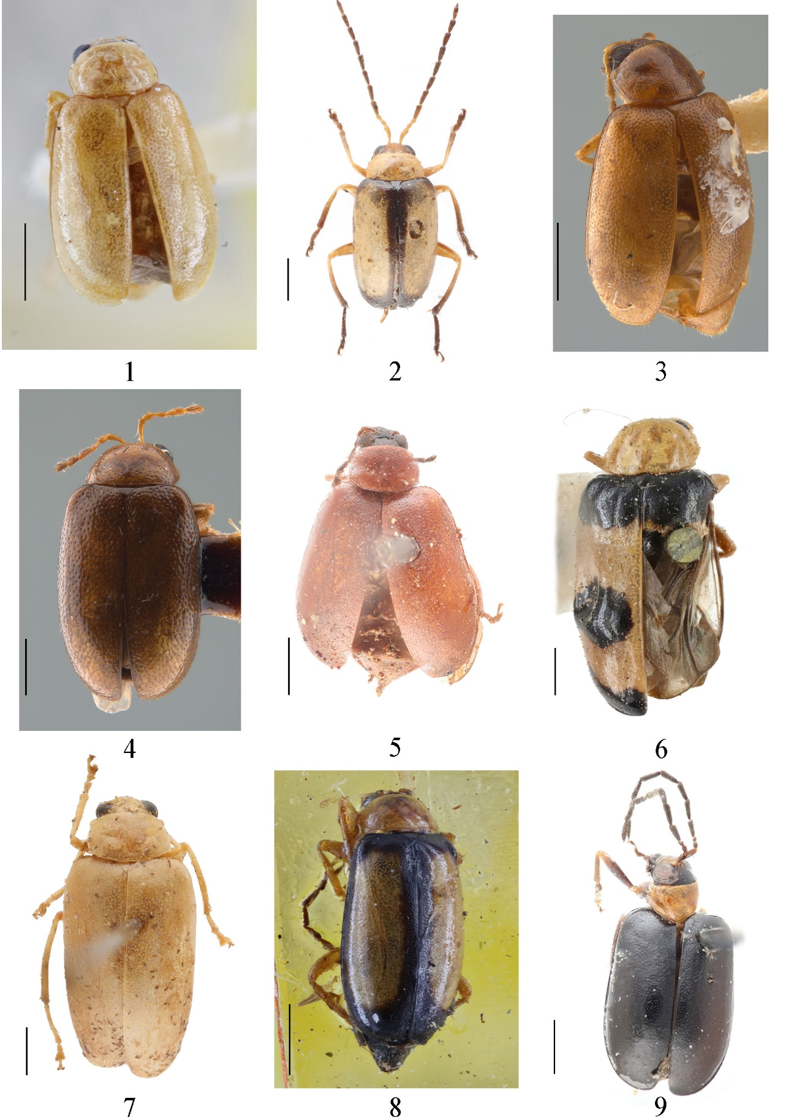
Figures S1–9. Habitus. 1 M. aglaonemae (Paratype, BMNH) 2 M. alnivora (identified species) 3 M. arundinariae (Holotype, CAS) 4 M. brittoni (Holotype, CAS) 5 M. capitata (Holotype, IZAS) 6 M. cavipennis (Paratype, BMNH) 7 M. cheni (Holotype, IZAS) 8 M. discalis (Paratype, BMNH) 9 M. epistomalis (identified species). Scale bar: 1 mm.

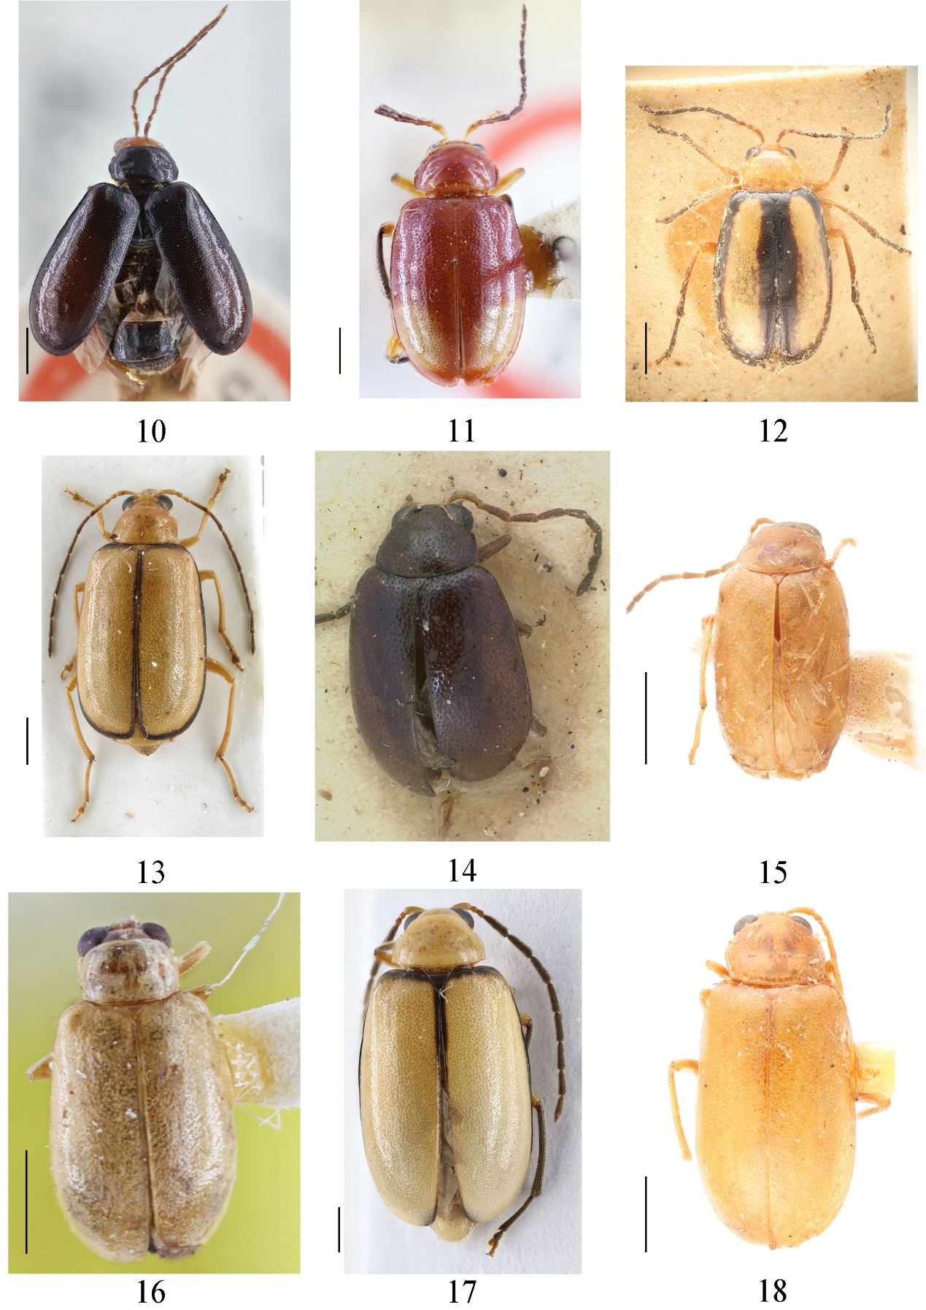
Figures S10–18. Habitus. 10 M. erythrocephala (Type, BMNH) 11 M. eunicia (Type, BMNH) 12 M. flavovittata (Holotype, IZAS) 13 M. gracilipes (identified species) 14 M. horni (Syntypus, NSNM) 15 M. hupehensis (Paratype, IZAS) 16 M. hupehensis (Paratype, BMNH) 17 M. kuroheri (identified species) 18 M. lauta (Paratype, IZAS). Scale bar: 1 mm.

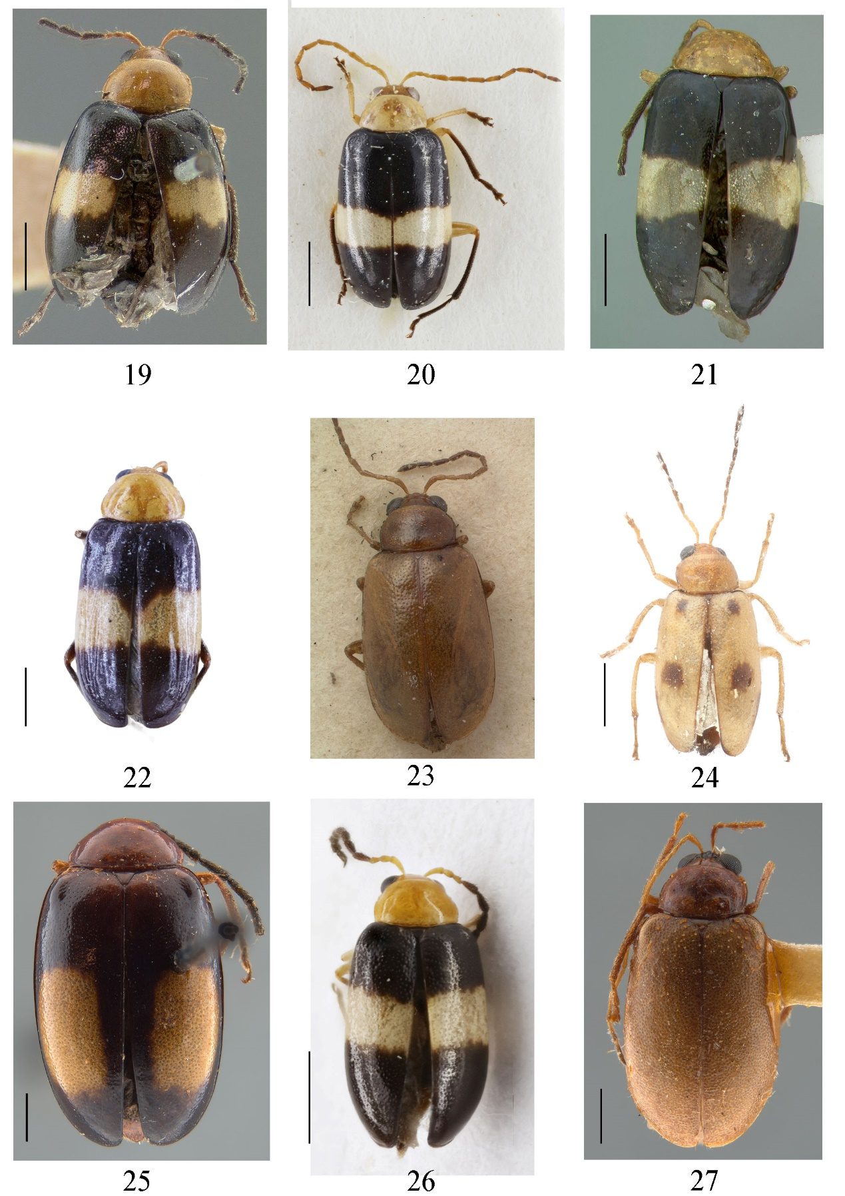
Figures S19–27. Habitus. 19 M. leechi (Holotype, MCZ) 20 M. leechi (identified species) 21 M. liui (Holotype, USNM) 22 M. liui (identified species) 23 M. longitarsoides (Syntypus, NSNM) 24 M. longitarsoides (identified species) 25 M. lunata (Holotype, CAS) 26 M. maana (identified species) 27 M. meridionalis (Holotype, CAS). Scale bar: 1 mm.

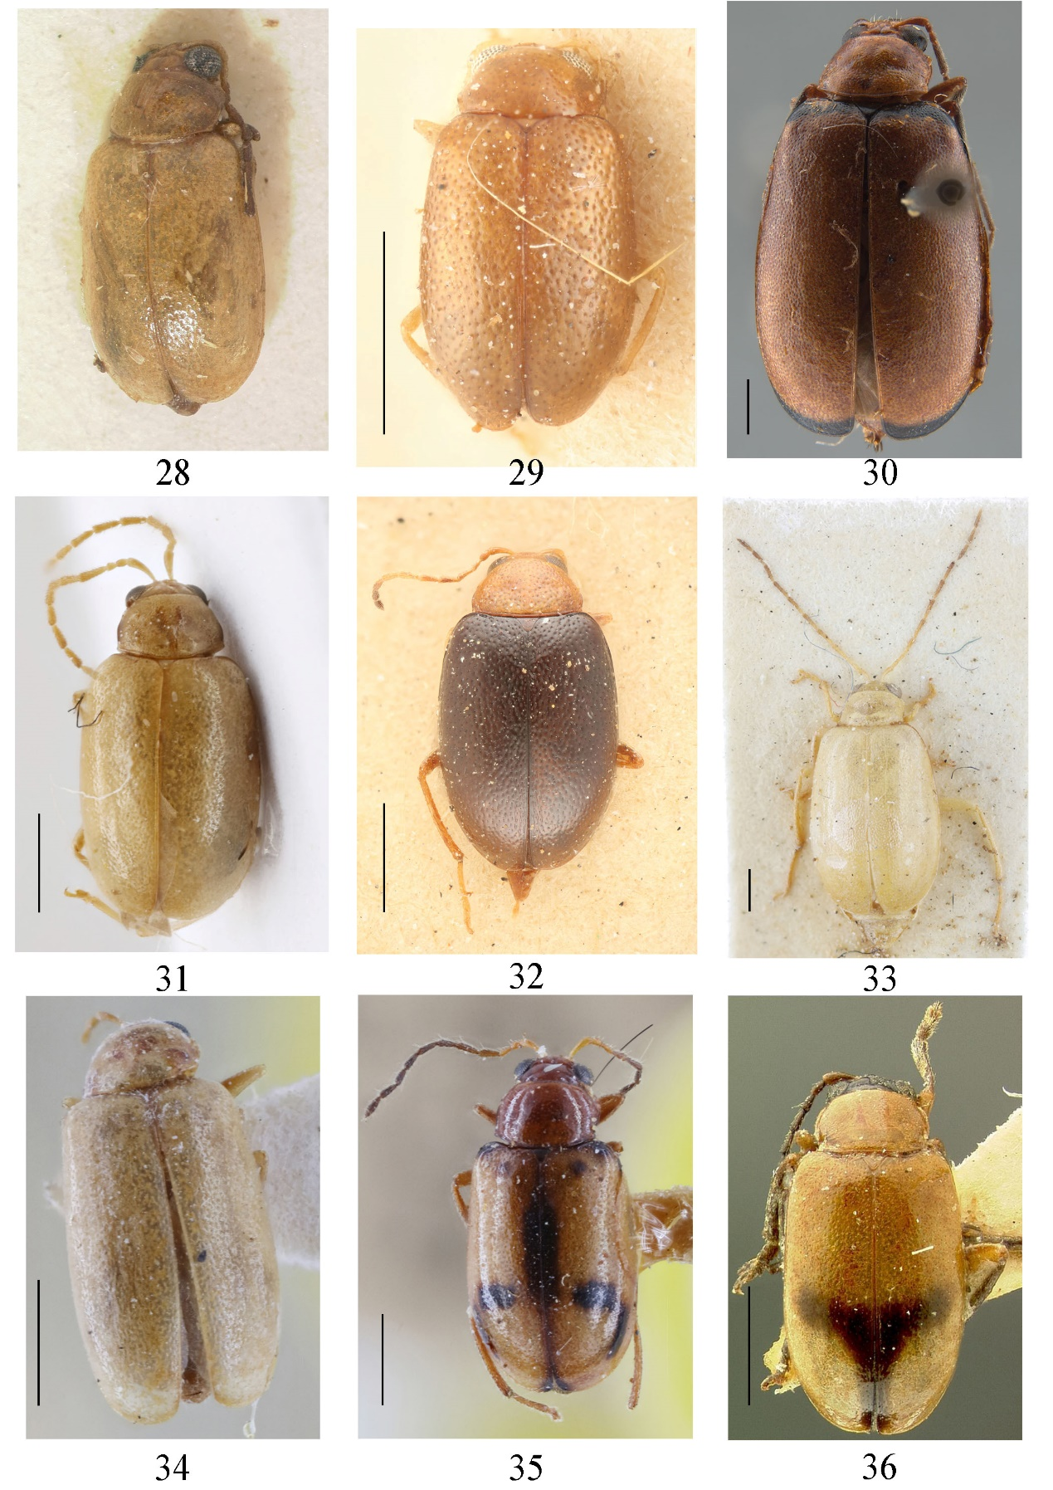
Figures S28–36. Habitus. 28 M. minor (Syntypus, NSNM) 29 M. minutissima (Holotype, IZAS) 30 M. occifluvis (Holotype, CAS) 31 M. ongi (identified species) 32 M. ovatula (Holotype, IZAS) 33 M. pallidula (Syntype, BMNH) 34 M. palliparva (Paratype, BMNH) 35 M. parenthetica (Paratype, BMNH) 36 M. postfasciata (Holotype, MCZ). Scale bar: 1 mm.

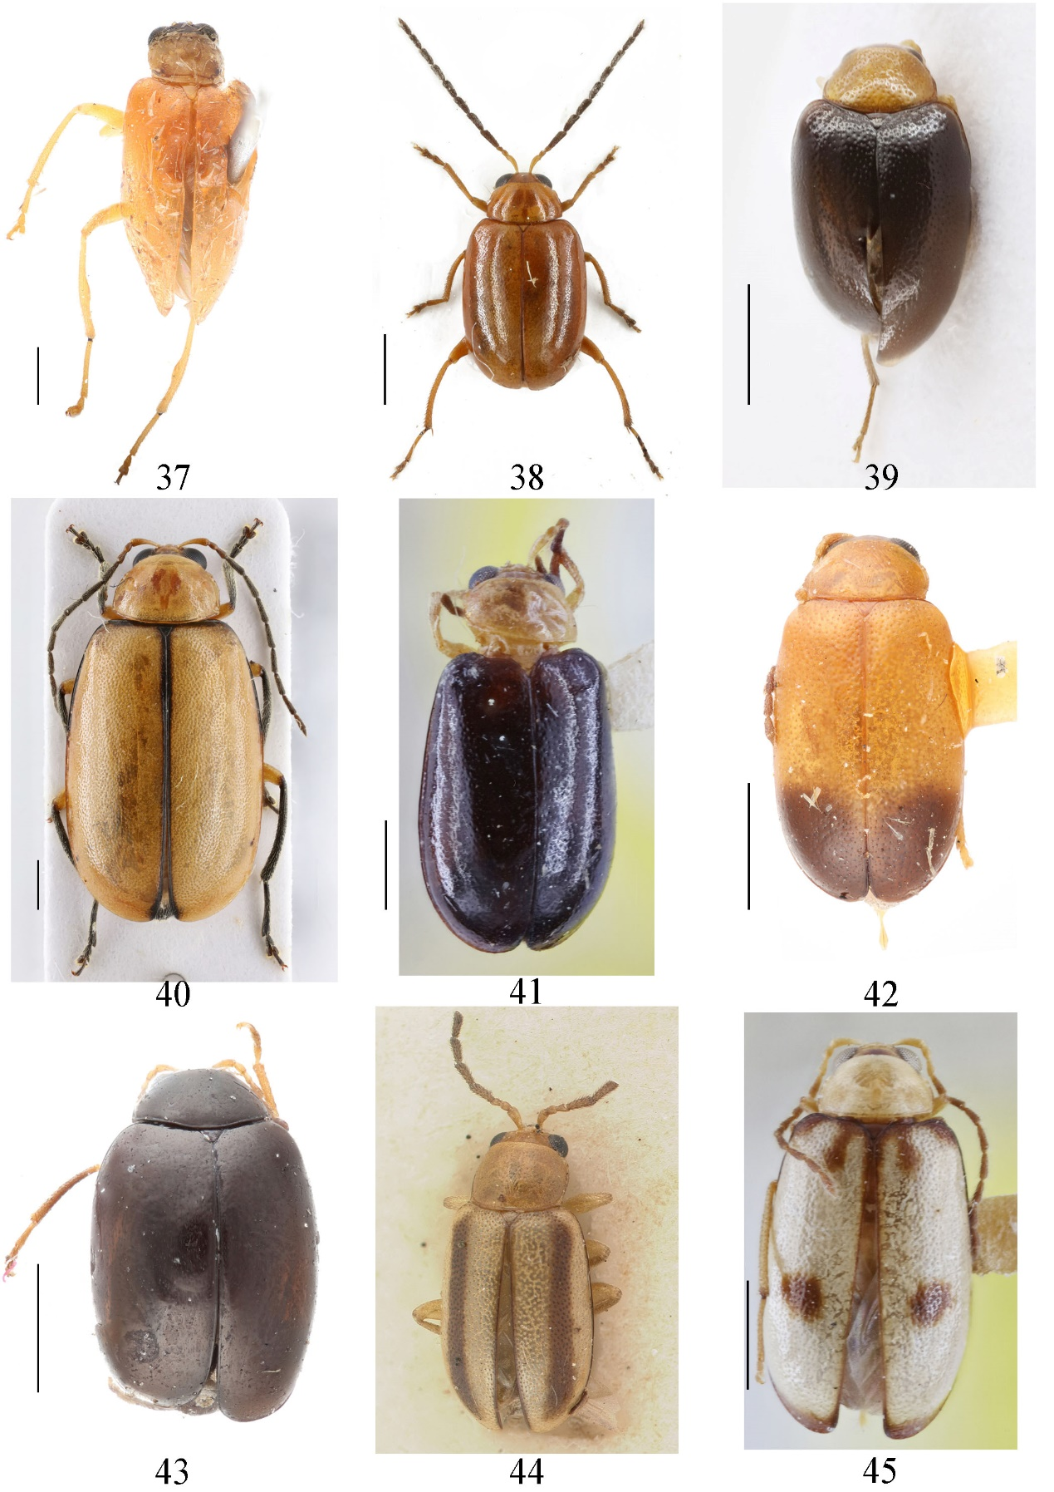
Figures S37–45. Habitus. 37 M. quadricavata (Holotype, IZAS) 38 M. rufofulva (identified species) 39 M. sasajii (identified species) 40 M. sauteri (identified species) 41 M. schereri (Paratype, BMNH) 42 M. selmani (Paratype, IZAS) 43 M. semenovi (identified species) 44 M. sexlineata (Syntypus, NSNM) 45 M. shaowuensis (Paratype, BMNH). Scale bar: 1 mm.

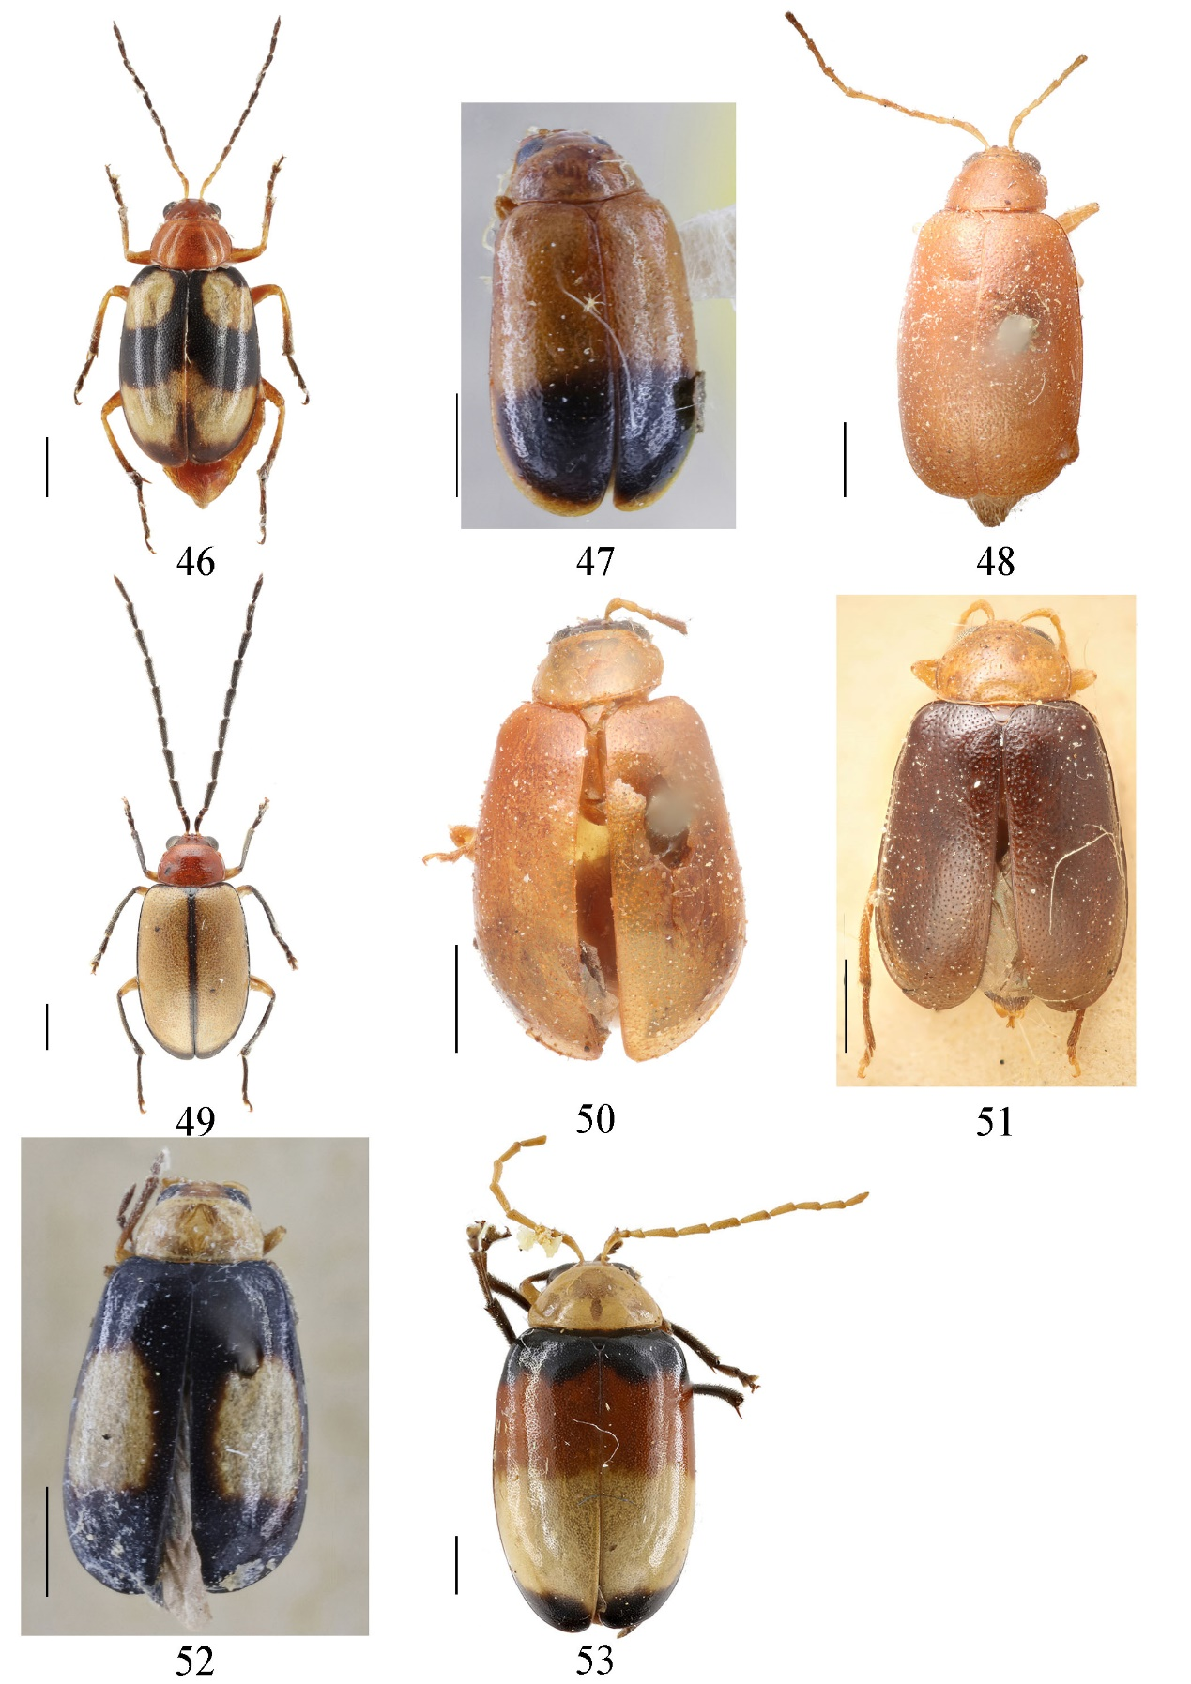
Figures S46–53. Habitus. 46 M. signata (identified species) 47 M. subapicalis (Paratype, BMNH) 48 M. subrubra (Holotype, IZAS) 49 M. wilcoxi (identified species) 50 M. xanthodera (Holotype, IZAS) 51 M. yaosanica (Holotype, IZAS) 52 M. yunnanica (Paratype, BMNH) 53 M. zonalis (identified species). Scale bar: 1 mm.

Notes.
Some photographs are from museum websites or were taken by the colleagues:
NSNM (from http://twinsecttype.nmns.edu.tw/?tdsourcetag=s_pcqq_aiomsg): M. horni (Syntypus, Fig. A14), M. longitarsoides (Syntypus, Fig. A23), M. minor (Syntypus, Fig. A28), M. sexlineata (Syntypus, Fig. A44).
CAS (taken by Christopher Grinter): M. arundinariae (Holotype, Fig. A3), M. brittoni (Holotype, Fig. A4), M. lunata (Holotype, Fig. A25), M. meridionalis (Holotype, Fig. A27), M. occifluvis (Holotype, Fig. A30).
MCZ (from http://140.247.96.247/mcz/recordlist.php?-skip=16315&-max=5): M. leechi (Holotype, Fig. A19), M. postfasciata (Holotype, Fig. A36).
USNM (from https://collections.nmnh.si.edu/search/ento/): M. liui (Holotype, Fig. A21).

