Supplementary Materials for
Cloning and physical localization of male-biased repetitive DNA sequences in spinach
Jian Zhou1**, Shaojing Wang1**, Li'ang Yu2, Ning Li1, Shufen Li1, Yulan Zhang1, Ruiyun Qin1, Wujun Gao1, Chuanliang Deng1*
¹ College of Life Sciences, Henan Normal University, Xinxiang 453007, China,
² Department of Plant Biology, University of Illinois at Urbana-Champaign, Urbana, IL 61801, USA
*Correspondence: dengchuanliang@htu.cn
**Co-first author

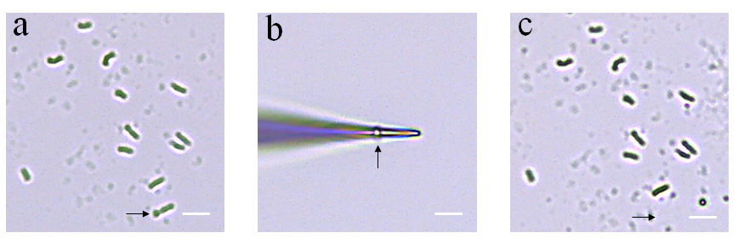
Supplemental Figure 1 Procedure of isolation of biggest chromosome in spinach by micromanipulator. a Mitosis metaphase chromosomes of a root tip cell before chromosome isolation (Arrow showed the biggest chromosome), b the target chromosome adhering to the tip of a glass needle, c metaphase chromosomes after isolation of the chromosome indicated by arrow in a by a glass needle. Bar 10 μm

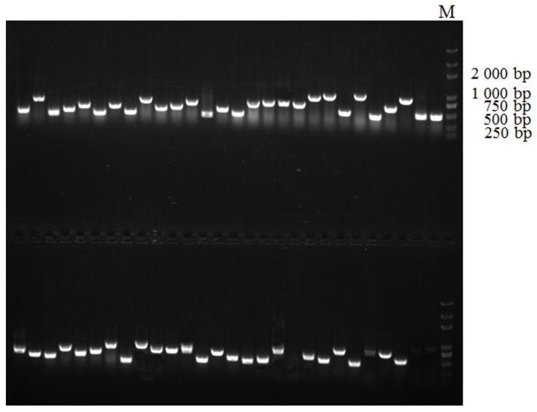
Supplemental Figure 2 Partial PCR products of recombinant clones using M13R and M13F as primers. M: Trans 2K Plus DNA Marker.

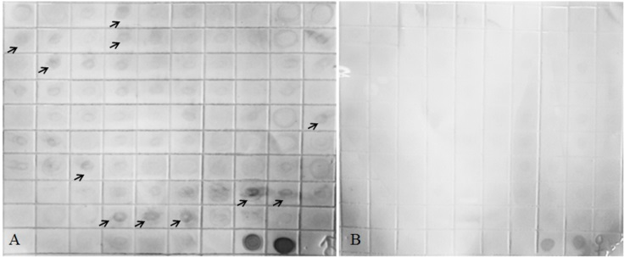
Supplemental Figure 3 Dot blot hybridization results of partial subtractive hybridization clones. Dot blot hybridization with DIG-labeled the genome DNA of male spinach (A) and the genome DNA of female spinach (B); Arrows showed male biased dots.

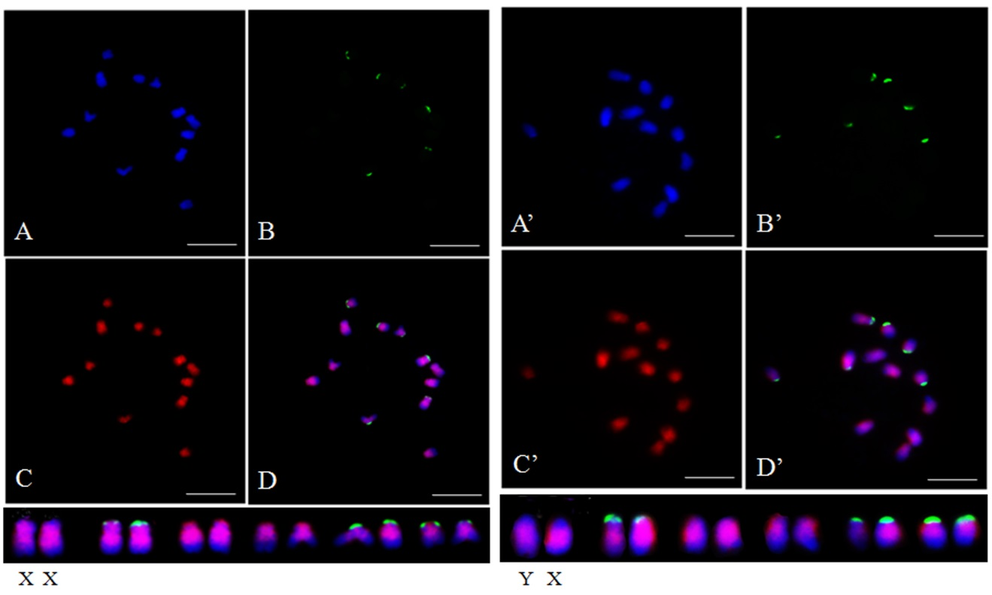
Supplemental Figure 4 Distribution patterns of hybridization signals from female and male spinach using 45S rDNA (green) and SP1-86 (red) as probes. A (A’), DAPI; B (B’), 45S rDNA (green) as probe; C (C’), SP1-86 (red) as probe; D (D’), The merged figure of A (A’), B (B’) and C (C’). (Bar=10 μm)

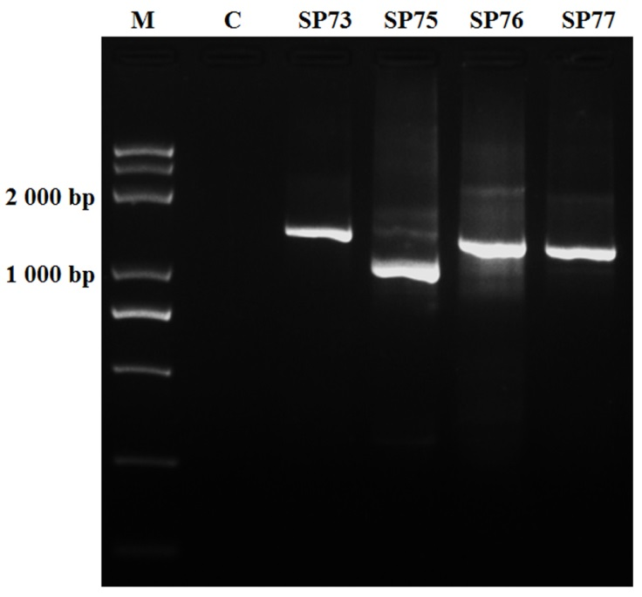
Supplemental Figure 5 PCR amplification result of SP73, SP75, SP76 and SP77 marker. M, Ttrans 2K Plus DNA Marker; C, negative control.

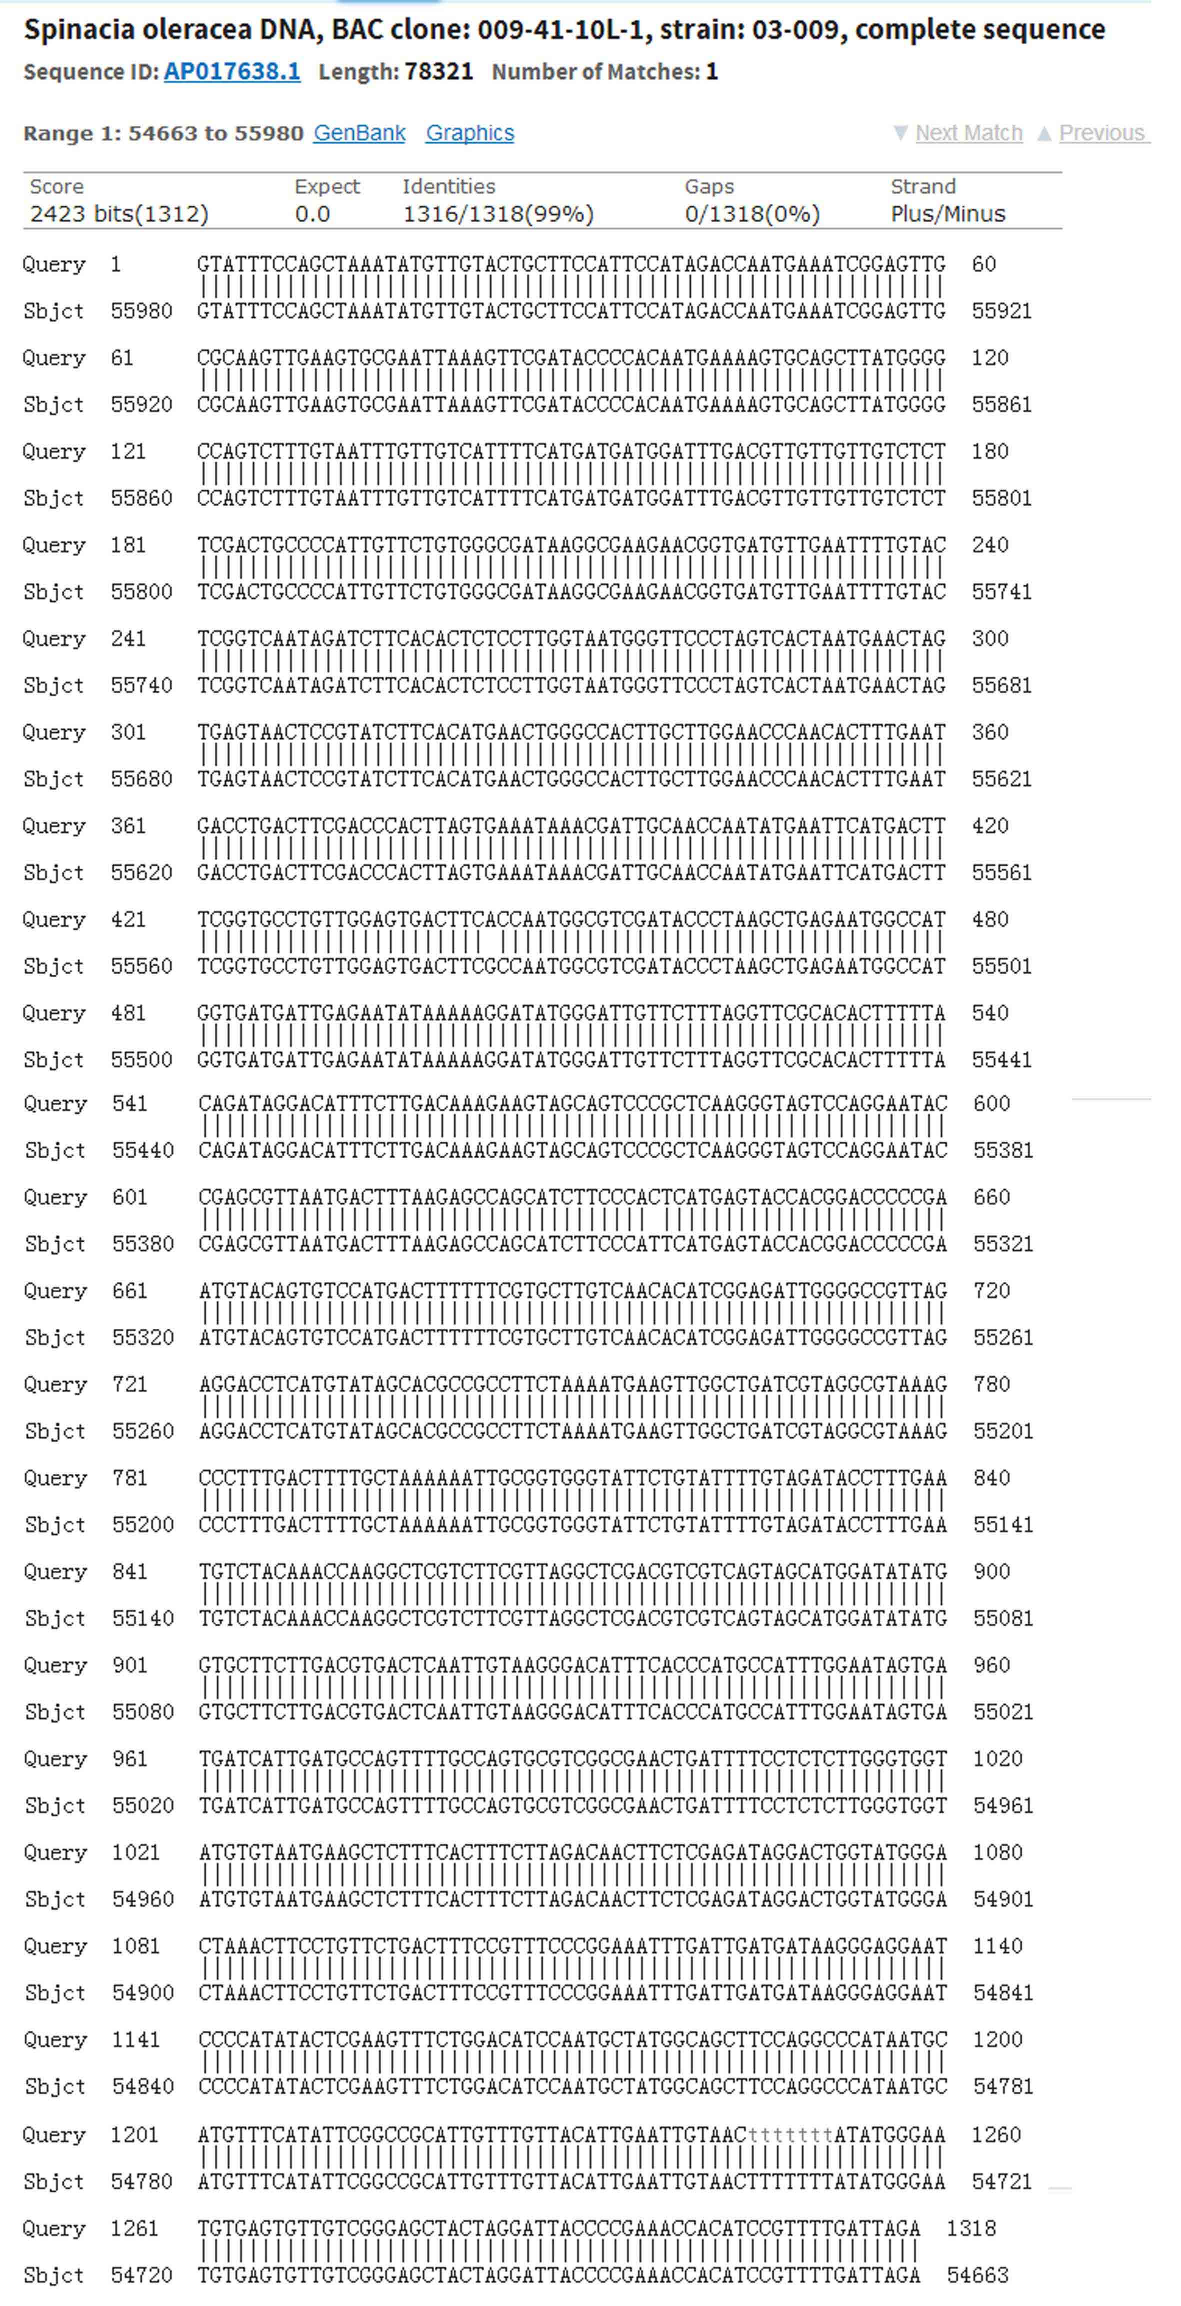

Supplemental Figure 6 Pair-wise alignment between SP73 and BAC clone 009-41-10L-1.
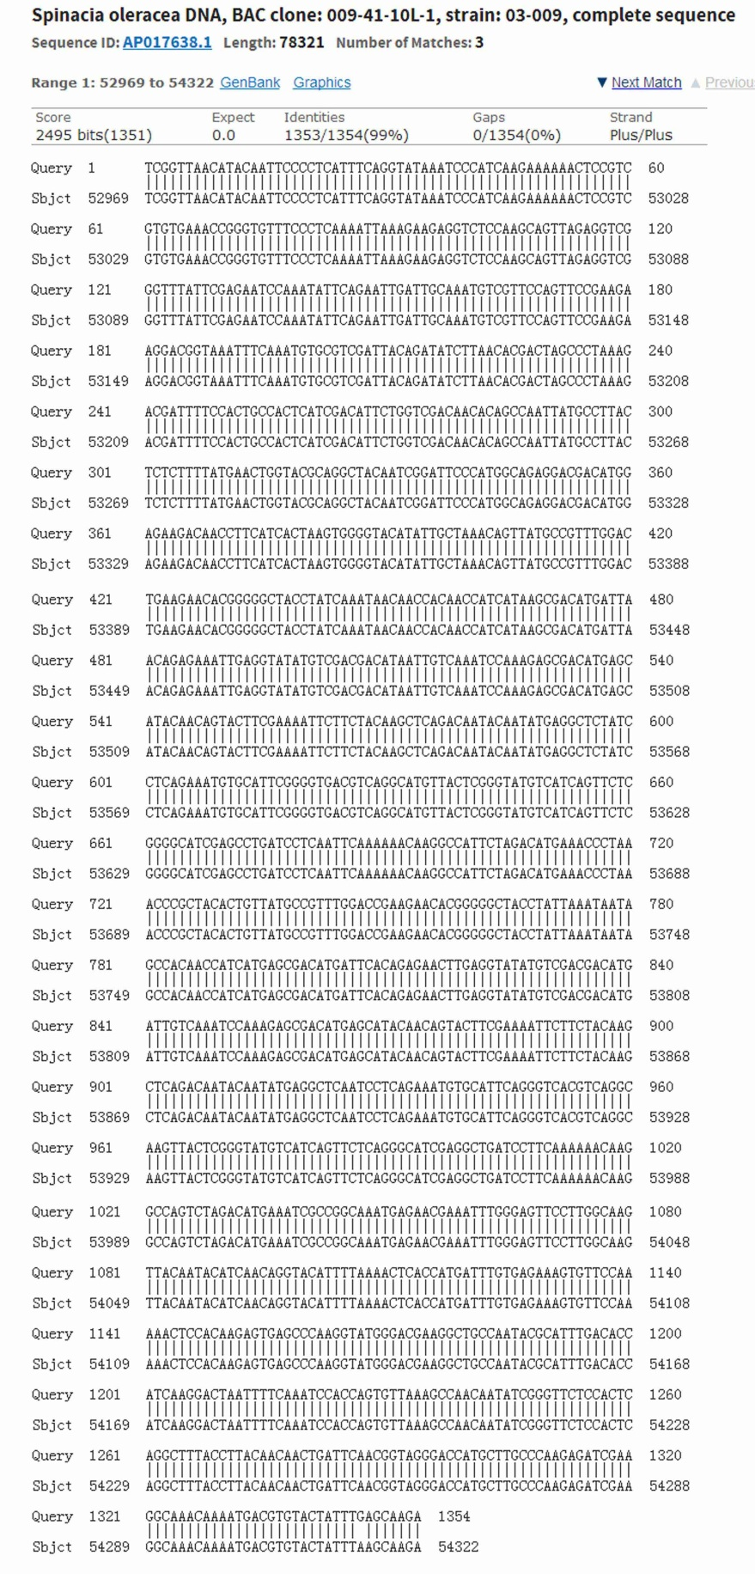

Supplemental Figure 7
Pair-wise alignment between SP75 and BAC clone 009-41-10L-1.
Supplemental Table 1 Primer sequences for repetitive DNA sequences.

Primer | 5’→3’ | Annealing temperature
73-F | GTATTTCCAGCTAAATATGTTGT | 51℃
73-R | CTAATCAAAACGGATGTGGT | 51℃
75-F | CTTGCTCAAATAGTACACGTC | 54℃
75-R | TCGGTTAACATACAATTCCC | 51℃
76-F | ATTTCAAAACACGATGCTC | 52℃
76-R | TAGAGGCCATATATAGACTCA | 52℃
77-F | TATACTGGCATCTGTATTCCC | 52℃
77-R | TGGTATTAAATACAGACAACCGA | 54℃

