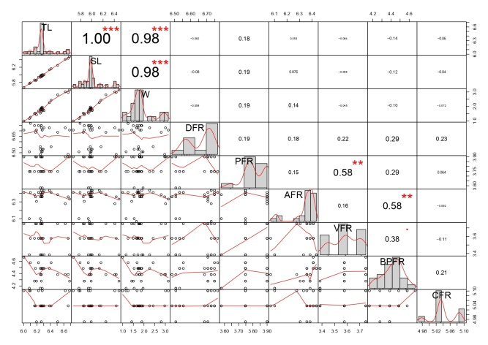
Fig. S1. Correlation plot, based on meristic data for Nesebar population (Significance of p-values: *** < 0.001, ** < 0.01, * < 0.05)

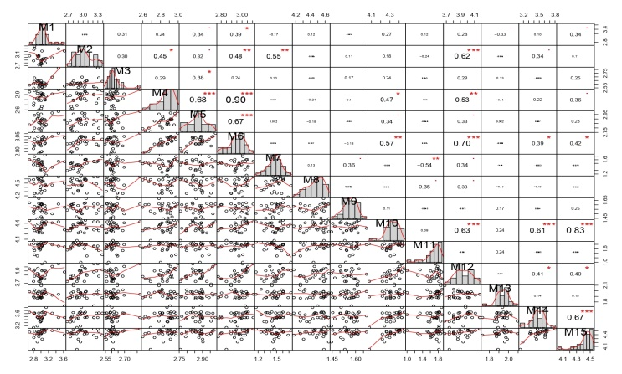
Fig. S2. Correlation plot, based on morphometric data for Nesebar population (Significance of p-values: *** < 0.001, ** < 0.01, * < 0.05)
.

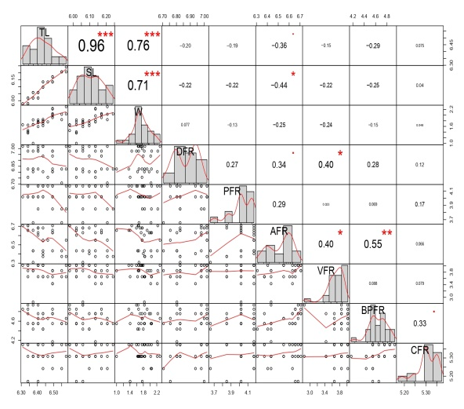
Fig. S3. Correlation plot, based on meristic data for Shabla populaion (Significance of p-values: *** < 0.001, ** < 0.01, * < 0.05).

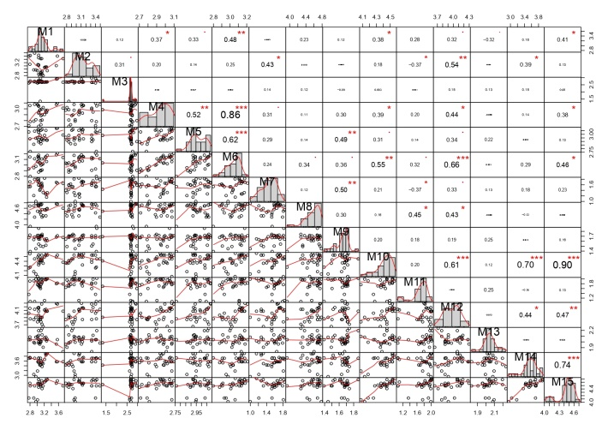
Fig. S4. Correlation plot, based on morphometric data for Shabla population (Significance of p-values: *** < 0.001, ** < 0.01, * < 0.05).

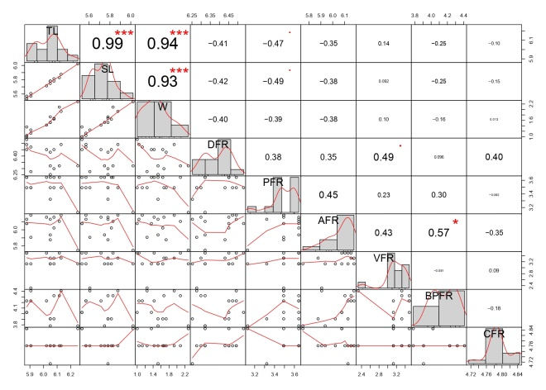
Fig. S5. Correlation plot, based on meristic data for Shkorpilovtsi population (Significance of p-values: *** < 0.001, ** < 0.01, * < 0.05).

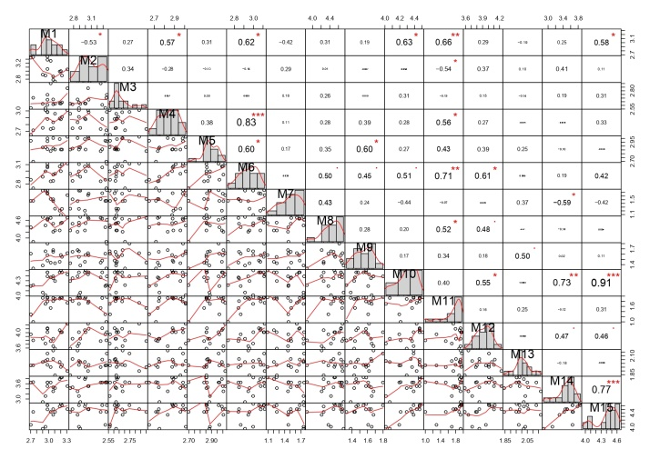
Fig. S6. Correlation plot, based on morphometric data for Shkorpilovtsi population (Significance of p-values: *** < 0.001, ** < 0.01, * < 0.05).

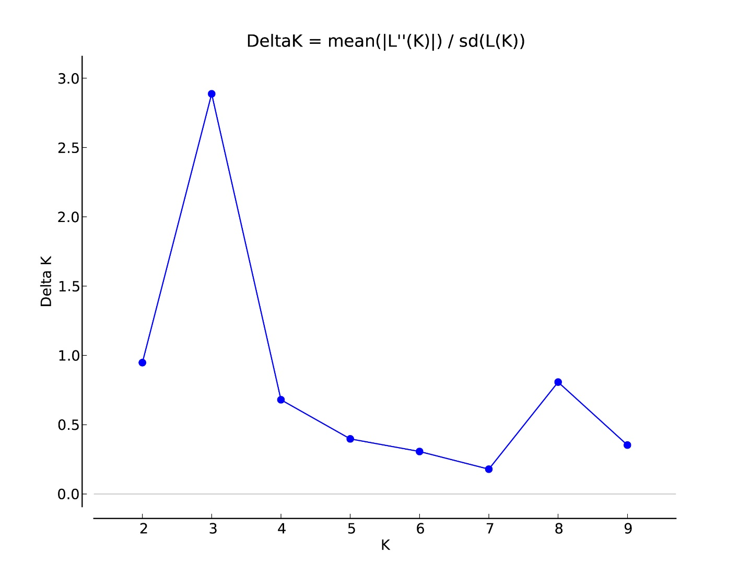
Fig. S7. Graph of delta K values obtained to determine the optimum number of groups generated in STRUCTURE Harvester.

