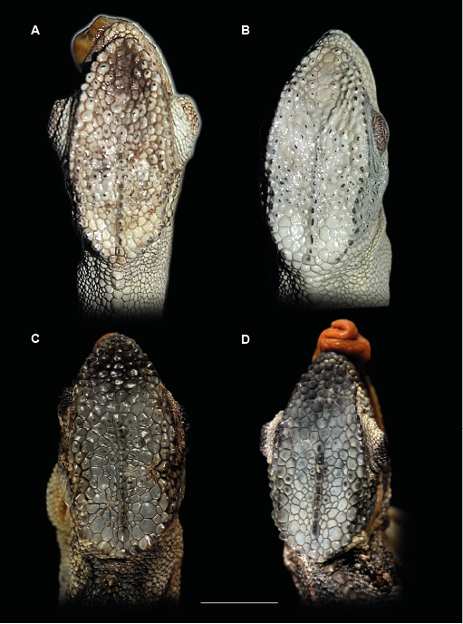
Supplementary material 3: Dorsal head views
Dorsal view of the head male lectotype (SMF 16402) (A) and female paralectotype (SMF 16403) (B) of Trioceros affinis and of the male holotype (ZFMK 84811) (C) and female paratype (ZFMK 84813) (D) of Trioceros wolfgangboehmei sp. nov.

