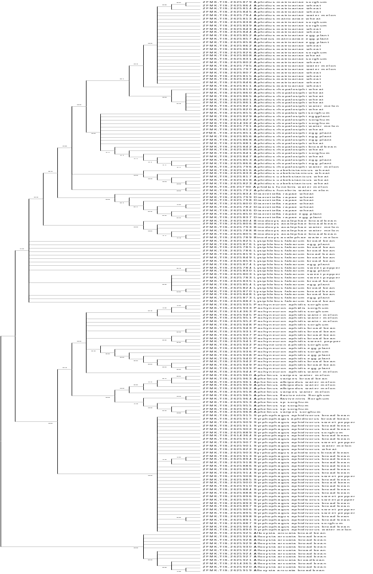

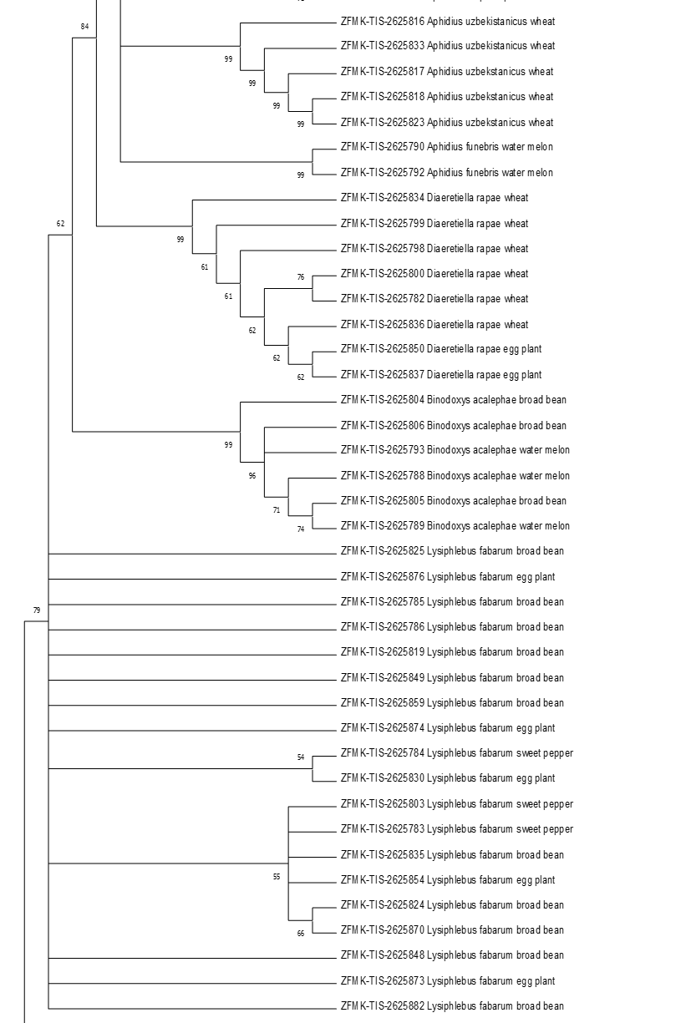

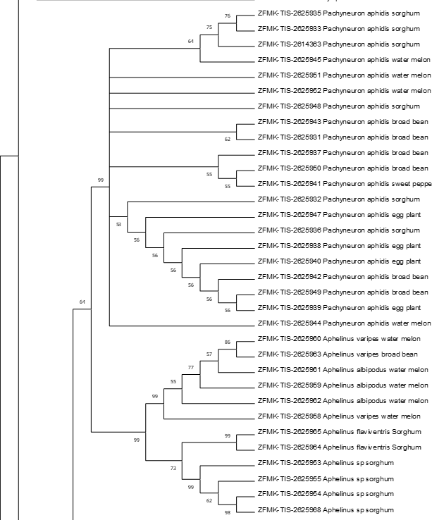

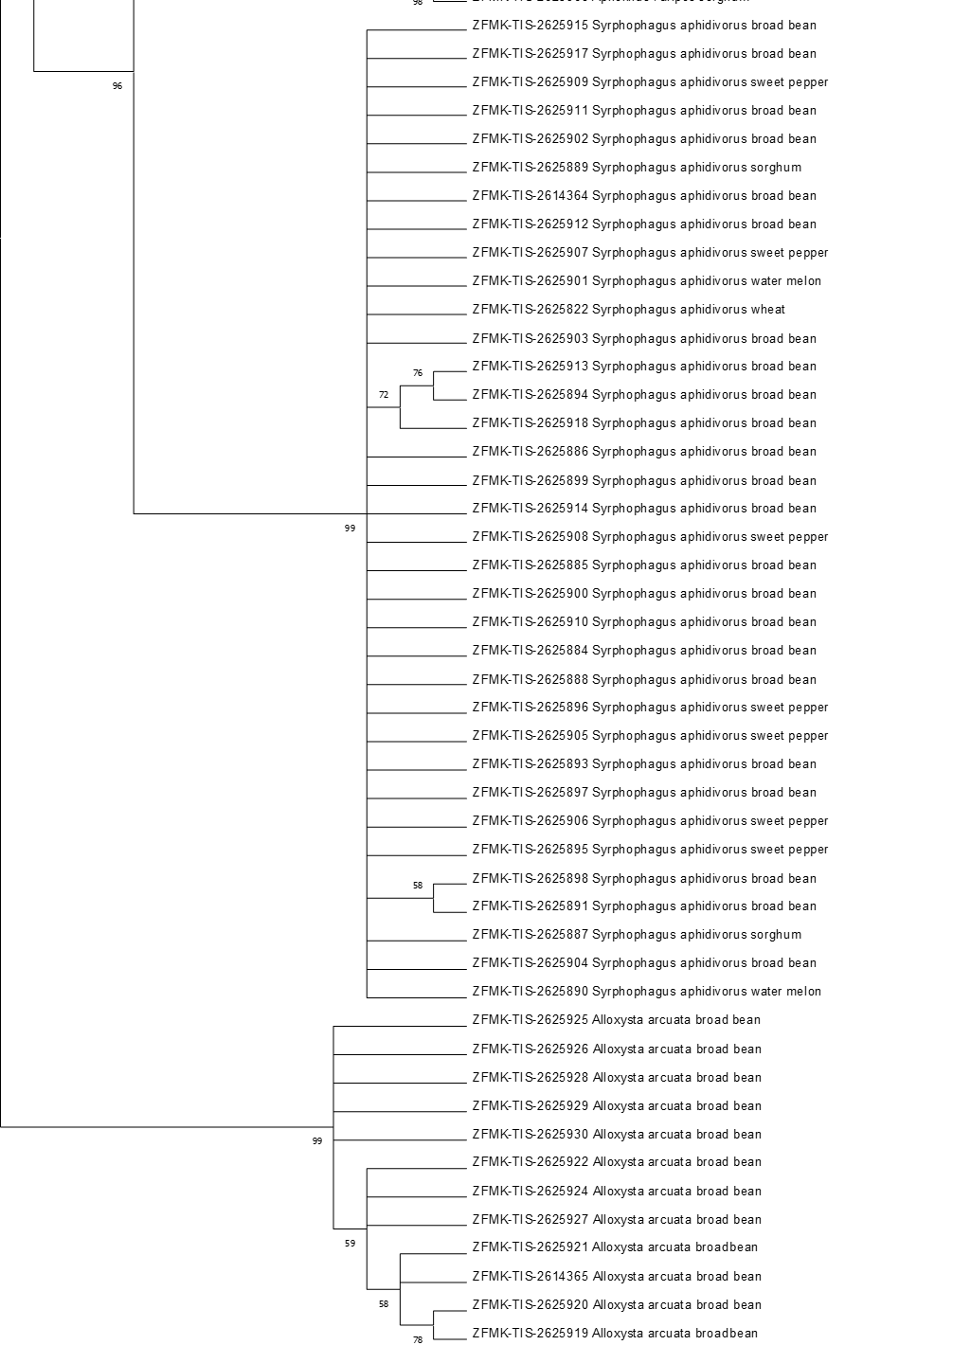

1.1

Figure S1. Neighbour joining tree using p- distance of 170 COI sequences of aphid parasitoids and hyperparasitoid on six crops (658 nucleotide positions). Bootstrap support values (1000 replicates) are shown next to the branches; Branches with less than 50% bootstrap support collapsed.

