Neotropical Biology and Conservation
Supplementary material
Vegetation structure as the main source of variability in scorpion assemblages at small spatial scales and further considerations for the conservation of Caatinga landscapes
Stênio Ítalo Araújo Foerster*, André Felipe de Araújo Lira, Cauê Guion de Almeida
* Author for correspondence: stenio.foerster@ut.ee

Table S1. Numerical output of the principal component analysis (PCA), showing the percentual contribution of each variables for the first two axis (PC1 and PC2) of the PCA. The first two axes accounted for 52.9% and 17.2% of the variation within the dataset, respectively. Environmental predictors are temperature (temp), relative humidity of the soil (ur), amount of debris (debr), number of trees (trees) and the coefficient of variation of their diameter at breast height (dapCV). Species abbreviation are as follow: Bothriurus asper (Basp), Bothriurus rochai (Broc), Jaguajir agamemnom (Jaga), Jaguajir rochae (Jroc), Physoctonus debilis (Pdeb), Tityus stigmurus (Tsti).
Variable | PC1 (%) | PC2 (%)
Basp | 0.6960 | 10.7176
Broc | 9.8651 | 3.6863
Jaga | 7.2476 | 21.0889
Jroc | 13.3559 | 8.6674
Pdeb | 10.1159 | 16.2950
Tsti | 9.8978 | 17.0310
temp | 1.2042 | 9.0310
ur | 11.8347 | 3.7718
debr | 8.3374 | 7.6290
tree | 14.0886 | 0.8891
dapCV | 13.3568 | 1.1930

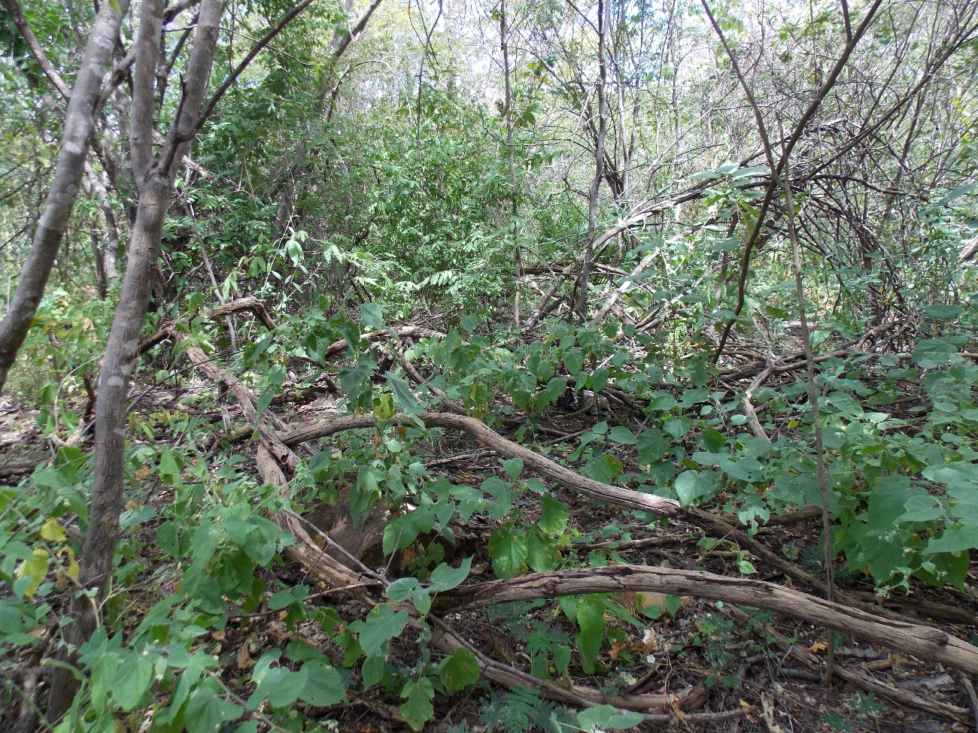
Figure S1. General composition of microhabitat structure representing the Parque Estadual Mata da Pimenteira, located in the municipality of Serra Talhada, state of Pernambuco, northeastern Brazil.

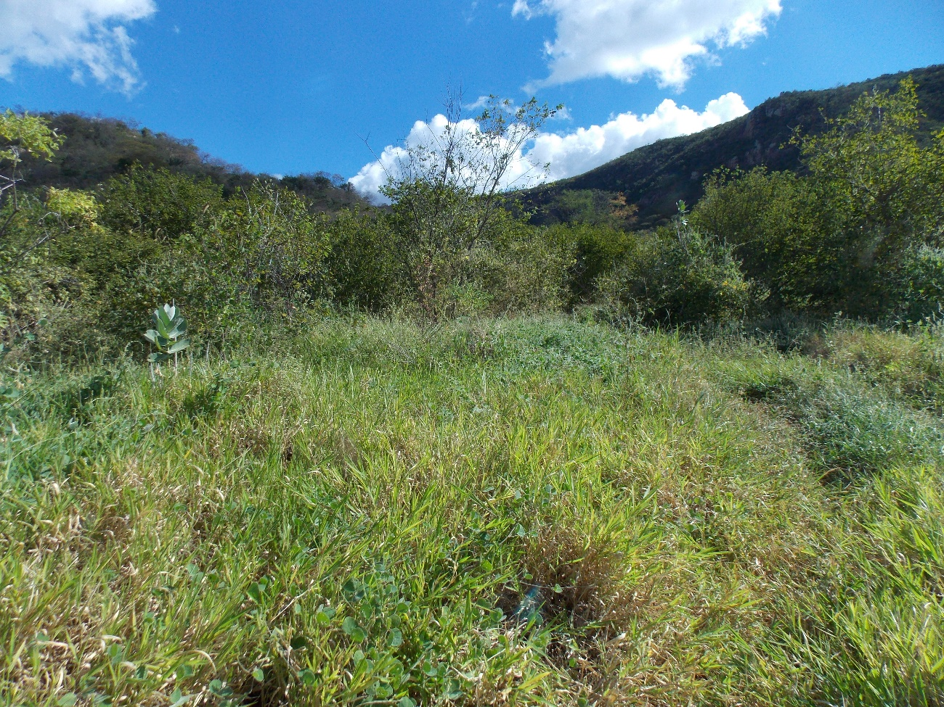 Figure S2. General composition of microhabitat structure representing the Pollinator Trail, located in the municipality of Serra Talhada, state of Pernambuco, northeastern Brazil.

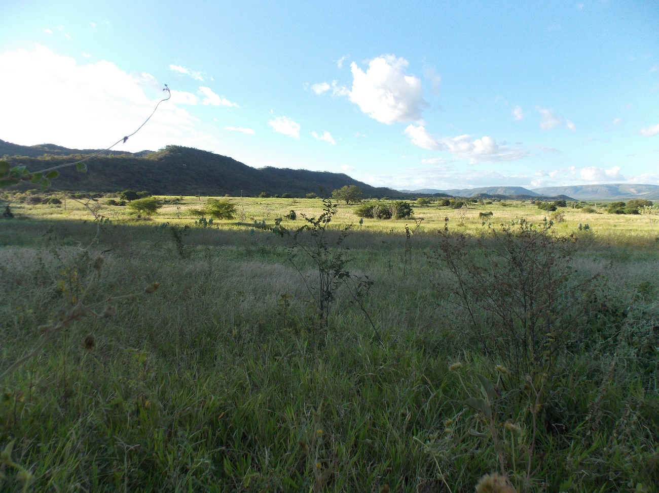 Figure S3. General composition of microhabitat structure representing the Saco Road, located in the municipality of Serra Talhada, state of Pernambuco, northeastern Brazil.

