Supplementary Materials 2
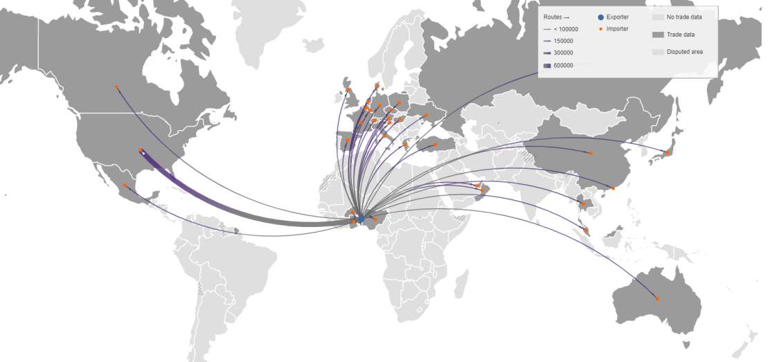
- BENIN
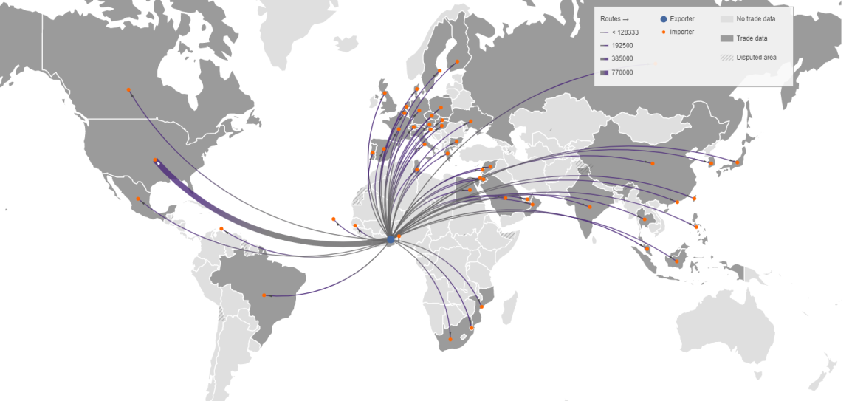
- GHANA
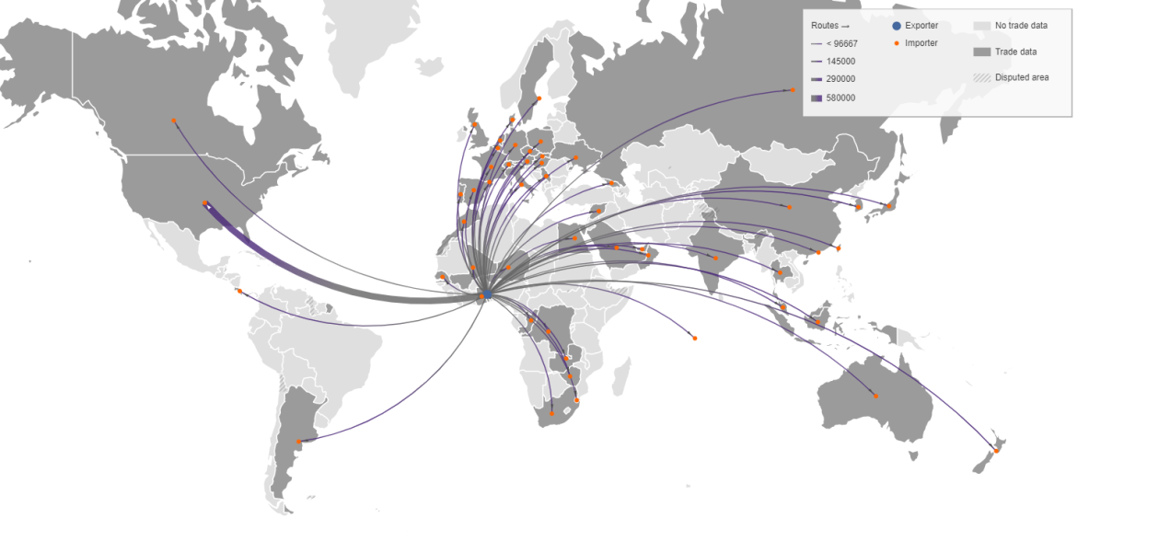
- TOGO
Figure S3.1. Countries and territories importing live ball pythons from Benin (A), Ghana (B), and Togo (C), 1978 - 2017, (line width proportional to total export volume, number of individuals). Data source: CITES trade database (https://trade.cites.org/), based on exporter-reported quantities. Map drawn using TradeMapper (TRAFFIC 2018).
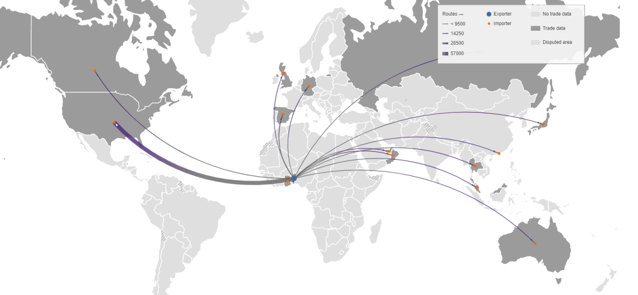
- BENIN
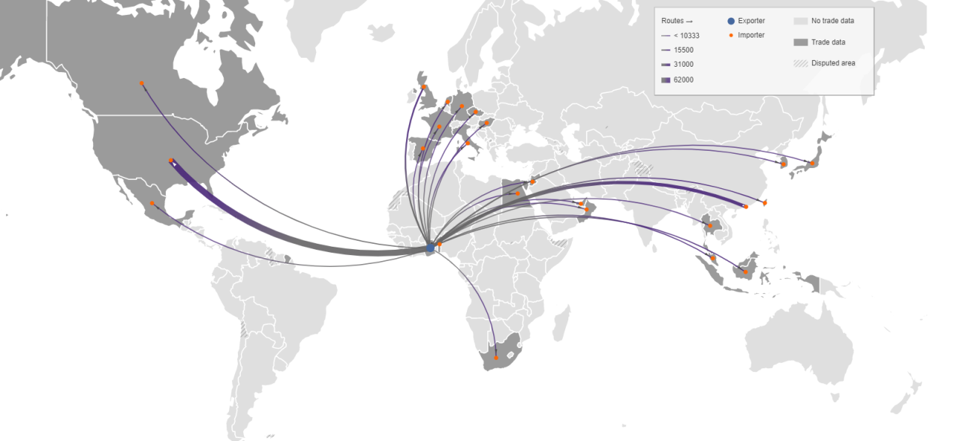
- GHANA
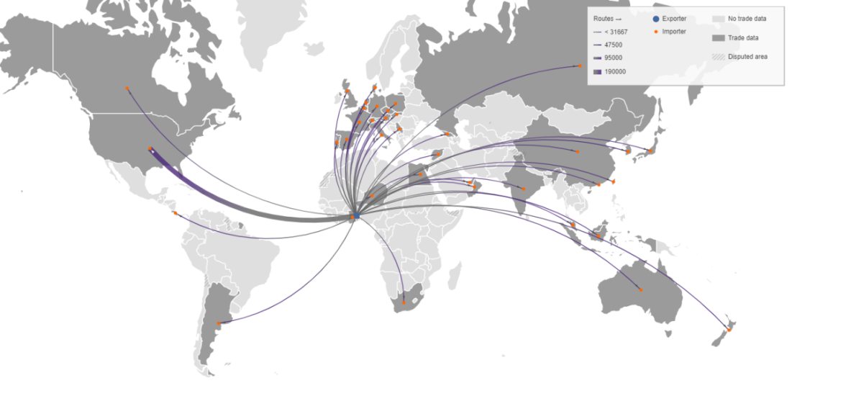
- TOGO
Figure S3.2. Countries and territories importing live ball pythons from Benin (A), Ghana (B), and Togo (C), 2012 - 2016, (line width proportional to total export volume, number of individuals). Data source: CITES trade database (https://trade.cites.org/), based on exporter-reported quantities. Map drawn using TradeMapper (TRAFFIC 2018).

TRAFFIC (2018) TradeMapper – a tool for visualising trade data. Available at www.trademapper.co.uk

