Supplementary material to Rodríguez et al.
Biogeographical comparison of terrestrial invertebrates and trophic feeding guilds in the native and invasive ranges of Carpobrotus edulis
Jonatan Rodríguez^{1,2,3,4,5*}, Ana Novoa^{4,5,6}, Adolfo Cordero-Rivera³, David M. Richardson⁴ and Luís González^{1,2}
¹Plant Ecophysiology Group, Department of Plant Biology and Soil Science, University of Vigo, 36310 Vigo, Spain.
²CITACA, Agri-Food Research and Transfer Cluster, Campus da Auga, University of Vigo, 32004-Ourense, Spain.
³ECOEVO Lab, E. E. Forestal, University of Vigo, 36005 Pontevedra, Spain.
⁴Centre for Invasion Biology, Department of Botany and Zoology, Stellenbosch University, Matieland, South Africa.
⁵Department of Invasion Ecology, Institute of Botany of the Czech Academy of Sciences, CZ-252 43, Průhonice, Czech Republic.
⁶South African National Biodiversity Institute, Kirstenbosch Research Centre, Claremont, South Africa
*Corresponding author: jonatan@uvigo.es Tel: +34 986 812 594
ORCID: Jonatan Rodríguez: 0000-0002-3757-5276; Ana Novoa: 0000-0001-7092-3917 Adolfo Cordero-Rivera: 0000-0002-5087-3550; David M. Richardson: 0000-0001-9574-8297; Luís González: 0000-0001-8091-9364.

Table S1. Locations (according to EPSG: 4326–WGS84) and characteristics of the studied areas with the presence of Carpobrotus edulis at native (South Africa) and introduced ranges (Iberian Peninsula).
Study site | Region | Population | Coordinates | Main plant species | Distance to the sea (m)
Native areas of Carpobrotus edulis in South Africa | Western Cape, South Africa | Cape of Good Hope | 34°21'01.1"S 18°28'08.3"E | Agrostis ‎L.  Arctotheca calendula (L.) Levyns  Osteospermum moniliferum L.  Vicia sp. L. | 40
 |  | Fish Hoek | 34°07'51.8"S 18°26'01.5"E | Arctotheca calendula (L.) Levyns  Euphorbia sp. L.  Oxalis pes-caprae L. | 520
 |  | Hermanus | 34°24'44.6"S 19°17'22.4"E | Agrostis ‎L.  Oxalis pes-caprae L.  Vicia sp. L. | 340
 |  | Stanford | 34°25'39.3"S 19°27'45.4"E | Lotus corniculatus L.  Oxalis pes-caprae L.  Vicia sp. L. | 11600
 |  | Gansbaai | 34°34'59.6"S 19°20'59.8"E | Ipomoea cairica (L.) Sweet  Osteospermum moniliferum L.  Plantago lanceolata L.  Tetragonia decumbens Mill. | 200
Introduced areas of Carpobrotus edulis in the Iberian Peninsula | Galicia, Spain | Baldaio | 43°18'05.6"N 8°39'26.6"W | Crucianella maritima L.  Helichrysum italicum (Roth) G.Don subsp. serotinum (Boiss.) P.Fourn.  Medicago littoralis Rohde ex Loisel. | 75
 |  | Nemiña | 43°00'43.1"N 9°15'60.0"W | Agrostis L.  Dactylis glomerata L.  Stenotaphrum secundatum (Walter) Kunze | 90
 |  | Corrubedo | 42°34'36.0"N 9°04'02.0"W | Crucianella maritima L.  Medicago littoralis Rohde ex Loisel.  Pancratium maritimum L. | 30
 |  | Punta de Rons | 42°29'55.0"N 8°52'56.2"W | Foeniculum vulgare Mill.  Hypochaeris sp. L.  Leontodon sp. L. | 10
 | Região Norte, Portugal | Praia da Arda | 41°46'11.5"N 8°52'23.6"W | Acacia longifolia (Andr.) Willd.  Artemisia crithmifolia L.  Leontodon sp. L. | 85

Table S2. List of arthropod species found in coastal areas of South Africa with and without Carpobrotus edulis.
Plant community | Order | Family | Species/morphospecies | Common name | Abundance
Zones with Carpobrotus edulis | Araneae | Salticidae | Evarcha sp. | Jumping spider | 5
Zones with Carpobrotus edulis | Araneae | Salticidae | Spider1 | Spider | 87
Zones with Carpobrotus edulis | Araneae | Salticidae | Spider2 | Spider | 16
Zones with Carpobrotus edulis | Araneae | Salticidae | Spider5 | Spider | 1
 | Araneae | Thomisidae | Spider3 | Spider | 9
 | Araneae | Thomisidae | Spider4 | Spider | 5
 | Coccoidea | Diaspididae | Aonidia mesembryanthemae | Armoured scale | 902
 | Coleoptera | Carabidae | Groundbeetle1 | Ground beetle | 5
 | Coleoptera | Chrysomelidae | Bruchidae1 | Bean weevil | 1
 | Coleoptera | Chrysomelidae | Leafbeetle1 | Leaf beetle | 29
 | Coleoptera | Coccinelidae | Exochomus sp. | Ladybug | 4
 | Coleoptera | Coccinelidae | Ladybug1 | Ladybug | 7
 | Coleoptera | Coccinelidae | Hippodamia variegata | Adonis ladybird | 2
 | Coleoptera | Curculionidae | Weevil1 | Weevil | 11
 | Coleoptera | Elateridae | Clickbeetle1 | Click beetles | 3
 | Coleoptera | Erotylidae | Pleasingfungusbeetle1 | Pleasing fungus beetle | 2
 | Coleoptera | Mordellidae | Tumblingflower1 | Tumbling flower beetle | 651
 | Coleoptera | Scarabaeidae | Scarab1 | Scarab beetle | 37
 | Coleoptera | Scarabaeidae | Scarab2 | Scarab beetle | 1
 | Diptera | ? | Fly3 | Fly | 8
 | Diptera | Agromyzidae | Leaf-minerfly1 | Leaf-miner fly | 3
 | Diptera | Asilidae | Robberfly1 | Robber fly | 15
 | Diptera | Athericidae | Watersnipefly1 | Water snipe fly | 3
 | Diptera | Calliphoridae | Lucilia sericata | Common greenbottle | 15
 | Diptera | Cecidomyiidae | Gallmidges1 | Gall midges | 192
 | Diptera | Ceratopogonidae | No-see-um1 | No-see-um | 2
 | Diptera | Chloropidae | Oscinella sp. | Frit fly | 8
 | Diptera | Chloropidae | Thaumatomyia notata | Yellow swarming fly | 2
 | Diptera | Culicidae | Mosquito1 | Mosquito | 51
 | Diptera | Culicidae | Mosquito2 | Mosquito | 11
 | Diptera | Dolichopodidae | Long-leggedfly1 | Long-legged fly | 63
 | Diptera | Dolichopodidae | Long-leggedfly2 | Long-legged fly | 4
 | Diptera | Muscidae | Fly1 | Fly | 98
 | Diptera | Muscidae | Fly2 | Fly | 63
 | Diptera | Mycetophilidae | Fungusgnat1 | Fungus gnat | 1
 | Diptera | Opomyzidae | Opomyza sp. | Grass fly | 3
 | Diptera | Stratiomyidae | Soldierfly1 | Soldier fly | 131
 | Diptera | Stratiomyidae | Soldierfly2 | Soldier fly | 4
 | Diptera | Syrphidae | Hoverfly1 | Hoverfly | 8
 | Diptera | Syrphidae | Hoverfly2 | Hoverfly | 8
 | Diptera | Syrphidae | Hoverfly3 | Hoverfly | 2
 | Diptera | Tabanidae | Horsefly1 | Horse fly | 2
 | Diptera | Tephritidae | Celeryfly1 | Celery fly | 5
 | Diptera | Tipulidae | Cranefly1 | Crane fly | 1
 | Diptera | Tipulidae | Tipula sp. | Crane fly | 2
 | Hemiptera | Aleyrodidae | Whitefly1 | Whitefly | 12
 | Hemiptera | Aphididae | Aphid1 | Aphid | 135
 | Hemiptera | Aphrophoridae | Poophilus sp. | Spittlebug | 55
 | Hemiptera | Aphrophoridae | Cordia sp. | Spittlebug | 1
 | Hemiptera | Cercopidae | Spittlebug1 | Spittlebug | 8
 | Hemiptera | Cicadellidae | Cicadella viridis | Green leafhopper | 1
 | Hemiptera | Cicadellidae | Empoasca sp. | Leafhopper | 13
 | Hemiptera | Cicadellidae | Leafhopper1 | Leafhopper | 199
 | Hemiptera | Cicadellidae | Leafhopper2 | Leafhopper | 78
 | Hemiptera | Coccidae | Pulvinariella mesembryanthemi | Soft scale | 65
 | Hemiptera | Coreidae | Cletus sp. | Cletus | 8
 | Hemiptera | Miridae | Capsidbug1 | Capsidbug | 41
 | Hemiptera | Pentatomidae | Stinkbug1 | Stink bug | 4
 | Hemiptera | Pentatomidae | Stinkbug2 | Stink bug | 1
 | Hemiptera | Psyllidae | Acizzia sp. | Psyllid | 41
 | Hemiptera | Psyllidae | Psyllid1 | Psyllid | 44
 | Hemiptera | Pyrrhocoridae | Cenaeus carnifex | Red bug | 11
 | Hymenoptera | Chalcididae | Aphytis sp. | Aphytis | 134
 | Hymenoptera | Chalcididae | Chalcidoid1 | Chalcidoid | 45
 | Hymenoptera | Chalcididae | Chalcidoid2 | Chalcidoid | 8
 | Hymenoptera | Encyrtidae | Parasitoidwasp1 | Parasitoid wasp | 168
 | Hymenoptera | Formicidae | Lepisiota capensis | Ant | 361
 | Hymenoptera | Formicidae | Tetramorium capense | Ant | 116
 | Hymenoptera | Ichneumonidae | Parasitoidwasp2 | Parasitoid wasp | 93
 | Hymenoptera | Ichneumonidae | Parasitoidwasp3 | Parasitoid wasp | 119
 | Hymenoptera | Tiphiidae | Tiphiidwasp1 | Tiphiid wasp | 5
 | Lepidoptera | Erebidae | Utetheisa pulchella | Crimson-speckled flunkey | 1
 | Lepidoptera | Nepticulidae | Midgetmoth1 | Midget moth | 5
 | Lepidoptera | Noctuidae | Moth1 | Moth | 2
 | Lepidoptera | Nymphalidae | Butterfly1 | Butterfly | 12
 | Mantodea | Mantidae | Prayingmantis1 | Prayingmantis | 1
 | Neuroptera | Chrysopidae | Greenlacewing1 | Green lacewing | 2
 | Neuroptera | Chrysopidae | Lacewings1 | Lacewing | 2
 | Neuroptera | Nemopteridae | Spoonwing1 | Spoonwing | 2
 | Orthoptera | Acrididae | Grasshopper1 | Grasshopper | 13
 | Orthoptera | Tettigoniidae | Katydid1 | Katydid | 5
 | Psocoptera | Psocidae | Barkfly1 | Barkfly | 24
 | Stylommatophora | ? | Landsnail1 | Land snail | 2
 | Stylommatophora | Helicidae | Cornu aspersum | Garden snail | 8
 | Stylommatophora | Helicidae | Theba pisana | White garden snail | 81
 | Thysanoptera | Thysanoptera | Thrip1 | Thrip | 270
 | Trombidiformes | Tetranychidae | Tetranychus sp. | Spider mite | 5
Zones without Carpobrotus edulis | Amphipoda | Talitridae | Landhopper1 | Landhopper | 14
Zones without Carpobrotus edulis | Araneae | Salticidae | Evarcha sp. | Jumping spider | 3
Zones without Carpobrotus edulis | Araneae | Salticidae | Spider1 | Spider | 18
 | Araneae | Salticidae | Spider2 | Spider | 7
 | Araneae | Salticidae | Spider4 | Spider | 1
 | Araneae | Salticidae | Spider5 | Spider | 2
 | Araneae | Thomisidae | Spider3 | Spider | 12
 | Araneae | Thomisidae | Spider6 | Spider | 3
 | Coleoptera | Carabidae | Groundbeetle1 | Ground beetle | 16
 | Coleoptera | Chrysomelidae | Bruchinae1 | Bean weevil | 2
 | Coleoptera | Chrysomelidae | Leafbeetle1 | Leaf beetle | 30
 | Coleoptera | Coccinelidae | Cheilomenes lunata | Ladybug | 1
 | Coleoptera | Coccinelidae | Exochomus sp. | Ladybug | 8
 | Coleoptera | Coccinelidae | Ladybug1 | Ladybug | 9
 | Coleoptera | Curculionidae | Weevil1 | Weevil | 5
 | Coleoptera | Elateridae | Clickbeetle1 | Click beetle | 2
 | Coleoptera | Mordellidae | Tumblingflower1 | Tumbling flower beetle | 747
 | Coleoptera | Scarabaeidae | Scarab1 | Scarab beetle | 89
 | Coleoptera | Scarabaeidae | Scarab2 | Scarab beetle | 6
 | Diptera | ? | Fly1 | Fly | 9
 | Diptera | ? | Fly3 | Fly | 40
 | Diptera | ? | Fly5 | Fly | 10
 | Diptera | Asilidae | Robberfly1 | Robber fly | 20
 | Diptera | Calliphoridae | Chrysomya | Blow fly | 1
 | Diptera | Cecidomyiidae | Gallmidges1 | Gall midges | 267
 | Diptera | Chloropidae | Oscinella sp. | Frit fly | 5
 | Diptera | Chloropidae | Thaumatomyia notata | Yellow swarming fly | 3
 | Diptera | Culicidae | Mosquito1 | Mosquito | 52
 | Diptera | Culicidae | Mosquito2 | Mosquito | 8
 | Diptera | Dolichopodidae | Long-leggedfly1 | Long-legged fly | 77
 | Diptera | Muscidae | Fly2 | Fly | 92
 | Diptera | Muscidae | Fly4 | Fly | 35
 | Diptera | Opomyzidae | Opomyza sp. | Grass fly | 13
 | Diptera | Stratiomyidae | Soldierflies1 | Soldier flies | 108
 | Diptera | Tephritidae | Celeryfly1 | Celery fly | 7
 | Diptera | Tipulidae | Cranefly1 | Crane fly | 2
 | Hemiptera | Aleyrodidae | Whitefly1 | Whitefly | 4
 | Hemiptera | Aphididae | Aphid1 | Aphid | 104
 | Hemiptera | Aphrophoridae | Poophilus sp. | Spittlebug | 19
 | Hemiptera | Cercopidae | Cordia sp. | Spittlebug | 2
 | Hemiptera | Cercopidae | Spittlebug1 | Spittlebug | 6
 | Hemiptera | Cicadellidae | Cicadella viridis | Leafhopper | 3
 | Hemiptera | Cicadellidae | Empoasca sp. | Leafhopper | 39
 | Hemiptera | Cicadellidae | Leafhopper1 | Leafhopper | 306
 | Hemiptera | Cicadellidae | Leafhopper2 | Leafhopper | 133
 | Hemiptera | Coreidae | Cletus sp. | Cletus | 6
 | Hemiptera | Miridae | Capsidbug1 | Capsidbug | 48
 | Hemiptera | Miridae | Capsidbug2 | Capsidbug | 23
 | Hemiptera | Pentatomidae | Stinkbug1 | Stink bug | 1
 | Hemiptera | Psyllidae | Acizzia sp. | Psyllid | 33
 | Hemiptera | Psyllidae | Psyllid1 | Psyllid | 36
 | Hemiptera | Pyrrhocoridae | Cenaeus carnifex | Red bug | 21
 | Hymenoptera | Chalcididae | Aphytis sp. | Aphytis | 5
 | Hymenoptera | Chalcididae | Chalcidoid1 | Chalcidoid | 70
 | Hymenoptera | Chalcididae | Chalcidoid2 | Chalcidoid | 8
 | Hymenoptera | Encyrtidae | Parasitoidwasp1 | Parasitoid wasp | 234
 | Hymenoptera | Formicidae | Ant1 | Ant | 13
 | Hymenoptera | Formicidae | Ant2 | Ant | 4
 | Hymenoptera | Formicidae | Lepisiota capensis | Ant | 91
 | Hymenoptera | Formicidae | Messor capensis | Ant | 5
 | Hymenoptera | Formicidae | Tetramorium capense | Ant | 41
 | Hymenoptera | Ichneumonidae | Parasitoidwasp2 | Parasitoid wasp | 164
 | Hymenoptera | Ichneumonidae | Parasitoidwasp3 | Parasitoid wasp | 64
 | Hymenoptera | Ichneumonidae | Parasitoidwasp4 | Parasitoid wasp | 19
 | Hymenoptera | Sphecidae | Sandwasp1 | Sand wasp | 3
 | Hymenoptera | Tiphiidae | Tiphiidwasp1 | Tiphiid wasp | 2
 | Lepidoptera | Nepticulidae | Midgetmoth1 | Midget moth | 10
 | Lepidoptera | Noctuidae | Moths1 | Moths | 3
 | Lepidoptera | Nymphalidae | Butterfly1 | Butterfly | 15
 | Lepidoptera | Nymphalidae | Butterfly2 | Butterfly | 1
 | Neuroptera | Chrysopidae | Greenlacewing1 | Green lacewing | 4
 | Neuroptera | Chrysopidae | Lacewings1 | Lacewing | 3
 | Neuroptera | Nemopteridae | Spoonwing1 | Spoonwing | 1
 | Orthoptera | Acrididae | Grasshopper1 | Grasshopper | 22
 | Orthoptera | Tettigoniidae | Katydid1 | Katydid | 1
 | Psocoptera | Psocidae | Barkfly1 | Barkfly | 34
 | Stylommatophora | ? | Landsnail1 | Land snail | 1
 | Stylommatophora | Helicidae | Cornu aspersum | Garden snail | 10
 | Stylommatophora | Helicidae | Theba pisana | White garden snail | 63
 | Thysanoptera | Thysanoptera | Thrip1 | Thrip | 192
 | Trombidiformes | Tetranychidae | Tetranychus sp. | Spider mite | 8

Table S3. List of arthropod species found in coastal areas of the Iberian Peninsula with and without Carpobrotus edulis.
Plant community | Order | Family | Species/morphospecies | Common name | Abundance
Zones with Carpobrotus edulis | Araneae | Clubionidae | Clubiona sp. | Leafcurling sac spider | 2
Zones with Carpobrotus edulis | Araneae | Salticidae | Evarcha sp. | Jumping spider | 1
Zones with Carpobrotus edulis | Araneae | Salticidae | Spider1 | Spider | 2
Zones with Carpobrotus edulis | Araneae | Thomisidae | Spider2 | Spider | 1
 | Coleoptera | Carabidae | Groundbeetle1 | Ground beetle | 1
 | Coleoptera | Chrysomelidae | Leafbeetle1 | Leaf beetle | 2
 | Coleoptera | Chrysomelidae | Sphaeroderma rubidum | Leaf beetle | 9
 | Coleoptera | Cleridae | Checkeredbeetle1 | Checkered beetle | 2
 | Coleoptera | Lampyridae | Phosphaenus hemipterus | Short-winged firefly | 1
 | Coleoptera | Mordellidae | Tumblingflower1 | Tumbling flower beetle | 9
 | Diptera | Anthomyiidae | Eustalomyia festiva | Fly | 29
 | Diptera | Asilidae | Dioctria atricapilla | Violet black-legged robber fly | 3
 | Diptera | Asilidae | Robberfly1 | Robber fly | 5
 | Diptera | Cecidomyiidae | Gallmidges1 | Gall midges | 268
 | Diptera | Cecidomyiidae | Gallmidges2 | Gall midges | 90
 | Diptera | Chaoboridae | Chaoborus sp. | Glassworm | 81
 | Diptera | Chloropidae | Oscinella (Oscinella) frit | Frit fly | 114
 | Diptera | Culicidae | Mosquito1 | Mosquito | 17
 | Diptera | Dixidae | Meniscusmidge | Meniscus midges | 2
 | Diptera | Dolichopodidae | Dolichopus popularis | Long-legged fly | 14
 | Diptera | Dryomyzidae | Helcomyza ustulata | Fly | 8
 | Diptera | Empididae | Empis sp. | Dance fly | 12
 | Diptera | Ephydridae | Psilopa nitidula | Shore fly | 41
 | Diptera | Lonchopteridae | Spear-wingedfly1 | Spear-winged fly | 1
 | Diptera | Muscidae | Anthomyia pluvialis | Fly | 10
 | Diptera | Muscidae | Fly1 | Fly | 14
 | Diptera | Muscidae | Fly2 | Fly | 2
 | Diptera | Muscidae | Graphomya maculata | Fly | 63
 | Diptera | Muscidae | Polietes lardaria | Fly | 25
 | Diptera | Opomyzidae | Opomyza sp. | Grass fly | 22
 | Diptera | Phoridae | Phora atra | Fruit fly | 16
 | Diptera | Platystomatidae | Platystoma seminationis | Kiss fly | 2
 | Diptera | Psychididae | Pericoma fuliginosa | Drain fly | 19
 | Diptera | Psyllidae | Chamaepsila rosae | Carrot fly | 11
 | Diptera | Sciaridae | Sciara sp. | Fungus gnat | 40
 | Diptera | Stratiomyidae | Soldierflies1 | Soldier fly | 15
 | Diptera | Syrphidae | Hoverfly1 | Hoverfly | 7
 | Diptera | Tabanidae | Horsefly1 | Horse fly | 1
 | Diptera | Tabanidae | Hybomitra micans | Horse fly | 1
 | Diptera | Tephritidae | Urophora cardui | Canada thistle gall fly | 1
 | Diptera | Therevidae | Thereva nobilitata | Common stiletto | 13
 | Diptera | Tipulidae | Cranefly1 | Crane fly | 5
 | Diptera | Tipulidae | Tipula oleracea | Marsh crane fly | 2
 | Hemiptera | Aleyrodidae | Whitefly1 | Whitefly | 1
 | Hemiptera | Aphididae | Aphis fabae | Black bean aphid | 112
 | Hemiptera | Aphrophoridae | Philaenus spumarius | Spittlebug | 121
 | Hemiptera | Cicadellidae | Anaceratagallia laevis | Leafhopper | 4
 | Hemiptera | Cicadellidae | Balclutha punctata | Leafhopper | 5
 | Hemiptera | Cicadellidae | Empoasca vitis | Leafhopper | 15
 | Hemiptera | Cicadellidae | Eupteryx aurata | Leafhopper | 3
 | Hemiptera | Cicadellidae | Leafhopper1 | Leafhopper | 1
 | Hemiptera | Cicadellidae | Limotettix anthracinus | Leafhopper | 2
 | Hemiptera | Cicadellidae | Macrosteles variatus | Leafhopper | 6
 | Hemiptera | Cicadellidae | Streptanus sordidus | Leafhopper | 18
 | Hemiptera | Cicadellidae | Zygina flammigera | Leafhopper | 2
 | Hemiptera | Psyllidae | Psyllid1 | Psyllid | 138
 | Hemiptera | Saldidae | Saldula sp. | Shore bug | 2
 | Hymenoptera | Apidae | Andrena pilipes | Bee | 1
 | Hymenoptera | Braconidae | Parasitoidwasps4 | Parasitoid wasp | 28
 | Hymenoptera | Chrysididae | Cuckoowasp1 | Cuckoo wasp | 7
 | Hymenoptera | Encyrtidae | Parasitoidwasps1 | Parasitoid wasp | 40
 | Hymenoptera | Formicidae | Ant1 | Ant | 22
 | Hymenoptera | Formicidae | Lasius niger | Black garden ant | 40
 | Hymenoptera | Ichneumonidae | Agriotypus armatus | Parasitoid wasp | 1
 | Hymenoptera | Ichneumonidae | Parasitoidwasps2 | Parasitoid wasp | 93
 | Hymenoptera | Ichneumonidae | Parasitoidwasps3 | Parasitoid wasp | 42
 | Isopoda | Porcellionidae | Porcellio sp. | Woodlice | 1
 | Julida | Julidae | Tachypodoiulus sp. | Black millipede | 1
 | Lepidoptera | Erebidae | Moth1 | Moth | 1
 | Lepidoptera | Hesperiidae | Skipper1 | Skipper | 8
 | Lepidoptera | Tortricidae | Tortrixmoth1 | Tortrix moth | 2
 | Opiliones | Phalangiidae | Leiobunum sp. | Harvestmen | 3
 | Orthoptera | Acrididae | Grasshopper1 | Grasshopper | 3
 | Stylommatophora | Helicidae | Cornu aspersum | Garden snail | 19
 | Stylommatophora | Helicidae | Theba pisana | White garden snail | 552
 | Thysanoptera | Thysanoptera | Thrips1 | Thrips | 5
Zones without Carpobrotus edulis | Amphipoda | Talitridae | Talitrus saltator | Sand hopper | 19
Zones without Carpobrotus edulis | Araneae | Clubionidae | Clubiona sp. | Leafcurling sac spider | 2
Zones without Carpobrotus edulis | Araneae | Dysderidae | Dysdera crocata | Woodlouse spider | 1
 | Araneae | Salticidae | Evarcha sp. | Jumping spider | 9
 | Araneae | Thomisidae | Spider1 | Spider | 2
 | Coleoptera | Chrysomelidae | Leafbeetle1 | Leaf beetle | 2
 | Coleoptera | Chrysomelidae | Sphaeroderma rubidum | Leaf beetle | 1
 | Coleoptera | Curculionidae | Weevil1 | Weevil | 1
 | Coleoptera | Mordellidae | Tumblingflower1 | Tumbling flower beetle | 9
 | Collembola | ? | Springtail1 | Springtail | 6
 | Diptera | Anthomyiidae | Anthomyia sp. | Fly | 1
 | Diptera | Anthomyiidae | Eustalomyia festiva | Fly | 2
 | Diptera | Asilidae | Robberfly1 | Robber fly | 14
 | Diptera | Bibionidae | Bibio sp. | March fly | 10
 | Diptera | Cecidomyiidae | Gallmidges1 | Gall midges | 457
 | Diptera | Cecidomyiidae | Gallmidges2 | Gall midges | 72
 | Diptera | Chaoboridae | Chaoborus sp. | Glassworm | 56
 | Diptera | Chironomidae | Chironomus plumosus | Mosquito | 59
 | Diptera | Chloropidae | Oscinella frit | Frit fly | 419
 | Diptera | Chloropidae | Thaumatomyia notata | Yellow swarming fly | 3
 | Diptera | Culicidae | Mosquito1 | Mosquito | 21
 | Diptera | Dixidae | Meniscusmidge | Meniscus midges | 33
 | Diptera | Dolichopodidae | Dolichopus popularis | Long-legged fly | 27
 | Diptera | Dolichopodidae | Sciapus sp. | Long-legged fly | 14
 | Diptera | Dryomyzidae | Helcomyza ustulata | Fly | 10
 | Diptera | Empididae | Empis sp. | Dance fly | 82
 | Diptera | Ephydridae | Psdilopa nitidula | Shore fly | 23
 | Diptera | Muscidae | Anthomyia pluvialis | Flies | 23
 | Diptera | Muscidae | Fly1 | Fly | 5
 | Diptera | Muscidae | Fly2 | Fly | 4
 | Diptera | Muscidae | Graphomya maculata | Fly | 67
 | Diptera | Muscidae | Polietes lardaria | Fly | 20
 | Diptera | Opomyzidae | Opomyza sp. | Grass Fly | 26
 | Diptera | Psyllidae | Chamaepsila rosae | Carrot fly | 19
 | Diptera | Scathophagidae | Cordilura impudica | Dung fly | 1
 | Diptera | Stratiomyidae | Soldierfly1 | Soldier fly | 26
 | Diptera | Syrphidae | Hoverfly1 | Hoverfly | 2
 | Diptera | Syrphidae | Melanostoma scalare | Hoverfly | 2
 | Diptera | Tabanidae | Hybomitra micans | Horse fly | 2
 | Diptera | Tachinidae | Tachinid1 | Tachinid | 1
 | Diptera | Tephritidae | Euleia heraclei | Fruit flies | 2
 | Diptera | Therevidae | Thereva nobilitata | Common stiletto | 20
 | Diptera | Tipulidae | Cranefly1 | Crane fly | 12
 | Diptera | Tipulidae | Tipula oleracea | Marsh crane fly | 9
 | Hemiptera | Aphididae | Aphis fabae | Black bean aphid | 91
 | Hemiptera | Aphididae | Rhopalosiphum nymphaeae | Waterlily aphid | 2
 | Hemiptera | Aphrophoridae | Philaenus spumarius | Spittlebug | 28
 | Hemiptera | Cicadellidae | Anaceratagallia laevis | Leafhopper | 1
 | Hemiptera | Cicadellidae | Balclutha punctata | Leafhopper | 7
 | Hemiptera | Cicadellidae | Empoasca vitis | Leafhopper | 16
 | Hemiptera | Cicadellidae | Eupteryx aurata | Leafhopper | 3
 | Hemiptera | Cicadellidae | Leafhopper1 | Leafhopper | 6
 | Hemiptera | Cicadellidae | Limotettix anthracinus | Leafhopper | 1
 | Hemiptera | Cicadellidae | Macrosteles variatus | Leafhopper | 36
 | Hemiptera | Cicadellidae | Psammotettix maritimus | Leafhopper | 3
 | Hemiptera | Cicadellidae | Streptanus sordidus | Leafhopper | 17
 | Hemiptera | Miridae | Systellonotus triguttatus | Ground-dwelling bug | 2
 | Hemiptera | Psyllidae | Psyllid1 | Psyllid | 93
 | Hymenoptera | Braconidae | Parasitoidwasps5 | Parasitoid wasp | 9
 | Hymenoptera | Encyrtidae | Parasitoidwasps1 | Parasitoid wasp | 27
 | Hymenoptera | Formicidae | Ant1 | Ant | 39
 | Hymenoptera | Formicidae | Camponotus lateralis | Ant | 7
 | Hymenoptera | Formicidae | Lasius niger | Black garden ant | 8
 | Hymenoptera | Ichneumonidae | Parasitoidwasps2 | Parasitoid wasp | 127
 | Hymenoptera | Ichneumonidae | Parasitoidwasps3 | Parasitoid wasp | 22
 | Isopoda | Porcellionidae | Porcellio sp. | Woodlice | 1
 | Lepidoptera | Crambidae | Crambus pratella | Snout moth | 7
 | Lepidoptera | Hesperiidae | Skipper1 | Skipper | 4
 | Opiliones | Phalangiidae | Leiobunum sp. | Harvestmen | 3
 | Orthoptera | Acrididae | Grasshopper1 | Grasshopper | 2
 | Stylommatophora | Helicidae | Cornu aspersum | Garden snail | 3
 | Stylommatophora | Helicidae | Theba pisana | White garden snail | 1048
 | Trombidiformes | Tetranychidae | Tetranychus sp. | Red mite | 10

Table S4. Results from multivariate test for homogeneity of dispersion analyses (PERMDISP) of differences in beta-diversity for South Africa and the Iberian Peninsula at locations that differ in plant community (with and without Carpobrotus edulis). Significance tests were performed based on a Jaccard’s dissimilarity matrix using the beta.pair function of the ‘vegan’ package in R.
 | South Africa |  |  |  |  |  | Iberian Peninsula
PERMDISP | df | SS | MS | F-value | Pr(>F) |  | df |  |  | F-value | Pr(>F)
Species turnover
Plant community | 1 | 0.002 | 0.001 | 0.313 | 0.558 |  | 1 | 0.001 | 0.001 | 0.017 | 0.901
Residuals | 48 | 0.283 | 0.006 |  |  |  | 48 | 0.514 | 0.011
Nestedness
Plant community | 1 | 0.001 | 0.001 | 0.050 | 0.839 |  | 1 | 0.001 | 0.001 | 0.050 | 0.833
Residuals | 48 | 0.091 | 0.002 |  |  |  | 48 | 0.086 | 0.002
Total beta-diversity
Plant community | 1 | 0.001 | 0.001 | 0.096 | 0.752 |  | 1 | 0.001 | 0.001 | 0.116 | 0.725
Residuals | 48 | 0.155 | 0.003 |  |  |  | 48 | 0.194 | 0.004
df= Degrees of Freedom, SS= Sum of Squares, MS= Mean Square, Pr(>F)~ p-value. Number of permutations for each analysis = 999.

Table S5. Results from the Generalized Linear Mixed Models (GLMM) to test the effect of the region (South Africa and Iberian Peninsula) and plant community (with and without Carpobrotus edulis) for differences on abundance and species richness for the six most abundant feeding guilds and the seven most abundant taxonomic groups. Models were carried out with species nested within plant community using Wald Chi-square Method and maximum likelihood (Laplace Approximation), with Poisson distribution and link function=log.
GLMM | Mean comparisons | χ² | Pr(>Chisq)
Abundance
Feeding guilds
Detritivore | IN = SC = SN = IC | 7.26 | 0.064
Herbivore | SC ≥ IN ≥ IC = SN | 267.01 | 0.001***
Nectar feeder | SN = SC > IN = IC | 41.31 | 0.001***
Omnivore | SC ≥ IN ≥ SN = IC | 173.26 | 0.001***
Parasite | SC = SN > IN = IC | 14.67 | 0.002**
Predator | SN = SC ≥ IN ≥ IC | 29.14 | 0.001***
Taxa
Araneae | SC > SN > IN = IC | 72.14 | 0.001***
Coleoptera | SN = SC > IC = IN | 136.32 | 0.001***
Diptera | IN ≥ IC ≥ SN = SC | 141.66 | 0.001***
Formicidae | SC > SN > IC = IN | 105.33 | 0.001***
Hemiptera | SN = SC > IC > IN | 39.63 | 0.001***
Hymenopteraª | SC > SN > IC = IN | 77.63 | 0.001***
Lepidoptera | SN = SC = IC = IN | 6.72 | 0.081
Other taxa | SC = IN > IC = SN | 633.37 | 0.001***
Species richness
Feeding guilds
Detritivore | SC = IN = IC = SN | 4.86 | 0.182
Herbivore | SC ≥ SN ≥ IC = IN | 8.08 | 0.044*
Nectar feeder | SC = SN > IN = IC | 17.08 | 0.001***
Omnivore | SC = IC = IN = SN | 2.47 | 0.479
Parasite | SC > SN > IC = IN | 39.03 | 0.001***
Predator | SC = SN > IN = IC | 41.58 | 0.001***
Taxa
Araneae | SC = SN > IN = IC | 29.22 | 0.001***
Coleoptera | SC = SN > IC = IN | 72.79 | 0.001***
Diptera | IN = IC = SC = SN | 7.58 | 0.055
Formicidae | SC > SN = IN = IC | 11.02 | 0.012*
Hemiptera | SC = SN > IN = IC | 8.95 | 0.030*
Hymenopteraª | SC > SN > IC = IN | 40.65 | 0.001***
Lepidoptera | SN = SC = IC = IN | 5.31 | 0.151
Other taxa | SC = SN > IC = IN | 33.56 | 0.001***
SC: South Africa Carpobrotus edulis, SN: South Africa no Carpobrotus edulis, IC: Iberian Peninsula Carpobrotus edulis, IN: Iberian Peninsula no Carpobrotus edulis; values are ordered with the highest mean on the left and the lowest on the right. Asterisks indicate statistical differences *, p < 0.05; **, p < 0.01; ***, p < 0.001. Values in bold indicate significance at p ≤ 0.05.
ªAll members of Hymenoptera except for Formicidae. ‘‘=’’ signifies no significant differences, ‘‘>’’ signifies that habitats to the left are significantly more abundant/species-rich, "≥” signifies that habitats to the left are equal or significantly more abundant/species-rich.

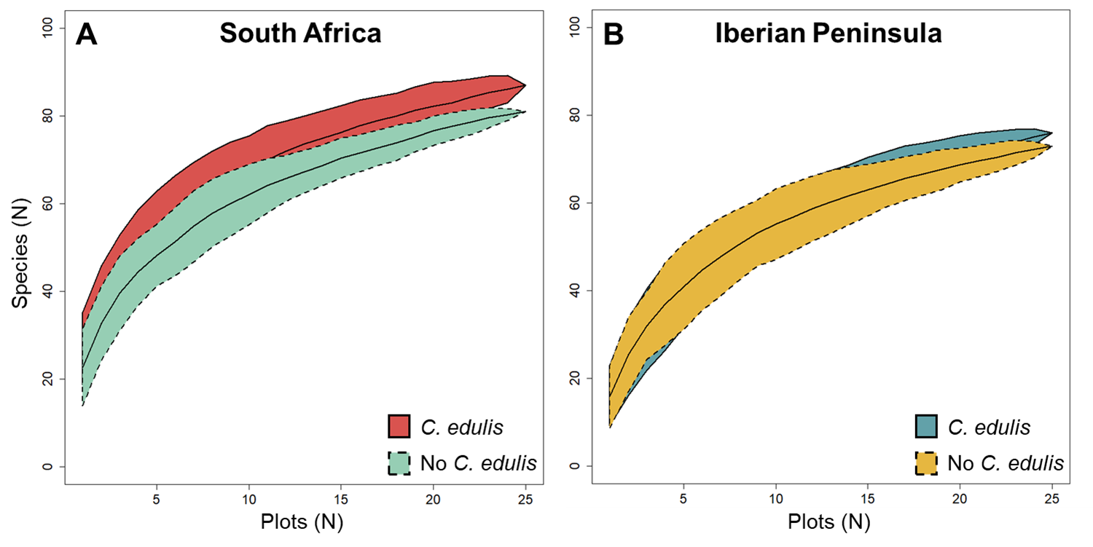Figure S1. Species accumulation curves of invertebrate species recorded among locations with and without Carpobrotus edulis in (A) South Africa and in (B) Iberian Peninsula for represent the cumulative species as a function of the number of plots sampled. Each curve represents the mean of 500 randomizations of sampling order.

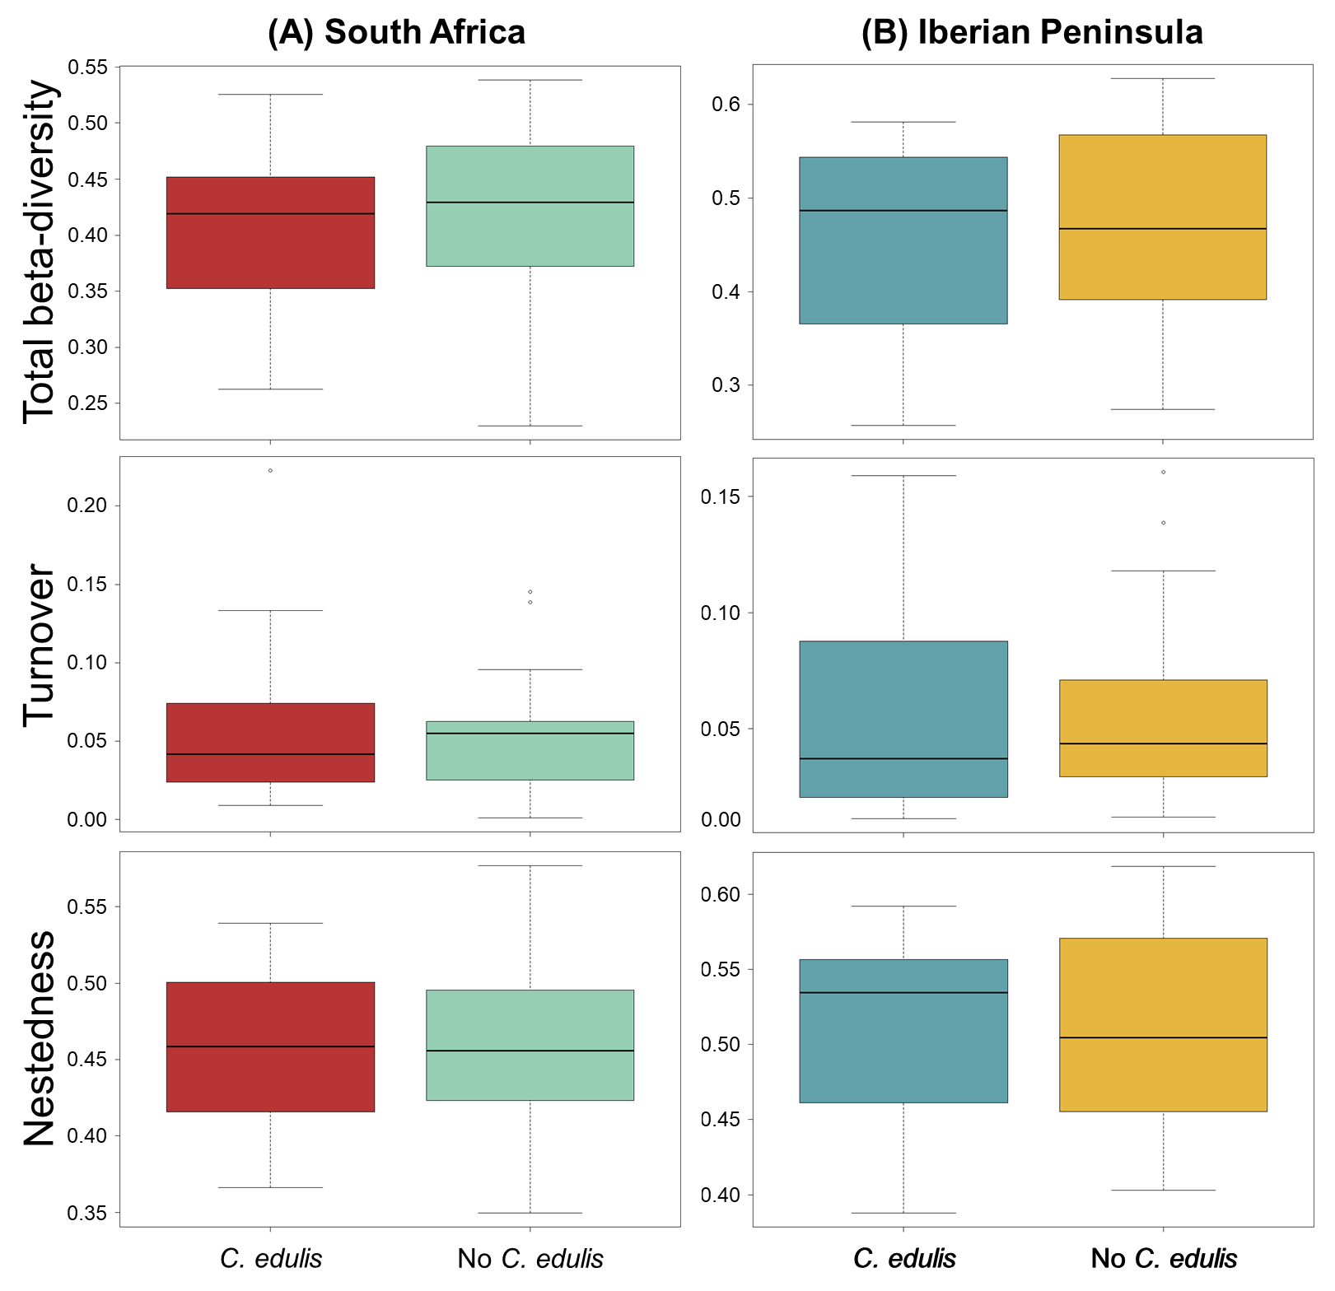Figure S2. Variation on beta-diversity based on multivariate test for homogeneity of dispersion analyses (PERMDISP) of differences in invertebrate composition among species turnover and nestedness, between locations of plant communities (with and without Carpobrotus edulis) at regions of (A) South Africa and (B) Iberian Peninsula. Mean distance to the geometric centre (centroid) of each predefined studied area was represent in each plot.

