Supplementary materials

Photos showing removal methods trialled on individual plant (clones) in this experiment.
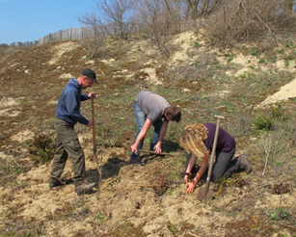 | 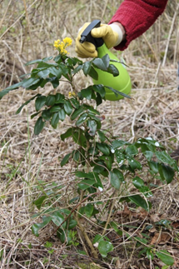
manual uprooting by digging with shovels (DIG) | leaf treatment using a spray bottle with a 5% glyphosate Roundup® Max solution (LEAF)
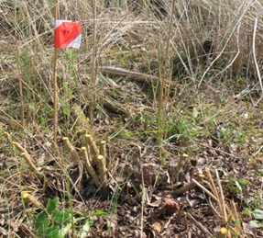 | 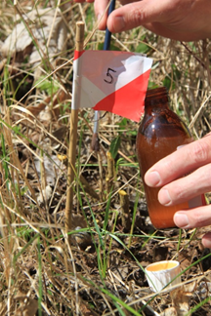
stem treatment (cut and paint) with the same glyphosate solution (STEM) | stem treatment with a saturated salt (NaCl) solution (SALT)
Larger scale mechanical removal of Berberis aquifolium (De Noordduinen, Koksijde, Belgium, November 19th 2013)

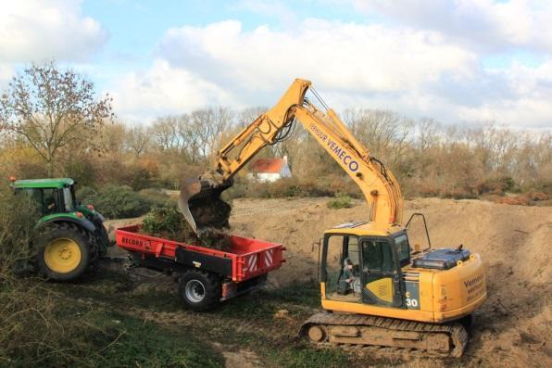 | 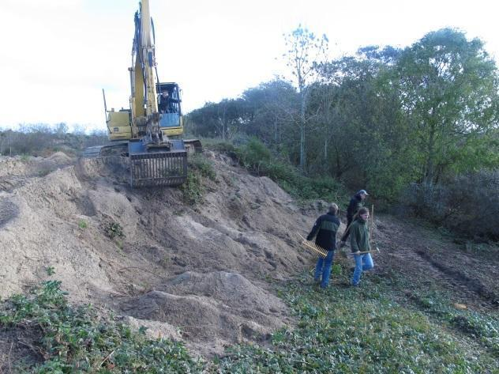
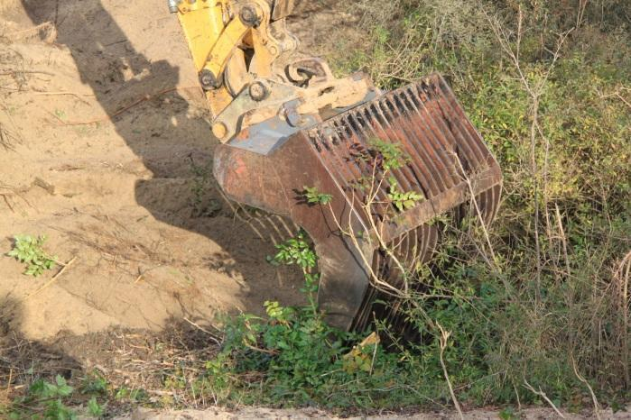 | 