Supplementary Material to:

The Caucasian Toad, Bufo verrucosissimus (Pallas, 1814) in the Levant: evidence from mitochondrial DNA
Daniel Jablonski and Riyad A. Sadek

Supplementary Table S1. Dataset of 16S sequences of Bufo verrucosissimus used in this study.
GB code | country | locality | N | E | sources
MN094870 | Lebanon | Moukhtara | 33.66 | 35.61 | This study
MN094871 | Lebanon | Moukhtara | 33.66 | 35.61 | This study
MN094872 | Lebanon | Moukhtara | 33.66 | 35.61 | This study
MN094873 | Lebanon | Moukhtara | 33.66 | 35.61 | This study
MN094874 | Lebanon | Moukhtara | 33.66 | 35.61 | This study
MN094875 | Lebanon | Moukhtara | 33.66 | 35.61 | This study
MN094876 | Lebanon | Moukhtara | 33.66 | 35.61 | This study
MN094877 | Lebanon | Moukhtara | 33.66 | 35.61 | This study
AY555024 | Turkey | Findikli, Rize | 41.28 | 41.15 | Kutrup et al. 2006
AY840240 | Turkey | Mersin | 36.93 | 34.46 | Kutrup et al. 2006
AY840241 | Turkey | Mersin | 36.93 | 34.46 | Kutrup et al. 2006
AY840245 | Turkey | Camlihemsin, Rize | 40.95 | 41.12 | Kutrup et al. 2006
AY840247 | Turkey | Borcka, Artvin | 41.36 | 41.68 | Kutrup et al. 2006
FJ882807 | Russia | - | - | - | Van Bocxlaer et al. 2009
JN647225 | Russia | Chernorechye | 43.93 | 40.66 | Recuero et al. 2012
JN647226 | Russia | Strizhament mt. | 44.65 | 41.54 | Recuero et al. 2012
JN647227 | Georgia | Malaya Ritza lake, Abkhazia | 43.47 | 40.50 | Recuero et al. 2012
JN647228 | Georgia | Charnali | 41.57 | 41.62 | Recuero et al. 2012
JN647229 | Russia | Chernorechye | 43.93 | 40.66 | Recuero et al. 2012
JN647230 | Georgia | Bakuriani, Jagoras-Veli | 41.73 | 43.52 | Recuero et al. 2012
JN647231 | Georgia | Akhaldaba river | 41.88 | 43.35 | Recuero et al. 2012
JN647232 | Turkey | Karagol | 41.31 | 42.48 | Recuero et al. 2012
JN647233 | Russia | Aderbiyevka | 44.60 | 38.10 | Recuero et al. 2012
JN647234 | Russia | Novoyekaterinovskaya | 44.77 | 42.03 | Recuero et al. 2012
JN647235 | Russia | Agura | 43.77 | 39.62 | Recuero et al. 2012
JN647236 | Russia | Vozrozhdeniye | 44.55 | 38.21 | Recuero et al. 2012
JN647237 | Russia | Dzhankot | 44.47 | 38.15 | Recuero et al. 2012
JQ348764 | Russia | Kyurdzhinovo | 45.42 | 40.62 | Garcia-Porta et al. 2012
JQ348789 | Russia | Tirala Mt. | 41.65 | 41.80 | Garcia-Porta et al. 2012
JQ348790 | Georgia | Lagodekhi | 41.83 | 46.27 | Garcia-Porta et al. 2012
JQ348791 | Russia | Gelenjik | 44.58 | 38.08 | Garcia-Porta et al. 2012
JQ348792 | Russia | Psebai | 44.08 | 40.77 | Garcia-Porta et al. 2012
JQ348807 | Russia | Krepostnaya | 44.72 | 38.68 | Garcia-Porta et al. 2012
JQ348811 | Turkey | Alanya | 36.55 | 32.12 | Garcia-Porta et al. 2012
JQ348814 | Russia | Guzeripl | 44.83 | 40.20 | Garcia-Porta et al. 2012
JQ348815 | Georgia | Katkova | 42.91 | 41.98 | Garcia-Porta et al. 2012
JQ348819 | Azerbaijan | Katekh | 41.72 | 46.60 | Garcia-Porta et al. 2012
JX218095 | Russia | Kyurdzhinovo | 45.42 | 40.62 | Litvinchuk et al. 2012
JX218097 | Georgia | Lidzava, Abkhazia | 43.18 | 40.35 | Litvinchuk et al. 2012
KY555652 | Georgia | Borzhomi | 41.78 | 43.43 | Liedtke et al. 2017

Supplementary Table S2. Summary of genetic polymorphism of Bufo verrucosissimus 16S rRNA sequences: sample size (n), number of haplotypes (h), number of polymorphic sites (S), average number of nucleotide differences (k), nucleotide diversity (π), haplotype diversity (Hd), Watterson’s theta per site (θW). SD = standard deviation.
 | n | h | S | k | π ±SD (%) | Hd ±SD | Θw±SD (%)
Bufo verrucosissimus | 40 | 12 | 13 | 1.63 | 0.34±0.05 | 0.77±0.05 | 0.63±0.24

Supplementary Figure S1. The map of Lebanon with an overview of Bufo verrucosissimus distribution records in the country: 1 - Jannat-Kartaba (Hraoui-Bloquet et al. 2001), 2 - Chouene, 3 - Maasriti, 4–6 - Moukhtara, 7 – Niha, 8 – Bater, 9 – Haret Jandal.

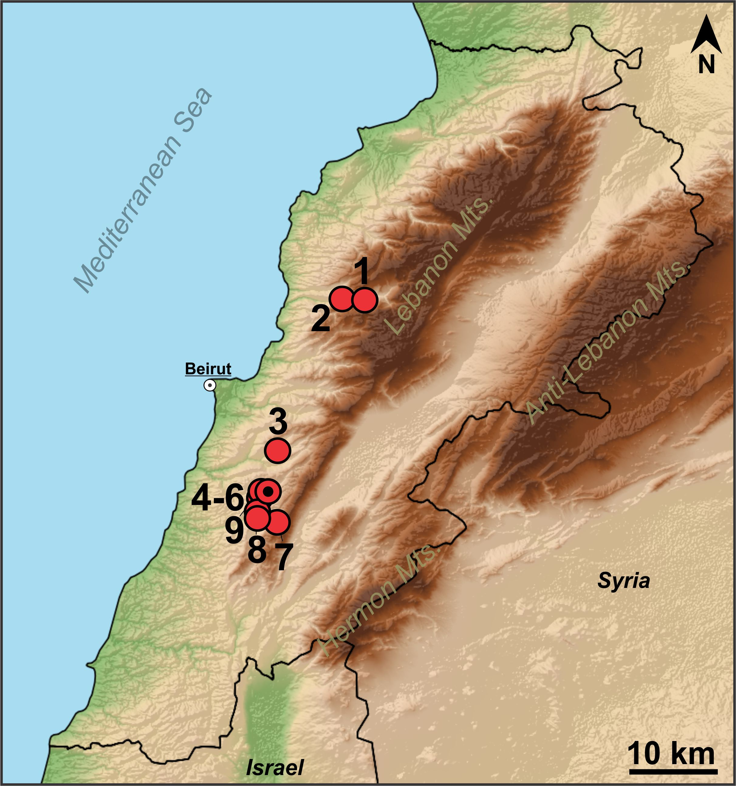

Supplementary Figure S2. Adult individuals of Bufo verrucosissimus from locality Mukhtara, Lebanon.

