Supplemental Material

Table S1. Results of the Generalized Mixed Yule-Coalescent (GMYC) analyses under the single threshold model.
Gene | N_{CLUSTER} (CI) | N_{GMYC} (CI) | L_{NULL} | L_{GMYC} | Λ | P | Threshold
Bloc | 11 (2-16) | 63 (2-65) | 477.524 | 479.895 | 4.7423 | 0.58929e-07n.s. | -0.0008098
RPB1 | 20 (18-21) | 28 (26-31) | 795.954 | 803.604 | 15.3006 | 0.0004759011*** | -0.0027721
tef1 | 18 (18-19) | 26 (25-27) | 785.479 | 798.443 | 25.9281 | 2.343082e-06*** | -0.0034657
Abbreviation: N_{CLUSTER}, number of GMYC lineages with more than one specimens; N_{GMYC}, number of GMYC lineages; CI, confidence interval; L_{NULL}, likelihood of the null model; L_{GMYC}, likelihood of the GMYC model; Λ, likelihood ratio; P, P values of the likelihood ratio test; Threshold, the threshold line between speciation and coalescent process.

Table S2. Highest posterior probabilities of the three-gene Bayesian species delimitation analysis (BPP) by jointing species delimitation and species tree inference (A11: species delimitation = 1, species tree = 1)
Delimited species | Run 1 | Run 2 | Run 3 | Average
B. amorpha | 0.486 | 0.601 | 0.534 | 0.540
B. asiatica | 0.532 | 0.565 | 0.510 | 0.536
B. australis | 0.491 | 0.556 | 0.534 | 0.527
B. bassiana | 0.506 | 0.550 | 0.566 | 0.540
B. brongniartii | 0.538 | 0.564 | 0.534 | 0.545
B. caledonica | 0.501 | 0.573 | 0.555 | 0.543
B. hoplocheli | 0.531 | 0.564 | 0.516 | 0.537
B. kipukae | 0.502 | 0.588 | 0.510 | 0.533
B. lii | 0.508 | 0.559 | 0.513 | 0.527
B. majiangensis | 0.537 | 0.585 | 0.528 | 0.550
B. malawiensis | 0.505 | 0.574 | 0.571 | 0.550
B. pseudobassiana | 0.547 | 0.530 | 0.529 | 0.535
B. sungii | 0.508 | 0.551 | 0.544 | 0.534
B. varroae | 0.533 | 0.592 | 0.569 | 0.564
B. vermiconia | 0.533 | 0.548 | 0.524 | 0.535
Beauveria sp. | 0.499 | 0.559 | 0.531 | 0.529
Splitting a species | 0.029 | 0.033 | 0.026 | 0.029
More than 2 species cluster | 0.031 | 0.025 | 0.030 | 0.029

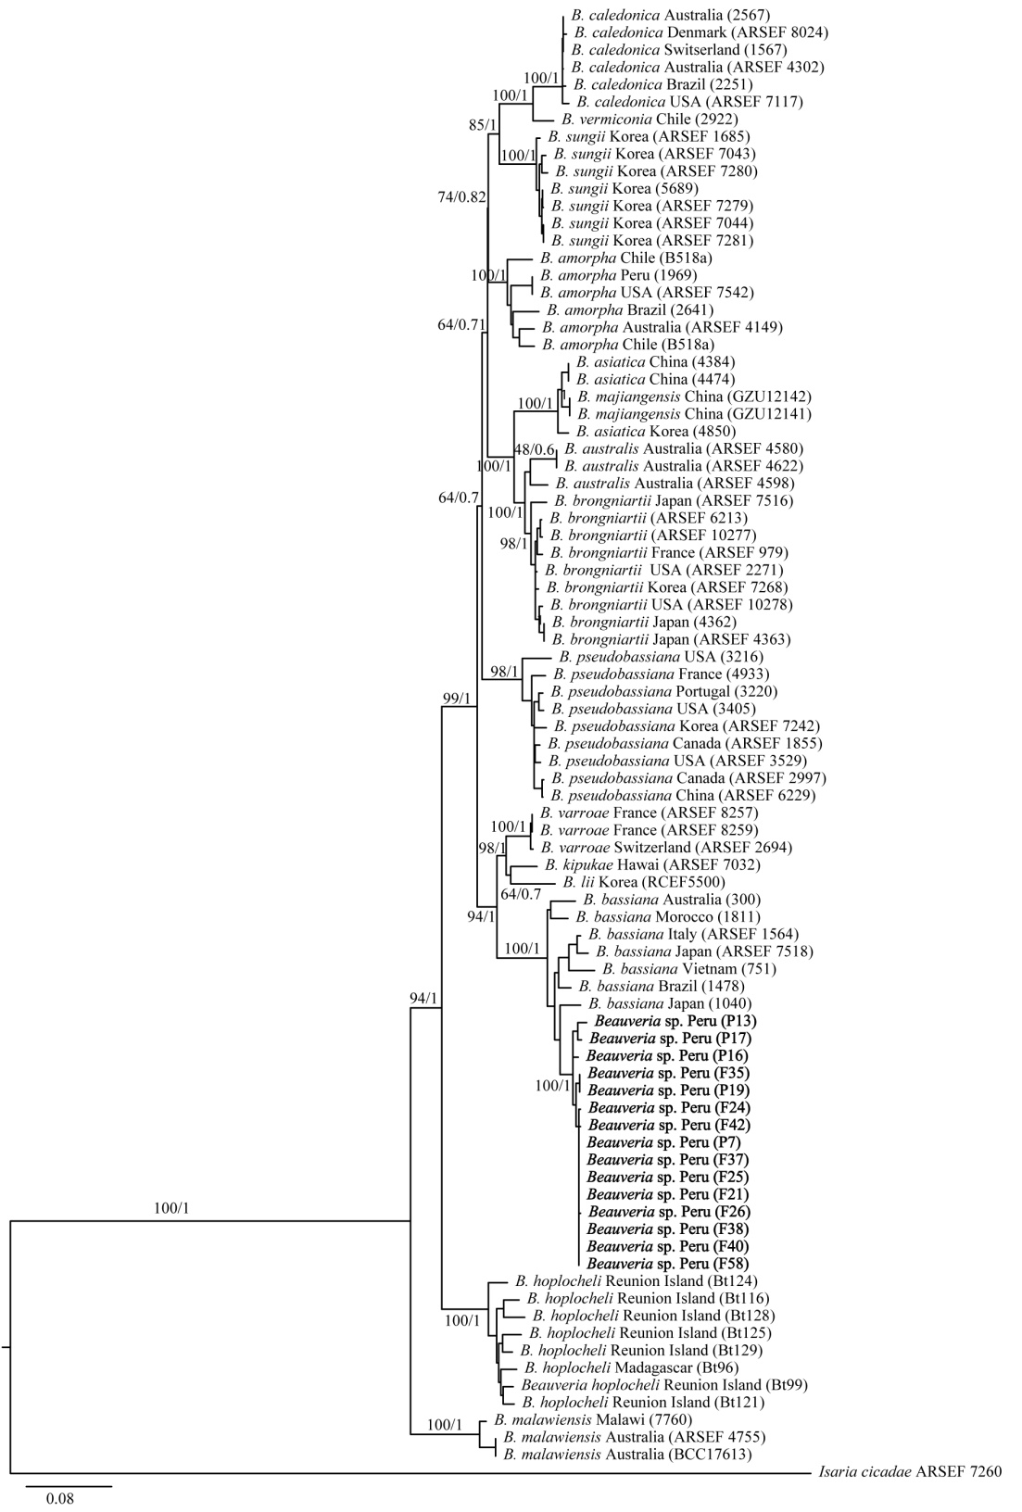
Fig. S1. Phylogenetic tree based on maximum likelihood inference of combined Bloc data. Value above branches = Maximum likelihood bootstrap values (BS) / Bayesian posterior probabilities. Scale bar indicates the number of nucleotide substitution per site.
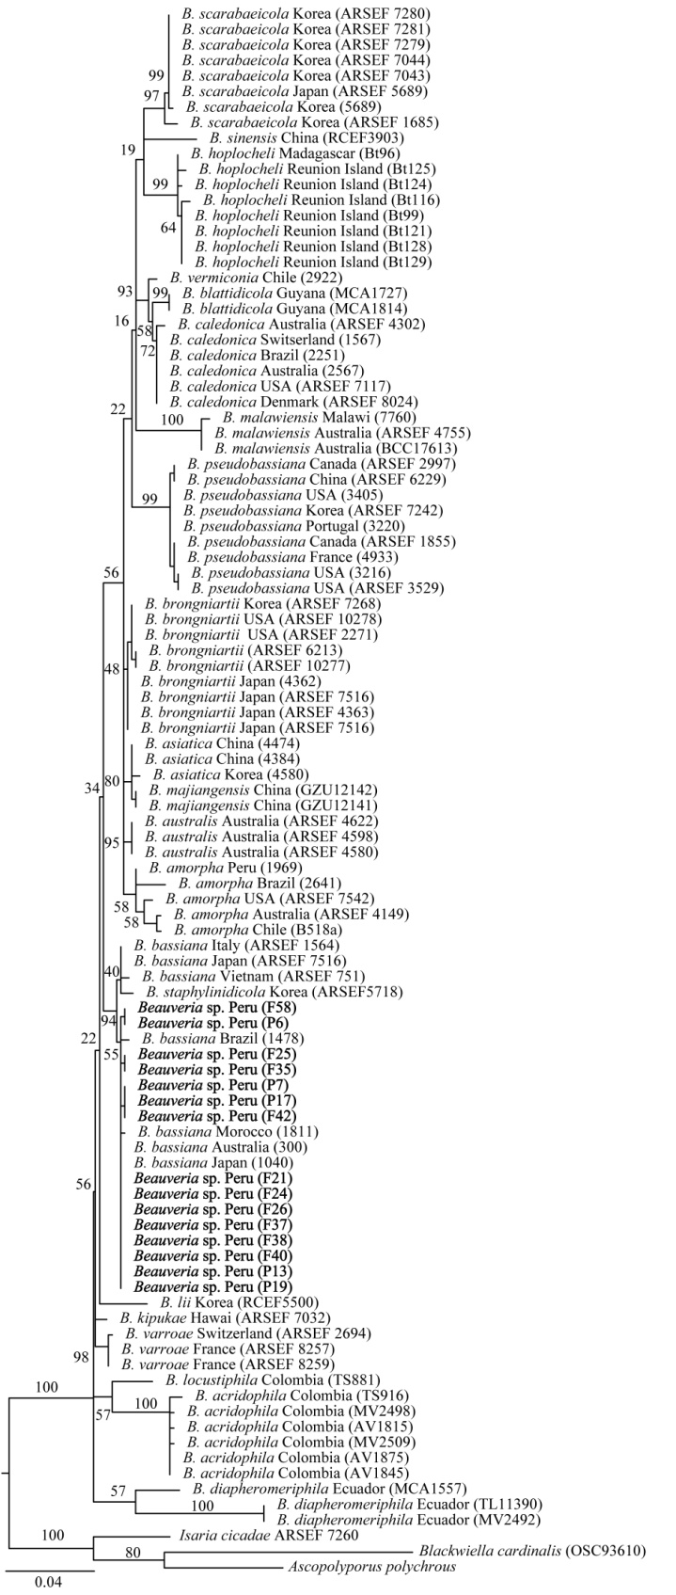
Fig. S2. Phylogenetic tree based on maximum likelihood inference of combined RPB1 data. Value above branches = Maximum likelihood bootstrap values (BS). Scale bar indicates the number of nucleotide substitution per site.
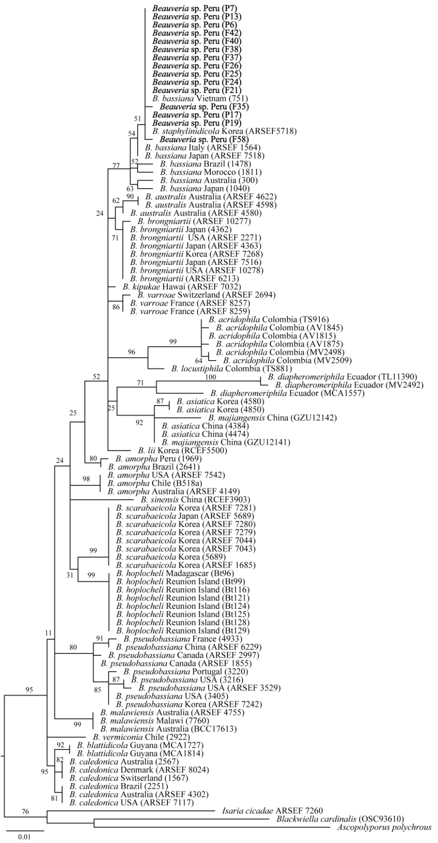
Fig. S3. Phylogenetic tree based on maximum likelihood inference of combined Tef1 data. Value above branches = Maximum likelihood bootstrap values (BS). Scale bar indicates the number of nucleotide substitution per site.

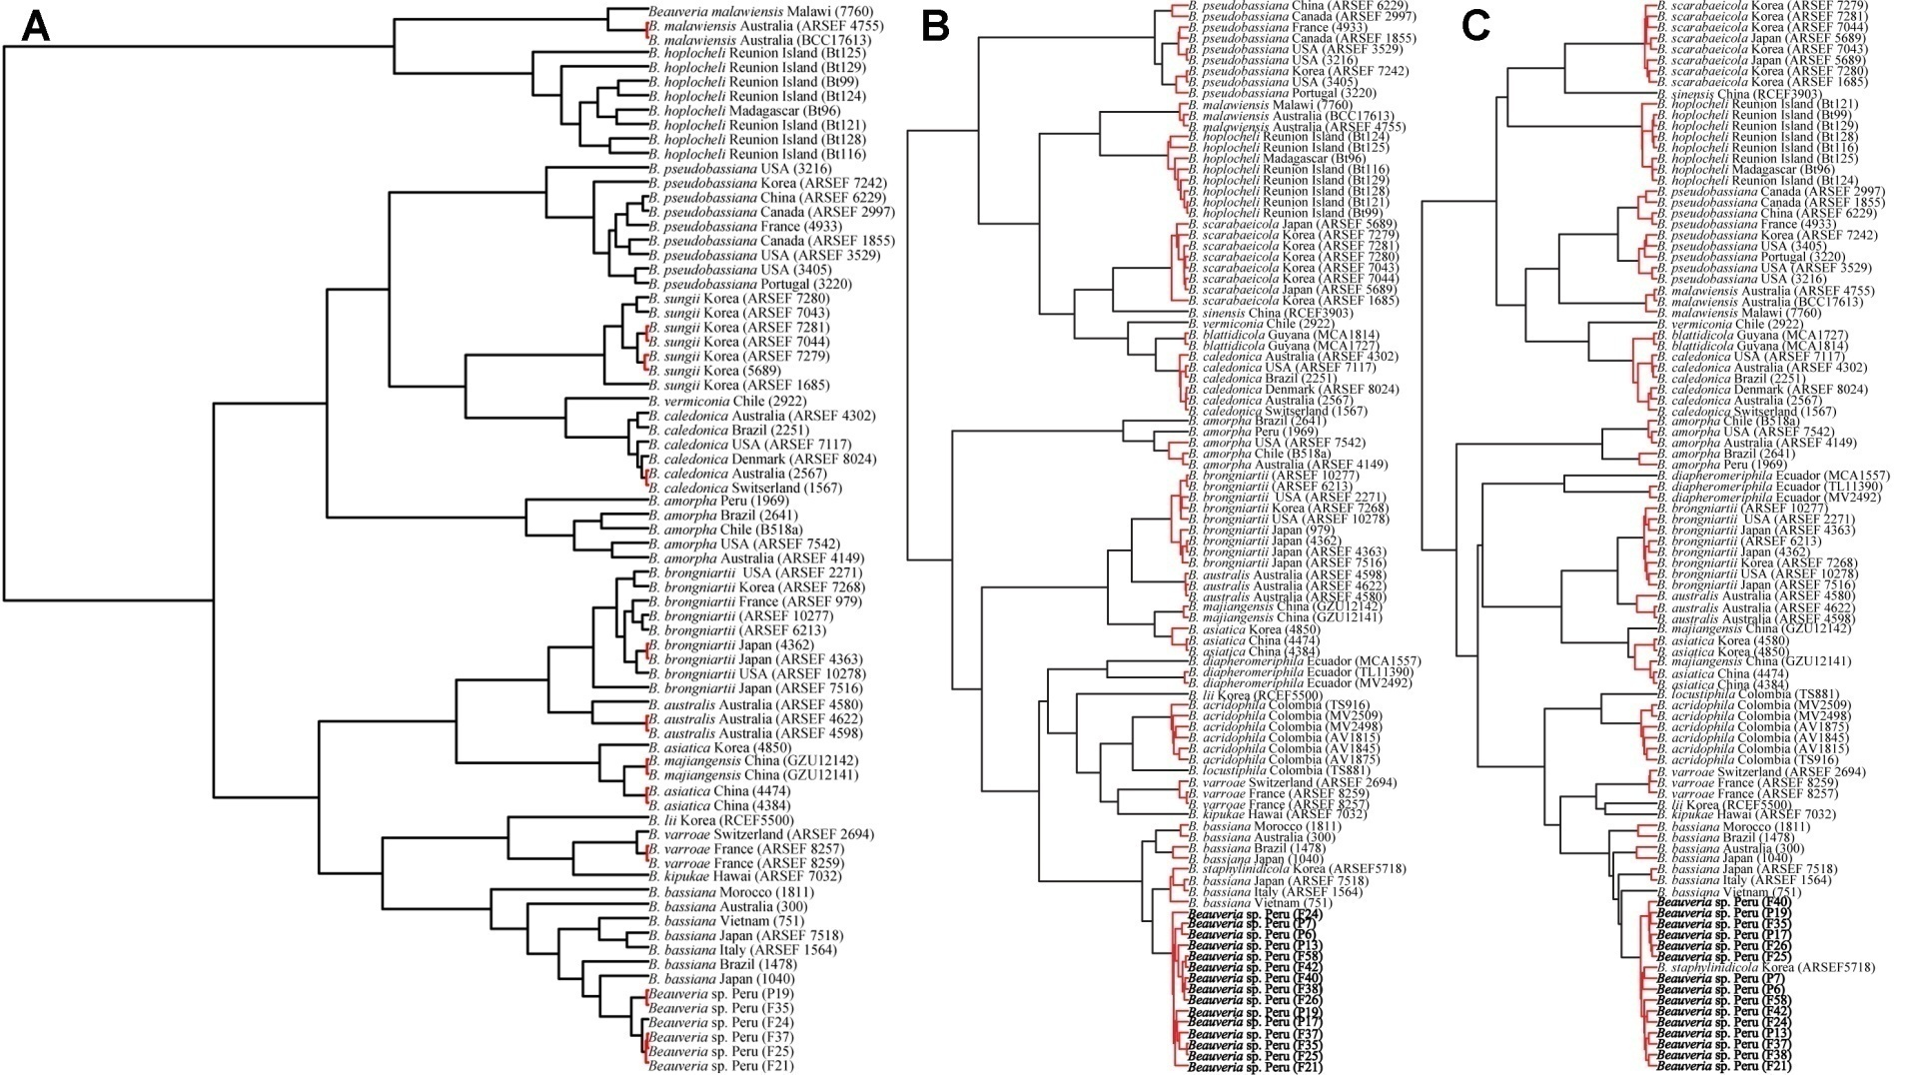Fig. S4. Bayesian inference ultrametric gene tree obtained using a Yule tree prior in BEAST with the statistical species delimitation results from GMYC based on Bloc (A), RPB1 (B), and Tef1 (C).

