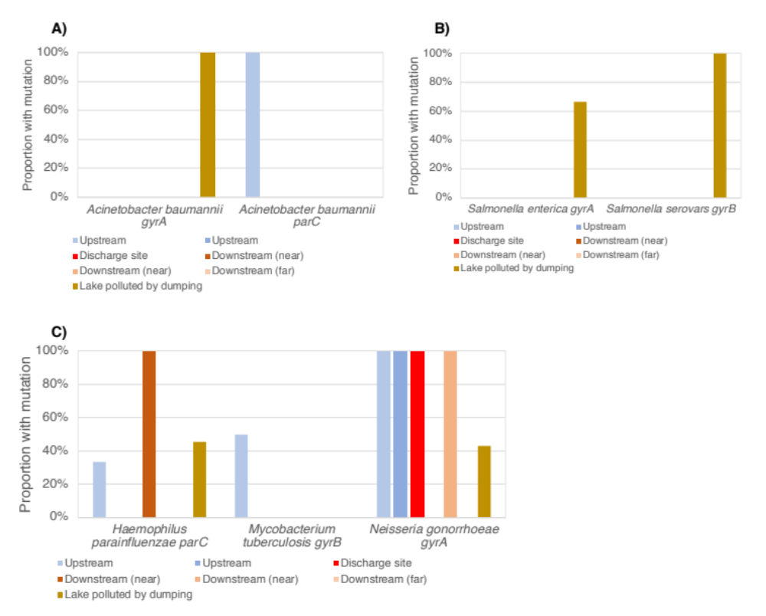
Figure S1. Relative frequency of sequences with resistance mutations in samples taken downstream, at, or upstream of the pharmaceutical production wastewater treatment plant, as well as in a lake polluted by dumping of pharmaceutical production waste, for Acinetobacter baumanii (A), Salmonella species (B) and Haemophilus parainfluenzae, Mycobacterium tubercolosis and Neisseria gonorrhoeae (C).

