Supplementary figures
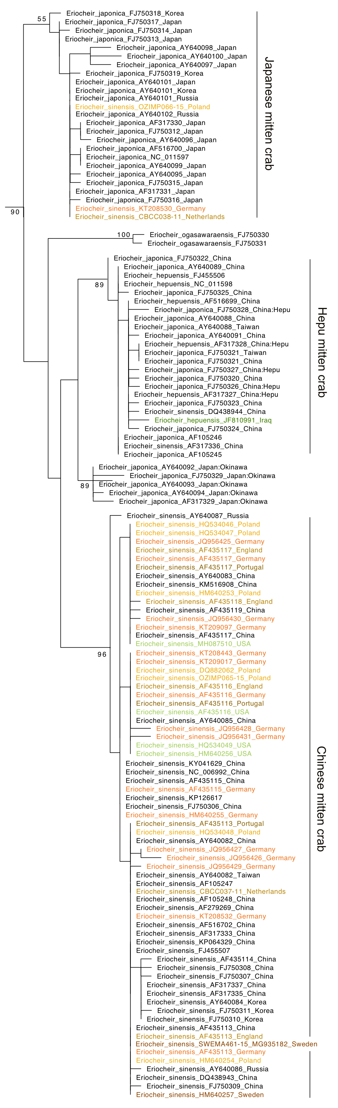

Figure S1 Maximum likelihood tree of mitten crab COI sequences from GenBank and BOLD. Each sequence is labeled with Latin species name as supplied during the sequence submission process, GenBank accession number (or BOLD accession when the respective sequence is not available in GenBank), and country where the crab was collected. Note that the invasive Japanese mitten crab sequences were identified as Chinese mitten crabs (Eriocheir sinensis), and that sequences belonging to the monophyletic Hepu mitten crab lineage were submitted as either Hepu mitten crab (E. hepuensis), Chinese mitten crab (E. sinensis) or Japanese mitten crab (E. japonica), reflecting ongoing discussions about their species status. Sequences of individuals from invaded ranges are colored based on the country of collection (yellow to brown: Europe, green: USA and Iraq), while sequences from the native ranges are black. Numbers on branches represent bootstrap support. Branches without numbers have less than 70% bootstrap support. We omitted the outgroups from the figure to save space.

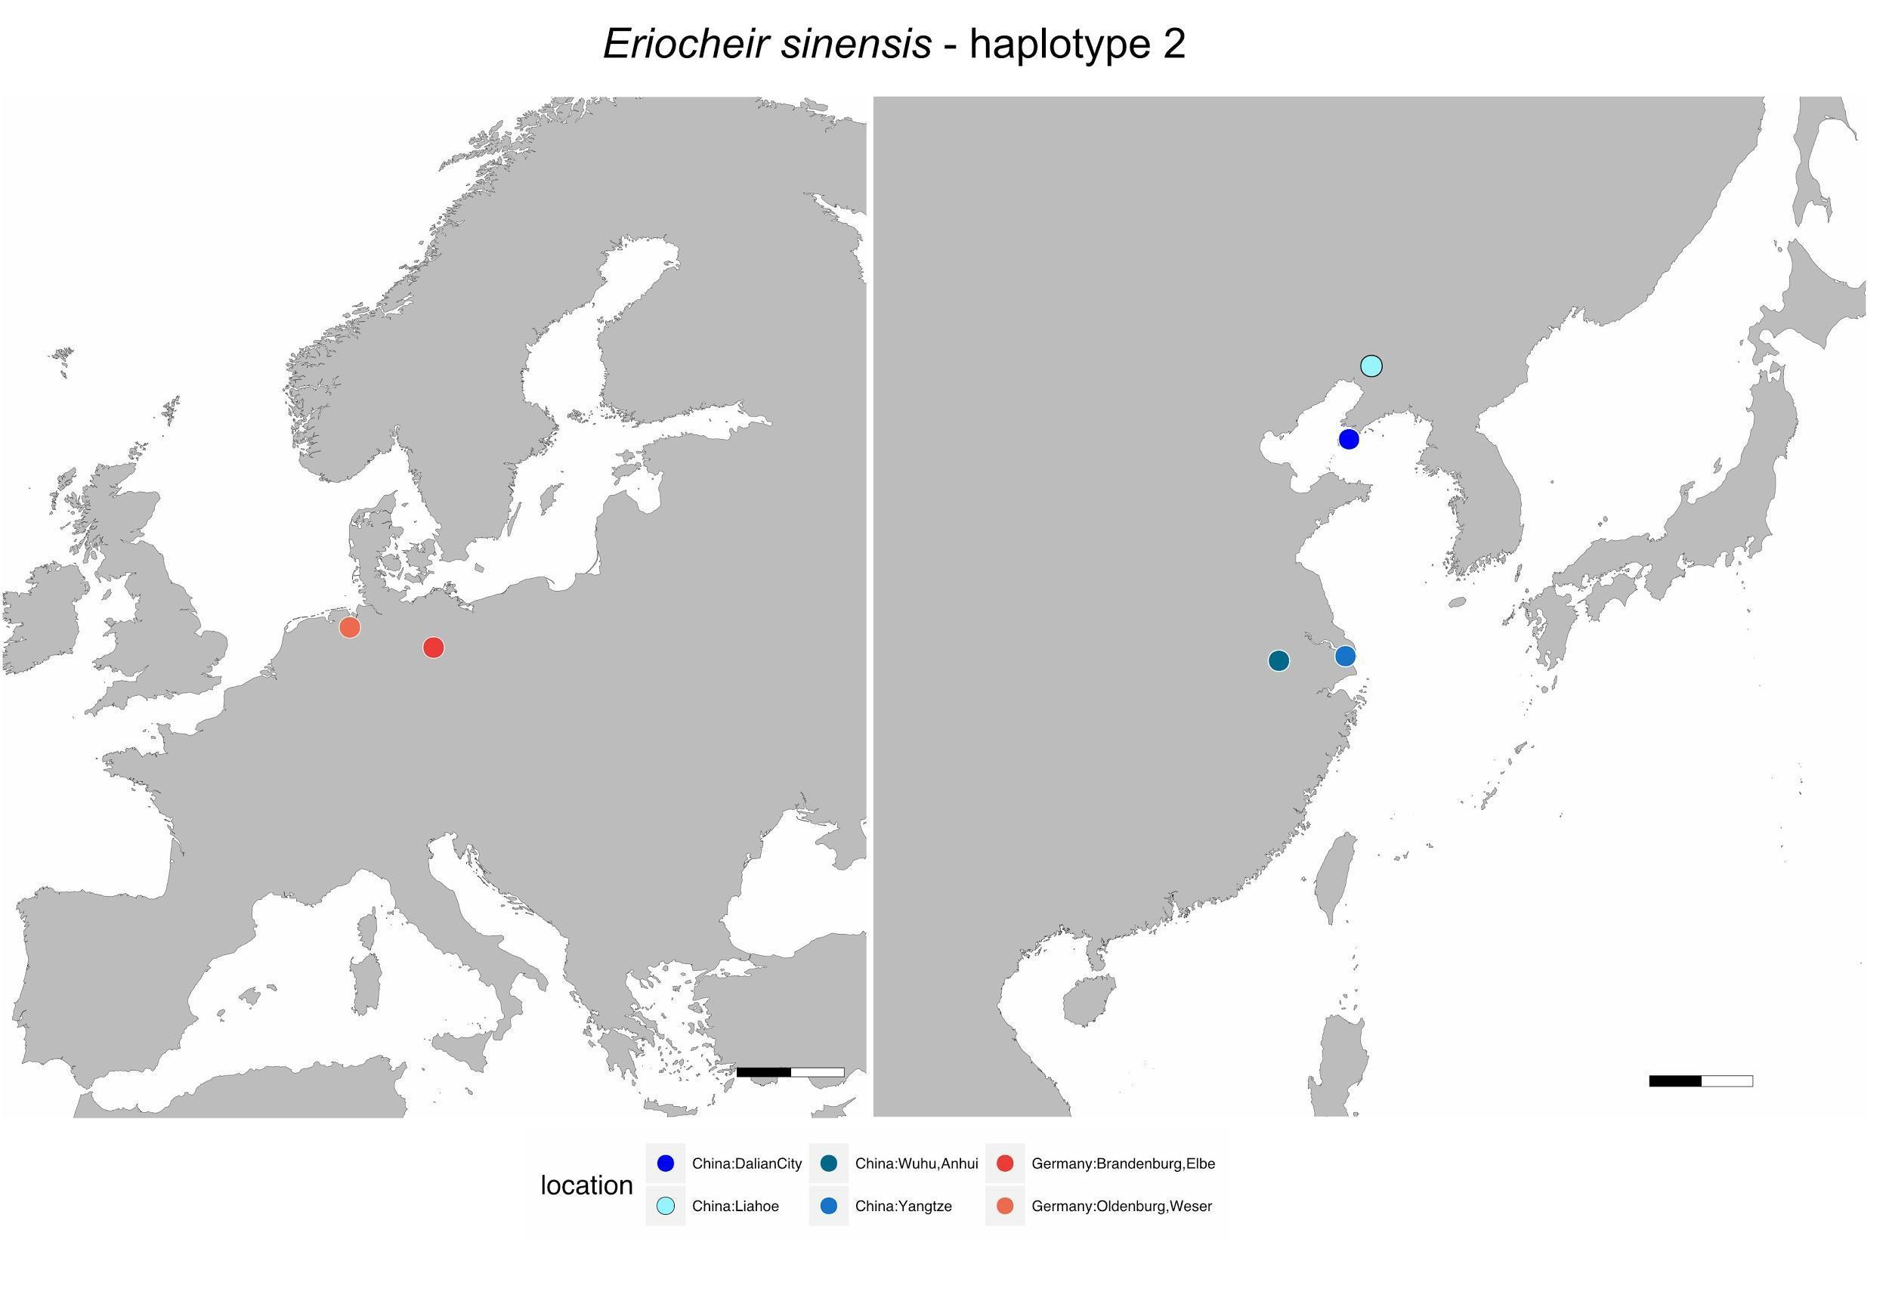
Figure S2 Geographic distribution of COI haplotype H2 of the Chinese mitten crab (Eriocheir sinensis).

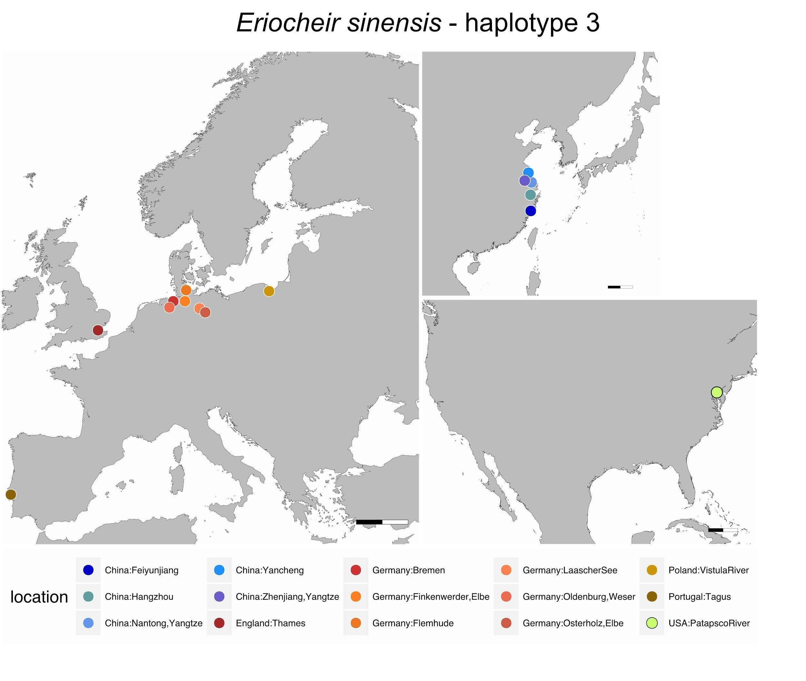
Figure S3 Geographic distribution of COI haplotype H3 of the Chinese mitten crab (Eriocheir sinensis).

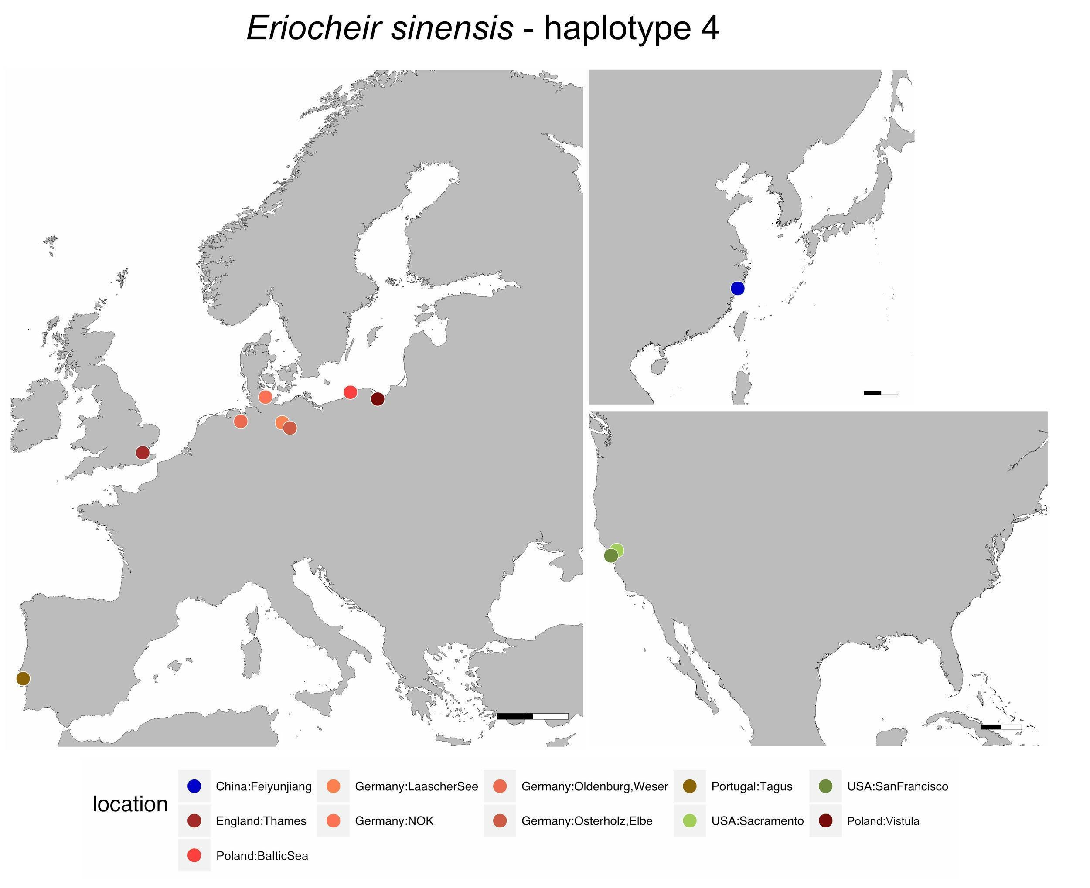
Figure S4 Geographic distribution of COI haplotype H4 of the Chinese mitten crab (Eriocheir sinensis).

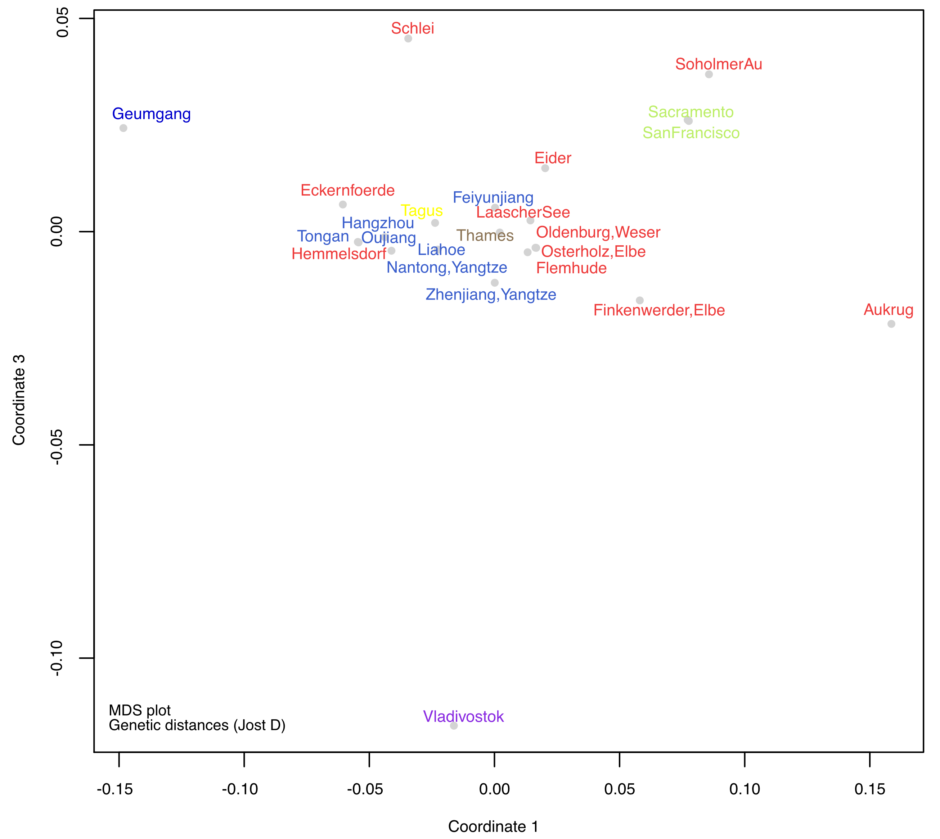
Figure S5 Multidimensional scaling plot of the first and third axes based on Jost's D distances between sampling locations.
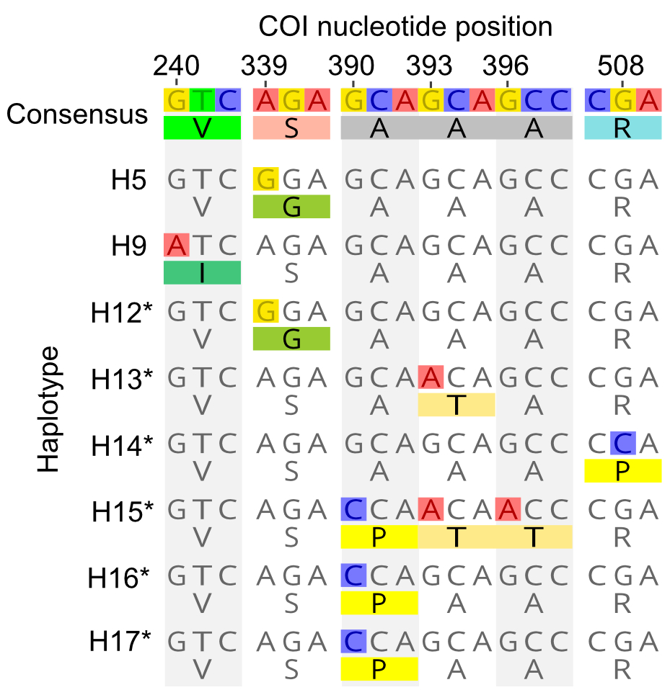

Figure S6 Codons of the COI sequence of Chinese mitten crabs that translate to amino acid substitutions (AAS). Shown are only haplotypes and nucleotide codons with AAS. For each haplotype, the DNA sequence is on top, and the amino acid sequence below. The base numbering refers to the position of the DNA nucleotides relative to the beginning of the COI gene (not the sequenced fragment). Haplotypes with an asterisk were only documented from Northern Germany. Colored amino acids and nucleotides of the haplotypes are likely the derived states.

