Supplementary material

Figure SM1. Examples of the three plates used in the first visual survey, with the information and instructions given to the respondents. The plates are ordered by brightness and colourfulness (from low to high) and the species are spatially reordered to avoid possible biases. To each person, we asked: “Mark with an X in its box ten of the birds that you would like to be part of this environment. There are no correct or incorrect responses, all the answers you choose are valid because we are interested in your opinion, nothing more.” If people asked for more information on the objectives of the survey or why the text “not native” was placed next to some species, the person taking the questionnaires would respond “I don´t know, my boss just asked me to do it this way”.

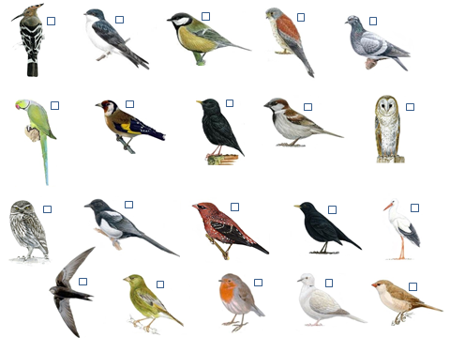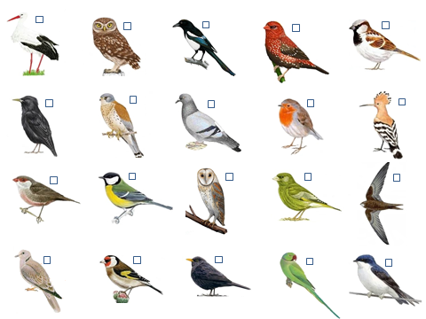

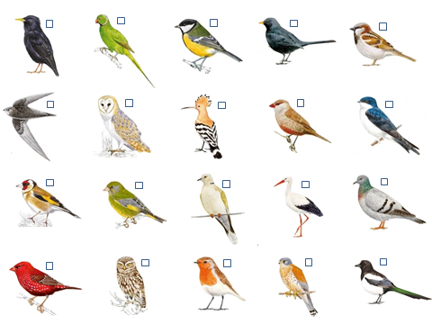

Figure SM2. Example of one of the pair of plates used in the first, visual survey, with the information and instructions given to the respondents. The first plate contains the text “non-native” for the four non-native species; the second plate does not have this information but is otherwise identical. To each person, we asked: “Mark with an X in its box ten of the birds that you would like to be part of this environment. There are no correct or incorrect responses, all the answers you choose are valid because we are interested in your opinion, nothing more.” If people asked for more information on the objectives of the survey or why the text “not native” was placed next to some species, the person taking the questionnaires would respond “I don´t know, my boss just asked me to do it this way”.

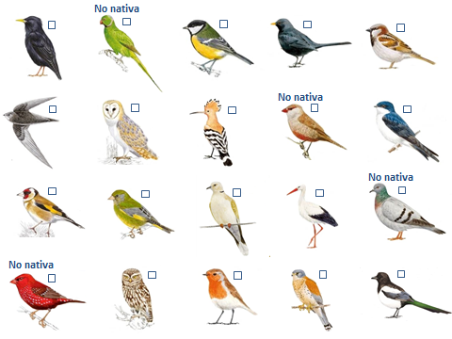

Figure SM3. Second, question-based survey with the information and instructions given to the respondents. The respondents should value 11 different characteristics attributable to the rose-ringed parakeet on a 7-point Likert scale, ranging between a positive and a negative adjective. We varied the order of some of the adjectives, such that negative adjectives could be either on the left or the right side of the scale. In addition, we included in the eleven characteristics some that were quite similar, to check for consistency of answers. To each person, we asked: “You have to evaluate different characteristics depending on what you think of the bird that I have pointed out in the first survey (which was the parakeet). For this, mark with an X the box closest to your opinion for each characteristic. The boxes on the sides represent the word that is on that side, while the box in the middle represents an intermediate opinion”

BEAUTIFUL |  |  |  |  |  |  |  | UGLY
NOT FRIENDLY |  |  |  |  |  |  |  | FRIENDLY
SILENT |  |  |  |  |  |  |  | NOISY
HARMLESS |  |  |  |  |  |  |  | HARMFUL
VALUABLE |  |  |  |  |  |  |  | WORTHLESS
UNPLEASANT |  |  |  |  |  |  |  | PLEASANT
CLEAN |  |  |  |  |  |  |  | DIRTY
BAD |  |  |  |  |  |  |  | GOOD
USEFUL |  |  |  |  |  |  |  | PLAGUE
MUTEDCOLOUR |  |  |  |  |  |  |  | COLORFUL
ABUNDANT |  |  |  |  |  |  |  | RARE

