Appendix S2: Procedure for modelling the allometric relationships between P. serotina dimensions and biomass.

We tested relationships between sample tree dimensions (root collar diameter – RCD [mm], height – H [cm] and joint pseudovolume measure – RCD²H [cm³]), and aboveground biomass. We split the dataset into two dimension-based groups: trees up to 10 mm RCD and over 10 mm RCD. For each dataset we developed ten models commonly used in tree biomass modeling (for methodological overview see Jagodziński et al. How do tree stand parameters affect young Scots pine biomass?—Allometric equations and biomass conversion and expansion factors. For. Ecol. Manag. 2018, 409, 74–83), and based on AIC we selected the best one. Model trees were chosen from the whole range of RCD and H – we randomly selected 59 trees from the subset of trees investigated in 2013. The selection was based on division of the dataset into equal intervals across increasing RCD and height. Then, we preselected trees with particular dimensions within particular study plots and in field we cut the first tree encountered with given dimensions. Only one model tree exceeded 1000 g, as larger trees were poorly represented within the study site.

Table S2. Summary of models of P. serotina biomass. Parameters of the best model were bolded.

Dataset | Larger trees  (10-126 mm RCD) |  |  |  | Smaller trees  (up to 10 mm RCD)
Model | AIC | RMSE | R² | ΔAIC | AIC | RMSE | R² | ΔAIC
AB=a×RCD^{b} | 88.303 | 39.495 | 0.999 | 6.431 | 67.652 | 0.384 | 0.988 | 68.438
AB=a+b×RCD² | 96.531 | <0.001 | 0.999 | 14.660 | 136.344 | <0.001 | 0.957 | 137.130
AB=a+b×log(RCD) | 139.917 | <0.001 | 0.859 | 58.045 | 270.440 | <0.001 | 0.429 | 271.227
AB=a+(b/RCD) | 148.597 | <0.001 | 0.512 | 66.725 | 289.079 | <0.001 | 0.183 | 289.865
AB=a×(RCD²H)^{b} | 81.872 | 7.810 | 0.999 | 0.000 | -0.786 | 0.360 | 0.997 | 0.000
AB=a×RCD^{b}×H^{c} | NA | NA | NA | NA | 0.751 | <0.001 | 0.997 | 1.537
AB=a+b×log(RCD²H) | 143.751 | <0.001 | 0.756 | 61.879 | 268.793 | <0.001 | 0.447 | 269.579
AB=a+b×RCD²+c×h | 93.145 | <0.001 | 0.999 | 11.273 | 120.772 | <0.001 | 0.969 | 121.558
AB=a+b*(RCD²H) | 85.179 | <0.001 | 0.999 | 3.307 | -0.760 | <0.001 | 0.997 | 0.026
AB=a+b× RCD²+c×h² | 95.694 | <0.001 | 0.999 | 13.822 | 138.331 | <0.001 | 0.957 | 139.118

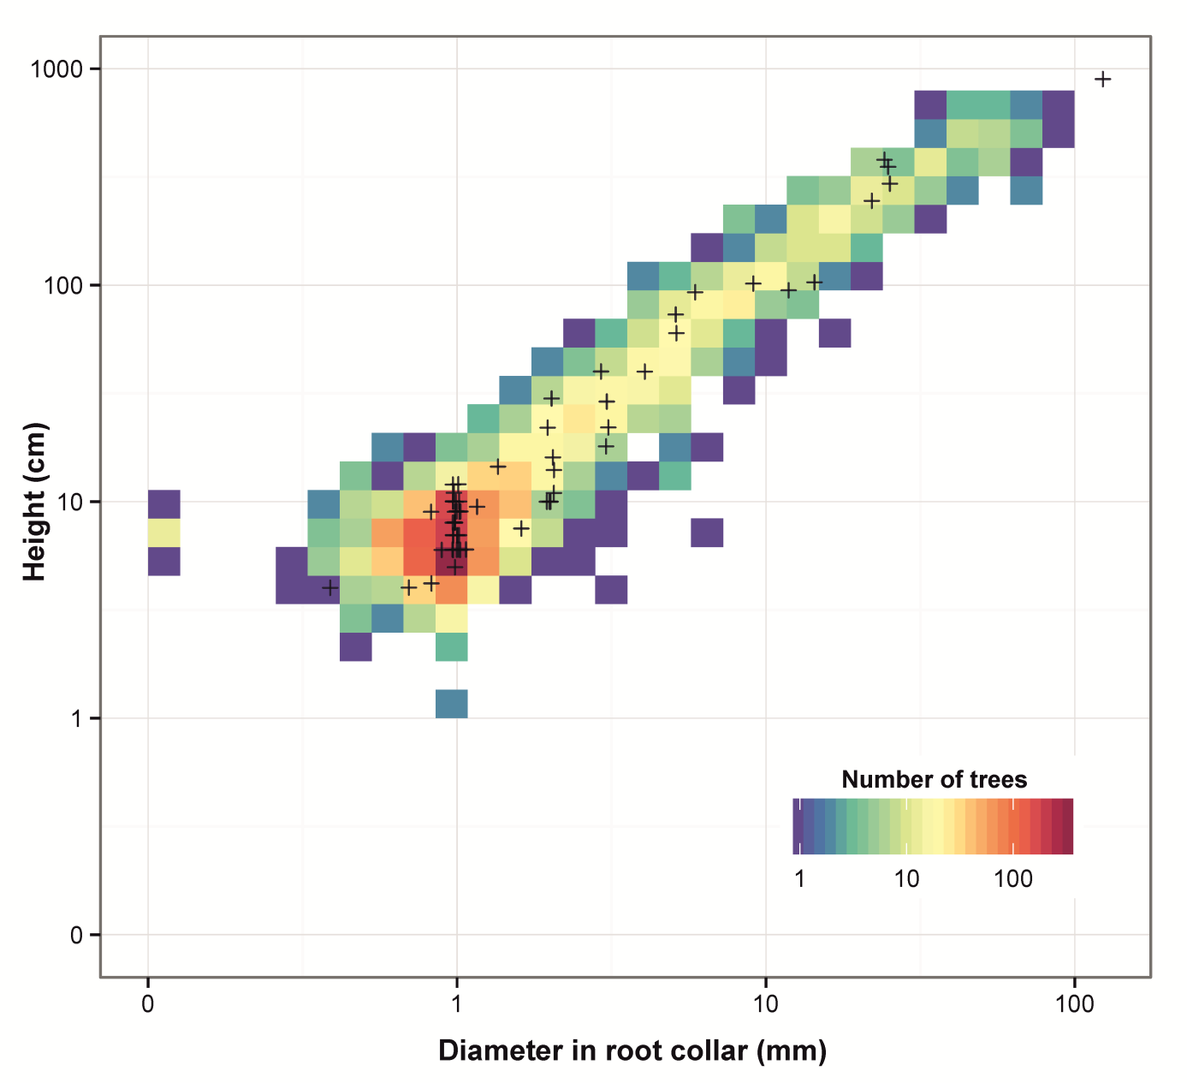
Fig. S1. Distribution of sampled trees compared with root collar diameter and height of all investigated trees.

