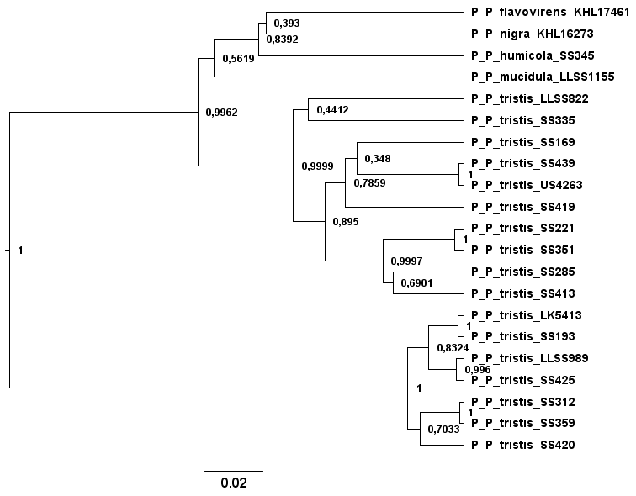
Figure S1. Bayesian Tef1α-phylogeny of the P. tristis group. Values between 0 and 1 denote posterior probability. The branch lengths are scaled in substitutions/site.

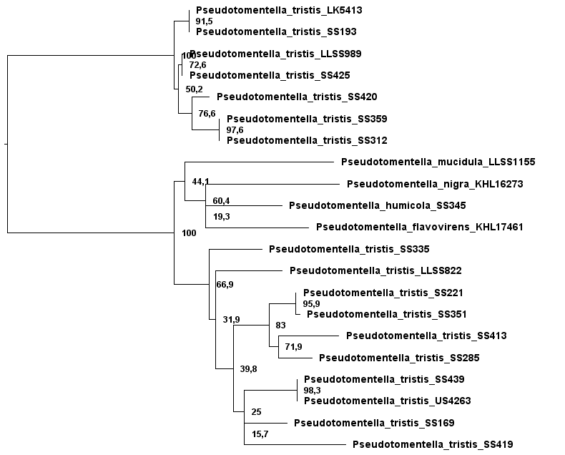
Figure S2. ML Tef1α-phylogeny of the P. tristis group. Values between 0 and 100 denote bootstrap support.

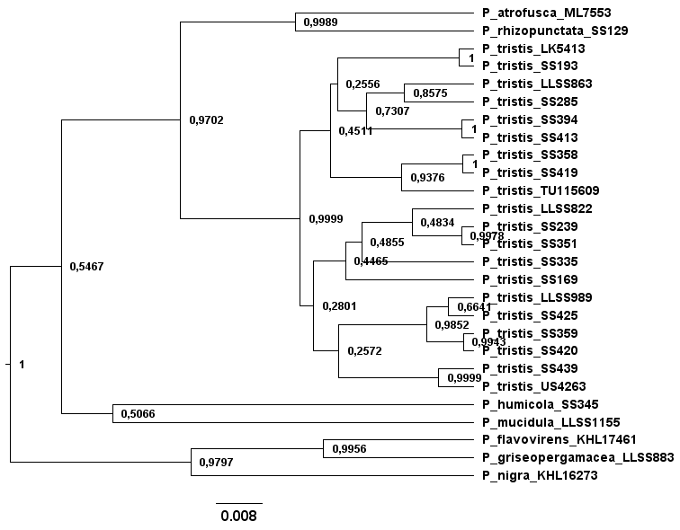
Figure S3. Bayesian mtSSU-phylogeny of the P. tristis group. Values between 0 and 1 denote posterior probability. The branch lengths are scaled in substitutions/site.

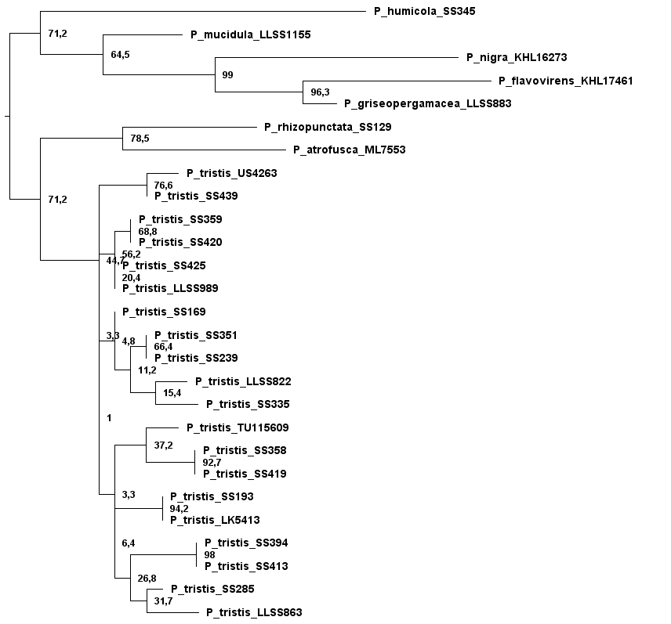
Figure S4. ML mtSSU-phylogeny of the P. tristis group. Values between 0 and 100 denote bootstrap support.

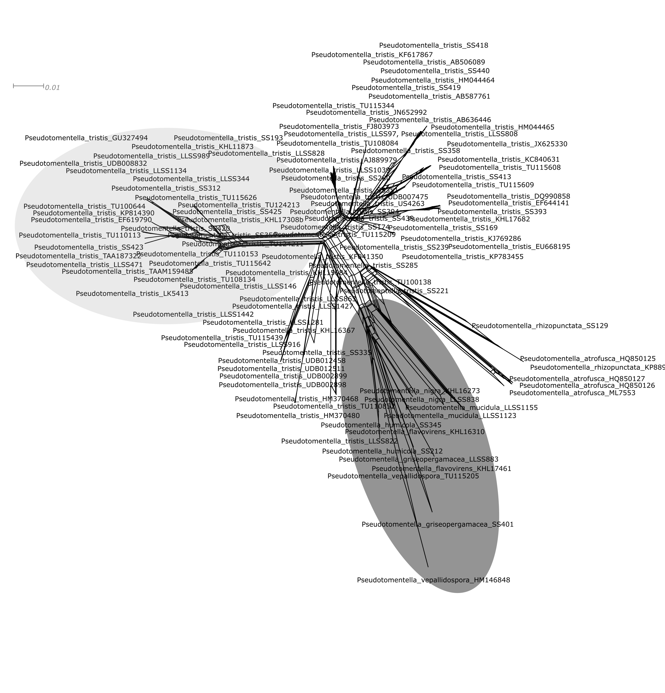
Figure S5. Neighbour net of the rDNA alignment. The branch carrying the species P. sciastra, P. tristoides, P. alobata and P. tristis is shown in pale grey and the outgroup is highlighted in darker grey. The network is scaled in uncorrected pairwise distances.

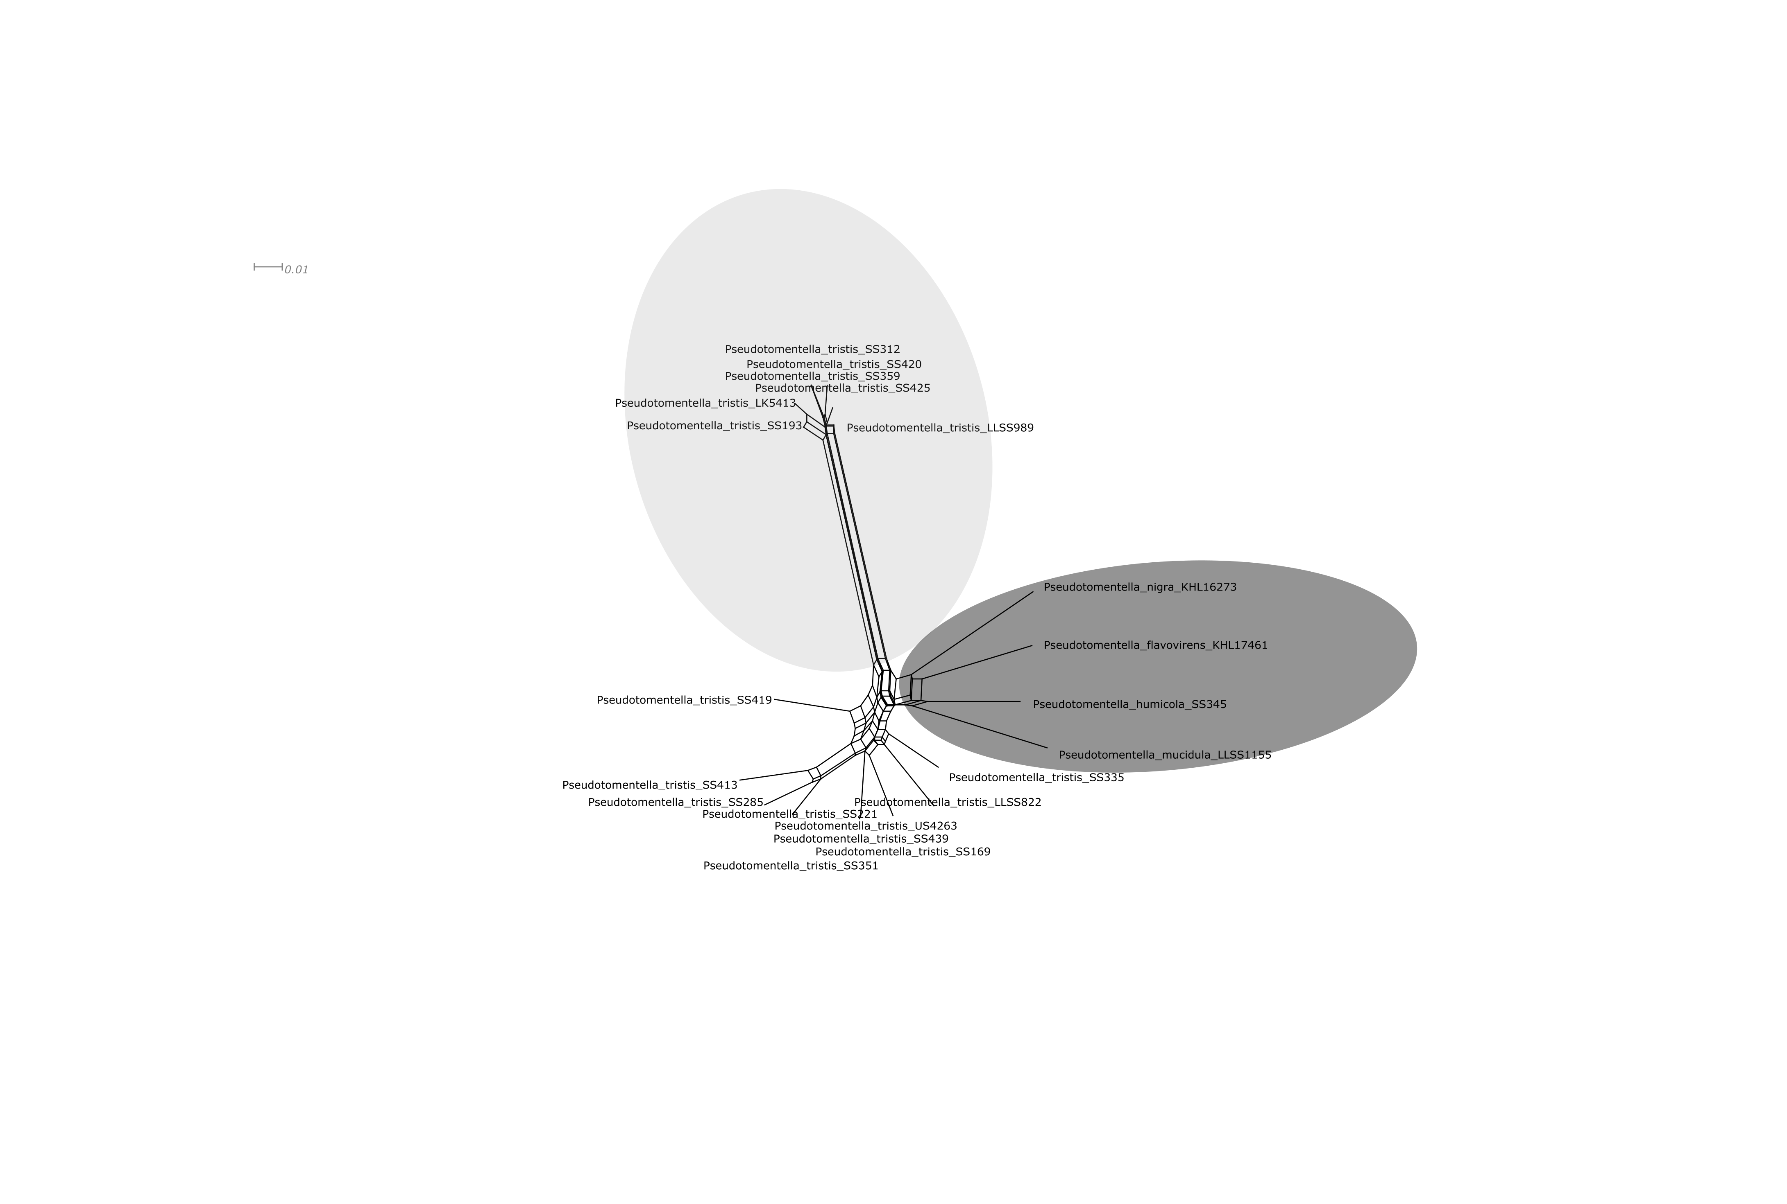
Figure S6. Neighbour net of the Tef1α alignment. The branch carrying the species P. sciastra, P. tristoides, P. alobata and P. tristis is shown in pale grey and the outgroup is highlighted in darker grey. The network is scaled in uncorrected pairwise distances.

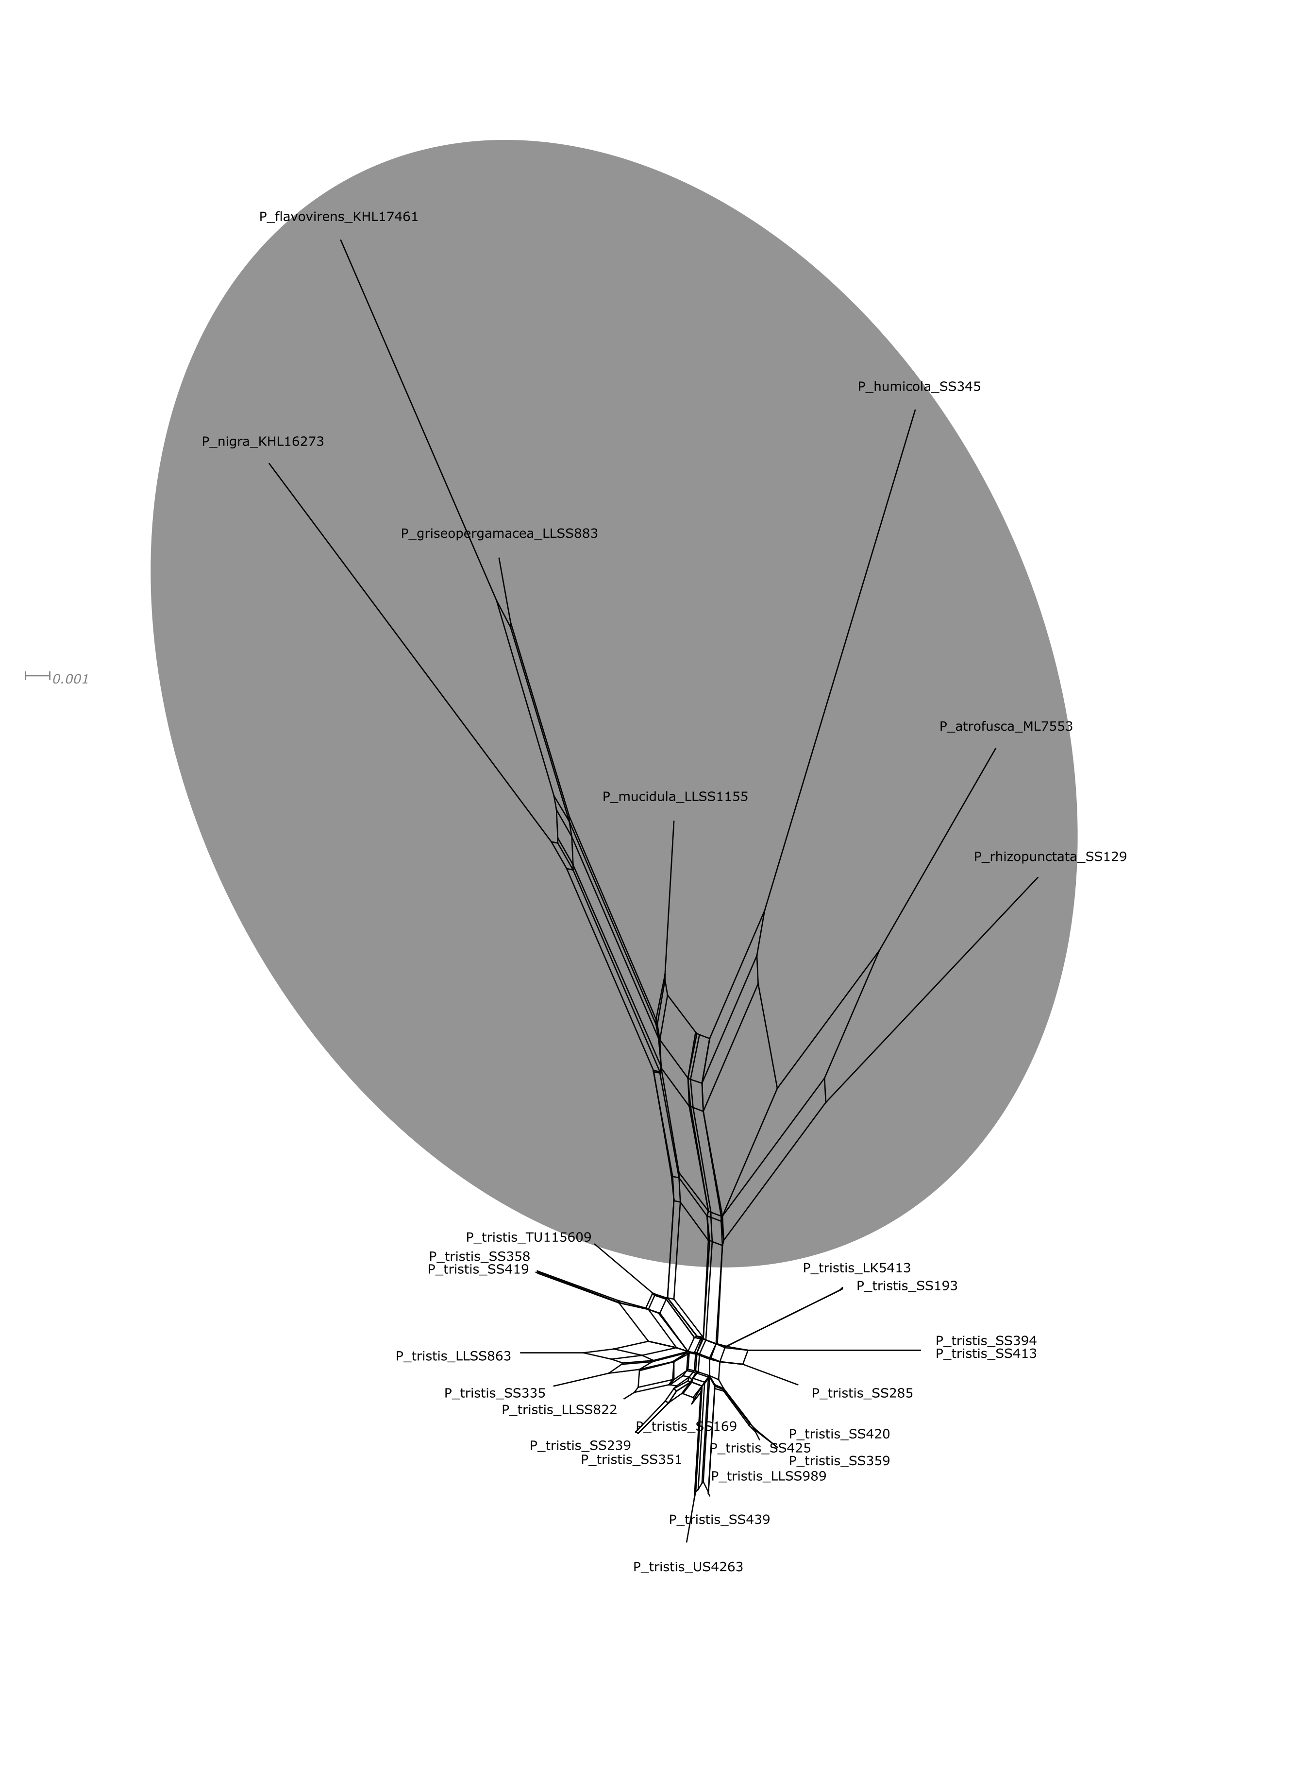
Figure S7. Neighbour net of the mtSSU alignment. The outgroup is highlighted in grey. The network is scaled in uncorrected pairwise distances.

