MycoKeys

Four new species of Tremella (Tremellales, Basidiomycota) based on morphology and DNA sequence data
Ying Zhao^{1,2}, Xin-Zhan Liu^{1*}, Feng-Yan Bai¹
¹State Key Laboratory for Mycology, Institute of Microbiology, Chinese Academy of Sciences, Beijing 100101, P.R. China
² Key Laboratory of Microbiology Diversity Research and Application of Hebei Province, College of Life Sciences, Hebei University, Baoding 071002, PR China
Correspondence to: Xin-zhan Liu
Tel./Fax: +86 10 64807352
E-mail address: liuxinzhan@im.ac.cn

Table S1 Physiological properties that differentiated the new proposed species Tremella basidiomaticola from its closely related taxa.
Abbreviations: +, positive; l, delayed positive; w, weakly positive; lw, delayed and weakly positive; -, negative; v, variable.
 | T.basidiomaticola | T. flava |  | T.yokohamensis | T. fuciformis
Fermentaion of glucose | - | - |  | - | -
Assimilation of Carbon compounds
Lactose | l | + |  | - | w
Melibiose | l | - |  | - | +
Raffinose | + | - |  | + | +
Inulin | + | - |  | w | -
Soluble starch | - | + |  | + | w
L-Rhamnose | l | - |  | w | -
Ethanol | + | - |  | + | +
Glycerol | - | + |  | - | w
DL-Lactic acid | - | - |  | - | +
Inositol | - | - |  | w | -
Assimilation of Nitrogen compounds
Nitrate | - | - |  | - | -
Nitrite | - | - |  | - | -
Other tests
Vitamin-free | + | - |  | - | v
Starch formation | + | + |  | + | +
Urease hydrolysis | + | + |  | + | +
DBB reaction | + | + |  | + | +
Growth at 25ºC | + | + |  | + | +
Growth at 30ºC | + | + |  | / | v
Growth at 32ºC | + | / |  | / | /
Growth at 35ºC | v | / |  | / | /

Figure S1. The phylogenetic relationships of the novel species with related taxa in Tremella sensu stricto based on the sequences of the ITS1 region (a); 5.8S rRNA (b); ITS2 region (c) and LSU rRNA D1/D2 domains (d). The tree backbone was constructed using the maximum likelihood analysis. Bootstrap supports (BP) over 50% from 1000 replicates and posterior probabilities (PP) of Bayesian inference above 0.9 are shown respectively from left to right. Note: ns, not supported (BP < 50% or BP < 0.9).
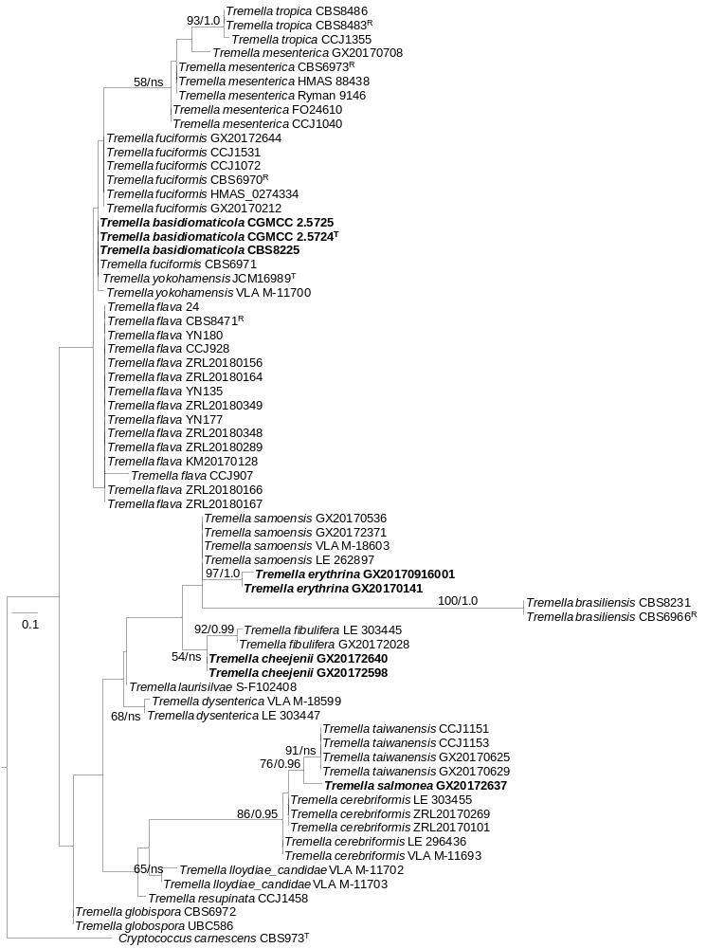Figure S1(a)
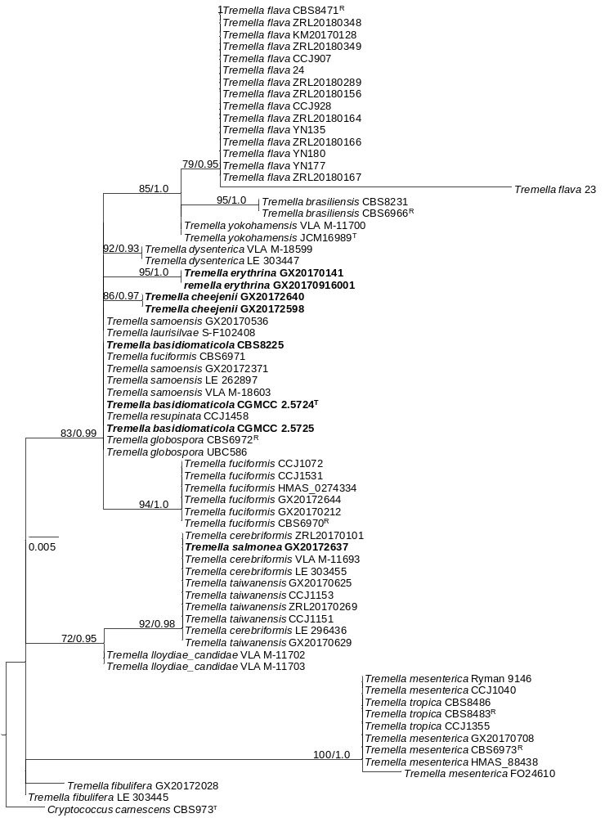Figure S1(b)
Figure S1(c)
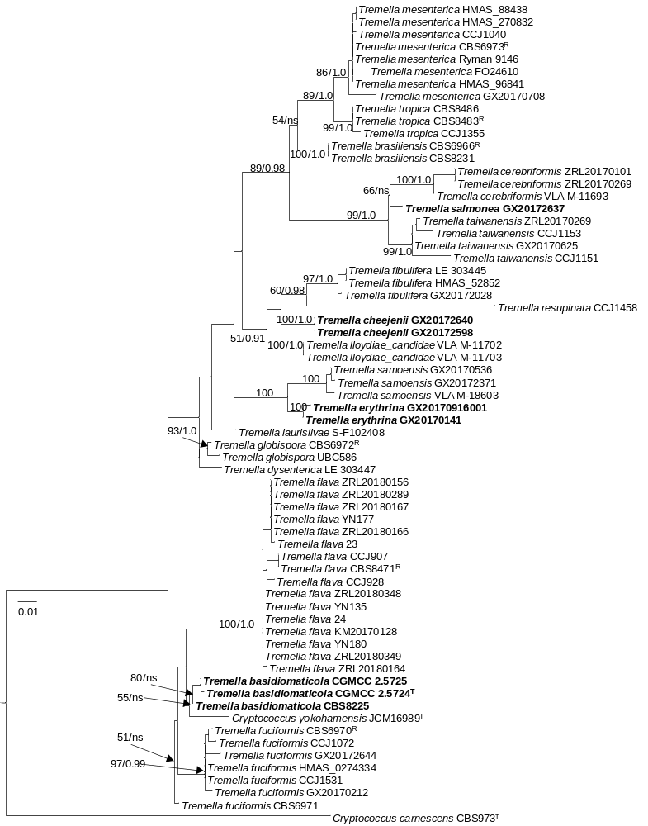Figure S1(d)

