Supplementary informations
Using field-based entomological research to promote awareness about forest ecosystem conservation

Figure S1. Introduction of insect forest inventory with the use of aerial fruit traps (butterflies, wasps) and pitfall traps (ants, beetles and spiders) commonly employed by entomologists in the understory and in the canopy.
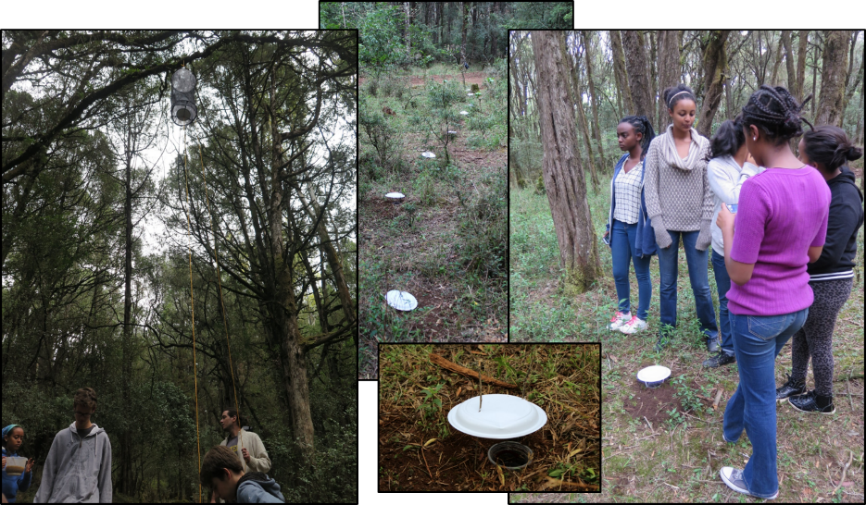

.
Figure S2. Words Cloud of the mostly used words of the test-group that followed the program to the question: “What terminology qualify best the role of insect in terrestrial biodiversity? Choose maximum 3 words (N=42) “.
