Supplementary material 2
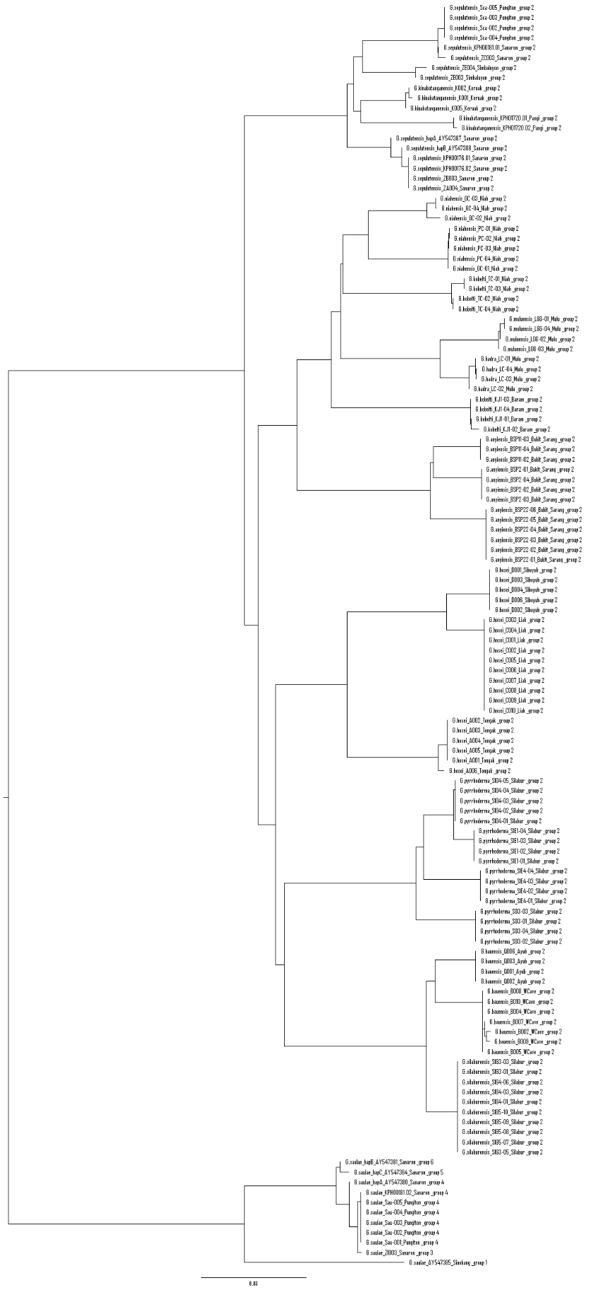
Figure S2.1 “Scaly” Georissa partitioning based on ABGD analysis at the lowest intraspecific divergence by using 16S mtDNA sequence alignment.

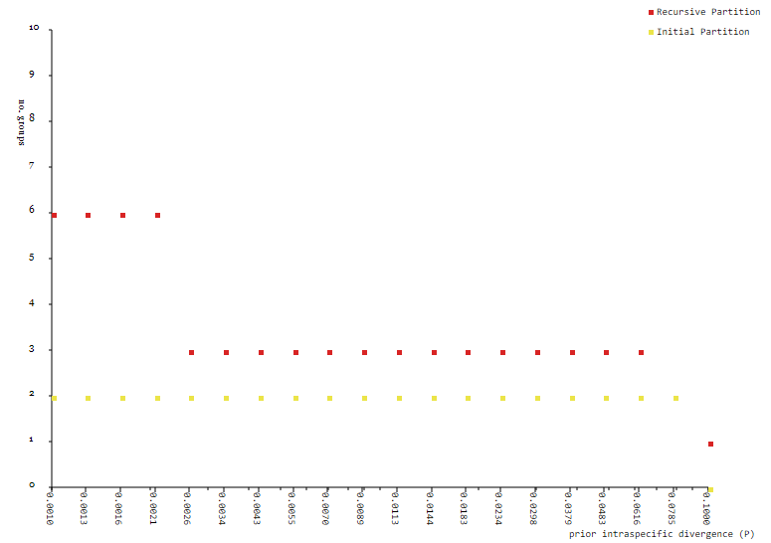
Figure S2.2 Number of groups from both initial and recursive partitioning from ABGD analysis at different level of intraspecific divergence.

