Supplementary Material 4. Details of the forestry trial at Damara Farm, South Africa, that included many species of wattles not previously recorded from South Africa

The forestry trial at Damara Farm in the Western Cape near Malmesbury significantly increased the number of species recorded to have been introduced and that are still present in South Africa. The possible presence of other such trials on private land represents a major source of uncertainty when compiling alien plant lists.
The trial plantation at Damara Farm was part of the Forestry Faculty of the University of Stellenbosch to plant trees at six dry land trial locations. The aim of the trial was to investigate tree species that could be planted for commercial purposes. In 1997, it was decided to extend the existing dryland trials into research in agroforestry system that could be used by small farmers (Fig. 1). Then, Mr Armstrong (owner of the Damara Farm) was approached to give advice about how to conduct these trials, since he had experience in tree planting and offerred to provide land to do these trials. In 1998, seeds of 33 Australian acacias provided by the Department of Environmental Affairs were planted at Damara Farm. Based on the observed populations at Damara Farm, none of the species left is outside of cultivation. On most individuals, we either observed no pods or flowers or saw flowers or pods with damage from biological agents. A few individuals had pods and seed with seedlings underneath and some were suckering, but there is no evidence that any have reached reproductive maturity (these species might arguably be C2 according to the Unified Framework for Biological Invasions see Appendix 1, but cannot be considered naturalised). From the molecular analysis, however, we could only identify 18 putatively distinct genetic entities, at least two of which had not been recorded in the trial report— A. hakeoides and A. ramulosa. On-going work by colleagues to collect comprehensive herbarium specimens that will be sent to Australia for identification and linked to the molecular samples here will hopefully help resolve much of the uncertainty.

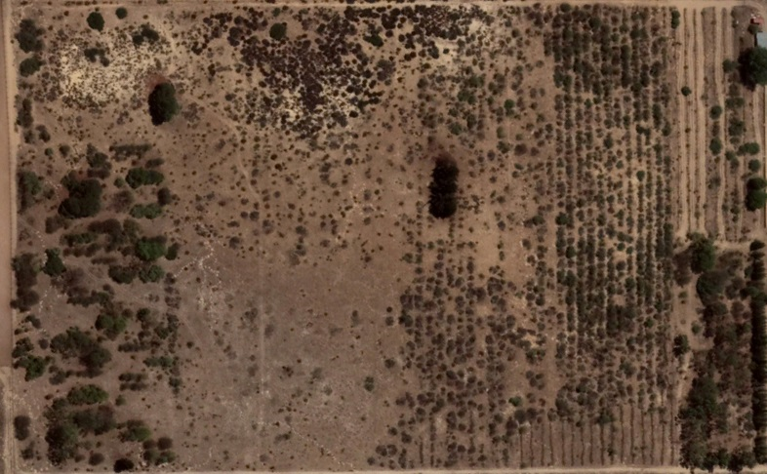

Figure S4 Google Earth image from 18 January 2018 of the trial on Damara Farm. Large wattles (presumably part of the original plantings) are visible to the far left, the bottom right, and a few in the centre of the image. The surrounding areas are largely farmland. None of the species has been observed to spread.

Table S4 Australian Acacia species recorded as having been planted at Damara Farm, Western Cape, South Africa. Note: no authorities are given, nor links to herbarium specimens. There is not a single comprehensive list of species in the report and this table represents a combination of Appendix 3 (Acacia spp. used in Acacia trial at Damara Farm (July 1998)); Appendix 4 (Species in the Sylvopastoral trial, at Damara Farm (July 1998)); and an unlabelled appendix (Basic information with regards to the Species planted at Damara Farm) (Gibbs, 1998).

Acacia species | Individuals reported to have survived
A. ampliceps | yes
A. acumunata | yes
A. ancistrocarpa | no
A. aneura | yes
A. auriculiformis | no
A. bivenosa | yes
A. brachystachya | yes
A. burrowii | no
A. calcicola | yes
A. cambagei | survival not recorded
A. colei | yes
A. coriacea | yes
A. difficilis | yes
A. elecantha | yes
A. harpophylla | yes
A. hemsleyii | yes
A. holosericea | yes
A. julifera | no
A. kempeana | survival not recorded
A. leptocarpa | no
A. ligulata | yes
A. maconochieana | yes
A. monticola | no
A. murrayana | no
A. neriifolia | yes
A. plectocarpa | yes
A. pruinocarpa | yes
A. salicina | yes
A. sclerosperma | yes
A. stenophylla | yes
A. tumida | yes
A. victoriae | yes
A. xiphophylla | yes

Gibbs, L. (1998) West Coast dryland forestry trials: as part of the species provenance and demonstration trials in arid zones to establish potential for cummunity development, Report UST 4/97-2. pp. 20. Stellenbosch University, Stellenbosch

