Fine-scale interactions between habitat quality and genetic variation suggest an impact of grazing on the critically endangered grasshopper, Prionotropis rhodanica
–
Appendix

Piry S.¹*, Berthier K.²*, Streiff, R.¹, Cros-Arteil S.³, Foucart A.^{4,5}, Tatin L.⁶, Bröder L.⁷, Hochkirch A.⁷, and Chapuis M.-P. ^{4,5}

¹CBGP, INRA, CIRAD, IRD, Montpellier SupAgro, Univ Montpellier, Montpellier, France.
²Pathologie Végétale, INRA, 84140 Montfavet, France.
³BGPI, INRA, Montpellier SupAgro, CIRAD, Montpellier, France.
⁴CIRAD, CBGP, Montpellier, France.
⁵CBGP, CIRAD, INRA, IRD, Montpellier SupAgro, Univ Montpellier, Montpellier, France.
⁶Conservatoire d'espaces naturels de Provence Alpes Côte d'Azur, 13310 Saint-Martin-de-Crau.
⁷Department of Biogeography, Trier University, D-54286 Trier, Germany.
*equal contribution

Table S1 – Detail of the circle-based sampling indicating for each circle: its name (Circle), its grid, (Grid), its radius, the date of prospection (Date), the coordinates of its center (latitude/longitude WGS84, EPSG: 4326) (Latitude, Longitude), the number of individuals sampled (Nb ind), the grasshopper density in individuals per hectare (Density) and the mean value of rescaled NDVI (NDVI).
Grid | Circle | Radius (m) | Date | Latitude | Longitude | Nb ind | Density | NDVI
A | A00 | 25 | 2001-05-29 | 43,546267 | 4,828405 | 0 | 0.0 | 0.4241
A | A01 | 25 | 2001-05-29 | 43,548290 | 4,828482 | 0 | 0.0 | 0.4135
A | A02 | 25 | 2001-05-29 | 43,544189 | 4,831099 | 0 | 0.0 | 0.4084
A | A03 | 25 | 2001-05-29 | 43,546255 | 4,831204 | 1 | 5.1 | 0.3804
A | A04 | 25 | 2001-05-27 | 43,548244 | 4,831290 | 0 | 0.0 | 0.4117
A | A05 | 25 | 2001-05-29 | 43,550273 | 4,831351 | 0 | 0.0 | 0.4070
A | A06 | 25 | 2001-05-27 | 43,542041 | 4,833789 | 0 | 0.0 | 0.4010
A | A07 | 25 | 2001-05-27 | 43,544113 | 4,833932 | 1 | 5.1 | 0.3642
A | A08 | 25 | 2001-05-27 | 43,546104 | 4,834060 | 0 | 0.0 | 0.3660
A | A09 | 25 | 2001-05-26 | 43,548127 | 4,834119 | 0 | 0.0 | 0.3714
A | A10 | 25 | 2001-05-28 | 43,550176 | 4,834185 | 0 | 0.0 | 0.3787
A | A11 | 25 | 2001-05-28 | 43,552263 | 4,834219 | 1 | 5.1 | 0.3948
A | A12 | 25 | 2001-05-26 | 43,541989 | 4,836660 | 0 | 0.0 | 0.3789
A | A13 | 25 | 2001-05-26 | 43,544018 | 4,836728 | 0 | 0.0 | 0.3759
A | A14 | 25 | 2001-05-26 | 43,546055 | 4,836813 | 0 | 0.0 | 0.3765
A | A15 | 25 | 2001-05-26 | 43,548114 | 4,836913 | 0 | 0.0 | 0.3607
A | A16 | 25 | 2001-05-26 | 43,550145 | 4,836982 | 0 | 0.0 | 0.3746
A | A17 | 25 | 2001-05-26 | 43,552152 | 4,837059 | 0 | 0.0 | 0.3715
A | A18 | 25 | 2001-05-26 | 43,543948 | 4,839523 | 0 | 0.0 | 0.3774
A | A19 | 25 | 2001-05-26 | 43,545980 | 4,839590 | 0 | 0.0 | 0.3740
A | A20 | 25 | 2001-05-25 | 43,548014 | 4,839677 | 0 | 0.0 | 0.3668
A | A21 | 25 | 2001-05-26 | 43,550063 | 4,839790 | 0 | 0.0 | 0.3859
A | A22 | 25 | 2001-05-24 | 43,552093 | 4,839880 | 0 | 0.0 | 0.4162
A | A23 | 25 | 2001-05-24 | 43,554130 | 4,839944 | 10 | 51.3 | 0.4137
A | A24 | 25 | 2001-05-24 | 43,545928 | 4,842423 | 0 | 0.0 | 0.3803
A | A25 | 25 | 2001-05-24 | 43,547943 | 4,842561 | 1 | 5.1 | 0.3835
A | A26 | 25 | 2001-05-25 | 43,550021 | 4,842556 | 0 | 0.0 | 0.4159
A | A27 | 25 | 2001-05-24 | 43,552029 | 4,842653 | 9 | 46.1 | 0.4363
A | A28 | 25 | 2001-05-24 | 43,554073 | 4,842702 | 19 | 97.4 | 0.4167
A | A29 | 25 | 2001-05-23 | 43,556081 | 4,842808 | 8 | 41.0 | 0.4296
A | A30 | 25 | 2001-05-23 | 43,547880 | 4,845294 | 0 | 0.0 | 0.3992
A | A31 | 25 | 2001-05-23 | 43,549915 | 4,845375 | 3 | 15.4 | 0.4051
A | A32 | 25 | 2001-05-23 | 43,551971 | 4,845444 | 7 | 35.9 | 0.4339
A | A33 | 25 | 2001-05-23 | 43,554006 | 4,845532 | 2 | 10.3 | 0.4511
A | A34 | 25 | 2001-05-23 | 43,556052 | 4,845593 | 0 | 0.0 | 0.4367
A | A35 | 25 | 2001-05-22 | 43,549887 | 4,848158 | 0 | 0.0 | 0.4244
A | A36 | 25 | 2001-05-22 | 43,551951 | 4,848263 | 1 | 5.1 | 0.4361
A | A37 | 25 | 2001-05-22 | 43,553996 | 4,848305 | 4 | 20.5 | 0.4361
A | A38 | 25 | 2001-05-22 | 43,556044 | 4,848391 | 12 | 61.5 | 0.4323
A | A39 | 25 | 2001-05-22 | 43,549841 | 4,850945 | 0 | 0.0 | 0.4692
A | A40 | 25 | 2001-05-22 | 43,551872 | 4,851023 | 0 | 0.0 | 0.4182
A | A41 | 25 | 2001-05-22 | 43,553846 | 4,851142 | 21 | 107.6 | 0.4161
A | A42 | 25 | 2001-05-21 | 43,555905 | 4,851173 | 17 | 87.1 | 0.4326
A | A43 | 25 | 2001-05-21 | 43,551784 | 4,853824 | 3 | 15.4 | 0.4042
A | A44 | 25 | 2001-05-21 | 43,553802 | 4,853905 | 0 | 0.0 | 0.4062
A | A45 | 25 | 2001-05-21 | 43,555844 | 4,854012 | 2 | 10.3 | 0.4094
A | A46 | 25 | 2001-05-21 | 43,555781 | 4,856803 | 0 | 0.0 | 0.4124
A | A47 | 25 | 2001-05-21 | 43,557820 | 4,856924 | 8 | 41.0 | 0.4334
A | A63 | 25 | 2001-05-29 | 43,553711 | 4,859515 | 1 | 5.1 | 0.4083
A | A64 | 25 | 2001-05-29 | 43,555744 | 4,859601 | 0 | 0.0 | 0.4079
A | A65 | 25 | 2001-05-29 | 43,557763 | 4,859696 | 0 | 0.0 | 0.4086
B | B04 | 25 | 2001-05-29 | 43,543081 | 4,832502 | 0 | 0.0 | 0.3888
B | B09 | 25 | 2001-05-30 | 43,541015 | 4,835229 | 2 | 10.3 | 0.4200
B | B10 | 25 | 2001-05-29 | 43,543048 | 4,835356 | 1 | 5.1 | 0.3665
B | B11 | 25 | 2001-05-30 | 43,545002 | 4,835380 | 0 | 0.0 | 0.3730
B | B16 | 25 | 2001-05-30 | 43,542940 | 4,838118 | 0 | 0.0 | 0.4024
B | B21 | 25 | 2001-05-31 | 43,553120 | 4,838504 | 0 | 0.0 | 0.3882
B | B25 | 25 | 2001-05-31 | 43,551032 | 4,841178 | 0 | 0.0 | 0.3891
B | B26 | 25 | 2001-05-31 | 43,553066 | 4,841280 | 3 | 15.4 | 0.4326
B | B27 | 25 | 2001-05-31 | 43,555130 | 4,841379 | 3 | 15.4 | 0.4234
B | B29 | 25 | 2001-05-31 | 43,548946 | 4,843892 | 0 | 0.0 | 0.4005
B | B30 | 25 | 2001-05-31 | 43,551098 | 4,843989 | 2 | 10.3 | 0.4107
B | B31 | 25 | 2001-05-31 | 43,553033 | 4,844086 | 8 | 41.0 | 0.4098
B | B32 | 25 | 2001-05-31 | 43,555057 | 4,844174 | 2 | 10.3 | 0.4399
B | B33 | 25 | 2001-05-30 | 43,557099 | 4,844257 | 0 | 0.0 | 0.4737
B | B34 | 25 | 2001-05-31 | 43,548883 | 4,846700 | 0 | 0.0 | 0.4065
B | B35 | 25 | 2001-05-30 | 43,550925 | 4,846785 | 0 | 0.0 | 0.4145
B | B36 | 25 | 2001-05-30 | 43,552952 | 4,846877 | 0 | 0.0 | 0.4590
B | B37 | 25 | 2001-05-29 | 43,555004 | 4,846978 | 0 | 0.0 | 0.4509
B | B38 | 25 | 2001-05-29 | 43,556992 | 4,847102 | 3 | 15.4 | 0.4382
B | B40 | 25 | 2001-05-30 | 43,550848 | 4,849593 | 1 | 5.1 | 0.4176
B | B41 | 25 | 2001-05-30 | 43,552896 | 4,849675 | 1 | 5.1 | 0.4155
B | B42 | 25 | 2001-05-29 | 43,554919 | 4,849767 | 15 | 76.9 | 0.4347
B | B43 | 25 | 2001-05-28 | 43,556955 | 4,849840 | 26 | 133.3 | 0.4286
B | B44 | 25 | 2001-05-30 | 43,550806 | 4,852386 | 0 | 0.0 | 0.4380
B | B45 | 25 | 2001-05-29 | 43,552815 | 4,852447 | 4 | 20.5 | 0.4170
B | B47 | 25 | 2001-05-28 | 43,556884 | 4,852607 | 7 | 35.9 | 0.4125
B | B48 | 25 | 2001-05-28 | 43,552731 | 4,855278 | 0 | 0.0 | 0.4096
B | B49 | 25 | 2001-05-28 | 43,554822 | 4,855233 | 2 | 10.3 | 0.4007
B | B50 | 25 | 2001-05-27 | 43,556819 | 4,855407 | 1 | 5.1 | 0.4100
B | B51 | 25 | 2001-05-27 | 43,558797 | 4,858315 | 5 | 25.6 | 0.4368
 | C1 | 50 | 2001-05-25 | 43,554523 | 4,852688 | 55 | 70.5 | 0.4214

Table S2. Eleven microsatellite loci developed for Prionotropis rhodanica. PCR and eletrophoresis multiplex sets and conditions were updated compared to previous studies. The observed size range was computed from the 266 individuals sampled for the present study.
Locus | Primer sequences (5’-3’) | Core repeat units | Dye | PCR  multiplex set# | Electrophoresis multiplex set$ | Size range (bp)
Phr880ª | F: GAAACAGCGCCTTAAAATTAGT  R: CTATGGGGTTGTAAGTTTCAGAC | (GT)₉A(TG)₁₄...(GT)₆ | VIC | 1 | 1 | [155-199]
Phr2Tª | F: CGTGTCAACCGCAAAGT  R: CAGAACCTGAAAATCAGCAG | (GT)₄A(TG)₁₃ | FAM | 2 | 2 | [112-144]
Phr228ª | F: ACCGATACTATGATGGTTCATTG  R: GCTTTGTCCAGTCTCTATCTCC | (CA)₆...(AC)₁₃(GCAC)₃(AC)₄ | FAM | 1 | 1 | [259-273]
Phr7178ª | F: AGAGTAGCCGAGAACACG  R: GATCCATCATTGTATTAACAC | (GT)₁₁ | FAM | 1 | 1 | [107-115]
Phr4H3b^{b} | F:ATGATGGGATCGCTGAC  R:GAGTATGGTAGCTTGTAAGAGG | (AG)₁₀...(AG)₅...(GC)₅(GT)₁₆ | PET | 3 | 2 | [194-213]
Phr1C7^{b} | F:TCCGCACGTGGTGACATTGG  R:CTCACCTGTGAGTCGCTACTGG | (CA)₁₅ | NED | 2 | 2 | [127-172]
Phr2C3^{b} | F:AGTTGTGCGAGCATCAG  R:GTCATCAGGCAATGCTAA | (AG)₂₀ | FAM | 2 | 2 | [210-231]
Phr3B3^{b} | F:ACCGCTGCGAATGACAGGTA  R:GCCAGCCTTGACAACACATATC | (TG)₈...GA)₉AA(GA)₁₅ | NED | 1 | 1 | [186-245]
Phr4G1^{b} | F:CAGCATAATTGCATTAGTAACCAG  R:GTCCATCGAGCGAGCTAGG | (GA)₆T(AG)₁₄ | FAM | 1 | 1 | [161-192]
Phr4A10^{b} | F:ATTGGCGCAGGACAGGAAGA  R:GTTACACGTAGCAACGGAACAGC | (GA)₁₇ | NED | 2 | 2 | [185-235]
Phr756 | F: AGGTTTCTGATGCCAACAGG  R: GGGCTAAAAGAAAGGCACAG | (GT)₁₄ | FAM | 2 | 2 | [166-191]
ªSee further details in Streiff R, Mondor-Genson G, Audiot P, Rasplus J-Y (2002) Microsatellite DNA markers for a grasshopper : Prionotropis hystrix rhodanica (Orthoptera, Pamphagidae). Molecular Ecology Notes 2, 265-267.
^{b}See further details in Streiff R, Audiot P, Foucart A, Lecoq M, Rasplus JY (2005) Genetic survey of two endangered grasshopper subspecies, Prionotropis hystrix rhodanica and Prionotropis hystrix azami (Orthoptera, Pamphagidae): within- and between-population dynamics at the regional scale. Conservation Genetics 7, 331-344.
#Three multiplex fluorescent PCR were performed. For each PCR multiplex set, we used the Qiagen Multiplex Kit (QIAGEN) in a 10µL volume containing 1X QIAGEN multiplex PCR Master Mix (providing a final concentration of 3 mM MgCl2), 0.2 µM each primer and 2 µL of genomic DNA (ca. 10 ng DNA/reaction). Cycling conditions were as follows: an initial denaturing step of 15 min at 95°C followed by a further 40 cycles at 94°C (30 s), 60°C (90 s), 72°C (60 s); and a final extension at 60°C for 30 min.
$Two multiplex electrophoresis were performed. For each electrophoresis multiplex set, we used an ABI PRISM 310 sequencing machine (Applied Biosystems) using a 20 µL volume containing 0.1 µL of GS-500LIZ-labelled internal marker size standard (Applied Biosystems), 18.9 µL of formamide and 1 µL of PCR products diluted 1:10.

Figure S1. Analysis of the spatial distribution: estimation of the Ripley K function using different edge correction techniques and theoretical expectation under spatial randomness. K_{iso} (black color): Ripley isotropic correction estimate; K_{trans} (red color): translation-corrected estimate; K_{bord} (green color): border-corrected estimate; K_{pois} (blue color): theoretical K function under complete spatial randomness. Both estimate (dotted line) and lower and higher confidence envelope (solid lines) are represented. The high similarity between the free empirical estimates means that K can be correctly estimated from the data. The empirical estimates clearly stand above the theoretical function, which support that individuals are highly aggregated in space.

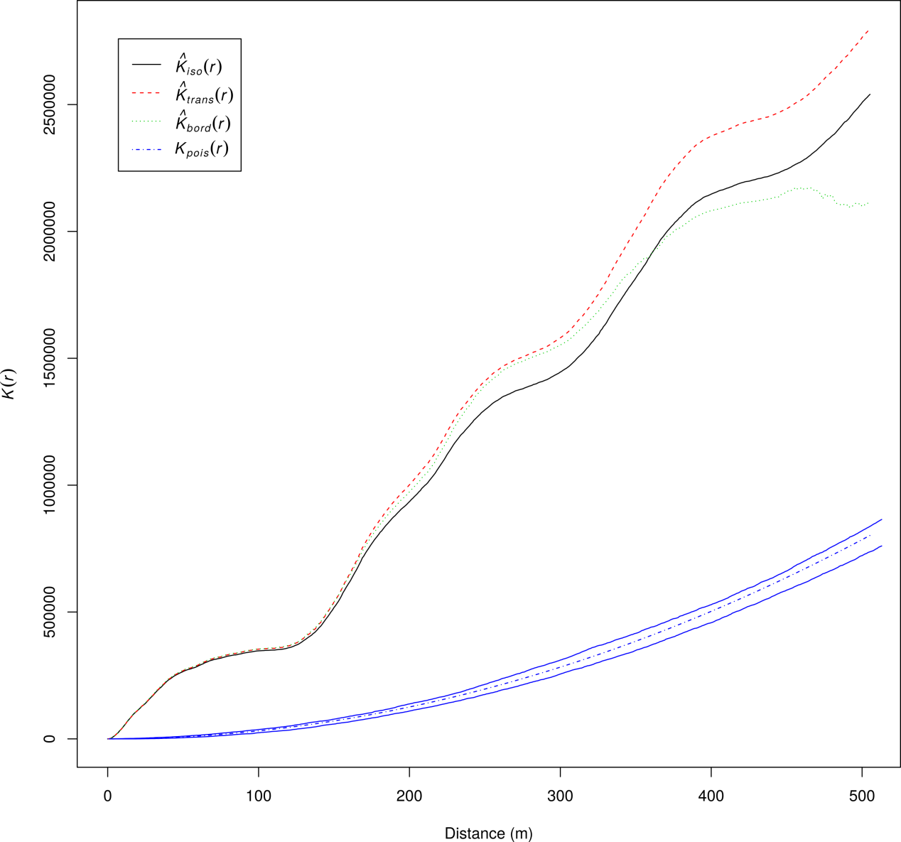

Figure S2 – Illustration of the regression of MODIS reference NDVI values against rescaled Landsat NDVI values: Intercept = 0.2398689, Slope = 0.6944841, r² = 0.7282.
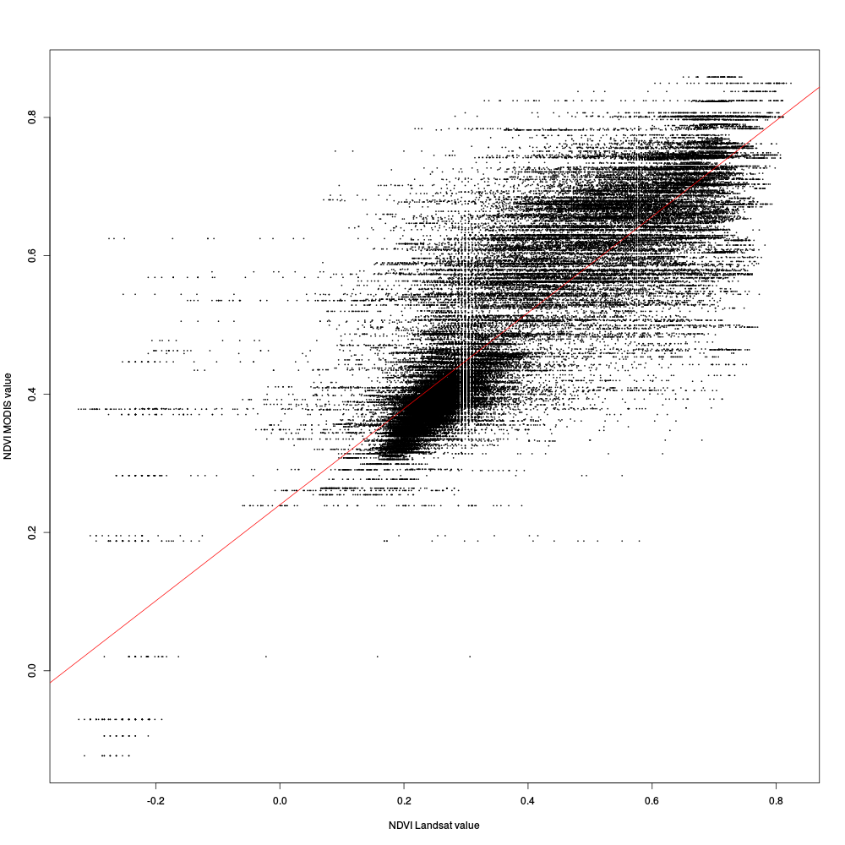

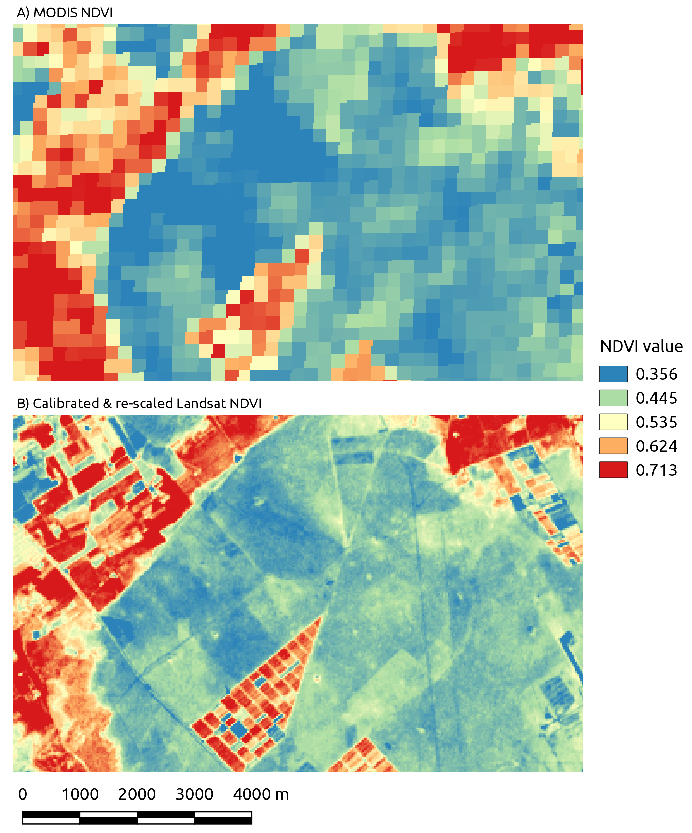
Figure S3 – Maps of A) MODIS NDVI reference values and B) calibrated Landsat NDVI values

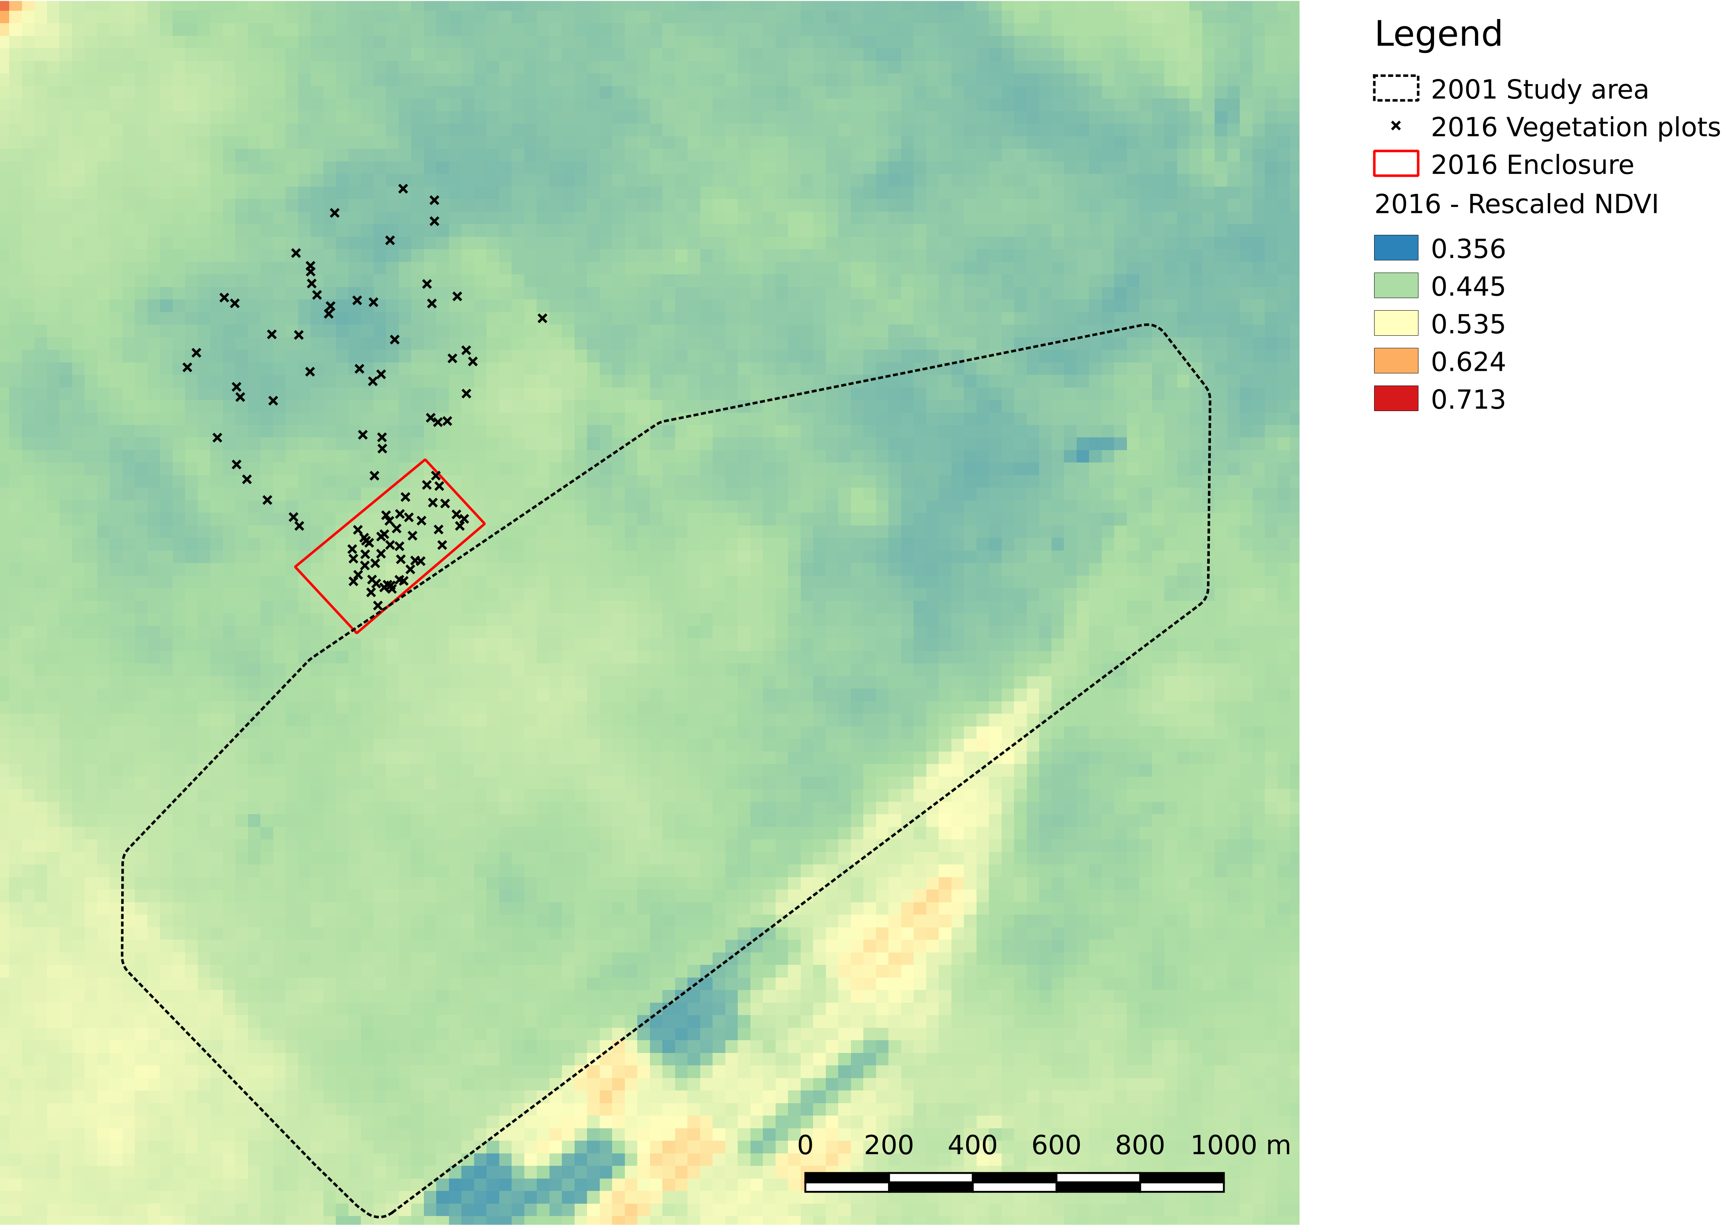
Figure S4 Localization of the enclosure and plots were vegetation productivity indices have been measured in 2016. The study area considered in 2001 is delineated by a black line and the map background corresponds to the 2016-rescaled NDVI.

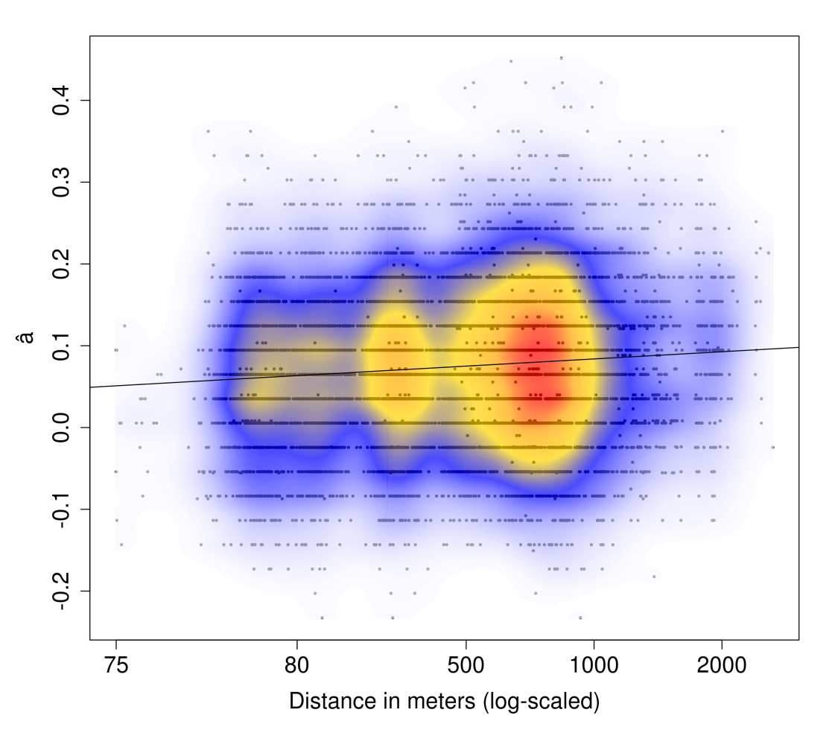
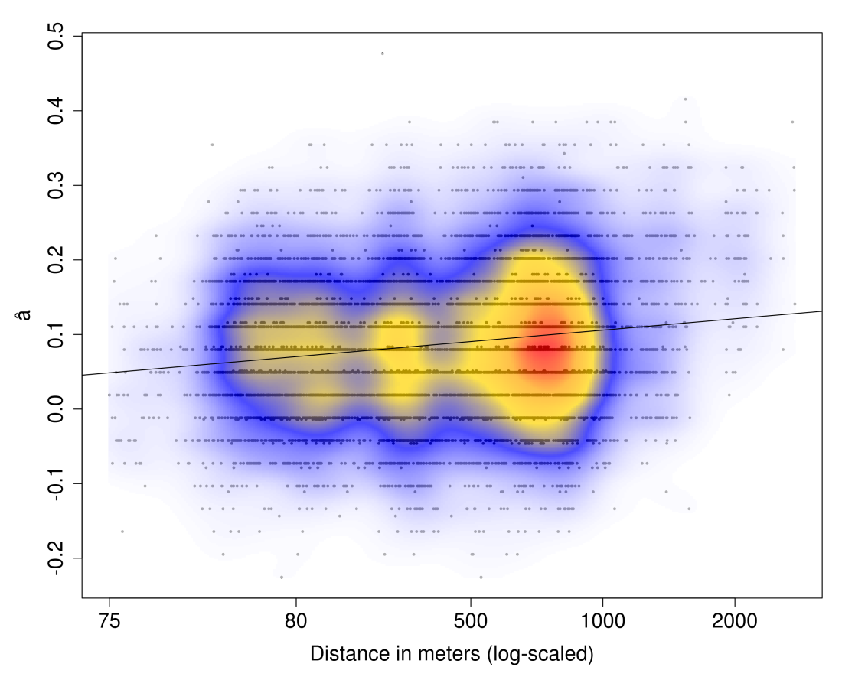
Figure S5 - Linear regression between genetic distance â and geographical distances computed between A) males and B) females. Variation in point density is represented by colors, from blue (low density) to red (high density).

A)

B)

Figure S6 -Boxplots comparing the distribution of the four vegetation productivity indices between plots located inside and outside the enclosure. The boxplots show the median in the middle (bold black line), upper and lower quartiles, and upper and lower fences. Outliers which are more or less than 1.5 times the upper or lower quartiles are represented by white circles.

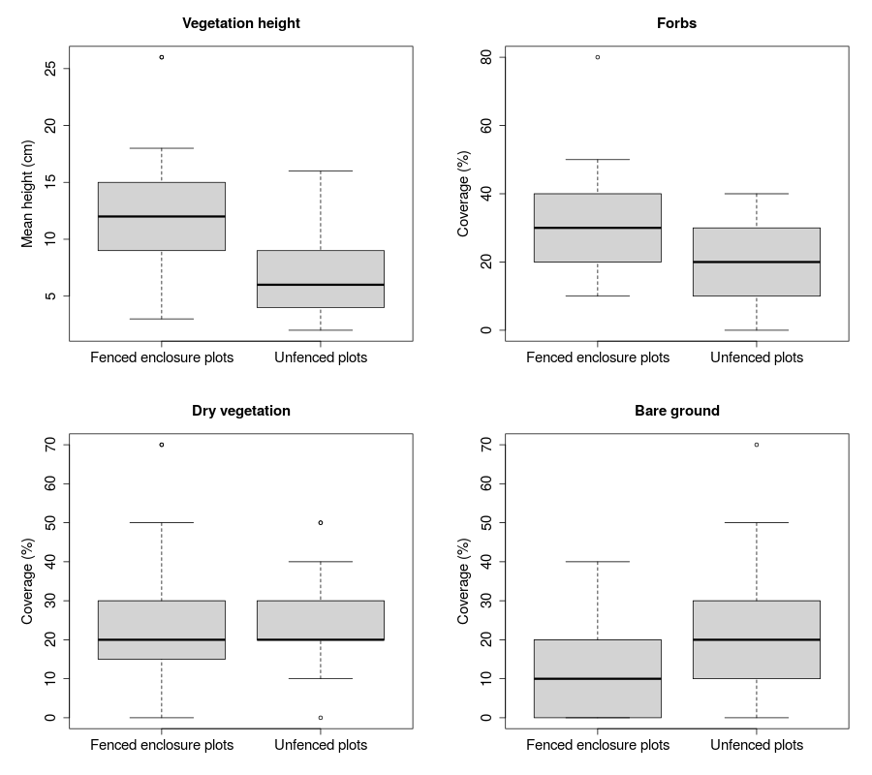

Figure S7 - Boxplots comparing the distribution of the rescaled NDVI values between plots located inside and outside the enclosure before (2014) and after (2016) fencing. The boxplots show the median in the middle (bold black line), upper and lower quartiles, and upper and lower fences

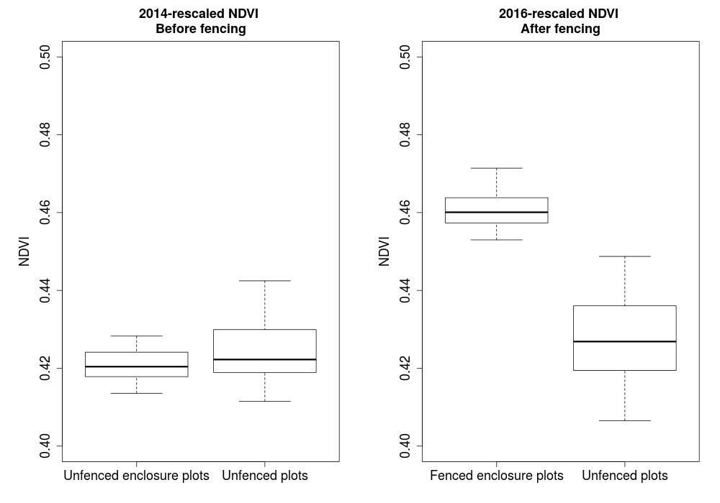

Figure S8 - Comparison of the MAPI results when using the complete dataset (top) or the resampled datasets with a maximum of three individuals from each circle (bottom). For clarity sake values obtained from the resampled datasets have been averaged within each cell of the grid.

