Supplementary materials

Taxonomic diversity of amphibians (Amphibia, Anura) and reptiles (Reptilia, Testudines, Squamata) in a heterogeneous landscape in west-central Mexico: a checklist and notes on their geographical distributions

Verónica Carolina Rosas-Espinoza¹, Eliza Álvarez-Grzybowska¹, Arquímedes Alfredo Godoy González¹, Ana Luisa Santiago-Pérez², Karen Elizabeth Peña-Joya³, Fabián Alejandro Rodríguez-Zaragoza¹, Leopoldo Díaz Pérez¹ and Francisco Martín Huerta Martínez*⁴
¹Laboratorio de Ecología Molecular, Microbiología y Taxonomía (LEMITAX), Departamento de Ecología, Centro Universitario de Ciencias Biológicas y Agropecuarias, Universidad de Guadalajara, Camino Ramón Padilla Sánchez 2100, CP 45200, Zapopan, Jalisco, México
²Departamento de Producción Forestal, Centro Universitario de Ciencias Biológicas y Agropecuarias, Universidad de Guadalajara, Camino Ramón Padilla Sánchez 2100, CP 45200, Zapopan, Jalisco, México
³Laboratorio de Ecología, Paisaje y Sociedad, Centro Universitario de la Costa, Universidad de Guadalajara, Puerto Vallarta 48280, Jalisco, México
⁴ Centro de Estudios en Interacciones Ecológicas, Departamento de Ecología, Centro Universitario de Ciencias Biológicas y Agropecuarias, Universidad de Guadalajara, Camino Ramón Padilla Sánchez 2100, CP 45200, Zapopan, Jalisco, México
*Corresponding author: Martín Huerta Martínez (martin.huerta@academicos.udg.mx)

Supplementary Table S1. Sample-based rarefaction curves generated using presence-absence data for both amphibians and reptiles. We report observed and expected species by land cover/use type using non-parametric estimators. Codes: sugar cane field (SCF), riparian habitat surrounded by crops (RH-C), cornfield (C), highly perturbated tropical dry forest (HPTDF), tropical dry forest (TDF), riparian habitat surrounded by tropical forest (RH-TDF), riparian habitat surrounded temperate forest (RH-TF), secondary vegetation surrounded by temperate forest (SV-TF), oak forest (OF), pine-oak forest (POF) and number of species observed (Sobs).
Land cover/use type | Sobs | Chao 2 | Jackknife 1 | Jackknife 2 | Average
Amphibians
SCF | 7 | 7.22 | 8.78 | 8.29 | 8.10
RH-C | 9 | 9.67 | 11.67 | 11.96 | 11.10
C | 6 | 6.67 | 8.67 | 8.96 | 8.10
HPTDF | 8 | 8.67 | 10.67 | 10.96 | 10.10
TDF | 5 | 6.31 | 7.63 | 9.23 | 7.72
RH-TDF | 10 | 11.05 | 13.5 | 13.93 | 12.83
RH-TF | 6 | 6 | 6.88 | 6 | 6.29
SV-TF | 7 | 7 | 7.88 | 7 | 7.19
OF | 5 | 7.63 | 7.63 | 9.88 | 8.38
POF | 3 | 3 | 3.88 | 4.63 | 3.84
Reptiles
SCF | 7 | 7 | 7 | 7 | 7
RH-C | 13 | 21.89 | 17.44 | 21.33 | 20.22
C | 7 | 9.67 | 9.67 | 12 | 10.45
HPTDF | 12 | 14.96 | 16.44 | 18.97 | 16.79
TDF | 14 | 24.5 | 21.88 | 14 | 20.13
RH-TDF | 10 | 11.31 | 13.5 | 14.57 | 13.13
RH-TF | 5 | 5 | 5.88 | 5.34 | 5.41
SV-TF | 18 | 22.08 | 25 | 27.79 | 24.96
OF | 12 | 12 | 12.88 | 11.7 | 12.29
POF | 9 | 9.29 | 10.75 | 10.96 | 10.33

Supplementary Figure S1. Species with the documented range extensions. A) Sarcohyla hapsa, B) Lampropeltis ruthveni, C) Thamnophis copei, D) Imantodes gemmistratus in a heterogeneous landscape in west-central Mexico. All photos by Eliza Álvarez-Grzybowska, except B) by Aldo Dávalos Martínez.

Supplementary Figure S2. Records of Sarchohyla hapsa in Jalisco state (black triangles, GBIF 2023a). The red star shows our record of range extension for S. hapsa.

A | 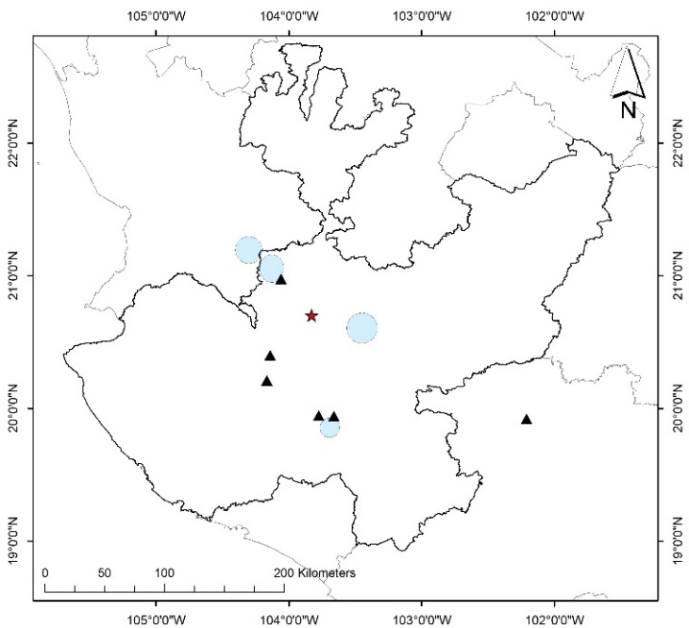  B
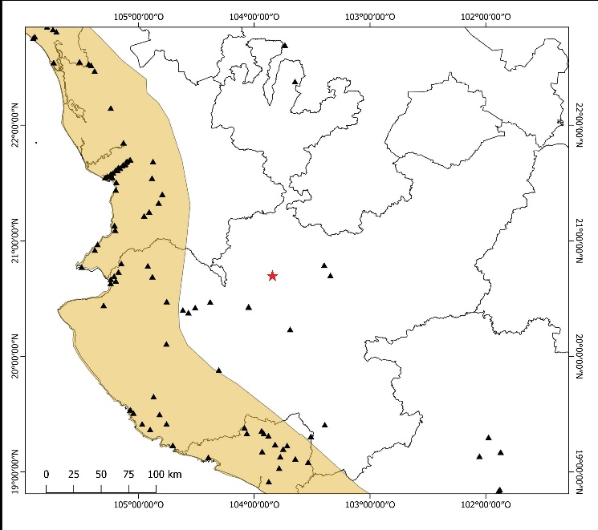
C
Supplementary Figure S3. Records of A) Lampropeltis ruthveni, B) Thamnophis copei, and C) Imantodes gemmistratus in Jalisco state (black triangles, GBIF 2023). The red stars show our records of range extension for these different species. The colored areas are published distributions (IUCN 2024).

