Supplementary Material 1
The file contains additional photos of specimenes mentioned in the main article (barcoded specimens) but not represented the main text:

Tropiduchidae Stål, 1866
Trypetimorpha occidentalis Huang & Bourgoin, 1993
CaBOL-ID 1011721

Miridae Hahn, 1831
Europiella decolor (Uhler, 1893)
CaBOL-ID 1025480

CaBOL-ID 1011721 | CaBOL-ID 1025480
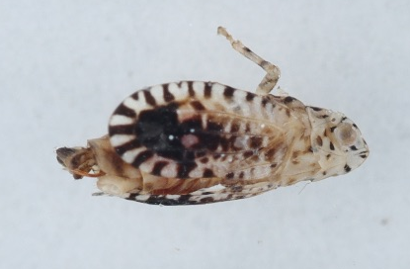 | 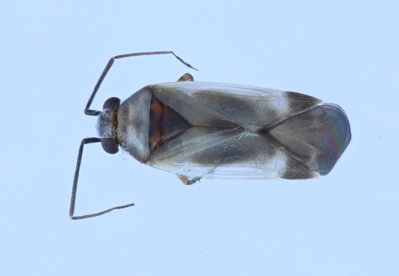

Tuponia mixticolor (A. Costa, 1862)
CaBOL-ID 1016840

Deraeocoris ventralis Reuter, 1904
CaBOL-ID 1025471

CaBOL-ID 1016840 | CaBOL-ID 1025471
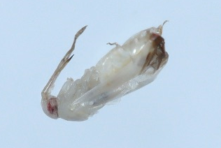 | 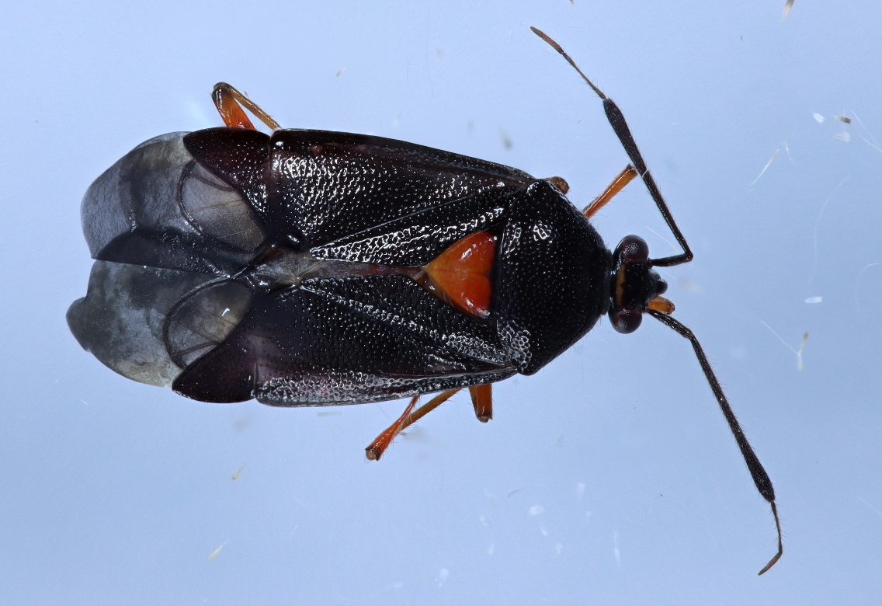

Orthocephalus brevis (Panzer, 1798)
CaBOL-ID 1035525

Nabidae Costa, 1853
Alloeorhynchus flavipes (Fieber, 1836)
CaBOL-ID 1018766

CaBOL-ID 1035525 | CaBOL-ID 1018766
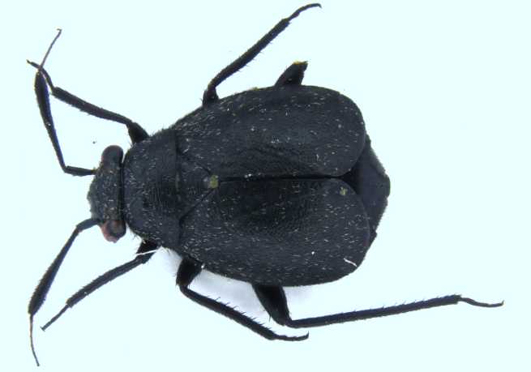 | 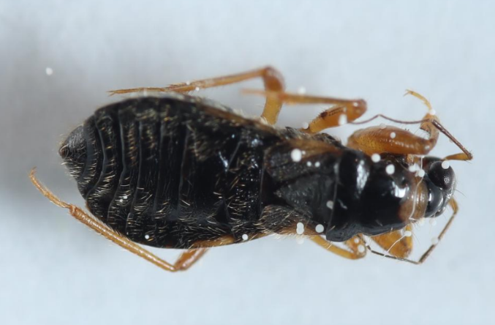

Rhyparochromidae Amyot and Serville, 1843
Diomphalus hispidulus Fieber, 1864
CaBOL-ID 1035717

