Supplementary Material for article: Variation of the stable isotope niches of native amphibians in ponds invaded by the red swamp crayfish

Nadège Belouard^{1,2,*}, Eric J. Petit², Julien Cucherousset³, Jean-Marc Paillisson¹
1 ECOBIO (Ecosystèmes, Biodiversité, Evolution), Univ Rennes, CNRS, 35042 Rennes, France
2 DECOD (Dynamique et Durabilité des Ecosystèmes), INRAE, Institut Agro, IFREMER, 35042 Rennes, France
3 Centre de Recherche sur la Biodiversité et l'Environnement (CRBE), Université de Toulouse, CNRS, IRD, Toulouse INP, Université Toulouse 3 – Paul Sabatier (UT3), Toulouse, France
*Corresponding author: nadege.belouard@gmail.com

Appendix I – Stable isotope niche metrics
Table S1. Nature and sample sizes of primary consumers for the standardization of niche metrics.
Table S2. Stable isotope niche metrics of amphibians and crayfish in each pond.
Table S3. Niche overlap between populations.
Table S4. Selection of models with ΔAICc < 2 excluding niche metrics of tree frog tadpoles.

Appendix II – Ontogenetic shift in the stable isotope values in the red swamp crayfish
Figure S1. Ontogenetic shift in δ¹³C_{cor} values of red swamp crayfish
Figure S2. Ontogenetic shift in the trophic position of red swamp crayfish
Figure S3. Stable isotope values of individuals with the associated standard ellipses, with crayfish split in adults and juveniles.
Table S5. Statistical models of the ontogenetic shift in stable isotope values of the red swamp crayfish.

Appendix I – Stable isotope niche metrics

Table S1. Name and sample sizes of primary consumers for the standardization of niche metrics. For each isotope, the mean value for each taxon and each pond was used to calculate δ¹³C_{C1}, CR_{C1} and δ¹⁵N_{m}.
 | For carbon values
 | For nitrogen values
Ponds | Corbiculidae spp. | Physa acuta | Asellus aquaticus | Corixidae spp. | Gammarus gammarus | Zooplankton
P01 | 1 | 1 | 3 | 3 | - | 3
P02 | - | 3 | 3 | 3 | - | 3
P03 | - | 3 | - | 2 | - | 2
P04 | 3 | 3 | - | 3 | - | 3
P05 | - | 3 | 2 | - | 3 | 1
P06 | 1 | 3 | 3 | 3 | 3 | 3
P07 | - | 3 | 2 | 3 | - | 1
P08 | - | 3 | - | 3 | 3 | 3
P09 | - | 3 | - | 3 | 3 | 3
P10 | 1 | 3 | 2 | 3 | 3 | 3
P11 | - | 3 | - | 3 | - | 2
P12 | 3 | - | 2 | 3 | 3 | 3
P13 | - | 3 | - | 1 | 3 | 2
P14 | - | 3 | 3 | 3 | 3 | 2
P15 | 2 | 3 | - | 3 | 3 | 3
P16 | - | 3 | - | 3 | - | 3
P17 | - | 3 | 3 | - | 3 | 3
P18 | - | 3 | - | 1 | 3 | 3

Table S2. Stable isotope niche metrics of amphibians and crayfish in each pond: niche size (SEA_{c}) and mean position (δ13C_{cor} and TP). A dash (-) indicates no population or low sample size that prevented the calculation of the metrics

Niche metrics | Pond | Crayfish | Agile frog | Tree frog | Palmate newt | Marbled newt
SEA_{c} | P01 | - | 0.162 | 0.033 | 0.076 | 0.088
 | P02 | - | - | 0.098 | 0.107 | 0.124
 | P03 | - | 0.247 | 0.107 | 0.238 | 0.121
 | P04 | - | 0.016 | 0.101 | 0.026 | 0.015
 | P05 | 0.089 | 0.024 | - | - | -
 | P06 | - | 0.034 | - | 0.044 | 0.041
 | P07 | 0.038 | 0.009 | - | - | -
 | P08 | 0.086 | 0.014 | - | 0.031 | -
 | P09 | 0.029 | 0.025 | 0.033 | 0.014 | -
 | P10 | 0.082 | 0.039 | - | 0.022 | -
 | P11 | - | 0.012 | 0.190 | 0.069 | 0.038
 | P12 | - | 0.019 | 0.035 | 0.030 | 0.020
 | P13 | 0.057 | - | - | - | -
 | P14 | 0.041 | 0.020 | 0.011 | - | -
 | P15 | 0.026 | 0.023 | 0.037 | 0.023 | -
 | P16 | 0.022 | 0.022 | - | - | -
 | P17 | 0.164 | - | - | - | -
 | P18 | 0.140 | - | - | - | -
Mean δ13Ccor | P01 | - | -0.605 | -0.605 | 0.951 | 1.141
 | P02 | - | - | 0.472 | 0.599 | 0.653
 | P03 | - | -2.368 | -1.736 | -0.631 | -1.178
 | P04 | - | -0.316 | 0.444 | 0.583 | 0.671
 | P05 | -0.514 | -1.033 | - | - | -
 | P06 | - | -0.194 | - | 0.586 | 0.728
 | P07 | 0.022 | -0.330 | - | - | -
 | P08 | 0.181 | -0.320 | - | 0.801 | -
 | P09 | 0.130 | -0.097 | -0.202 | 0.426 | -
 | P10 | -0.119 | -0.298 | - | 0.258 | -
 | P11 | - | 0.068 | -0.054 | 0.813 | 1.153
 | P12 | - | -0.107 | -0.347 | 0.550 | 0.690
 | P13 | 0.166 | - | - | - | -
 | P14 | -0.026 | -0.226 | -0.234 | - | -
 | P15 | 0.172 | -0.330 | -0.400 | 0.789 | -
 | P16 | 0.002 | -0.205 | - | - | -
 | P17 | 0.064 | - | - | - | -
 | P18 | 0.136 | - | - | - | -

Table S2. Continued

Niche metrics | Pond | Crayfish | Agile frog | Tree frog | Palmate newt | Marbled newt
Mean TP | P01 | - | 2.246 | 2.095 | 3.008 | 3.003
 | P02 | - | - | 1.490 | 2.825 | 3.147
 | P03 | - | 2.478 | 2.329 | 3.030 | 3.220
 | P04 | - | 1.965 | 2.955 | 2.380 | 2.408
 | P05 | 2.416 | 2.345 | - | - | -
 | P06 | - | 2.034 | - | 2.093 | 2.119
 | P07 | 2.867 | 2.543 | - | - | -
 | P08 | 2.983 | 1.860 | - | 3.104 | -
 | P09 | 2.643 | 2.252 | 2.326 | 2.706 | -
 | P10 | 2.807 | 2.029 | - | 2.547 | -
 | P11 | - | 2.210 | 2.640 | 2.413 | 2.296
 | P12 | - | 1.931 | 2.715 | 1.932 | 2.086
 | P13 | 1.905 | - | - | - | -
 | P14 | 2.567 | 2.049 | 2.734 | - | -
 | P15 | 2.386 | 2.005 | 1.951 | 2.423 | -
 | P16 | 2.694 | 2.520 | - | - | -
 | P17 | 2.398 | - | - | - | -
 | P18 | 2.090 | - | - | - | -

Table S3. Niche overlap between populations. Overlap was expressed as the proportion of species 1’s standard ellipse that is overlapped by species 2.

Pond | Species 1 | Species 2 | Niche overlap |  | Pond | Species 1 | Species 2 | Niche overlap
P05 | Agile frog | Crayfish | 0 |  | P01 | Palmate newt | Tree frog | 0
P07 | Agile frog | Crayfish | 0 |  | P02 | Palmate newt | Tree frog | 0
P08 | Agile frog | Crayfish | 0 |  | P03 | Palmate newt | Tree frog | 0
P09 | Agile frog | Crayfish | 0 |  | P04 | Palmate newt | Tree frog | 0
P10 | Agile frog | Crayfish | 0 |  | P09 | Palmate newt | Tree frog | 0
P14 | Agile frog | Crayfish | 0 |  | P11 | Palmate newt | Tree frog | 0
P15 | Agile frog | Crayfish | 0 |  | P12 | Palmate newt | Tree frog | 0
P16 | Agile frog | Crayfish | 0 |  | P15 | Palmate newt | Tree frog | 0
P09 | Tree frog | Crayfish | 0 |  | P01 | Marbled newt | Tree frog | 0
P14 | Tree frog | Crayfish | 0 |  | P02 | Marbled newt | Tree frog | 0
P15 | Tree frog | Crayfish | 0 |  | P03 | Marbled newt | Tree frog | 0
P08 | Palmate newt | Crayfish | 0 |  | P04 | Marbled newt | Tree frog | 0
P09 | Palmate newt | Crayfish | 0 |  | P11 | Marbled newt | Tree frog | 0
P10 | Palmate newt | Crayfish | 0 |  | P12 | Marbled newt | Tree frog | 0
P15 | Palmate newt | Crayfish | 0 |  | P01 | Agile frog | Palmate newt | 0
P01 | Tree frog | Agile frog | 0.59 |  | P03 | Agile frog | Palmate newt | 0
P03 | Tree frog | Agile frog | 0.20 |  | P04 | Agile frog | Palmate newt | 0
P04 | Tree frog | Agile frog | 0 |  | P06 | Agile frog | Palmate newt | 0
P09 | Tree frog | Agile frog | 0 |  | P08 | Agile frog | Palmate newt | 0
P11 | Tree frog | Agile frog | 0 |  | P09 | Agile frog | Palmate newt | 0
P12 | Tree frog | Agile frog | 0 |  | P10 | Agile frog | Palmate newt | 0
P14 | Tree frog | Agile frog | 0 |  | P11 | Agile frog | Palmate newt | 0
P15 | Tree frog | Agile frog | 0.31 |  | P12 | Agile frog | Palmate newt | 0
P01 | Palmate newt | Agile frog | 0 |  | P15 | Agile frog | Palmate newt | 0
P03 | Palmate newt | Agile frog | 0 |  | P01 | Tree frog | Palmate newt | 0
P04 | Palmate newt | Agile frog | 0 |  | P02 | Tree frog | Palmate newt | 0
P06 | Palmate newt | Agile frog | 0 |  | P03 | Tree frog | Palmate newt | 0
P08 | Palmate newt | Agile frog | 0 |  | P04 | Tree frog | Palmate newt | 0
P09 | Palmate newt | Agile frog | 0 |  | P09 | Tree frog | Palmate newt | 0
P10 | Palmate newt | Agile frog | 0 |  | P11 | Tree frog | Palmate newt | 0
P11 | Palmate newt | Agile frog | 0 |  | P12 | Tree frog | Palmate newt | 0
P12 | Palmate newt | Agile frog | 0 |  | P15 | Tree frog | Palmate newt | 0
P15 | Palmate newt | Agile frog | 0 |  | P01 | Marbled newt | Palmate newt | 0.13
P01 | Marbled newt | Agile frog | 0 |  | P02 | Marbled newt | Palmate newt | 0.08
P03 | Marbled newt | Agile frog | 0 |  | P03 | Marbled newt | Palmate newt | 0
P04 | Marbled newt | Agile frog | 0 |  | P04 | Marbled newt | Palmate newt | 0
P06 | Marbled newt | Agile frog | 0 |  | P06 | Marbled newt | Palmate newt | 0
P11 | Marbled newt | Agile frog | 0 |  | P11 | Marbled newt | Palmate newt | 0
P12 | Marbled newt | Agile frog | 0 |  | P12 | Marbled newt | Palmate newt | 0
P01 | Agile frog | Tree frog | 0.12 |  | P01 | Agile frog | Marbled newt | 0
P03 | Agile frog | Tree frog | 0.08 |  | P03 | Agile frog | Marbled newt | 0
P04 | Agile frog | Tree frog | 0 |  | P04 | Agile frog | Marbled newt | 0
P09 | Agile frog | Tree frog | 0 |  | P06 | Agile frog | Marbled newt | 0
P11 | Agile frog | Tree frog | 0 |  | P11 | Agile frog | Marbled newt | 0
P12 | Agile frog | Tree frog | 0 |  | P12 | Agile frog | Marbled newt | 0
P14 | Agile frog | Tree frog | 0 |  | P01 | Tree frog | Marbled newt | 0
P15 | Agile frog | Tree frog | 0.50 |  | P02 | Tree frog | Marbled newt | 0

Table S3. Continued

Pond | Species 1 | Species 2 | Niche overlap
P04 | Tree frog | Marbled newt | 0
P11 | Tree frog | Marbled newt | 0
P12 | Tree frog | Marbled newt | 0
P01 | Palmate newt | Marbled newt | 0.15
P02 | Palmate newt | Marbled newt | 0.10
P03 | Palmate newt | Marbled newt | 0
P04 | Palmate newt | Marbled newt | 0
P06 | Palmate newt | Marbled newt | 0
P11 | Palmate newt | Marbled newt | 0
P12 | Palmate newt | Marbled newt | 0

Table S4. Selection of models with ΔAICc < 2 excluding niche metrics of tree frog tadpoles. All models included pond identity as a random factor. For TP and δ¹³C_{cor}, no additional model was within ΔAICc < 2 of the top model. Best-ranked model including crayfish presence/absence or abundance, and null models added for comparison of AIC criteria (grey background). Estimates ± SE are provided for each fixed variable. Variance explained (marginal and conditional R²), number of parameters (K) and AIC selection criteria are provided for each model.
Variable | Model rank | Intercept | Agile frog density | Marbled newt abundance | Group | Crayfish presence | Crayfish abundance | Marginal R² | Conditional R² | K | AICc | ΔAICc | wAICc
log(SEAc) | 1 | -3.30 ± 0.10 | -0.39 ± 0.11 | 0.61 ± 0.11 |  |  |  | 0.55 | 0.77 | 4 | 68.2 | 0 | 0.19
 | 2 | -3.28 ± 0.17 |  | 0.54 ± 0.16 |  |  |  | 0.38 | 0.77 | 3 | 69.1 | 0.87 | 0.12
 | 3 | -2.89 ± 0.28 |  |  |  | -0.92 ± 0.37 |  | 0.27 | 0.77 | 3 | 70.9 | 2.70 | 0.05
 | 16 | -3.31 ± 0.13 |  |  |  |  | -0.40 ± 0.13 | 0.20 | 0.77 | 3 | 73.3 | 5.06 | 0.01
 | 20 | -3.42 ± 0.21 |  |  |  |  |  | 0 | 0.75 | 2 | 73.6 | 5.36 | 0.01
TP | 1 | 2.63 ± 0.09 |  |  | -0.44 ± 0.08 |  |  | 0.30 | 0.72 | 3 | 26.6 | 0 | 0.51
 | 4 | 2.65 ± 0.13 |  |  | -0.44 ± 0.08 | -0.03 ± 0.17 |  | 0.29 | 0.74 | 4 | 31.2 | 4.56 | 0.05
 | 7 | 2.63 ± 0.09 |  |  | -0.45 ± 0.08 |  | 0.04 ± 0.08 | 0.28 | 0.73 | 4 | 32.4 | 5.79 | 0.03
 | 12 | 2.41 ± 0.08 |  |  |  |  |  | 0 | 0.32 | 2 | 39.0 | 12.36 | < 0.01
δ13Ccor | 1 | 0.55 ± 0.14 |  |  | -1.00 ± 0.10 |  |  | 0.46 | 0.89 | 3 | 45.5 | 0 | 0.45
 | 3 | 0.46 ± 0.21 |  |  | -1.01 ± 0.10 | 0.16 ± 0.28 |  | 0.44 | 0.89 | 4 | 48.7 | 3.22 | 0.09
 | 9 | 0.54 ± 0.15 |  |  | -1.01 ± 0.10 |  | 0.06 ± 0.13 | 0.44 | 0.89 | 4 | 50.4 | 4.88 | 0.04
 | 11 | 0.07 ± 0.16 |  |  |  |  |  | 0 | 0.33 | 2 | 78.6 | 33.09 | 0.03

Appendix II – Ontogenetic shift in the stable isotope values in the red swamp crayfish

Figure S1. Ontogenetic shift in the δ¹³C_{cor} values of red swamp crayfish. P06 was not statistically tested due to low sample size. Regression lines are displayed when the model is significant.

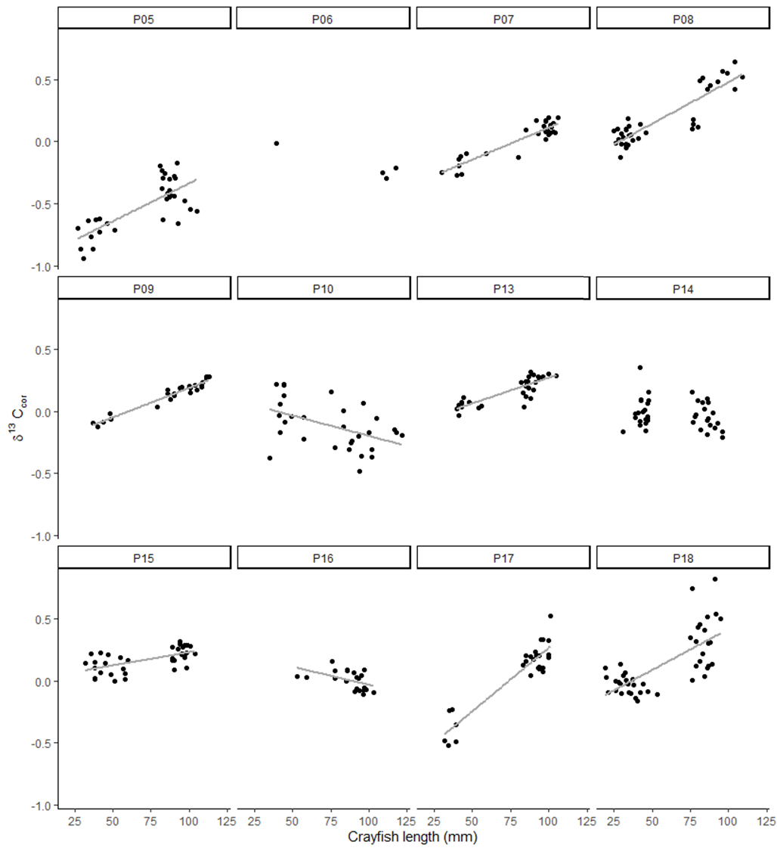

Figure S2. Ontogenetic shift in the trophic position of red swamp crayfish. P06 was not statistically tested due to low sample size. Regression lines are displayed when the model is significant.

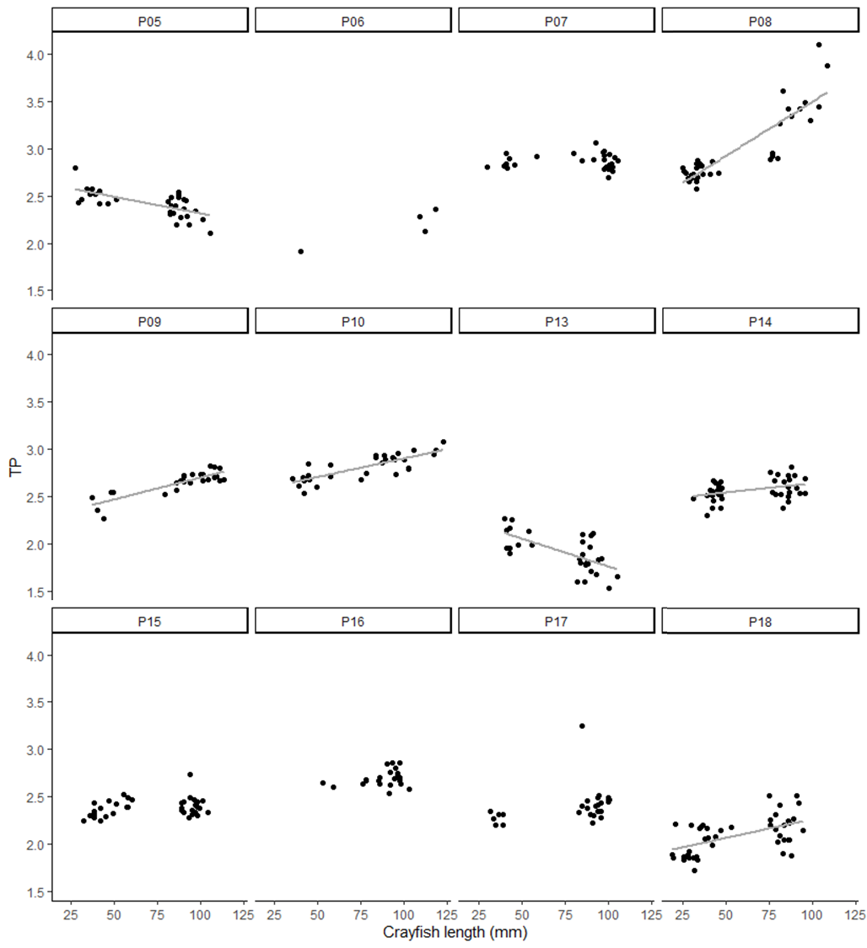

Figure S3. Stable isotope values of individuals with the associated standard ellipses where sample size ≥ 10, with crayfish split in adults and juveniles.
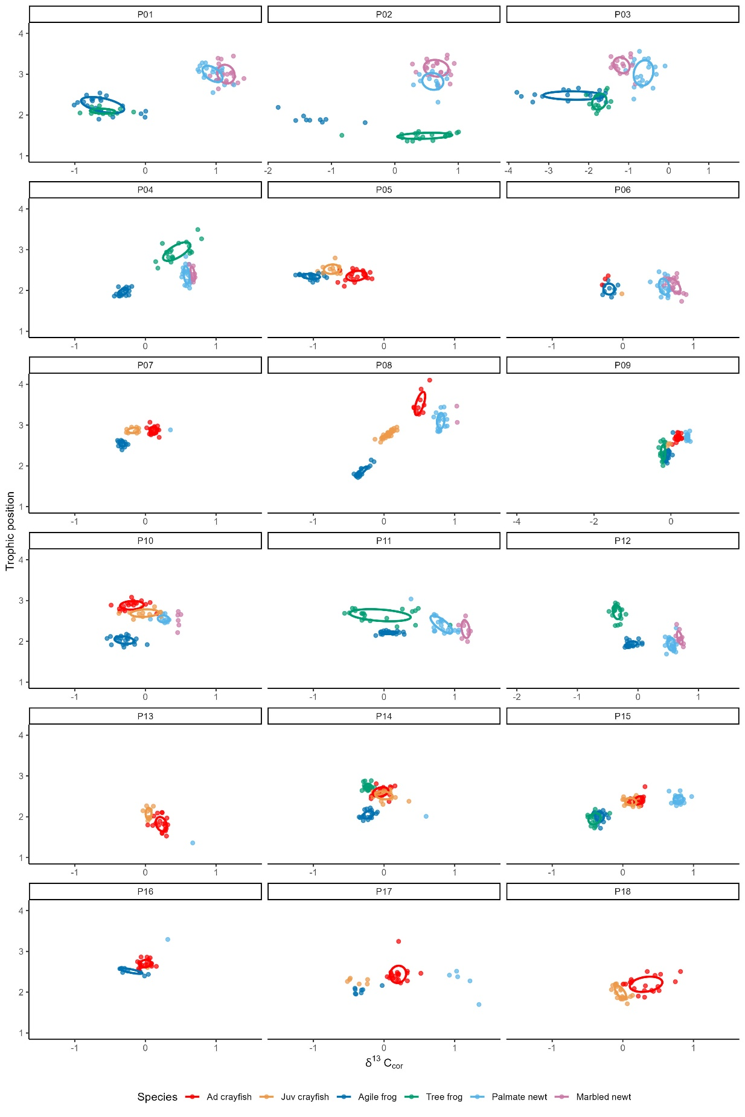

Table S5. Statistical models of the ontogenetic shift in stable isotope values of the red swamp crayfish. Not tested in P06 due to low sample size. *** < 0.001, ** < 0.01, * < 0.05, NS > 0.05

Element | Pond | Statistical model
δ¹³C_{cor} | P05  P07  P08  P09  P10  P13  P14  P15  P16  P17  P18 | -0.944 + 0.006 length ***  -0.401 + 0.005 length ***  -0.188 + 0.007 length ***  -0.287 + 0.005 length ***  0.127 - 0.003 length **  -0.143 + 0.004 length ***  NS  0.018 + 0.002 length ***  0.258 - 0.003 length *  -0.751 + 0.010 length ***  -0.239 + 0.007 length ***
TP | P05  P07  P08  P09  P10  P13  P14  P15  P16  P17  P18 | 2.666 - 0.004 length ***  NS  2.350 + 0.011 length ***  2.234 + 0.005 length ***  2.509 + 0.004 length ***  2.346 - 0.006 length ***  2.441 + 0.002 length *  NS  NS  NS  1.863 + 0.004 length ***

