Supplementary Material 2: Maps of sites by project and sampling method (Figs. S1–S3).

Pintar, M.R., N.D. Strickland, J.L. Kline, M.I. Cook, and N.J. Dorn. Asian swamp eels (Synbranchidae: Monopterus) in Florida: distribution, spread, and range of hydrologic tolerance over twenty-seven years (1997–2023). Aquatic Invasions.

Full resolution maps are archived with the dataset:
Pintar, M.R., N.D. Strickland, J.L. Kline, M.I. Cook, and N.J. Dorn. 2024. Asian Swamp Eel (Synbranchidae: Monopterus) occurrence data in Florida 1997–2023. Figshare. https://doi.org/10.6084/m9.figshare.25521346.

Fig. S1. Map of sites by project sampled as part of long-term projects in the Water Conservation Areas (including Loxahatchee National Wildlife refuge).
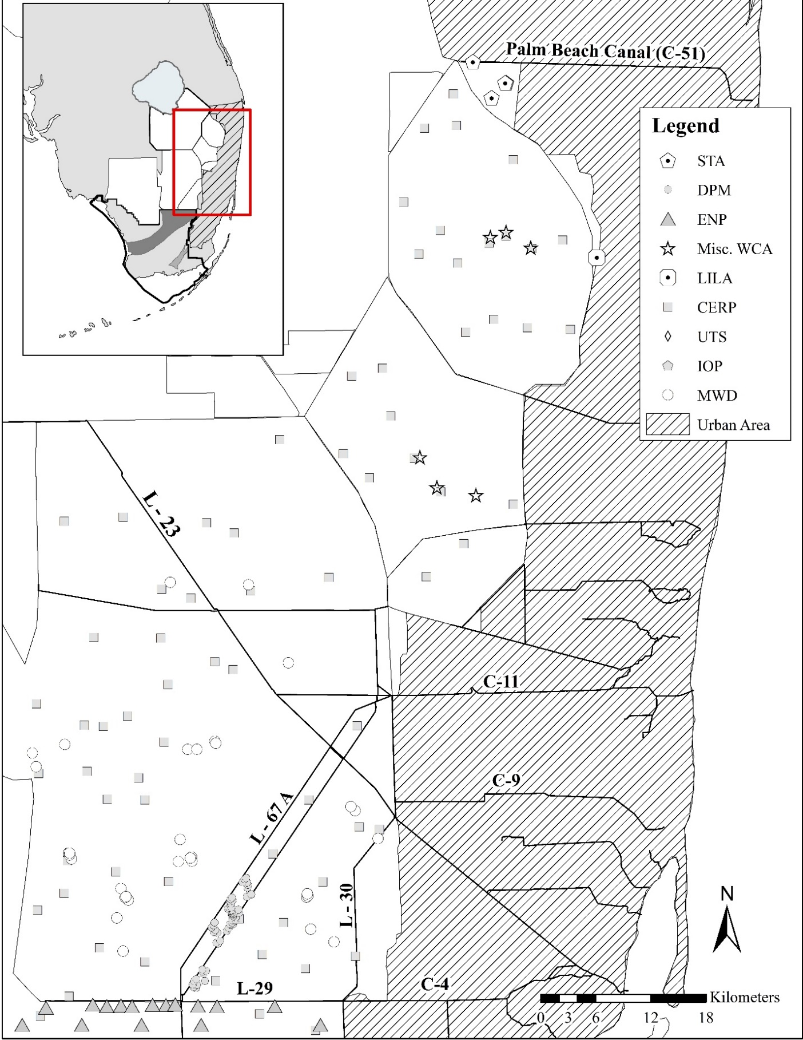
Fig. S2. Map of sites by project sampled as part of long-term projects in Everglades National Park and southern WCA 3.
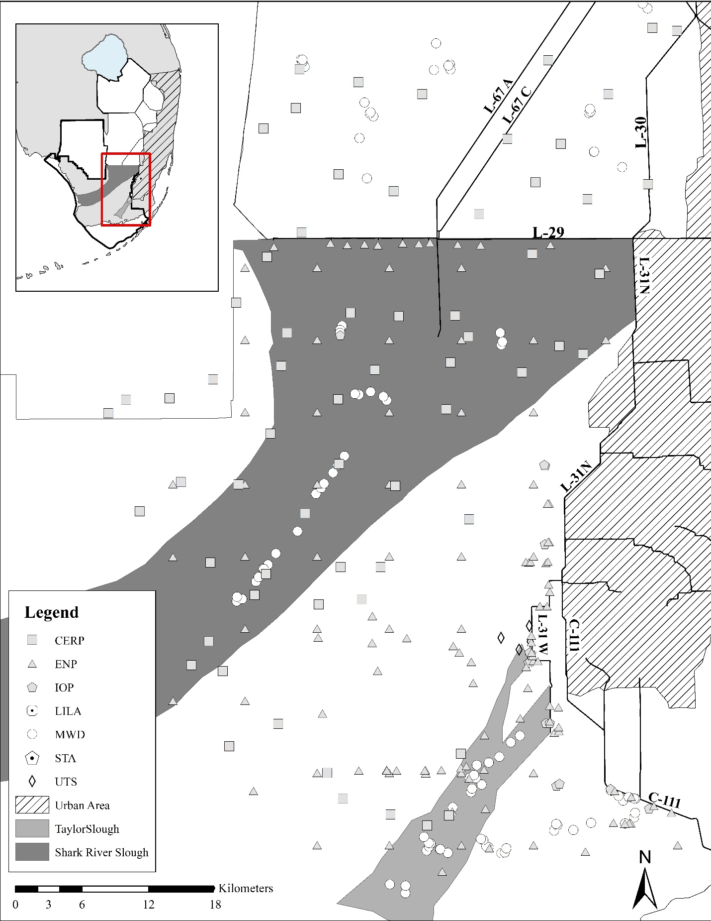
Fig. S3. Map of sites by sampling methods of long-term projects in the southern Everglades (Everglades National Park and WCA 3). ENP Parkwide locations are excluded from this map.
