Supplementary Materials 2

Establishment potential for the two gecko species adapted to different climates, Gekko japonicus and G. swinhonis, introduced to South Korea
Il-Kook Park, Yucheol Shin, Hae-Jun Baek, Jongsun Kim, Dae-In Kim, Minjeong Seok, Yaechan Oh, Daesik Park

Predictions for models calibrated without occurrence points from South Korea.

Table 1. Comparison of ENM results with all location data and excluding the introduced region (South Korea). Compared to the ENM results with all location data, the results without the Korean location data predicted a 30% and 10% decrease in habitable areas for G. japonicus and G. swinhonis, respectively.
Country | Gekko japonicus |  | Gekko swinhonis
Country | All data | Excluding Korean points | All data | Excluding Korean points
Location data | 309 | 300 | 51 | 50
Threshold | 0.217 | 0.279 | 0.334 | 0.353
Habitable area | 1,470,179 | 1,028,387 | 977,952 | 879,122

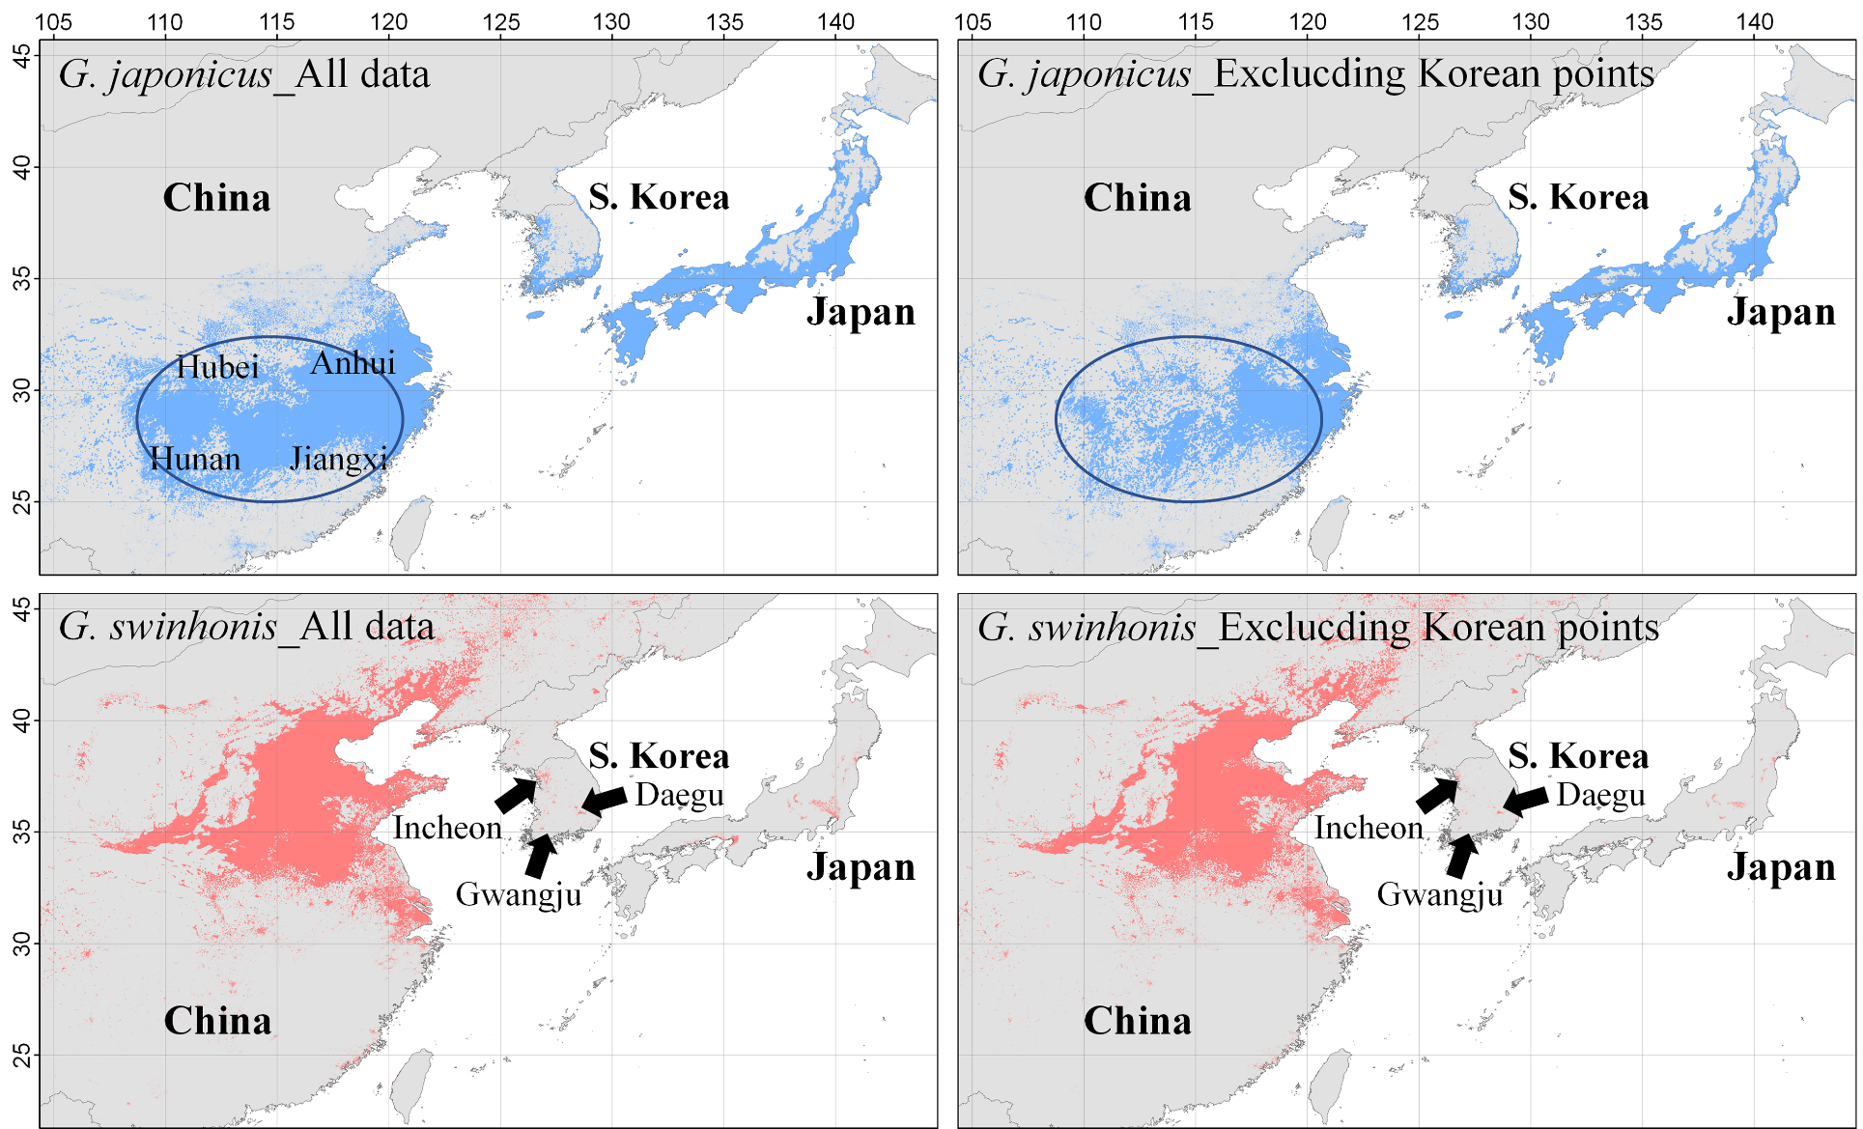
Figure 1. Distribution maps of habitable areas predicted with all location data and those excluding Korean location data. In the ENM results constructed without Korean location data, habitable areas for Gekko japonicus and G. swinhonis were also predicted. When Korean location data were excluded, a decrease in the habitable areas of G. japonicus were mainly. The habitable areas for G. swinhonis decreased slightly, but they were still predicted in Incheon, Daegu, and Gwangju in South Korea.

