Table S1. GenBank accession numbers of sequences for species taxa used in the phylogenetic analyses or genetic distance calculation
Species | Location | Accession number |  | References
Species | Location | 28S rDNA | COI | References
Enchiridium daidai | Bonotsu, Kagoshima, Japan | LC504235 | NA | Tsuyuki and Kajihara (2020)
Enchiridium evelinae | Rio de Janeiro State, Brazil | KY263662 | NA | Bahia et al. (2017)
Enchiridium japonicum | Eilat, Israel | MH700298 | NA | Litvaitis et al. (2019)
Enchiridium magec | Barcelona, Spain | MK299371 | NA | Cuadrado et al. (2021)
Enchiridium periommatum | Tavernier Key, Florida, USA | MH700301 | NA | Litvaitis et al. (2019)
Enchiridium sp. 1 | Tenerife, Buena Vista del Norte, Spain | KY263680 | NA | Bahia et al. (2017)
Enchiridium sp. 2 | New South Wales, Australia | MH700302 | NA | Litvaitis et al. (2019)
Enchiridium sp. 3 | Lizard Island, Australia | MN384686 | NA | Litvaitis et al. (2019)
Enchiridium sp. 4 | Organos, Peru | KY263679 | NA | Bahia et al. (2017)
Euprosthiostomum mortenseni | St. Ann’s Parish, Jamaica | MH700304 | NA | Litvaitis et al. (2019)
Prosthiostomum acroporae | Victorville, California, USA | MH700370 | NA | Litvaitis et al. (2019)
Prosthiostomum acroporae | Queensland, Australia | MT668970 | NA | Barton et al. (2020) Unpublished
Prosthiostomum auratum | Misaki, Kanagawa, Japan | LC625886 | LC625892 | Tsuyuki et al. (2021)
Prosthiostomum cf. ostreae | Misaki, Kanagawa, Japan | LC625890 | LC625897 | Tsuyuki et al. (2021)
Prosthiostomum cynarium | St. John, US Virgin Islands | MH700371 | NA | Litvaitis et al. (2019)
Prosthiostomum grande | Sakurajima, Kagoshima, Japan | LC635089 | LC625900 | Tsuyuki et al. (2021)
Prosthiostomum hibana | Misaki, Kanagawa, Japan | LC625887 | LC625894 | Tsuyuki et al. (2021)
Prosthiostomum lobatum | Missouri Key, Florida, USA | MH700372 | NA | Litvaitis et al. (2019)
Prosthiostomum milcum | Long Key, Florida, USA | MH700373 | NA | Litvaitis et al. (2019)
Prosthiostomum purum | Gulf of Aqaba, northern Red Sea | MH700374 | NA | Litvaitis et al. (2019)
Prosthiostomum siphunculus | Barcelona, Spain | MN421934 | NA | Dittmann et al. (2019)
Prosthiostomum sp. | Eilat, Israel | MH700375 | NA | Litvaitis et al. (2019)
Prosthiostomum torquatum | Shirahama, Wakayama, Japan | LC504234 | LC625899 | Tsuyuki and Kajihara (2020)
Prosthiostomum trilineatum | Ritidian Point, Guam | MH700376 | NA | Litvaitis et al. (2019)
Prosthiostomum utarum | Piscadera Baai, Curaçao | MH700377 | NA | Litvaitis et al. (2019)
Prosthiostomum vulgare | Misaki, Kanagawa, Japan | LC625891 | LC625898 | Tsuyuki et al. (2021)
Prosthiostomum siphunculus P33 | NA | NA | MZ273080 | Rodriguez et al. (2021) Unpublished
Prosthiostomum sp. J52 | NA | NA | MZ273071 | Rodriguez et al. (2022) Unpublished
Prosthiostomum siphunculus (Spain) | Almuñecar, Almería, Spain | NA | KT363736 | Aguado et al. (2016)
Prosthiostomum amri | New South Wales, Australia | NA | MW375900 | Rodriguez et al. (2021)
Prosthiostomum huidongense sp. nov. | Huidong, China | OR680129 | OR680085 | This study
Pseudobiceros stellae (Outgroup) | Israel | MH047293 |  | Velasquez et al. (2018)
NA: not available from reference
 | P. torquatum | P. hibana | P. auratum | P. grande | P. cf. ostreae | P. vulgare | P. siphunculus (Spain) | P. amri | P. siphunculus P33 | P. sp. J52 | P. huidongense sp. n.
P. torquatum
P. hibana | 0.1983
P. auratum | 0.1573 | 0.1846
P. grande | 0.1790 | 0.1953 | 0.1573
P. cf. ostreae | 0.1795 | 0.2068 | 0.2000 | 0.2098
P. vulgare | 0.1470 | 0.1812 | 0.1453 | 0.1754 | 0.1863
P. siphunculus (Spain) | 0.1795 | 0.2103 | 0.1795 | 0.1917 | 0.2188 | 0.1795
P. amri | 0.0572 | 0.2098 | 0.1935 | 0.1910 | 0.2262 | 0.1553 | 0.1880
P. siphunculus P33 | 0.1878 | 0.2073 | 0.1756 | 0.1958 | 0.2073 | 0.1902 | 0.1585 | 0.1831
P. sp. J52 | 0.1898 | 0.2117 | 0.1776 | 0.2111 | 0.2092 | 0.1946 | 0.1995 | 0.1853 | 0.2122
P. huidongense sp. n. | 0.2068 | 0.2308 | 0.2171 | 0.2170 | 0.2034 | 0.2171 | 0.2051 | 0.2425 | 0.2341 | 0.2336

Table S2. Interspecific uncorrected p-distances for the COI gene fragments

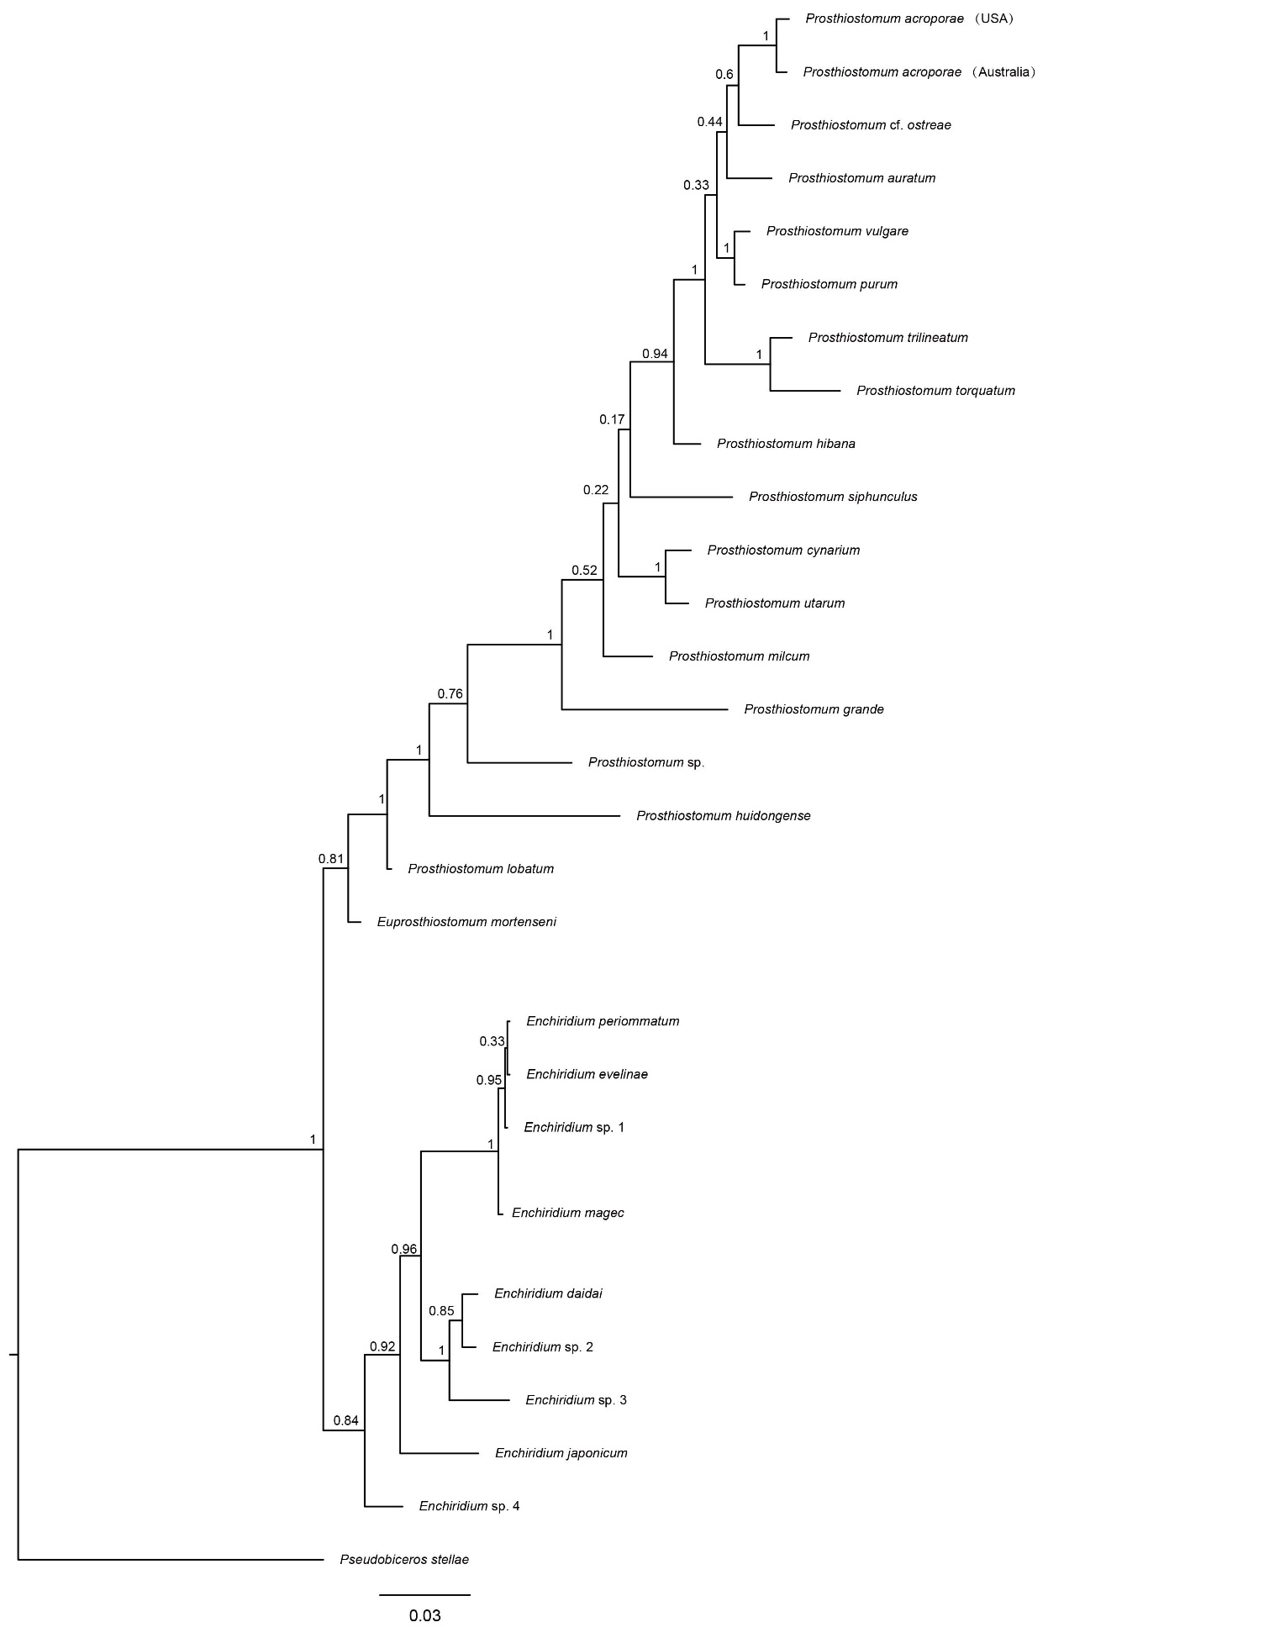
Figure S1. The tree is reconstructed by Bayesian inference analyses based on the 28S rDNA.

